All quantities are estimated.
This bid solicitation has been reserved for Small Business Contracting. Only those Bidders certified as DGS Small Businesses through the Small Business Contracting Program may submit a bid for these materials.
Please complete and attach the BOP-2201 Worker Protection Form to your bid.
WORKER PROTECTION - Pursuant to Executive Order 2021-06, Worker Protection and Investment
(October 21, 2021), the Commonwealth is responsible for ensuring that every Pennsylvania worker has a safe and healthy work environment, and the protections afforded them through labor laws. To that end, contractors and grantees of the Commonwealth must certify that they are in compliance with all applicable Pennsylvania state labor and workforce safety laws. Such certification shall be made through the Worker Protection and Investment Certification Form (BOP-2201) and submitted with the bid, proposal, or quote.
The container must be wind & watertight All rust is hammer-tested prior to delivery. Rusty pinholes and thinning steel are repaired with an overlay patch, extending beyond the affected area. Scratches and Dents should not exceed 4 inches inward or outward.
The seals must be intact
The door seal gaskets secure the wind and watertightness of the moving door parts of the shipping container. The door gaskets will show no daylight from the interior of the container outward. The retainer strip holding the door gaskets will be intact and secured.

The floor is intact and in good condition
All container floors must be inspected to ensure they are intact, providing a secure environment for storing goods. Flooring will not be broken or show holes, especially through to the undercarriage. Delamination may be present but will not exceed multiple layers. The floor should not be flexing or "spongy. “Holes and excessive delamination must be repaired with a wooden or steel plate. Crossmembers must be checked in conjunction with flooring. No broken welds should be present, and the crossmember should remain flush with the flooring.

The doors on the container open & close
The doors to be able to be fully opened and peeled back. Container doors are heavier; however, they should open without maximum effort involved.
The door hardware has no malfunctions
To close and lock the container from outside elements The lock rods to be able to rotate open and close, to lock or unlock the latch.
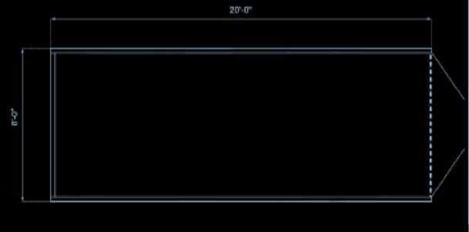
Door Opening: End wall doors are required. Side wall doors optional.
Easy open-door design and locking box which is typically only found on new units or the standard (4) locking bars will work.

Delivered to:

4 qty- 20 ft Conex containers
PENNDOT Garage
160 SR 519, Eighty Four PA, 15330

2 qty- 20 ft Conex containers
PENNDOT Clover Hill Shed
25 Grange Road, Coal Center PA 15423

2 qty- 20 ft Conex containers
PENNDOT West Brownsville Shed
1 PennDOT Rd, Brownsville PA 15417

All containers need to face the cab of the delivery truck. Delivery needs to be with a tilt bed.

Site contact: Bonnie Cunningham RPC- 724-223-4480

All bidders must submit their bids electronically through the Commonwealth’s electronic system (SRM) via the PA Supplier Portal: www.pasupplierportal.state.pa.us
If you have trouble with the bidding, please contact the Supplier Service Center at (877) 435-7363 and choose option #1.
PUBLIC BID OPENING: Public Bid Opening Will Be Held Virtually via Microsoft Teams on 7/29/25 at 10:00A.M. (EST). Please contact Tricia Olesko (tolesko@pa.gov) for meeting invitation.

Questions & Answers: All questions pertaining to Solicitation # must be made prior to 7/22/25 at 10:00A.M. (EST). All questions and answers will be posted to the Solicitation in eMarketplace for public viewing.

Work Schedule (Deliveries/Receiving):
  - No deliveries shall be scheduled to occur on the following holidays unless written permission to do so is provided by the Department Project Manager or designee:
    - New Year’s Day
    - Dr. Martin Luther King Jr. Day
    - President’s Day
    - Memorial Day
    - Juneteenth Day
    - Independence Day
    - Labor Day
    - Columbus Day
    - Veteran’s Day
    - Thanksgiving Day
    - Day after Thanksgiving Day
    - Christmas Day

