STATEMENT OF WORK

COMMONWEALTH OF PENNSYLVANIA

DEPARTMENT OF TRANSPORTATION MIFFLIN COUNTY 2-7

I. SCOPE OF WORK
The Pennsylvania Department of Transportation – Mifflin County is seeking a qualified and accredited contractor to install a Thermoform PVC pipe liner as listed in PENNDOT Publication 35 (Bulletin 15) Section MISC: Miscellaneous. The contractor will be responsible for the installation of the pipe liner, as well as any items incidental to the project. This includes providing all necessary equipment, labor, and materials required to complete the installation in accordance with applicable standards and specifications.

II. PROJECT DESCRIPTION
This project involves the installation of a Thermoform PVC liner manufactured by Warrior Trenchless Solutions (using just steam in the installation process) within an existing, deteriorating metal pipe located on US 522. The pipe is situated under approximately 8 to 20 feet of cover and lies on a hard skew beneath SR 0522.
The Contractor shall provide all labor, materials, equipment, and supervision necessary to install approximately 165 linear feet of Thermoform PVC liner at the specified project location.
The installation process should be as follows:
- Pre-Installation TV Inspection
- Pre-Installation Pipeline Cleaning and Preparation
- Linear Installation
- Equipment Setup
- Heat Coiled Liner
- Insert Liner into Hose Pipe
- Process Liner
- Post-Installation TV Inspection
- Reinstatement of Service Connections
The Contractor is responsible for all aspects of the work and any items incidental to the completion of the project, with the following exclusions to be performed by PennDOT:
- Traffic control, including flaggers and short-term signage
- Preparation of the pipe ends for access and installation

Environmental and Public Safety Requirements
The installation process must be environmentally responsible and adhere to all applicable environmental protection regulations. Specifically:
- The pipe lining installation shall not result in the release of volatile monomers, chemicals, or contaminants into groundwater, soil, or nearby waterways.
- The process must be free of harmful vapors or emissions that could pose a risk to the environment, wildlife, or public health.
- The contractor shall take all necessary precautions to ensure that no pollutants are discharged into streams, stormwater systems, or the surrounding environment during the execution of the work.
The selected contractor is responsible for implementing best management practices (BMPs) to minimize environmental impact and ensure full compliance with local, state, and federal environmental regulations.

III. LOCATION OF WORK
All work associated with this project will be performed at the following location:
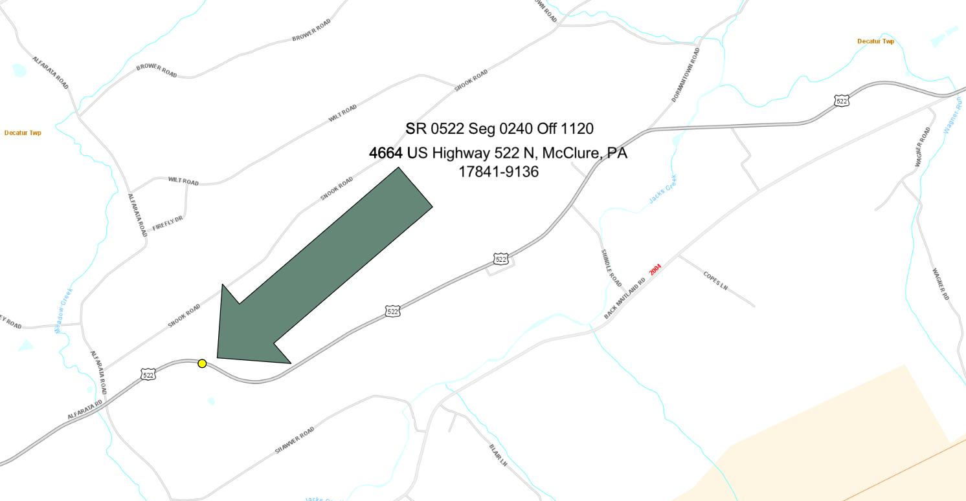
SR 0522, Segment 0240, Offset 1120
Decatur Township, Mifflin County (east of Alfarata)
4664 US Highway 522 N
McClure, PA 17841-9136
United States Figure 1: General Site Location
IV. CONTRACTOR REQUIREMENTS
- Worker Protection and Investment Certification
In accordance with Executive Order 2021-06: Worker Protection and Investment (issued October 21, 2021), the Commonwealth of Pennsylvania is committed to ensuring that all Pennsylvania workers have a safe and healthy work environment, as well as the protections guaranteed by applicable labor laws.
Contractors and grantees must certify compliance with all relevant Pennsylvania labor and workforce safety laws. This certification must be completed using the Worker Protection and Investment Certification Form (BOP-2201) and submitted with the bid, proposal, or quote.
Failure to submit a completed BOP-2201 form may result in the disqualification of your submission as non-responsive.
- Certificate of Insurance
The Contractor must provide a valid Certificate of Insurance demonstrating appropriate coverage, including general liability, workers’ compensation, and any other insurance required by PennDOT or applicable law. The certificate must name the Commonwealth of Pennsylvania as an additional insured and be submitted prior to the commencement of work.

- References
The Contractor must provide a minimum of three (3) professional references from recent clients for whom similar services have been performed within the last five (5) years. Each reference must include the following information:
- Name of the client or organization;
- Contact person’s name, title, phone number, and email address;
- Description of services provided;
- Dates of service or project duration;
- Any relevant outcomes or performance highlights.
References must be submitted with the bid, proposal, or quote. The Commonwealth reserves the right to contact any or all references to verify the Contractor’s experience and qualifications. Failure to provide references as specified may result in disqualification of the submission as non-responsive.

- Prevailing Wage

The Pennsylvania Department of Labor and Industry have determined that this job falls under Pennsylvania’s Prevailing Wage Act .Therefore the contractor must pay prevailing wage for this project . The attached document outlines the category and pay rates for those working on this project and what they must be paid. Contractor must keep record of payroll of this project that can be asked upon request to determine compliance. The project serial number is 25-07920.For any questions concerning this project please call (814)940-6224 and reference the serial number.

- Small Business Procurement

The Commonwealth identified this procurement as fitting the established criteria under the Small Business Procurement Initiative set forth in Executive Order 2011-09. Accordingly, only those bidders who are certified as a Small Business through the Department of General Services’ self-certification process found at www.smallbusiness.pa.gov are eligible to submit a bid and be awarded a contract in response to this IFB. In order to be eligible to receive an award in response to this procurement, the bidder must be certified at the time of bid opening and include a copy of the certification in the bid response.

V. CONTRACT TERM
The contract will commence upon the issuance and receipt of a Purchase Order from the Pennsylvania Department of Transportation.

VI. CHANGE CONTROL PROCESS
Any changes to the scope of work, project timeline, or overall cost must be submitted in writing and formally approved by both parties through a Change Order prior to implementation. Unauthorized changes will not be recognized or compensated.

VII. BID AWARD
To be considered for award, the bidder must complete and submit the following:
A.The electronic Invitation for Bid (IFB), available at:
www.pasupplierportal.state.pa.us
B. A properly executed Worker Protection and Investment Certification Form (BOP-2201)

C. A valid Certificate of Insurance.
D. Domestic Workforce Utilization Form
E. TradeSecrets/Confidential Proprietary Information Notice
F. GSPUR-89 Reciprocal Limitations Form

G.A minimum of (3) professional references from recent clients for whom similar services have been performed within the last five (5) years.
The unit price submitted must be all-inclusive, covering all labor, materials, equipment, tools, insurance, and any other costs necessary to complete the project as described.
The contract will be awarded to the responsible bidder submitting the lowest total bid that meets all requirements.

VIII. PAYMENT TERMS
Payment will be made upon satisfactory completion of all contract tasks and deliverables, as verified by the Pennsylvania Department of Transportation.
All payments under this contract will be issued via Automated Clearing House (ACH), commonly known as direct deposit. Contractors are advised to review Section V.20 CONTRACT-016.2, Payment – Electronic Funds Transfer of the attached Commonwealth Terms and Conditions for full details regarding payment procedures and contractor responsibilities.
A. Special Invoice and Billing Instructions:
Upon completion of the service, the selected Offeror must:
- Complete the attached Confirmation of Service Form (OS-501)
- Prepare a Billable Summary Report detailing all work performed, hours spent, materials used, and costs incurred for the project. This will serve as supporting documentation to provide transparency and justification for the charges billed.
These documents must be sent to the Project Manager (or designee) in the county where the work was performed.
The Project Manager (or designee) will:
- Review and confirm that the work has been completed as required
- Perform a final inspection
- Contact the contractor to correct any discrepancies or issues in the billing, if necessary
Only after successful confirmation of work and proper submission of documentation will the invoice be processed for payment.
INVOICES
Invoices submitted under this contract must comply with the format requirements outlined in the Invitation for Bid (IFB).
All invoices must be submitted using one of the following methods:
A. Paperless Email Invoice Option
Email a copy of the correctly executed invoice to:
69180@pa.gov
For more information about the Commonwealth’s E-Invoicing Program, visit:
http://www.budget.pa.gov/Programs/Pages/E-Invoicing.aspx
B. Mail Option
Mail the invoice to:
Commonwealth of Pennsylvania – PO Invoice
PO Box 69180
Harrisburg, PA 17106
Important Invoice Requirements:
- Each invoice must include the Purchase Order Number and your SAP Number.
- The name and address on the invoice must match those listed on the Purchase Order.
- Failure to provide the above information may result in a delay in payment.
Please Note:
For security purposes, contractors must NOT include employer identification numbers, Social Security Numbers, bank account details, or other personally identifiable information on invoices. This sensitive information is linked to your SAP Number and should be kept confidential.

IX. RECEIPT AND OPENING OF BIDS
All bids must be submitted electronically via the PA Supplier Portal, accessible at:
www.pasupplierportal.state.pa.us.
Bids submitted by email, fax, or regular mail will not be accepted.
The Department of Transportation assumes no responsibility for the premature opening of a bid, the failure to open a bid that is not properly addressed or identified, or for any other issues related to the submission process.
The department will conduct a bid opening on teams on 9/2/25 at 12:30 eastern time. Please contact glenn mcmullen at glmcmullen@pa.gov for an invitation.

X. QUESTIONS & ANSWERS
All questions regarding Solicitation must be submitted prior to August 26, 2025, at 12:00 PM.
All questions and their corresponding answers will be posted publicly on the Solicitation page in E-Marketplace for all interested parties to view.
Questions submitted after this deadline may not be answered.
Please send your questions via email to:
Glenn McMullen
Email: glmcmullen@pa.gov

XI. BID RESULTS
Bidders may obtain bid results by visiting:
www.emarketplace.state.pa.us/bidtabs.aspx.
Bid results will be posted as soon as practicable following the bid opening. The posted results represent the apparent bidders; however, all bids remain under review until the final award of the Purchase Order.

