GENERAL SPECIFICATIONS: SGL 293 Herbaceous Opening Tree Clearing/Mulching

- SCOPE OF WORK:

The Pennsylvania Game Commission, Northcentral Region, requires the services of a contractor to clear approximately 139 acres of land to create new herbaceous openings on State Game Land 293 in Cameron County. The contractor is required to provide the equipment, labor, insurance, and all miscellaneous expenses to complete the operation.

Questions regarding the technical aspects, site characteristics and location of this bid should be directed to Land Management Group Supervisor Jason Wagner at 570-398-4744. Questions regarding the bidding or contracting procedures should be directed to Contracts and Procurement at 717-787-6594.

- CONTRACT TASKS:

- Project Location: Lat/Long

41.50111, -78.41242

- Clearing Specifications:

Site Description
The project area consists of 9 distinct plots totaling 139 acres. The perimeter of each herbaceous opening (HO) block and reserve islands are flagged heavily with orange flagging. The entire site is a 10-year-old clear cut with a small amount of overstory trees remaining. Overstory tree size varies from 8”- 20” in diameter. The harvest that took place was a whole tree chip harvest that left minimal slash and debris within the blocks. The HO blocks are also for the most part free of large surface rock. Most of the stumps from the original clearcut harvest are decaying. The topography of the land is relatively flat with some minor slope and the ground is rather bumpy. Stems are mostly trees that vary in height from 5’ tall up to 20’ tall and are anywhere between 1”- 4” in diameter. Some of the blocks also have a small laurel component. Stem density is extremely dense with well over 5,000 stems per acre.

Work To Be Completed
The contractor will be required to fell all stems within the defined HO’s and mulch/grind the material in place, incorporating the ground material into the topsoil. There shall be no piles of chipped or mulched material within the project area. All woody material whether from felled stems or those already lying on the surface must be ground. Debris may not be dozed or otherwise pushed off of the site. All organic material and topsoil must be retained in place within the plots. All overstory trees within the HO’s must be felled. Tops and trunks shall be placed outside of the herbaceous openings or within reserve islands in coordination with the Land Management Group Supervisor. Trunks and tops may not be within 20 feet of the edge of an HO. All remnant stumps as well as stumps from mowing and overstory felling, must be ground to a minimum of 6 inches below the soil surface.

Erosion and Sedimentation control devices will be constructed as needed by the contractor to prevent soil erosion from the site.

Do not damage standing timber outside of the flagged project site.

Upon completion of the clearing, the Agency Designee must approve the condition of each site. The contractor must contact the Agency Designee a minimum of 72 hours in advance for an evaluation of site clearing conditions. The decision of the Agency Designee will be final.

Site Location Map Attached (Attachment 1)

- SITE INSPECTION AND ASSISTANCE:

The PGC will conduct an optional one-time-only tour of the work site for prospective bidders. We will meet Friday, April 5, 2024 at 0900. The GPS coordinates for the meeting location are 41.50111, -78.41242 at a Game Lands parking lot at the top of Reed Hollow Ln off of West Creek Road between Saint Mary’s and Emporium.

- CONTRACT REQUIREMENTS:

- All work must be completed by the termination date: June 28, 2024.

- No contract extensions will be approved.

- The contractor agrees to comply with all attachments.

- As a further guarantee of faithful performance of the conditions set forth in this contract, the successful bidder hereby agrees to furnish the Commission with cashiers or treasurers check, line of credit or insurance bond payable to the PA Game Commission, in the amount of $1,000.00.

- Failure to comply with any terms or conditions of the contract may result in cancellation of the agreement and claim may be made against the surety or the security for all or part of the damages sustained by such noncompliance.

- The contractor may use any construction equipment deemed suitable by agency representative and must be cleaned prior to arrival on site to limit transfer of seeds from other sites.

- Erosion control will be the responsibility of the contractor.

- Damage any plants or trees, natural growth, or other objects outside the areas to be cleared and grubbed is not acceptable. Payment for damages will be determined if deemed necessary by the agency representative at a rate determined by the agency forester.

- Damage to existing infrastructure (roads, trails, food plots) will be repaired by the contractor.

- Burning is not permitted at the site.

- The winning bidder will coordinate site clearing by making a PA One Call. The contractor must provide at least 72 hours advance notice prior to commencing work on the project. Failure to provide adequate lead time will delay the start of the project.

- The contractor will remove all trash and garbage generated from the completion of this contract. This is to include all materials related to the support of felling tools and equipment, as well as items generated through personal use by the contractor’s employees.

- Access gates to the area will remain closed at all times.

- Clean all equipment and vehicles thoroughly (especially the undercarriage and wheels) before they are brought on site, this will remove invasive plant seeds from the equipment and undercarriages of the vehicles that may have been picked up at other sites.

- The contractor will notify the PGC representative three days prior to beginning the project. The contractor may work at times other than the schedule of the PGC representative. Inspection of the project will occur during normal working hours.

- Final inspection of the habitat project will be conducted by the agency representative. The contractor may be present at the final inspection. Upon successful completion of the required work, payment will be released to the contractor.

- INSURANCE REQUIREMENTS:

A. The contractor will provide Workmen’s Compensation insurance sufficient to cover all of the employees of contractor working to fulfill this contract.

B. Comprehensive General Liability Insurance, including bodily injury and property damage insurance, to protect the Commonwealth and the contractor from claims arising out of the performance of the contract. The amount of Bodily Injury Insurance shall not be less than $300,000.00 for injury to or death of persons per occurrence. The amount of Property Damage Insurance shall not be less than $300,000.00 per occurrence.

C. Such policies shall name the Commonwealth as an additional insured. Prior to the commencement of work under this contract, the contractor must provide the Commonwealth with current Certificates of Insurance. These Certificates shall contain a provision that coverage afforded under the policy shall not be canceled or changed until at least thirty (30) days prior written notice has been given to the Commonwealth.

D. HOLD HARMLESS: The contractor shall be responsible for and agrees to indemnify and hold harmless the Commonwealth from and against damages to property or injuries (including death) to any persons and other losses, damages, expenses, claims, demands, suits, and actions by any party against the Commonwealth in connection with the work performed by the contractor.

VI. DAMAGE TO COMMONWEALTH PROPERTY:

The Contractor shall be responsible for any damage to Commonwealth property resulting from the improper use of equipment for this habitat project. The Contractor will be given one (1) written warning that damage is becoming excessive and if the action continues damages will be assessed.

A. TIMBER DAMAGES – When, in the opinion of the Regional Forester, damage to the residual stand becomes excessive the Contractor shall pay the Commission a fair base current value determined by the Regional Forester per unit of volume. If this value for damage due to Contractor’s carelessness or negligence is less than $10.00 per tree then a minimum charge of $10.00 per tree will be made whether the tree is commercial, non-commercial, merchantable or non-merchantable.

B. COMMISSION FACILITIES – Contractor shall immediately repair, in a manner that meets with the approval of the Land Management Group Supervisor, any damage to Game Land roads and other facilities, including access roads, resulting from their use for this construction operation, general wear and tear excepted. The Land Management Group Supervisor may notify the Contractor in writing to temporarily discontinue use of any of the above whenever, in their opinion, such action is necessary to prevent serious damage.

VII. Bid AWARD:

Bids are to be submitted electronically through the Commonwealth’s “PA Supplier Portal” system by 2:00 PM, Thursday, April 11, 2024. If you have not registered as a vendor with the state, you must do this first at www.pasupplierportal.state.pa.us before submitting an electronic bid. Any questions regarding this may be directed to Contracts and Procurement at 717-787-6594

The bid will be awarded on a lump sum total of the entire project. The work may begin as soon as the Purchase Order is fully executed, and the work must be completed by June 28, 2024. No extension of time will be awarded.

The Commission reserves the right to reject any and all bids and to choose the bid that, in its sole opinion, best meets the needs of this project.

ALL VENDORS WHO CONDUCT BUSINESS WITH THE PENNSYLVANIA GAME COMMISSION MUST HAVE A VENDOR NUMBER ASSIGNED TO THEM IN ORDER TO RECEIVE PAYMENT FROM THE COMMONWEALTH.

The unit (per acre) price shall include all labor, equipment, tools, insurance and all items necessary for the completion of the project.

VIII. PAYMENT TERMS:

A lump sum is the unit of bidding and payment will be based on the amount of work completed to the specifications. Once the work has been approved the operator will be paid.

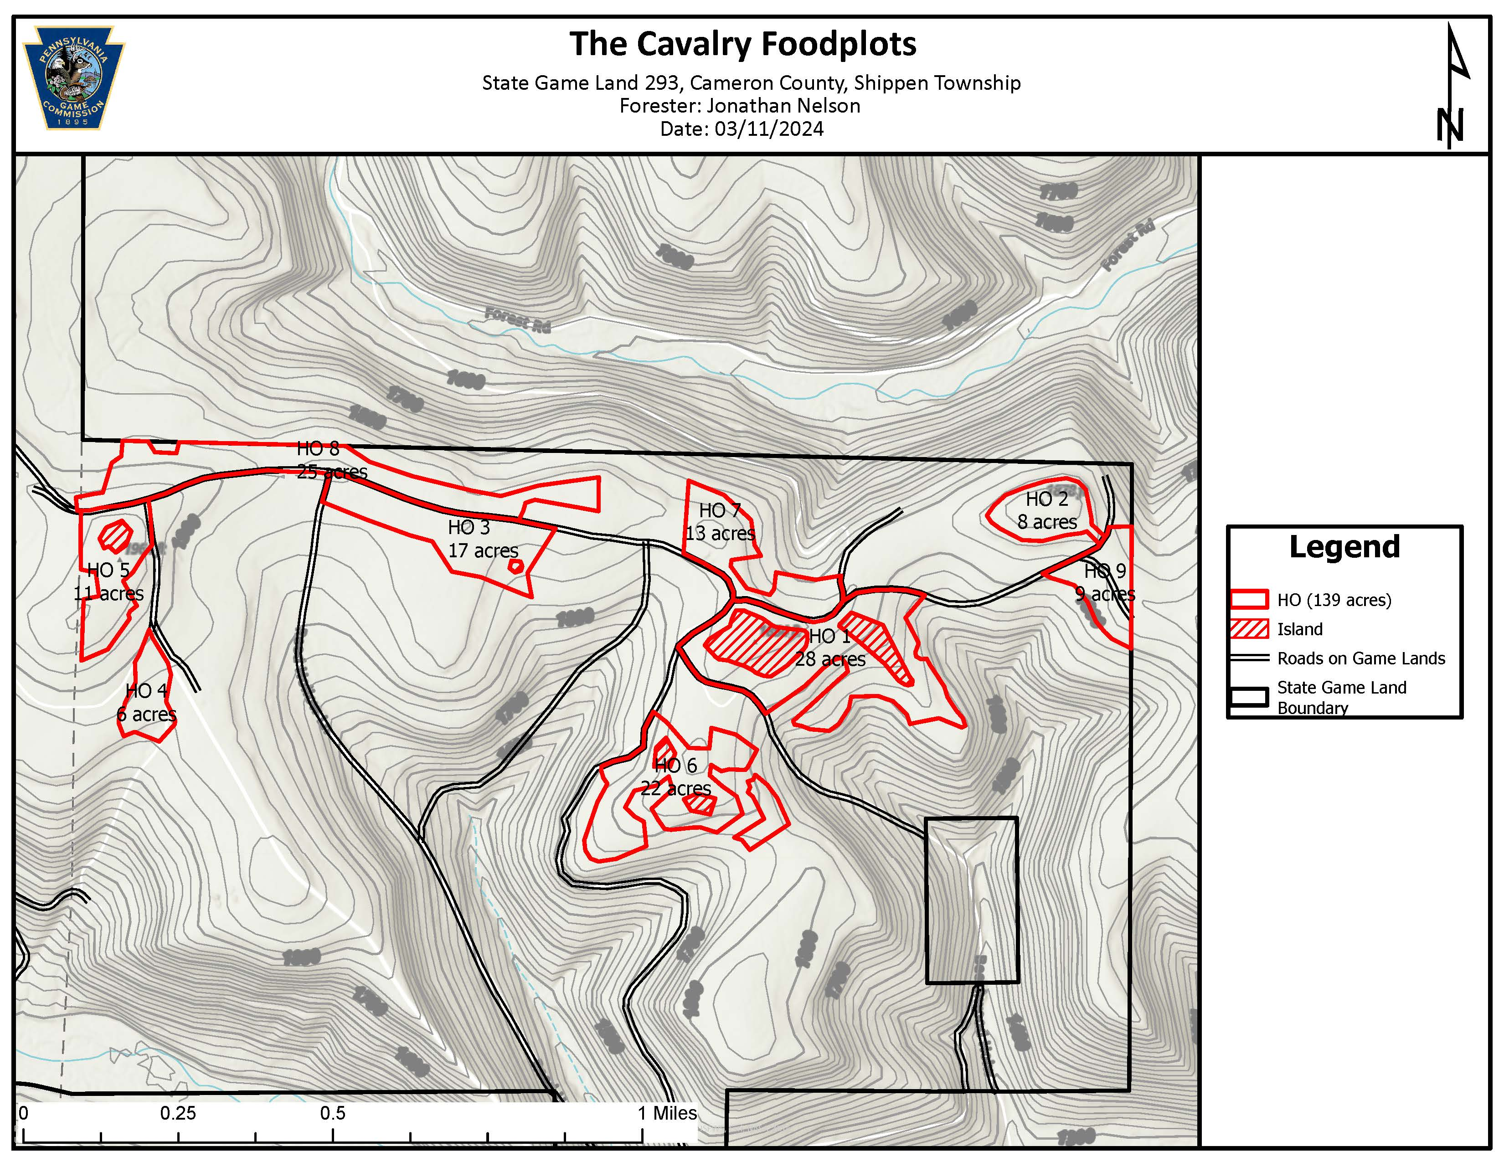
Attachment 1 – Project site map

