Plant List

Plant Quantity

Chamaecyparis obtusa ‘Nana’-Dwarf hinoki cypress 6

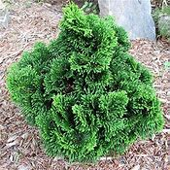
Nepeta ‘Walker’s Low’- Catmint 9
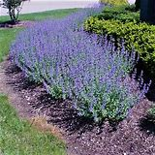
Buxus ‘Green Velvet’-Green Velvet boxwood 8
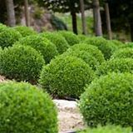

Sedum spectabile ‘Autumn Joy’- Autumn Joy Sedum 8

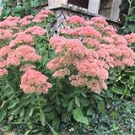

Liriope muscari- Liriope A non-variegated cultivar, such as ‘Big Blue’ 8

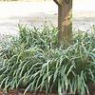

Echinacea purpurea-Purple cone flower 14

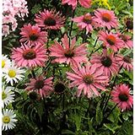

Pennisetum alopecuroides ‘Hameln’- Hamlen Dwarf fountain grass 6

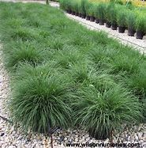

Juniperus procumbens ‘Nana’ -Dwarf Japanese garden juniper 3

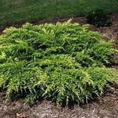

Sporobolus heterolepis- Praire dropseed grass 8

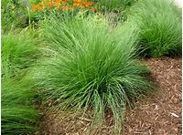

Forsythia x intermedia ‘Courtasol’ - Gold Tide® forsythia 9

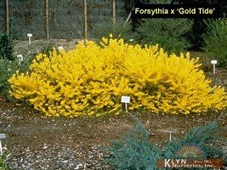

Festuca glauca-Blue fescue 12

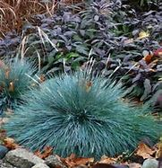

Hemerocallis- a reblooming cultivar- Yellow Daylilies 8

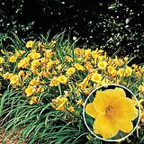b

Bobo® Hydrangea paniculata 'ILVOBO' USPP 22,782-
Bobo hydrangea 6

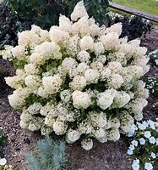

Helictotrichon sempervirens-Blue oat grass 5

