UPDATED

INTEGRATED CULTURAL RESOURCES MANAGEMENT PLAN

FOR

INSTALLATIONS OF THE

XX ARMY NATIONAL GUARD

20XX

FINAL

Insert state emblem or logo here

XXX Army National Guard
Address

ABBREVIATIONS AND ACRONYMS

AASF Army Aviation Support Facilities
ACEIT Automated Cost Estimated Integrated Tools
ACHP Advisory Council on Historic Preservation
ACSIM Assistant Chief of Staff for Installation Management
ACTS Army Compliance Tracking System
AD Anno Domini
AEC Army Environmental Command
AEDB Army Environmental Database
AEDB-EQ Army Environmental Database - Environmental Quality
AFB Air Force Base
AHPA Archaeological Historic Preservation Act of 1974
AIRFA American Indian Religious Freedom Act of 1978
a.k.a. Also Known As
AMCOS Army Military-Civilian Cost System
APE Area of Potential Effect
AR Army Regulation
ARE Army-Environmental
ARNG Army National Guard
ARPA Archaeological Resources Protection Act of 1979
ASP Ammunition Supply Point
ATAG Assistant to The Adjutant General
ATP Ammunition Transfer Point
AVCRAD Aviation Classification Repair Activity Depot
BIA Bureau of Indian Affairs
BIRTC Branch Immaterial Replacement Training Center
BRAC Base Realignment and Closure
BC Before Christ
BLM Bureau of Land Management
BP Before Present
CA Comprehensive Agreement
CAA Clean Air Act
CCC Civilian Conservation Corps
CD Compact Disk
CEQ Council on Environmental Quality
CERCLA Comprehensive Environmental Response, Compensation and Liability Act
CERL Construction Engineering Research Laboratories
CFR Code of Federal Regulations
CFMO Construction and Facility Management Office
COL Colonel
COTR Contracting Officer’s Technical Representative
CPL Corporal
CRM Cultural Resources Manager
CSA Confederate States of America
CSMS Combined Support Maintenance Shops
CX Categorical Exclusion
CWA Clean Water Act
DA Department of the Army
DA-PAM Department of the Army Pamphlet
DCA Departmental Consulting Archaeologist
DoD U.S. Department of Defense
DoDI U.S. Department of Defense Instruction
DOI Department of the Interior
DSCOPS Operations Manager in the Directorate of Operations
EA Environmental Assessment
EBS Environmental Baseline Survey
ECAS Environmental Compliance Assessment System
EIS Environmental Impact Statement
ENV Environmental
EO Executive Order
EPA Environmental Policy Act
EPAS Environmental Performance Assessment System
EPR Environmental Program Requirements
EQCC Environmental Quality Control Committee
EQR Environmental Quality Report
ERDC U.S. Army Engineer Research and Development Center
ESA Endangered Species Act
ESOH Environmental Safety and Occupational Health
FBI Federal Bureau of Investigation
FED Facility Engineering Department
FEIS Final Environmental Impact Statement
FGDC Federal Geographic Data Standards
FISP Facility Inventory and Stationing Plan
FMO Facilities Management Office
FMS Field Maintenance Shop
FOB Forward Operating Base
FONSI Finding of No Significant Impacts
FOIA Freedom of Information Act
FOUO For Official Use Only
FWPCA Federal Water Pollution Control Act
FY Fiscal Year
GIS Geographic Information System
GMO Game Management Office
GPS Global Positioning System
HABS Historic American Building Survey
HAER Historic American Engineering Record
HQDA Headquarters, Department of the Army
HPP Historic Preservation Plan
ICBM Intercontinental Ballistic Missiles
ICRMP Integrated Cultural Resources Management Plan
IFS Integrated Facilities System
INF Infantry
INRMP Integrated Natural Resources Management Plan
IPR In-progress Review
IRTC Infantry Replacement Training Center
ISO Isolated Find
ISR Installation Status Report
ITAM Integrated Training Area Management
JAG Judge Advocate General
JFHQ Joint Forces Headquarters
LTC Lieutenant Colonel
MACOM Major Army Command
MAJ Major
MATES Maneuver Area Training Equipment Site
MFR Memorandum for Record
MILCON Military Construction
MOA Memorandum of Agreement
MOU Memorandum of Understanding
MTP Maintenance and Treatment Plans
NAAQS National Ambient Air Quality Standards
NAGPRA Native American Graves Protection and Repatriation Act of 1990
NATO North Atlantic Treaty Organization
NEPA National Environmental Policy Act of 1969, as amended
NGB National Guard Bureau
NHL National Historical Landmark
NHPA National Historic Preservation Act of 1966, as amended
NOI Notice of Intent
NPS National Park Service
NRHP National Register of Historic Places
NRMP Natural Resources Management Plan
ODEP Officer of Department of Environmental Protection
OSHA Occupational Safety & Health Administration
PA Programmatic Agreement
PAM Pamphlet (Army Regulations)
PAO Public Affairs Office
PL Public Law
PLS Planning Level Survey
POC Point of Contact
POTO Planning Operations and Training Office
POW Prisoner of War
PRIDE Planning Resource for Infrastructure Development and Evaluation
PVT Private
RC Readiness Center
R&D Research and Development
REC Record of Environmental Consideration
RCRA Resource Conservation and Recovery Act
RMDA Records Management and Declassification Agency
RPDP Real Property Development Plan
ROTC Reserve Officer Training Corps
RTC Recruit Training Center
RTLA Range Training Land Assessment
RTI Regional Training Institute
SDCOPS Operations Manager in the Directorate of Operations
SDSFIE Spatial Data Standards for Facilities, Installation and Environment
SHPO State Historic Preservation Officer
SIP State Implementation Plans
SJA Staff Judge Advocate
SOP Standard Operating Procedure
SOW Scope of Work
SPIRS State Performance Indicator Reporting System
STEP Status Tool for Environmental Program
SQM State Quartermaster
SWDA Solid Waste Disposal Act
TA Training Area
TAG The Adjutant General
TCP Traditional Cultural Property
TDA Table of Distribution and Allowances
THPO Tribal Historic Preservation Officer
TOE Table of Organization and Equipment
Tribes Federally-Recognized Native Americans
TSCA Toxic Substances Control Act
UFC Unified Facilities Criteria
UPH Unaccompanied Personnel Housing
USC United States Code
USACE United States Army Corps of Engineers
USACERL US Army Construction Engineering Research Laboratory
USAEC United States Army Environmental Center
USAF United States Air Force
USFWS US Fish & Wildlife Service
USPFO US Property and Fiscal Office
UTES Unit Training Equipment Site
WAC Women’s Army Corps
WAAC Women’s Auxiliary Army Corps
WPA Works Progress Administration
ADD ACRONYMNS AS WARRANTED

XX Army National Guard
Integrated Cultural Resources Management Plan

20XX

Signature Page

This Integrated Cultural Resources Management Plan (ICRMP) meets the requirements for ICRMPs set forth in Department of Defense Instruction 4715.16 Cultural Resources Management, and Army Regulation 200-1 Environmental Protection and Enhancement.

APPROVING OFFICIALS:

Erik T. Gordon DATE
Col, GS
Chief, Installations & Environment
Army National Guard

NAME DATE
The Adjutant General
XX Army National Guard

NAME DATE
Construction & Facilities Management Officer
XX Army National Guard

NAME DATE
Director, Plans, Operations, Training and Military Support
XX Army National Guard

NAME DATE
Chief of Environmental Programs
XX Army National Guard

THIS PAGE INTENTIONALLY LEFT BLANK

EXECUTIVE SUMMARY

Army Regulation (AR) 200-1 and Department of Defense Instruction (DoDI) 4715.16 require installations to develop an Integrated Cultural Resources Management Plan (ICRMP) as an internal compliance and management tool that integrates the entirety of the cultural resources program with ongoing mission activities. Used in tandem with the Army National Guard Cultural Resources Handbook and an integrated Geographic Information Systems geodatabase, this ICRMP provides a more concise management document than in previous iterations. The goal of this ICRMP is to offer a State-level reference and management document that is meant to be updated or supplemented with program information over its lifetime. The ICRMP will be reviewed annually and updated every 5 years as needed.

THIS PAGE INTENTIONALLY LEFT BLANK

TABLE OF CONTENTS
EXECUTIVE SUMMARY

TABLE OF CONTENTS

1.0 INTRODUCTION
1.1 Site Information Restrictions

2.0 CULTURAL RESOURCE LAWS AND REGULATIONS
2.1 State and Local Laws and Regulations

3.0 STATE LEVEL CULTURAL RESOURCE MANAGEMENT PLAN
3.1 Statewide Installation Overview
3.2 XX ARNG Cultural Resource Management Program
3.3 Research Questions for XX ARNG Properties
3.3.1 Architectural Projects
3.3.2 Archaeological Projects
3.4 Integration of Natural and Cultural Resources 3.5 Curation
3.5.1 Curation Procedures
3.5.2 36 CFR 79 Reporting and Inspection Requirements
3.5.3 Curation Facilities
3.6 Cultural Resources Manager’s Guidance and Procedures

4.0 STANDARD OPERATING PROCEDURES

5.0 TRIBAL CONSULTATION
5.1 XX ARNG Tribal Consultation Program

6.0 REFERENCES

Appendices

Appendix A Glossary
Appendix B Planning Level Survey and Historic Contexts
Appendix C Curation Agreement, NAGPRA, Collections Summary, Tribal Points of Contact, and Native American Consultation Summaries
Appendix D ICRMP Database Historic Buildings/Sites/Features
Appendix E Standard Operating Procedures
Appendix F Installation-Specific Cultural Resources Management Projects (Historical and Proposed), 20XX-20XX
Appendix G XXARNG 20XX ICRMP Record of Environmental Consideration
Appendix H Annual Reports and Updates

THIS PAGE INTENTIONALLY LEFT BLANK

INTRODUCTION

Integrated Cultural Resource Management Plans (ICRMPs) are required by internal military statutes and regulations, which include Army Regulation (AR) 200-1: Environmental Protection and Enhancement, DoDI 4715.16, Cultural Resources Management, and DoD Measures of Merit. The AR 200-1 requires the designation of an (inherently governmental) installation cultural resources manager (CRM) to coordinate the installation’s cultural resources management program.

The ICRMP is a plan that supports the military training mission through the identification of compliance actions required by applicable federal laws and regulations concerning cultural resources management. The ICRMP ties directly to the Army National Guard Cultural Resources Handbook (2013) and the Army National Guard Cultural Resources Handbook, Volume II: Appendices (2013).

An Environmental Assessment (EA) was completed for the original ICRMP in 20XX. The XXARNG took a "hard look" at the existing EA, per 32 Code of Federal Regulations (CFR) 651.5.g.2, to ascertain the adequacy of its analysis and see if it is still relevant. After examining the goals, existing conditions, projects, and environmental consequences of the original EA, XXARNG has determined there is no significant change since the original environmental assessment. Therefore, this updated ICRMP can be treated as a tiering action and documented in a Record of Environmental Condition (REC). This REC is attached in Appendix G. States with NEPA questions or requiring a new EA should contact ARNG-IEN before requesting funds or beginning project.

Appendix A includes a glossary of frequently used terms and definitions. Appendix B provides an overview of the XX ARNG’s historic contexts, cultural landscapes, and planning level surveys. Appendix C includes a copy of the Curation Agreement, Native American graves Protection and Repatriation Act (NAGPRA), Collections Summary, Tribal Points of Contact, and Native American Consultation Summaries. Appendix D provides the CRM Database, with links and summaries generated through a combined CRM Geographic Information Database (GIS) geodatabase used for managing cultural resources. Appendix E contains essential Standard Operating Procedures (SOPs) for easy reference. Appendix F provides a history of completed cultural resources projects, uncompleted projects, and an overview of proposed cultural resources management projects for the period covering 20XX-20XX.

Appendix H contains annual updates and reports inserted at the end of every fiscal year to keep the ICRMP current.

Archaeological Site Information Restrictions
Section 304 of the National Historic Preservation Act (NHPA) (16 United States Code [U.S.C.] 470w-3(a) – Confidentiality of the location of sensitive historic resources) states that:

“(a) The head of a Federal agency or other public official receiving grant assistance pursuant to this Act, after consultation with the Secretary, shall withhold from disclosure to the public, information about the location, character, or ownership of a historic resource if the Secretary and the agency determine that the disclosure may –

- cause a significant invasion of privacy;
- risk harm to the historic resources; or
- impede the use of a traditional religious site by practitioners.”

On federal property, the Archeological Resources Protection Act (ARPA) of 1979 also provides provisions for the confidentiality of archaeological site locations. Tribes also have an interest in site confidentiality and are not expected to divulge such information unless confidentiality can be reasonably ensured. Therefore, it is extremely important that persons using this document and other cultural resources reports and maps understand that all archaeological resource descriptions and locations are confidential. For this reason, no maps delineating the locations of archaeological resources are included in this ICRMP, nor will any be released to the public.

THIS PAGE INTENTIONALLY LEFT BLANK

CULTURAL RESOURCE LAWS AND REGULATIONS

Cultural resources are defined as historic properties in the NHPA, as cultural items in the Native American Graves Protection and Repatriation Act of 1990 (NAGPRA), as archaeological resources in ARPA, as sacred sites (to which access is provided under the American Indian Religious Freedom Act of 1978 [AIRFA]) in Executive Order (EO) 13007 Indian Sacred Sites, and as collections and associated records in 36 CFR Part 79, Curation of Federally Owned and Administered Collections. Requirements set forth in National Environmental Policy Act (NEPA), the NHPA, ARPA, NAGPRA, AIRFA, 36 CFR Part 79, EO 13007, EO 13175, and their implementing regulations, define the ARNG’s compliance responsibilities for management of cultural resources. AR 200-1 specifies Army policy for cultural resources management. A list of federal statutes and regulations applicable to the management of cultural resources at AL ARNG installations is found in the Section 1.4 of the Army National Guard Cultural Resources Handbook (2013).

Implementation of this updated ICRMP is subject to availability of annual funding. All actions contemplated in this ICRMP are subject to the availability of funds properly authorized and appropriated under federal and state law. Nothing in this ICRMP is intended to be nor shall be construed to be a violation of the Anti-Deficiency Act, 31 USC § 1341.

State and Local Laws and Regulations
The historic preservation laws in some states can be more restrictive than federal laws, and meeting the requirements of the state’s regulations may require additional or more extensive compliance activities on the part of the agency conducting a federal undertaking (36 CFR 800.16[y]). Many states have cemetery laws to consider. Readiness centers (armories) can be a contributing element or located within a historic district. Historic districts have covenants or building codes.

Some XX ARNG properties are leased from local governments (i.e., city or county); when local governments own the leased property, the property falls under the jurisdiction of the local government. The State Historical Preservation Officer (SHPO) recognizes properties under the Main Street Program, the Historic Cemetery Program, and those listed on the [state] Register of Landmarks and Heritage. A list of certified local governments can be found at http://www2.cr.nps.gov/clg/.

In cases where a project is not a federal undertaking (36 CFR 800.16[y]), for which the XX ARNG or another federal agency is responsible for compliance with NHPA or other requirements, compliance with state, local, city, county, and/or certified local government laws and regulations may be required. A common example of an action that generally does not involve compliance with federal regulations is an action such as maintenance, repairs, remodeling, or demolition of a historic building or land that is not owned or leased by the federal government, does not support a federal mission, and where no federal funding, federal permit, or other assistance is involved.

In cases where a project is a federal undertaking for which the XX ARNG or another federal agency is responsible for compliance with NHPA or other requirements, both federal and state laws can apply. An example of this action is when the federal undertaking affects a historic property owned and managed by the state. Another example is if the action occurs on state-owned land, state permits for archaeological work on state land could be required.

Examples of applicable state, local, city, county or certified local government cultural resources laws and regulations include:

- List State Codes, including a summary of what the regulation addresses (e.g., cemeteries, burials, human remains, desecration, promotion of Native American cultural and religious traditions, archaeological investigations, designations of Landmarks, or guidance related to armory commissions, etc.) and any penalties associated with violations of this code/act/etc.

state Level CULTURAL RESOURCE MANAGEMENT PLAN

This chapter provides a brief description of the State ARNG, an overview of all known cultural resources across all of the XX ARNG installation(s), the status of those resources at each site and training installation, and appropriate compliance and management activities for the next 5 years. This section also provides guidance to the state level (CRM) and cultural resources personnel in terms of goals and responsibilities.

Statewide Installation Overview
List facilities within the state (include here or reference table/section in Appendices), along with the following information:
- Cultural Resources Summary
- Training Lands
- Armories / Readiness Centers
  - Predictive Model (if applicable)
  - Total Acres
    - Total amount surveyed to modern archaeological standards
    - Total acreage needing survey
  - Total number of resources identified
    - Prehistoric
    - Historical
    - Multicomponent
    - Military
    - Other
  - Total number of NRHP eligible properties
  - Historic Building Surveys
    - Number buildings surveyed
    - Number buildings needing survey
    - Total number of NRHP eligible properties
  - Tribal Consultation
    - Tribal Areas of interest
    - Sacred Sites / Traditional Cultural Properties (TCPs)
    - Other Tribal Topics
  - Cultural Landscapes
    - Total acreage
    - Boundaries
    - Contributing and non-contributing elements
  - Cemeteries
    - Per National Guard Bureau (NGB), all named burial grounds which currently contain buried remains and for which there is a historical record shall be categorized as Post Cemetery with a category code of 76030 in the Planning Resource for Infrastructure Development (PRIDE) database.
    - Potential burial areas which have been identified solely through archaeological field work and for which there are no historical records and cemeteries from which all remains have been exhumed and relocated shall be considered archaeological sites and not included in PRIDE
    - Arranged burial grounds or lands set aside for burial grounds are addressed by the Assistant Chief of Staff for Installation Management (ACSIM).
    - Repatriation Areas (Reference back to Tribal Consultation section)

XX ARNG Cultural Resource Management Program
This section summarizes the specific actions required to manage the cultural resources under the stewardship of the XX ARNG for the next 5 years, as well as summarizing the actions taken over the past 5 years. Cultural resource actions can include initiation or continuation of Native American consultation not related to a specific project, GIS cultural resource layer development, development of a cultural resource training and awareness program for non-CRM staff, CRM training, development of agreement documents, and fulfillment of federal curation requirements. [Select as Applicable]

Appendix F includes a list of the Installation-Specific Cultural Resources Management Projects completed and uncompleted over the previous 5 years; and proposed projects covering the next 5 years. In summary, these project focus on the following goals:

- Supporting the military mission through effective cultural resources management;

- Enhancing XX ARNG personnel awareness of, and appreciation for, cultural resource preservation and improving the effectiveness of their decision making;

- Enhancing working relationships with the SHPO to identify and protect cultural resources that may exist on XX ARNG lands;

- Continuing consultation with Tribes in order to further the partnership that will permit the protection of irreplaceable cultural resources while XX ARNG continues its mission essential activities;

- Strengthening partnerships between the Tribes and the XX ARNG in order to ensure the continued stewardship of XX ARNG cultural resources;

- Promoting outreach with an interested public who are stakeholders in local, natural, and cultural resources and ensuring their access to these resources;

- Continuing an approach to protecting archaeological resources that is consistent with the Department of the Interior’s National Strategy for Federal Archaeology. This approach focuses on the preservation and protection of archaeological sites in place, conservation of archaeological collections and records, sharing of archaeological research results, and increasing outreach and participation in public archaeology (http://www.cr.nps.gov/archeology/tools/NatStrat.htm).

- Identifying procedures for updating the ICRMP, such as changes in Points of Contact (POCs), property exchanges, etc., annually or as new cultural resource data are acquired;

- Incorporating the ICRMP into master planning, Integrated Training Area Management (ITAM), Natural Resources Management Plans (NRMP), Land Condition Trend Analysis, Range and Training Land Program, Threatened and Endangered Species Program, and other XX ARNG planning efforts;

- Ensuring continued compliance with the requirements of NHPA, especially Section 106;

- Ensuring continued confidentiality of archaeological site information through the use of such measures as password protected GIS maps and thorough review of public documents by the CRM before they are released. Note: Site locational information will remain confidential to the public;

- Developing a curation program, including the maintenance of an in-house artifact catalog that corresponds to collections housed at a curation facility, ARNG museum, or other repository. The XX ARNG should establish a curation agreement with the [curation facility name], for curating records, files, notes, maps, photographs, reports, artifacts, and other documentation pertaining to cultural resources investigations at XX ARNG installations. The curation program should include an annual inspection of the XX ARNG collections at the repository in accordance with 36 CFR 71;

- Ensure compliance with NAGPRA, including providing the Tribes with a copy of the in-house artifact catalogs and other information;

- Establishing long-term working relationships with stakeholders to identify and protect historic properties that may exist at XX ARNG installations – note, however, site locational and other information may be confidential or restricted in such cases; and

- Ensuring that scientific and historical data recovered from cultural resources at XX ARNG facilities are made available to researchers, Tribes, and other interested parties. Note: site locational and other information may be confidential or restricted in such cases.

Research Questions for XX ARNG Properties

Architectural Projects
During the lifespan of this ICRMP, additional buildings, structures and objects on XX ARNG installations will become 50 years of age. Projects for architectural resources generally include the identification and evaluation of historic properties subject to immediate damage or loss resulting from training, maintenance, and other activities at XX ARNG facilities; and/or the development of a Programmatic Agreement (PA) with the SHPO on treatment and management of potentially-eligible or eligible for the National Register for Historic Places (NRHP) (buildings, structures, or objects) (See Appendix E, SOP 1).

Research questions that may be posed for architectural resources include the following:

- Does this resource convey a specific aspect of the Cold War? How central was this resource to the Cold War mission?
- How many individuals worked at this location? What were their roles?
- Was this resource part of a larger network or planned design? Is this property part of the National Defense Facilities Act (NDFA), 81st Congress Public Act 783 Series standardized designs? (NOTE: These were National Guard Bureau type designs that are One-Unit Series A-K. There is a difference between context and structure).
- How many resources of this type were constructed or developed? Where are they located? How much historical integrity do they retain?
- Has the building or facility been modified? Does this site or structure retain historical integrity?

Archaeological Projects

Projects relating to archaeological resources generally include the following:

- Distributing the procedures regarding inadvertent discoveries of cultural artifacts during potential ground-disturbing activities on all XX ARNG installations;

- Developing explicit procedures and training for managing accidental or unanticipated discovery of archaeological resources that were previously unknown on XX ARNG installations;

- Having the option to develop a Memorandum of Understanding (MOU) with the SHPO for emergency operations (see Appendix E, SOP Number XX) and inadvertent discovery (see Appendix E, SOP Number XX);

- Defining resource-specific inventory and evaluation procedures for various classes of cultural resources at XX ARNG facilities (i.e., pre-contact and historic sites, buildings, structures, objects, artifact assemblages, etc.). In particular, procedures for dealing with potentially NRHP-eligible resources and surveying high priority areas will be clearly outlined or defined.

- Ensuring reasonable, effective and timely communications between the responsible personnel from the XX ARNG and the SHPO concerning cultural resources on XX ARNG facilities and their identification, evaluation, and when necessary, preservation and/or mitigation.

- Identification of archaeological resources that are eligible for, or require further evaluation to make a determination of eligibility for, listing in the NRHP that are subject to immediate damage or loss resulting from training, maintenance, and other activities at XX ARNG facilities. Surveys will be performed either in-house or by contractors to XX ARNG.

- Development of guidelines for annual review of archaeological and historic sites that are eligible or need further evaluation to make a determination of eligibility for listing in the NRHP, including checking for looting, signs of disturbance, etc. Develop a monitoring program for sites left in situ.

- Protection of artifacts by arranging curation. Presently, XX ARNG has a curation agreement with the [curation facility name], for curating records, files, notes, maps, photographs, reports, artifacts, and other documentation pertaining to cultural resources investigations at XX ARNG installations. XX ARNG performs and annual inspection of its collections at the repository in accordance with 36 CFR 71. Additional historical information (i.e., newspaper articles, official government records, and personal memorabilia. No agreement has been signed between the curation facility and XX ARNG for permanent storage of these materials.

- Distribution of the SOPs to XX ARNG facilities managers, CFMO, and Operations Manager.

- Continuing efforts to complete Phase I surveys at all XX ARNG installations.

Research questions that may be posed for archaeological resources may include the following:

- Add research questions here

Integration of Natural and Cultural Resources
Natural resources and forestry actions are considered undertakings on XX ARNG federal lands and most often require cultural resources compliance under Section 106 of the NHPA and NEPA consideration. Examples of such undertakings include aspects of forest and fire management that involve ground disturbing activities (i.e., cutting or harvesting, timber thinning, prescribed burning, wildfire suppression, construction and maintenance of fire breaks, Pine Beetle salvage operations, reforestation, establishing wildlife food plots, erosion control, re-vegetation, and soil conservation).

Natural resources management activities, as well as training and routine operational and maintenance activities that could require Section 106 consultation within the following program areas (SEE TABLE 3.4-x) include, but are not limited to:

Program Area | Type of Activity
Range Operations | Artillery impact and live-firing of weapons, Ordnance disposal
Maintenance Operations | Facility construction, right-of-way easements, repair, alteration, modification, demolition, or disposal of standing structures (bridges + 45 years of age), Construction of a modern structure or feature within the view shed of an historic property or district, Construction of new roads (dirt or paved), Other earthmoving activities (i.e., terrain modification),
Integrated Training Area Management | Restoration in areas that have been disturbed by troop activities (Stream banks, trials, low water crossing, maneuver damage
Environmental | Remediation activities that involve building demolition and earth excavation to remove contaminants, spill/hazard response for soil removal (emergency Section 106)
Forestry Management | Forest management (i.e., timber harvesting, tree planting, prescribed burning, crop tree release, timber stand improvements)
Wildlife Prescribed Fire | Construction of fire breaks in new areas which involve earthmoving activities
Vegetative Management | Repair of extreme erosion, removal of woody vegetation
Wildlife Management | In ground trapping arrays
Agricultural and Grazing | New agricultural or grazing allotments on undisturbed land
Soil Conservation | Erosion control measures that alter original ground surface
Wetlands Management | In ground water control systems, earthen dams or mound features.
Other | Construction of new food plots, or ground disturbance at food plots located on known archaeological sites; plowing and disking in historically agricultural areas; and construction of pedestrian trails.

Generally, activities that do not require Section 106 consultation include:

- Mowing and routine landscaping;
- Field bivouacking and Land Navigation;
- Use of existing excavated areas;
- Munitions storage;
- Fueling and refueling activities;
- Repair, alteration, modification, demolition, or disposal of structures less than 50 years of age [Exceptions apply to properties that meet Criteria Considerations that would make it eligible for listing to the NRHP); and
- Transfer of a structure under 50 years of age to another State or Federal Agency.
- No till drills
- Reno mattress installation or replacement

As integrated with the XX ARNG Integrated Natural Resources Management Plan (INRMP), to reduce potential for disturbance, the XX ARNG will plan natural resources projects to avoid archaeological sites that may be eligible for the NRHP. As a result, all projects involving ground disturbance will be coordinated with the XX ARNG CRM.

Curation
[Note: AR 200-1, 2-7 (a) and (b) – The installation commander will ensure that all collections are possessed maintained, and curated in accordance with the requirements of 36 CFR 79. Generally, installations should not establish archaeological curation facilities on the installation due to the permanent recurring costs and personnel requirements to maintain such repositories to the minimum standards in 36 CFR 79 in perpetuity.]

In accordance with the requirements of 36 CFR 79, Curation of Federally Owned and Administered Archaeological Collections, AR 200-1 requires The Adjutant General of the XX ARNG to ensure that all archaeological collections and associated records, as defined in 36 CFR 79.4(a), are processed, maintained, and preserved. Collections are material remains that are excavated or removed during a survey, excavation, or other study of a prehistoric or historic resource, and associated records that are prepared or assembled in connection with the survey, excavation, or other study (36 CFR 79.4[a]). Associated records are original records (or copies thereof) that are prepared or assembled, that document efforts to locate, evaluate, record, study, preserve, or recover a prehistoric or historic resource (36 CFR 79.4([2]).

The CRM should consider long-term and the ongoing cost of permanent collection curation and include this in the funding request.

Collections from federal lands or obtained during federally funded projects should be deposited in a repository that meets the standards outlined in 36 CFR 79, to ensure that they will be safeguarded and permanently curated in accordance with federal guidelines. Collections from state owned property have title vested in the XX ARNG and should be curated in facilities that meet the requirements of the SHPO.

A curation facility is specifically designed to serve as a physical repository where collections and records are sorted, repackaged, assessed for conservation needs, and then placed in an appropriate, environmentally controlled, secure storage area. Proper curation also includes a review and update of all paper records. An important component of artifact curation is the selection of artifacts for site-specific reference collections. Artifact data are entered into a database, which is an important management and research tool. The overall goal of the federal curation program, as set forth in 36 CFR 79, is to ensure the preservation and accessibility of cultural resource collections and documents for use by members of the public interested in the archaeology and history of the region.

3.5.1 Curation Procedures

- Before permanent curation, all artifacts recovered on XX ARNG installations will be analyzed using commonly accepted methods for artifacts in the region. Artifact analyses will be consistent with current archaeological research objectives for the region.

- Cleaning, curation, and storage of artifacts and associated documents will meet professional standards.

- Artifacts and associated documents will be stored in clean, spacious, temperature-controlled facilities while on the installation and kept in archival-quality bags, folders, or boxes.

- The XX ARNG may choose to negotiate a MOU or similar agreement with the SHPO or other state repository, museum, or university, or other approved curation facility for final curation of all artifacts.

- All field, laboratory, and other project records will be reproduced on archival-quality paper.

3.5.2 36 CFR 79 Reporting and Inspection Requirements

The annual Secretary of the Interior’s report to Congress requires an assessment of archaeological records and materials in federal repositories. The CRM shall determine, on an annual basis, the volume of records and materials held by the XX ARNG installation or curated on its behalf at a curation facility. Inspections of federally curated archaeological collections shall be conducted periodically in accordance with the Federal Property and Administrative Services Act (40 USC 484), and it’s implementing regulation (41 CFR 101). Consistent with 36 CFR 79.11(a), the CRM shall:

- Maintain a list of any U.S. Government-owned personal property received by the CRM (see Appendix C).

- Periodically inspect the physical environment in which all archaeological materials are stored for the purpose of monitoring the physical security and environmental control measures (see Appendix C).

- Periodically inspect the collections in storage for the purposes of assessing the condition of the material remains and associated records, and of monitoring those remains and records for possible deterioration and damage (see Appendix C).

- Periodically inventory the collection by accession, lot, or catalog record for the purpose of verifying the location of the material remains and associated records (see Appendix C).

Periodically inventory any other U.S. Government-owned personal property in the possession of the CRM (see Appendix C).

3.5.3 Curation Facilities

Materials or artifacts collected as a result of previous archaeological investigations on XX ARNG are curated at:

Repository name (e.g., University of Alabama)
Address
City, State Zip
Telephone numbers
Email

This facility meets the standards outlined in 36 CFR 79. Requirements for curating items at this facility, as well as the current curation agreement between the facility and the XX ARNG are included in Appendix C. Also see Section 4.2.6 for curation facility requirements.

Records, artifacts, and donated private collections that are associated with the XX ARNG’s military history are curated and/or stored in accordance with Military Regulation under NGR 870-20 (see http://www.ngbpdc.ngb.army.mil/pubs/870/ngr870_20.pdf), at the following facility:

Repository name (e.g., State Department of Archives and History)
Address
City, State Zip
Telephone numbers
Email

CuLTURAL rESOURCES mANAGER’S gUIDANCE AND pROCEDURES
Guidance for the Cultural Resources program is provided in the Army National Guard Cultural Resources Handbook (2013). A full copy of the Handbook may be found at GKO under the Installations and Environment, Cultural Resources.

Integration and coordination among XX ARNG offices can be very challenging. Installation program managers (including cultural resources, natural resources, training, housing, landscape maintenance, etc.) manage multiple programs and it may be difficult to communicate with other offices on a regular basis. To effectively manage a cultural resource program, coordination is absolutely essential. Other offices need to be aware of the cultural resource program’s responsibilities. The CRM also must be aware of the activities of other installation offices that could have a potential impact on cultural resources.

An effective CRM should:

- Understand the military mission.

- Have or acquire an inventory of archaeological resources with locations, maps, etc. This must be closely controlled and discussed in a case-by-case manner.

- Formulate a coherent and persuasive argument for how their job supports the military mission.

- Review proposed programs and projects to determine necessary compliance.

- Align cultural resources compliance with NEPA requirements whenever possible.

- Work on gaining proponents for cultural resource management up the chain of command.

- Know what other installation offices are doing, explain cultural resource responsibilities, and discuss potential impacts to cultural resources.

- Coordinate and consult with outside entities including the SHPO, Federally recognized tribes, and local interest groups. Neglecting to consult with these interested parties early in the planning process may result in unnecessary tension, which will cause delays that translate into government time and cost. Recent legislation has strengthened responsibilities to consult with Federally recognized tribes, Native Hawaiian organizations, and Alaskan Corporations.

- Meet the professional qualification standards of the Secretary of the Interior under 36 CFR 61 (see section 4.2.2).

Coordination and staffing procedures are critical for activities such as construction; long-range planning; building repair, maintenance, or renovation; and planning and execution of mission training or other mission essential activities. Coordination is also critical for cultural resources stewardship and compliance. Actions that typically trigger internal coordination and compliance include:

- ground disturbance;
- building maintenance and repair;
- landscape and grounds repair or replacement;
- new construction – buildings or additions, infrastructure, roads, and trails;
- major renovations to buildings;
- major changes in use of buildings;
- major changes in training locations or type;
- master planning;
- disposal or divesting of property;
- alterations to any buildings, structures or objects that are 45 years of age or older;
- demolishing building or structures;
- leasing or using private or public property;
- emergency operations; and/or
- compliance with Homeland Security requirements.

Construction or military mission activities may adversely affect cultural resources. Each XX ARNG staff member involved with planning, construction, building repair, or maintenance; or management of training or other mission activities coordinates with the CRM in the planning process. The Environmental Analysis of the project or activity is normally done through development of the appropriate NEPA document. A Section 106 consultation with the can be coordinated with the NEPA review process to help streamline the entire environmental review. Analysis typically commences with completion and review of Military Construction Project Data Form 1391, Project Request form 420, or a work order.

To facilitate integration of planning and analysis of effects from XX ARNG actions, the CRM will:

- distribute the ICRMP to and solicit input from the internal stakeholder;

- distribute cultural resources project list (Appendix F) and emphasize time requirements for compliance;

- distribute SOPs to applicable parties (see Appendix E);

- distribute list of historic structure and archaeological sensitivity maps;

- develop and conduct cultural resource awareness training;

- meet, at a minimum, once a year with construction and facility management office (CFMO) and Operations Manager in the Directorate of Operations to discuss upcoming projects and plans;

- meet with the Environmental Quality Control Committee (EQCC); and

- participate in staff meetings.

The CRM should contact the above personnel to determine if they understand the cultural resources management program, and periodically, interface with these individuals on updates and as new XX ARNG mission essential plans and programs are developed.

Coordination with non-XX ARNG entities is required under several federal laws and regulations and AR 200-1. NHPA, NEPA, and NAGPRA require coordination with interested parties and other government agencies, depending on the action involved.

External agencies and stakeholders that may be involved in cultural resources management include:

- SHPO;
- Tribal Historic Preservation Officer (THPO);
- Advisory Council on Historic Preservation (ACHP);
- Departmental Consulting Archaeologist, National Park Service;
- Keeper of the National Register, Department of the Interior;
- Federally Recognized Tribes; and/or
- Interested members of the public, including ethnographic groups, historic organizations and others.

The XX ARNG will comply with all pertinent laws and regulations concerning the management and preservation of cultural resources and will, where appropriate, consult with the SHPO, THPO, the ACHP, Tribes, and interested persons, as required (see Cultural Resources Handbook [2013: Section 1.4]).

STANDARD OPERATING PROCEDURES

The SOPs are designed to provide guidance for ARNG non-environmental personnel in addressing the most common actions and situations involving cultural resources. The SOPs have been prepared to assist the ARNG in complying with applicable state and federal laws, regulations, and guidelines pertaining to cultural resources management. Additional SOPs may be added as required/needed for each state, examples include but are not limited to: Archeological Surveys, Curation Guidelines, Site Testing and Evaluation, Internal Project Reviews, Historic Cemeteries, Safety, etc.

Cultural Resources Manager. AR 200-1 requires the designation of a CRM to coordinate the virtual installation’s cultural resources management program. For ARNGs, the CRM is, therefore, responsible for the oversight of activities that may affect cultural resources on XX ARNG land, or XX ARNG activities that may have an effect on cultural resources on non-ARNG lands.

Annual Cultural Resources Training. A requirement of the XX ARNG Cultural Resources Management Program is annual cultural resources awareness training. Training for non-environmental personnel is crucial to ensure a successful cultural resources management program, compliance with environmental laws and policies, and protection of cultural resources. The CRM personnel will develop a training program for the training site managers, field commanders and their troops, maintenance staff, and others who may encounter cultural resources. Training subjects can include understanding SOPs, introduction to cultural resources regulations and management, and identification of cultural resources.

Timing: An awareness training course would be approximately 2 to 4 hours.

Timing of SOPs

SOP | Timing
SOP No. 1: Maintenance and Care for Historic Buildings and Structures | For exempt actions, no additional time is required.  For non-exempt actions, anticipate a minimum of 4 months.
SOP No. 2: Disposal or Demolition of Excess Property | Anticipate a minimum of 4 to 6 months for historic structures. See Appendix XXX for additional guidance.
SOP No. 3: Mission Training of Military and Tenant Personnel | Clearing lands for training requires approximately 4 to 6 months for archaeological surveys.  Personnel should be familiar with the contents of SOP 5; can be done as part of annual training and unit in-briefings.
SOP No. 4: Emergency Actions | A minimum of 7 days.
SOP No. 5: Inadvertent Discovery | Personnel should be familiar with the contents of the SOP; can be done as part of annual training and unit in-briefings.  Inadvertent discoveries will take a minimum of 30 days.

THIS PAGE INTENTIONALLY LEFT BLANK

TRIBAL CONSULTATION

The NHPA, EO 13007, EO 13175, Presidential Memorandum for Heads of Executive Departments and Agencies dated 29 April 1994: Government-to-Government Relations with Native American Tribal Governments, and the Annotated Policy Document for DoD American Indian and Alaska Native Policy, updated 2012, require federal agencies to consult with federally recognized American Indian Tribes. (DoDI 4710.02)

Consultation takes on many forms. The XX ARNG may need to consult on a project basis for proposed actions that may affect cultural resources of interest to Tribes. If XX ARNG activities have the potential to affect tribal properties or resources, all interested Tribes will be consulted early in the planning process and their concerns will be addressed to the greatest extent possible. Establishing a permanent relationship with Tribes will lead to a better understanding of each party’s interests and concerns and development of a trustful relationship. This will streamline future project-based consultation and streamline the inadvertent discovery process.

For project-specific consultation, the CRM should send appropriate reports and documentation to potentially affected THPO/Tribes describing the proposed action and analysis of effects (either Section 106 and/or NEPA documents) and request comments and input. After 30 days, the CRM should follow up with THPO/Tribes for input if no correspondence has been received. A thorough MFR must be kept. For projects of particular interest to THPOs/Tribes, the CRM could consider a site visit and meeting with affected THPOs/Tribes. Consultation meetings should be held and include representation from the XX ARNG command leadership (i.e., The Adjutant General, CFMO, etc.).

A list of the regulatory requirements is provided in the Army National Guard Cultural Resources Handbook (2013) Chapter 4. Additional information regarding Tribal consultation and a listing of the Tribal representatives and POCs is provided in Appendix C.

XX ARNG Tribal Consultation Program

In 2012, the DoD updated its annotated American Indian and Alaska Native Policy, which emphasizes the importance of respecting and consulting with tribal governments on a government-to-government basis. The policy requires an assessment, through consultation, of the effect of proposed DoD actions that may have the potential to significantly affect protected American Indian tribal resources, American Indian tribal rights, and American Indian lands before decisions are made by the services. DoDI 4710.02 provides additional emphasis to this policy. If it appears that there may be an effect, the appropriate federally recognized tribes and Native Hawaiian organizations would be contacted.

Appendix C includes a description of the XX ARNG’s consultation program to date. The Appendix includes:

- a state map with tribal lands overlain
- summary of past consultation activities (meetings)
- letters and memorandums for record
- planned future consultation
- point of contact list
- any agreement documents

  - The Appendix should be updated as necessary to include Memorandum for Record (MFR), meeting agendas and summaries, updated POC lists, and agreement documents.

  - The POC list should be updated whenever new information becomes available. At a minimum, the list should be checked annually. The CRM can call/access the following resources for update information

- SHPO
- THPOs
- Bureau of Indian Affairs Web page
- other federal or state agencies, including the state department of transportation

3. Phone calls, emails, and correspondence relating to consultation should be tracked in the Communication Record table of the ICRMP database. Reports can be printed from this table to serve as MFRs or to provide a timeline of communications regarding a particular issue.

REFERENCES

Advisory Council on Historic Preservation
1983 Where to Look: A Guide to Preservation Information. Advisory Council on Historic Preservation, Washington, DC.
1988 Identification of Historic Properties: A Decision-making Guide for Managers. Advisory Council on Historic Preservation, Washington, DC. 1988.
1989 Preparing Agreement Documents. Advisory Council on Historic Preservation, Washington, DC.
1989 Public Participation in Section 106 Review: A Guide for Agency Officials. Advisory Council on Historic Preservation, Washington, DC.
n.d. Advisory Council on Historic Preservation Guidance
Army National Guard
2000 Civilian in Peace, Soldier in War… I Am The Guard: A History of the Army National Guard, 1636-2000. Foreword by Gen. John W. Vessey, Jr. Electronic document, available online at http://www.arng.army.mil/guard_docs/presentations/guardhistorybook.pdf.
Boatner, Mark Mayo
1988 The Civil War Dictionary. McKay, New York.
Bryant, Fred B., Sam C. Sarkesian and John Allen Williams
1995 Soldiers, Society, and National Security. Lynne Rienner Publishers, London.
Cocroft, Wayne D.
2003 “Defining the national archaeological character of Cold War Remains,” a paper presented at the Fifth World Archaeological Conference, “Theme: The Heritage of War Session: A Fearsome Heritage: Diverse Legacies of the Cold War, 1946-89.”
Department of Defense (DoD)
1993 Coming in from the Cold: Military Heritage in the Cold War. A report on the Department of Defense Legacy Cold War Project.
1994 The Benefits of Cultural Resource Conservation: Commander’s Guide. Legacy Resource Management Program, March.
Derthick, Martha
1965 The National Guard in Politics. Harvard University Press, Cambridge.
Doubler, LTC Michael D.
2004 “A New Super Power Emerges: 1940-1960.” Electronic document, available online at http://www.nguas.org/ngmagazine/guardcentury1940to1960-1199.asp, accessed March 2006.
Dupuy, Ernest
1971 The National Guard: A Compact History. Hawthorne Books, Inc., New York.
Federal Register
1983 Secretary of Interior’s Standards and Guidelines for Archeology and Historic Preservation. Federal Register, Vol. 48, No. 190, September 29, 1983.
1984 Uniform Rules and Regulations: Archeological Resources Protection Act of 1979 (43 CFR Part 7). Federal Register, Vol. 43, No. 4. January 6, 1984.
1987 Curation of Federally Owned and Administered Archeological Collections (36 CFR 79) Proposed Rule. Federal Register, Vol. 52, No. 167. August 28, 1987.
1988 Guidelines for Federal Agency Responsibilities under Section 110 of the National Historic Preservation Act. Federal Register, Vol. 53, No. 31. February 17, 1988.
Fogelson, Robert M.
1989 America’s Armories: Architecture, Society, and Public Order. Harvard University Press, Cambridge.
Jacobs, Jeffrey A.
1994 The Future of the Citizen-Soldier Force: Issues and Answers. The University of Kentucky Press: Lexington.
Lochel, Suzanne Keith, Samuel A. Batzli, and Susan I. Enscore
n.d. Guidelines for Documenting and Evaluating Historic Military Landscapes: An Integrated Landscape Approach. An AEC Technical Guideline prepared by USACERL.
Lonnquest, John C., and David F. Winkler
1996 To Defend and Deter: The Legacy of the United States Cold War Missile Program. A study sponsored by the Department of Defense Legacy Resource Management Program, Cold War Project. USACERL Special Report 97/01, November.
Mahon, John K.
1983 History of the Militia and the National Guard. MacMillan Publishing Company, New York.
Mariah Associates, Inc.
1994 Draft Historic Context and Methodology for Assessment of Air Combat Command Cold War Material Culture. Prepared for the US Army Corps of Engineers, Fort Worth District, May.
National Guard Association of the United States
1954 The Nation’s National Guard. National Guard Association Press, Washington, D.C.
National Park Service
1982 How to Apply the National Register Criteria for Evaluation. (Bulletin 15). National Park Service, U.S. Department of the Interior, Washington, DC.
1998 National Register Bulletin 22: Guidelines for Evaluating and Nominating Properties that Have Achieved Significance within the Last 50 Years. Report prepared by the National Register Branch, National Park Service, Washington, D.C.
n.d. National Register Bulletin Series. National Park Service, Department of the Interior, Washington, DC.
U.S. Department of Defense
1994 The Benefits of Cultural Resource Conservation: Commander’s Guide.
U.S. Department of Interior
1983 Standards and Guidelines for Archeology and Historic Preservation.

THIS PORTION INTENTIONALLY LEFT BLANK

THIS PAGE INTENTIONALLY LEFT BLANK

APPENDIX A
GLOSSARY

THIS PAGE INTENTIONALLY LEFT BLANK

Advisory Council on Historic Preservation (ACHP) – The ACHP was established by Title 11 of the National Historic Preservation Act to advise the president and Congress, to encourage private and public interest in historic preservation, and to comment on federal agency action under Section 106 of the National Historic Preservation Act.

American Indian Religious Freedom Act (AIRFA) – States that the policy of the United States is to protect and preserve, for American Indians, their inherent rights of freedom to believe, express, and exercise the traditional religions of the American Indian, Eskimo, Aleut, and Native Hawaiians. These rights include, but are not limited to, access to sites, use and possession of sacred objects, and the freedom to worship through ceremony and traditional rites.

Antiquities Act of 1906 – Provides for the protection of historic and prehistoric ruins and objects of antiquity on federal lands, and authorizes scientific investigation of antiquities on federal lands subject to permits and other regulatory requirements.

Archaeological Artifacts – An object, a component of an object, a fragment or sherd of an object, that was made or used by humans; a soil, botanical or other sample of archaeological interest.

Archaeological Records – Notes, drawings, photographs, plans, computer databases, reports, and any other audio-visual records related to the archaeological investigation of a site.

Archaeological Resource – Any material of human life or activities that is at least 100 years of age and is of archaeological interest (32 CFR 229.3(a)).

Archaeological Resources Protection Act (ARPA) of 1979 – Prohibits the removal, sale, receipt, and interstate transportation of archaeological resources obtained illegally (without permits), from federal or Indian lands and authorizes agency permit procedures for investigations of archaeological resources on lands under agency control.

Area of Potential Effect (APE) – The geographical area within which the undertaking may cause changes in the character of or use of historic properties, if any such properties exist. The APE may change according to the regulation under which it is being applied.

Categorical Exclusion (CX) – Under the National Environmental Policy Act, CXs apply to actions that have no foreseeable environmental consequences to resources other than cultural resources, and are not likely to be highly controversial. CXs may also be applied to cultural resources management activities. A list of approved Army CXs can be found in 32 CFR 651.

Code of Federal Regulations (CFR) – Includes the government-wide regulations that all federal agencies must follow and have the force of law.

Cultural Items – As defined by NAGPRA, human remains and associated funerary objects, unassociated funerary objects (at one time associated with human remains as part of a death rite or ceremony, but no longer in possession or control of the federal agency or museum), sacred objects (ceremonial objects needed by traditional Native American religious leaders for practicing traditional Native American religions), or objects of cultural patrimony (having ongoing historical, traditional, or cultural importance central to a federally recognized tribe or Native Hawaiian organization, rather than property owned by an individual Native American, and which, therefore, cannot be alienated, appropriated, or conveyed by any individual of the tribe or group).

Cultural Landscape – A cultural landscape is a geographic area, including both cultural and natural resources and the wildlife or domestic animals therein, associated with a historic event, activity, or person, or exhibiting other cultural or aesthetic values. A cultural landscape can be a historic site, historic designed landscape, historic vernacular landscape, or ethnographic landscape (Cultural Resource Management Guidelines, NPS-28).

Cultural Landscape Approach – To serve as an organizing principle for cultural and natural features in the same way that the idea of an ecosystem serves as an organizing principle for different parts of the natural environment.

Cultural Resources – Historic properties as defined by the NHPA; cultural items as defined by NAGPRA; archaeological resources as defined by ARPA; sites and sacred objects to which access is afforded under AIRFA; and collections and associated records as defined in 36 CFR 79.

Cultural Resources Management Program – Activities carried out under the authority of AR 200-1 to comply with federal statutes and regulations pertaining to cultural resources.

Curation of Federally Owned and Administered Archaeological Collections (36 CFR 79) – The practices associated with the storage, preservation, and retrieval for subsequent study of archaeological records and artifacts.

Environmental Assessment (EA) – An EA is prepared under NEPA for actions that the project proponent does not anticipate will have a significant effect on the environment, or if significance of the potential impact is unknown. An EA results in a Finding of No Significant Impact or a Notice of Intent.

Environmental Compliance Assessment System (ECAS) – Assists the Army in achieving, maintaining, and monitoring environmental compliance with federal, state, and local environmental regulations. ECAS identifies environmental compliance deficiencies and develops corrective actions and cost estimates to address these deficiencies.

Environmental Impact Statement (EIS) – Under NEPA, an EIS is required when significant adverse impacts are expected to occur to cultural resources.

Executive Order (EO) 11593 of 1971 – Directs federal agencies to provide leadership in preserving, restoring, and maintaining the historic and cultural environment of the nation; to ensure the preservation of cultural resources; to locate, inventory, and nominate to the NRHP all properties under their control that meet the criteria for nomination; and to ensure that cultural resources are not inadvertently damaged, destroyed, or transferred before the completion of inventories and evaluation for the NRHP.

Executive Order (EO) 13006 of 1996 – Directs federal agencies to provide leadership in utilizing and maintaining, wherever appropriate, historic properties and districts, especially those located in central business areas. This EO intends to aid in the location of federal facilities on historic properties in our central cities; to identify and remove regulatory barriers; and to improve preservation partnerships.

Executive Order 13007 of 1996 on Indian Sacred Sites – Provides additional direction to federal agencies regarding American Indian sacred sites. Federal agencies are “within the constraints of their missions” required to accommodate federally recognized tribes’ and Native Hawaiian organizations’ requirements for access to and ceremonial use of sacred sites on public lands; and to avoid damaging the physical integrity of such sites.

Executive Order 13175 of 2000 on Consultation and Coordination with Indian Tribal Governments – This EO was issued on 6 November 2000, expanding on and strengthening EO 13084 (Consultation and Coordination with Indian Tribal Governments 1998). Federal agencies are to recognize the right of self-governance and the sovereignty of federally recognized tribes and Native Hawaiian organizations, and are to consult with them in developing and implementing policies that have tribal implications. Each federal agency is to have “an accountable process to ensure meaningful and timely input by tribal officials in the development of regulatory policies that have tribal implications.” EO 13084 is revoked as of 5 February 2001, under this new executive order.

Geographical Information System (GIS) – Electronic maps that can provide information regarding identified structures and archaeological sites that are potentially NRHP-eligible, or that have been determined to be NRHP-eligible.

Indian Tribe – Any tribe, band, nation, or other organized American Indian group or community of Indians, including any Alaska Native village or corporation as defined in or established by the Alaska Native Claims Settlement Act (43 USC 1601 et seq.) that is recognized as eligible for special programs and services provided by the United States to Indians because of their status as Indians. Such acknowledged or “federally recognized” Indian tribes exist as unique political entities in a government-to-government relationship with the United States. The Bureau of Indian Affairs maintains the listing of federally recognized Indian tribes.

Installation – (Standard definitions according to DoDI 4165.14). A Base, camp, post, station, yard, center, homeport facility for any ship, or other activity under the jurisdiction of the DoD. An installation can be a single site or a grouping of two or more sites for inventory. Installation is appropriate for leased facilities or sites where the DoD is conducting environmental restoration activities. This term does not apply to contingency operations or projects involving civil works, river and harbor, or flood control. Installations represent management organizations with a mission. For the ICRMP Template, an installation refers to both the state-wide ARNG as a whole, and individual XX ARNG locations throughout the state (e.g., camp, FMS complex, etc). For real property purposes, an installation is a single site or a grouping of two or more sites for inventory reporting. Each State represents a single virtual installation consisting of all sites the State controls except sites designated as training installations. Training installations can be their own installations if they have their own command structure and if ARNG Directorate has approved that they may be listed as their own ARNG training installation. One or more sites may be assigned to any one installation but each can only be assigned to a single installation. An installation can exist in three possible forms: (1) A single site designated as an installation (e.g., Camp Roberts, CA); (2) Several non-contiguous or contiguous sites grouped together as a single ARNG training installation (e.g., Camp Shelby, MS); or (3) Several contiguous or non-contiguous sites grouped together as a single virtual installation (e.g., ARNG manages all the sites in a single state as a virtual installation).

Integrated Cultural Resources Management Plan (ICRMP) – A 5-year plan developed and implemented by an installation commander to provide for the management of cultural resources in a way that maximizes beneficial effects on such resources and minimizes adverse effects and impacts without impeding the mission of the installation and its tenants.

Memorandum of Agreement (MOA) – A formal written agreement containing the results of discussions among the federal agency, the SHPO, and the ACHP, and can include other entities, state agencies, and/or interested public. The MOA documents mutual agreements upon statements of facts, intentions, procedures, and parameters for future actions and matter of coordination. It shows how the needs of the federal agency, the needs and desires of the public, and the scientific / historical significance of the property have all been protected. An MOA is not required by law or regulation except to resolve adverse effects issues (see 36 CFR 800.6(c)). In all other circumstances, it is an optional tool that can be used to ensure compliance with NHPA.

Memorandum for Heads of Executive Departments and Agencies dated 29 April 1994, Government-to-Government Relations with Native American Tribal Governments – Directs that consultation between the Army and federally recognized tribes and Native Hawaiian organizations shall occur on a government-to-government basis in accordance with this memorandum. Installation commanders, as the representatives of government, shall treat designated representatives of federally recognized American Indian tribal governments. Consultation with federally recognized tribes and Native Hawaiian organizations on a government-to-government basis occurs formally and directly between installation commanders and heads of federally recognized tribal governments. Installation and tribal staff-to-staff communications do not constitute government-to-government consultation.

National Environmental Policy Act of 1969 (NEPA) – (PL 91-90; 42 USC 4321-4347), states that the policy of the federal government is to preserve important historic, cultural, and natural aspects of our national heritage and requires consideration of environmental concerns during project planning and execution. This act requires federal agencies to prepare an EIS for every major federal action that affects the quality of the human environment, including both natural and cultural resources. It is implemented by regulations issued by the Council on Environmental Quality (40 CFR 1500-08) that are incorporated into 32 CFR 651, Environmental Analysis of Army Actions.

National Historic Landmark (NHL) – National Historic Landmarks are buildings, historic districts, structures, sites, and objects that possess exceptional value in commemorating or illustrating the history of the United States. They are so designated by the Secretary of the Interior after identification by National Park Service professionals and evaluation by the National Park System Advisory Board, a committee of scholars and other citizens.

National Historic Preservation Act (NHPA) of 1966 – (as amended [PL 89-665; 16 USC 470-470w-6]), establishes historic preservation as a national policy and defines it as the protection, rehabilitation, restoration, and reconstruction of districts, sites, buildings, structures, and objects significant in American history, architecture, archaeology or engineering.

Section 106 of the National Historic Preservation Act provides direction for federal agencies on undertakings that affect properties listed, or those eligible for listing on the NRHP, and is implemented by regulations (36 CFR 800) issued by the ACHP. Section 110 requires federal agencies to locate, inventory, and nominate all properties that may qualify for the NRHP.

National Park Service – The bureau of the Department of the Interior to which the Secretary of the Interior has delegated the authority and responsibility for administering the National Historic Preservation Program.

National Register Criteria – The criteria established by the Secretary of the Interior for use in evaluating the eligibility of properties for the NRHP (36 CFR 60).

National Register of Historic Places (NRHP) – A nationwide listing of districts, sites, buildings, structures, and objects of national, state, or local significance in American history, architecture, archaeology, or culture that is maintained by the Secretary of the Interior. NRHP listings must meet the criteria found in 36 CFR 60.4.

Native American Graves Protection and Repatriation Act (NAGPRA) of 1990 – (PL 101-601), requires federal agencies to establish Native procedures for identifying American Indian groups associated with cultural items on federal lands, to inventory human remains and associated funerary objects in federal possession, and to return such items upon request to the affiliated groups. The law also requires that any discoveries of cultural items covered by the act shall be reported to the head of the responsible federal entity, who shall notify the appropriate federally recognized Tribes or Native Hawaiian organizations and cease activity in the area of the discovery for at least 30 days.

Paleontological Resources – Scientifically significant fossilized remains, specimens, deposits, and other such data from prehistoric, non-human life.

Parcel - A parcel is a contiguous piece or pieces of land described in a single real estate instrument. A parcel also can be described as a specific area of land whose perimeter is delineated by metes and bounds or other survey methods. A parcel represents each individual land acquisition by deed or grant (i.e., each separate real estate transaction). A single real estate transaction may acquire multiple parcels. Each parcel is shown by a single lot record in the Real Property Inventory (RPI). Parcels are, therefore, the building blocks of land for a site. A parcel is created by a real estate transaction whereby a Military Department or the State acquires an interest in land, and a legal instrument evidences the interest so acquired.

Phase 1 Survey – A survey conducted to identify and map archaeological sites and to obtain data on site types in an area. Methodology involves a review of historic records, environmental characteristics, and locational data concerning previously recorded sites in the area. Based on research, the area is divided into sections of high, moderate, and low potential for cultural resources. Shovel pits measuring up to 50 centimeters in diameter and 100 centimeters deep are excavated in the field and soil is passed through ¼-inch mesh hardware cloth. The density of shovel pits is determined by site probability. Areas of high probability receive shovel tests in 25-meter intervals. For areas of moderate probability, tests are conducted in 50-meter intervals. Areas of low probability are visually examined and shovel test pits are dug at the principal investigator’s discretion.

Predictive Model – Modeling used to determine areas of high, medium, and low archaeological potential.

Planning Resource for Infrastructure Development and Evaluation (PRIDE) – The PRIDE database is the Planning Resource for Infrastructure Development and Evaluation (PRIDE). It is a centralized database to support the identification of assets within an installation at each state. It provides ARNG Directorate with real property information from which to manage its real property assets. The PRIDE database includes information about facilities, equipment, and grounds at each installation, and information regarding whether the building has been evaluated for its eligibility to the NRHP and whether it is eligible for or listed on the NRHP. The PRIDE does not contain information regarding archaeological sites at installations.

Programmatic Agreement (PA) – A formal agreement between agencies to modify and/or replace the Section 106 process for numerous undertakings in a program.

Real Property Development Plans (RPDP) – A written resource prepared by the ARNG, to be consulted and used during the preparation of an ICRMP, specifically in dealing with standing structures at each activity or installation.

Record of Environmental Consideration (REC) – A document that is used to explain how an action is covered in a CX.

Section 106 – Under the NHPA, Section 106 provides direction for federal agencies regarding undertakings that affect properties listed or those eligible for listing on the NRHP, and is implemented by regulations (36 CFR 800), issued by the ACHP.

Section 110 – Under the NHPA, section 110 outlines agencies’ responsibilities with respect to historic properties and requires federal agencies to locate, inventory, and nominate all properties that may qualify for the NRHP.

Section 111 – Under the NHPA, section 111 addresses leases and exchanges of historic properties. It allows the proceeds of any lease to be retained by the agency for use in defraying the costs of administration, maintenance, repair, and related expenses of historic properties.

Site – Refers to an individual ARNG holding except for Training Installations (e.g., AASF, FMS, Readiness Center). In the broadest terms, a site is a geographic location. In more focused terms, a site is a specific area of land consisting of a single parcel or several contiguous parcels. Each site must be able to produce a closed cadastral survey. A site can be any physical location that is or was owned by, leased to, or otherwise possessed by one Military Service or State (for National Guard purposes), to include locations under the jurisdiction of the Army National Guard (ARNG) where a hazardous substance has been deposited, stored, disposed of, placed, or otherwise came to be located. Do not combine Federal parcels with state parcel in a single site, even if contiguous. There will be no sites that contain both Federal and state owned property; create separate files. A site may exist in one of three forms: (1) Land only, where there are no facilities present and where the land consists of either a single parcel or two or more contiguous parcels. (2) Facility or facilities only, where the underlying land is neither owned nor controlled by the Federal or State government. A stand-alone facility can be a site. If a facility is not a stand-alone facility, it must be assigned to a site. (3) Land and all the facilities thereon, where the land consists of either a single parcel or two or more contiguous parcels. Example of rule applied – a state or municipal owned road that traverses an area (i.e., the road only is granted by the easement, not the property underneath). The rule defines such an area as a single site if the military retains controls or ownership of the land under the road. However, if the road and right-of-way along the road are owned by a party other than the Military Department (i.e., the road and the right-of-way [including property under the road] is granted in the easement), than this would be two sites since contiguous ownership does not exist.

Site Locational Models – A model, through past examples, used to predict locations of archaeological sites.

State Historic Preservation Officer (SHPO) – The person who has been designated in each state to administer the State Historic Preservation Program, including identifying and nominating eligible properties to the NRHP and otherwise administering applications for listing historic properties in the NRHP.

Survey – A scientific sampling of the extent and nature of archaeological resources within a specific area.

Traditional Cultural Property (TCP) – A property that is eligible for inclusion in the NRHP because of its association with cultural practices or beliefs of a living community that (a) are rooted in that community’s history, and (b) are important in maintaining the continuing cultural identity of the community. (See National Register Bulletin No. 38.) In order for a traditional cultural property to be found eligible for the NRHP, it must meet the existing criteria for eligibility as a building, site, structure, object, or district.

Training Installation – Refers to one of the 45 training installations operated by the ARNG (see list in Handbook).

Tribal Historic Preservation Officer (THPO) – A THPO appointed or designated in accordance with the NHPA is the official representative of a Tribe for the purposes of Section 106.

Tribes – “Tribes” (with a capital T) is used inclusively throughout this ICRMP to include American Indian tribes, Alaska Natives and organizations, Native Americans, and Native Hawaiians, and organizations as defined in the National Historic Preservation Act and the Native American Graves Protection and Repatriation Act.
.
Undertaking – “An undertaking is a project, activity, or program funded in whole or in part under the direct or indirect jurisdiction of a federal agency, including those carried out by or on behalf of a federal agency; those carried out with federal financial assistance; those requiring a federal permit, license, or approval; and those subject to state or local regulation administered pursuant to a delegation or approval by a federal agency” (36 CFR 800.16{y]).

Virtual Installation – (Standard definitions according to DoDI 4165.14). For the purposes of this ICRMP, a virtual installation refers to all holdings of the XX ARNG within the boundaries of the State of XX.

THIS PORTION INTENTIONALLY LEFT BLANK

APPENDIX B
Planning Level Survey and Historic Contexts

THIS PAGE INTENTIONALLY LEFT BLANK

APPENDIX C
Curation Agreement,
NAGPRA and Collections Summary
Native American Consultation Summary

THIS PAGE INTENTIONALLY LEFT BLANK

APPENDIX D
Cultural Resources Databases
bUILDINGS/sITE/hISTORIC fEATURES/ETC.

THIS PAGE INTENTIONALLY LEFT BLANK

APPENDIX E
Standard Operating Procedures

THIS PAGE INTENTIONALLY LEFT BLANK

STANDARD OPERATING PROCEDURE NO. 1
for
Maintenance and Repair Activities

Contact: Cultural Resources Manager
XX Army National Guard
Address
Phone:
DSN:
Fax:
Email

Scope: This Standard Operating Procedure (SOP) outlines the steps to be taken prior to the maintenance and repair activities on XX ARNG properties. It is intended for all personnel other than the Cultural Resources Manager (CRM). Examples of applicable personnel are:

- Leadership
- Construction, Facilities, Maintenance Office (CFMO), Directorate of Public Works
- US Property and Fiscal Officer (USPFO)
- Master and strategic planning
- Reservation maintenance
- Facility managers and armorers
- Range control
- Environmental Quality Control Committee (EQCC)
- Personnel assigned to historic facilities.

All personnel above are referred to as “manager.”

These procedures are intended to ensure that no disturbance or destruction of significant architectural resources (or their character-defining features) and archaeological resources take place.

Affected Site(s) or Training Installation(s): This SOP applies to all installations with buildings or structures 45 years or older in age.

Statutory Reference(s) and Guidance:

- National Historic Preservation Act (NHPA) and its implementing regulations (36 CFR 800)

- Secretary of the Interior’s Standards and Guidelines for the Treatment of Historic Properties with Guidelines for Preserving, Rehabilitating, Restoring, and Reconstructing Historic Buildings

- Secretary of the Interior’s Standards and Guidelines for the Treatment of Historic Properties with Guidelines for the Treatment of Cultural Landscapes

- National Park Service Preservation Briefs

- DoD Minimum Antiterrorism Standards for Buildings (Unified Facilities Code [UFC] 04-010-01)

- Programmatic Memorandum of Agreement for the demolition of World War II Temporary Buildings, 07 June 1986

- Executive Order 13423 – Strengthening Federal Environmental, Energy, and Transportation Management

- AR Engineering Technical Letter 1110-3-491 – Sustainable Design for Military Facilities (2001)

- American Disability Act Accessibility Guidelines for Buildings and Facilities as amended in 2002

Applicability:

Typical actions that may trigger these requirements:

- building maintenance and repair (Form 420R, Form 1391, or work order);
- landscape and grounds replacement;
- clearing and grubbing;
- road clearing and repair;
- trail clearing.

Specific events that may trigger these requirements:

- window, roof, and siding repair or replacement;
- interior modifications and/or renovations;
- exterior modifications and/or renovations;
- clearing and vegetation replacement; and
- road, trail, and curb repair or replacement.

Coordination (see Flowchart):

- Check the Integrated Cultural Resource Management Plan (ICRMP) or consult with the CRM to determine if the building, structure, or landscape element affected by proposed maintenance activity or use is a historic property.

- If building, structure, or landscape element is not listed as a historic structure, determine its age. If it is 50 years old or older, or if the building has the potential for Cold War historical significance (1946–1989), contact the CRM for technical assistance. It is the CRM’s responsibility to activate the NHPA Section 110/106 process.

- Coordinate with the CRM for issues and technical assistance related to all matters relating to the NRHP or eligible properties. The CRM is responsible for coordination with the State Historic Preservation Office (SHPO) for significant historic property issues.

- The CRM will advise the Manager of any project modifications of treatment plans or appropriate treatments that have been defined in consultation with the SHPO.

When the proposed activity involves ground-disturbing activities, proponents must:

- Check with the CRM to determine if the activity location has been previously surveyed for archeological resources.

- The CRM will advise on clearances or needed surveys. No ground-disturbing activity may occur until authorized by the CRM.

- Refer to SOP 4 for inadvertent discoveries during ground-disturbing activities.

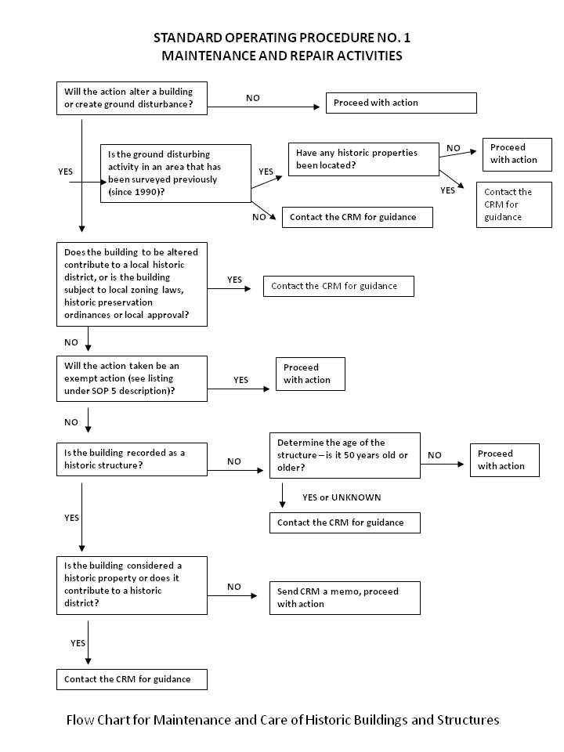

THIS PAGE INTENTIONALLY LEFT BLANK

STANDARD OPERATING PROCEDURE NO. 2
for
Disposal or Demolition of Excess Property

Contact: Cultural Resources Manager
XX Army National Guard
Address
Phone:
DSN:
Fax:
Email

Scope: This Standard Operating Procedure (SOP) outlines the steps to be taken prior to excessing property that is eligible for listing on the National Register of Historic Places (National Register) or needs further evaluation to determine eligibility. The SOP is intended for all personnel other than the Cultural Resources Management (CRM). Examples of applicable personnel are:

- Leadership
- Construction, Facilities, Maintenance Office (CFMO), Directorate of Public Works
- US Property and Fiscal Officer (USPFO)
- Master and strategic planning
- Reservation maintenance
- Facility managers and armorers
- Range control
- Environmental Quality Control Committee (EQCC)
- Personnel assigned to historic facilities.

All personnel above are referred to as “manager.”

Affected Site(s) or Training Installation(s): This SOP applies to all installations with buildings or structures 45 years or older in age.

Statutory Reference(s) and Guidance:

- National Historic Preservation Act, 36 CFR 800

- Secretary of the Interior’s Standards and Guidelines for the Treatment of Historic Properties with Guidelines for Preserving, Rehabilitating, Restoring, and Reconstructing Historic Buildings

- Secretary of the Interior’s Standards and Guidelines for the Treatment of Historic Properties.

Typical situations: Building or structure demolition and/or replacement; building transfer or excessing

Typical triggering event: Mission requirement change causing the removal and/or replacement of buildings or structures (see Flowchart).

Procedures: If mission requirements cause the demolition and replacement of buildings or structures onsite, the replacement design should be compatible with other buildings in the same area. Changes to the landscape should convey the historic pattern of land use, topography, transportation patterns, and spatial relationships. Retain the character-defining materials and features, design and workmanship of buildings, structures, and landscape through maintenance and preservation activities.

When rehabilitation costs exceed 70% of a building’s replacement cost, replacement construction may be used. Consult the CRM for guidance. The CRM will also need to initiate compliance with federal regulations.

- Contact the CRM to determine if the building, structure, or landscape element affected by the proposed demolition and/or replacement activity is a historic property or significant component of a historic district.

- If the building, structure, or landscape element is not listed as a historic structure, determine its age. If it is 50 years old or older, contact the CRM for technical assistance. It is the CRM’s responsibility to activate the NHPA Section 106 process.

- Coordinate with the CRM for issues and technical assistance related to all matters relating to historic properties. The CRM is responsible for coordination with the SHPO for compliance issues.

- Coordinate with the CRM on the design of a replacement building if it is within a historic district.

Compliance procedures will require a minimum of 4 to 6 months to complete.

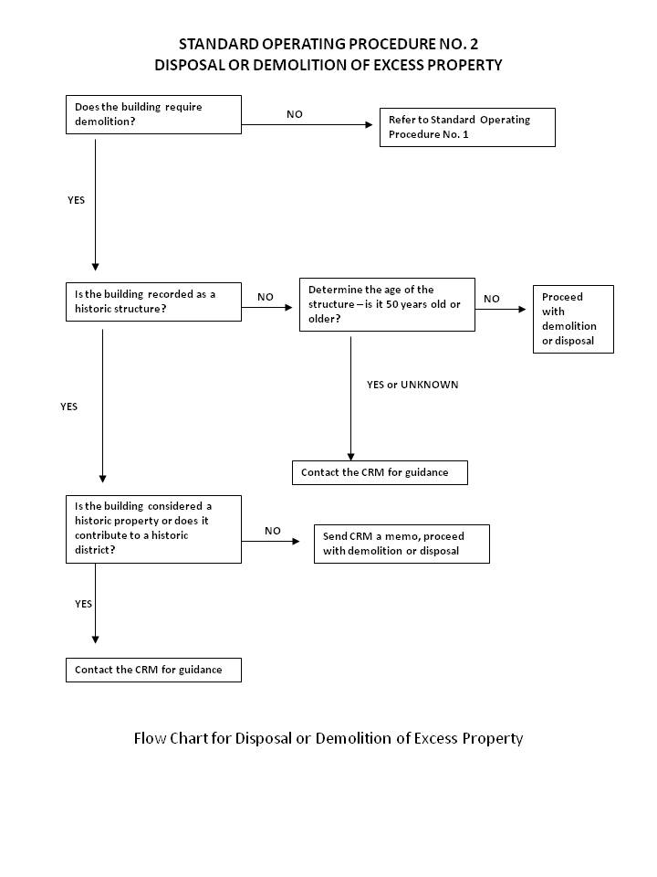

THIS PAGE INTENTIONALLY LEFT BLANK

STANDARD OPERATING PROCEDURE NO. 3
for
Mission Training of Military and Tenant Personnel

Contact: Cultural Resources Manager
XX Army National Guard
Address
Phone:
DSN:
Fax:
Email

Scope: This Standard Operating Procedure (SOP) outlines the steps to be taken prior to conducting mission training exercises on XX ARNG and non- XX ARNG property. It is intended for all personnel other than the Cultural Resources Manager (CRM). Examples of applicable personnel are:

- Plans, Operations, and Training Officer (POTO)
- Reservation maintenance
- Environmental program manager
- Range control
- Unit commander and environmental liaison
- Integrated Training Area Management (ITAM)
- Environmental unit command officer
- Public affairs
- Joint forces
- Unit / activity personnel

Non-military units or tenants using XXARNG installations will also be instructed on responding to inadvertent discovery situations (see SOP No. 5).

Statutory Reference(s):

- Native American Graves Protection and Repatriation Act
- Archaeological Resources Protection Act
- National Historic Preservation Act
- National Environmental Policy Act (on federal and tribal lands)

Applicability:

Typical actions that may trigger these requirements:

- outside field training exercises on ARNG and non-ARNG property

Specific events that may trigger these requirements:

- planning and scheduling field training exercises
- expansions of training areas
- major changes in types and locations of training exercises

Affected Site(s) or Training Installation(s):

- XXX ARNG Training Center or XXX ARNG Training Site
- XX Readiness Center

Actions: This section describes specific actions to be taken before and during training to protect cultural resources (see Flowchart):

Planning Operations and Training Office (POTO), Reservation Maintenance, Unit Commanders and Environmental Liaison, Environmental Unit Command Officer – planning and scheduling of training

- When planning field training, particularly for expansions at training areas or major changes in types and locations of training exercises, contact the CRM, at least four months in advance for archaeological clearances.

- Check with CRM to determine archaeological sensitivity of training areas. If possible, avoid areas of high sensitivity.

- Coordinate with CRM for archaeological clearances for mission essential areas.

At the initiation of and during training of an XX ARNG training site

- Ensure units using the site(s) or training installation(s) have been provided with proper information on protection of cultural resources including SOP 4 on inadvertent discovery and maps illustrating closed areas prior to conducting mission training

- Monitor compliance with SOPs and closures by units training at the site(s) or training installation(s)

- Report violations of closures and SOPs to the CRM

- Provide feedback to CRM on effectiveness of orientation materials

Unit Commander

- Ensure field troops understand applicable cultural resource policies and SOPs.

- Direct questions clarifying cultural resource policies and procedures to the CRM.

- Ensure training does not occur in areas that are closed and training restrictions are observed.

- Report violations of policies, SOPs, and closures to facility manager.

Field Troops/Tenants

- Review cultural resource information regarding the proposed training area prior to conducting training exercises

- Follow applicable SOPs for the training area

- Comply with all closures of locations within training areas and any restrictions on training activities in locations of resource sensitivity

- Report any discoveries to unit commander

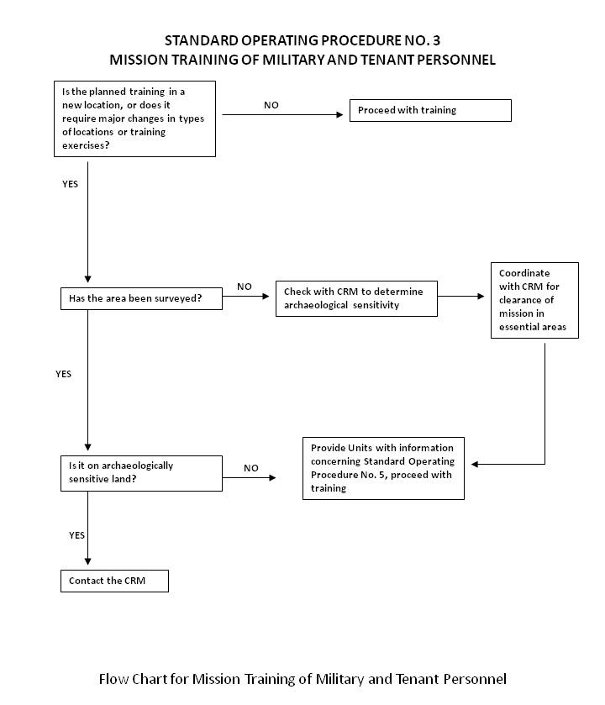

THIS PAGE INTENTIONALLY LEFT BLANK

STANDARD OPERATING PROCEDURE NO. 4
For
Emergency Operations and Homeland Security Activities

Contact: Cultural Resources Manager
XX Army National Guard
Address
Phone:
DSN:
Fax:
Email

Scope: This Standard Operating Procedure (SOP) outlines the steps to be taken prior to conducting emergency operations or Homeland Security activities on XX ARNG and non- XX ARNG property. It is intended for all personnel other than the Cultural Resources Manager (CRM). Examples of applicable personnel are:

- Plans, Operations, and Training Officer (POTO)
- Reservation maintenance
- Environmental program manager
- Range control
- Unit commander and environmental liaison
- Integrated Training Area Management (ITAM)
- Environmental unit command officer
- Public affairs
- Joint forces
- Unit / activity personnel

Non-military units or tenants using XXARNG installations will also be instructed on responding to inadvertent discovery situations (see SOP No. 5).

Policy: Responses to emergencies and all planning for emergency response and Homeland Security at XX ARNG site(s) and training installation(s) will be carried out in accordance with the statutory applications contained in:

- Native American Graves Protection and Repatriation Act, Archaeological Resources Protection Act, and NHPA on federal lands

- National Historic Preservation Act for federally supported actions on nonfederal public lands and private lands

- National Environmental Protection Act for federally supported actions that require it

It should be noted that immediate rescue and salvage operations conducted to preserve life or property are exempt from the provisions of Section 106 (36 CFR 800.12[d]).

Procedure (see Flowchart): All reasonable efforts are made to avoid or minimize disturbance of significant cultural resources during emergency operations and Homeland Security activities and will communicate with applicable CRM regarding potential effects to significant cultural resources that may occur in association with such activities.

Upon notification of a proposed emergency operation or Homeland Security activity, the CRM will notify and consult with the appropriate agencies and parties, regarding the known or likely presence of cultural resources in the area of the proposed operation. The agencies and parties are expected to reply in 7 days or less. Notification may be verbal, followed by written communication. This applies only to undertakings that will be implemented within 30 days after the need for disaster, emergency, or Homeland Security action has been formally declared by the appropriate authority. An agency may request an extension of the period of applicability prior to expiration of the 30 days. The CRM will ensure that all XX ARNG personnel and units involved in the project are briefed regarding the protocol to be followed in the case of the inadvertent discovery of cultural resources during emergency operations (SOP No. 5).

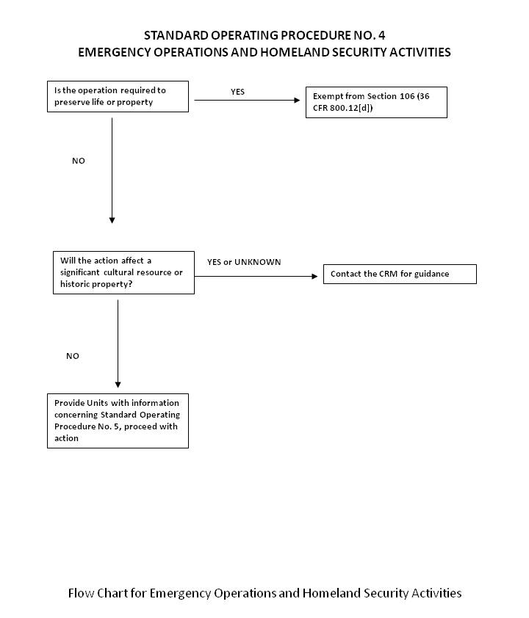

STANDARD OPERATING PROCEDURE NO. 5
for
Inadvertent Discovery of Cultural Materials

Contact: Cultural Resources Manager
XX Army National Guard
Address
Phone:
DSN:
Fax:
Email

Scope: This Standard Operating Procedure (SOP) outlines the steps to be taken upon inadvertent discovery of cultural resources. It is intended for all personnel other than the Cultural Resources Manager (CRM). Examples of applicable personnel are:

- Plans, Operations, and Training Officer (POTO)
- Reservation maintenance
- Environmental program manager
- Range control
- Unit commander and environmental liaison
- Integrated Training Area Management (ITAM)
- Environmental unit command officer
- Public affairs
- Joint forces
- Unit / activity personnel

Statutory Reference(s):

- Native American Graves Protection and Repatriation Act

- Archaeological Resources Protection Act

- National Historic Preservation Act

Applicability:

Typical actions that may trigger these requirements:

- field training exercises
- construction and maintenance
- activities such as digging, bulldozing, clearing or grubbing
- off-road traffic
- general observations (i.e., eroded areas, gullies, trails, etc.)

Discovery of the following will trigger these requirements:

- discovery of known or likely human remains
- unmarked graves
- Indian or historical artifacts
- archaeological features
- paleontological remains

Actions: This section describes specific actions to be taken for inadvertent discovery. The flow chart, which is intended to be used by unit/activity level personnel, unit commanders, and similar personnel, as a decision-making guide when inadvertent discoveries are made as described under the applicability section of this SOP (see Flowchart).

Unit personnel, contractor, field crews, other tenants:

- Cease ground-disturbing activity when possible historical artifacts and features, human remains, or burials are observed or encountered.

- Report any observations or discoveries of historical artifacts and features, human remains, burials, or features immediately to the unit commander or facility manager.

- Secure the discovery location(s).

Unit Commander:

- Immediately notify the range control.

- Await further instructions from the range control officer.

- Examine the location of the discovery to ensure that it has been properly secured. Take appropriate measures to further secure location if needed.

- Coordinate with range control officer on where activities can resume.

- Give direction to the field troops, construction crew, or non- XX ARNG user regarding locations where training exercises or activity may continue.

Range Control Officer:

- Examine the location of the discovery to ensure that it has been properly secured. Take appropriate measures to further secure location (from vandalism and weather) if needed.

- Give direction to the unit commander, construction crew, or non- XX ARNG user regarding locations where training exercises or activity may continue.

- Immediately notify the CRM.

- If human remains are known or suspected to be present, also promptly notify the state police.

Activity may not resume in area of discovery until cleared by the CRM. Anticipate 30 days.

Need to include law enforcement and FBI for federal lands; it is crime scene until determined otherwise. Then follow through with CRM determination. You have to have the law report for file on inadvertent discoveries.

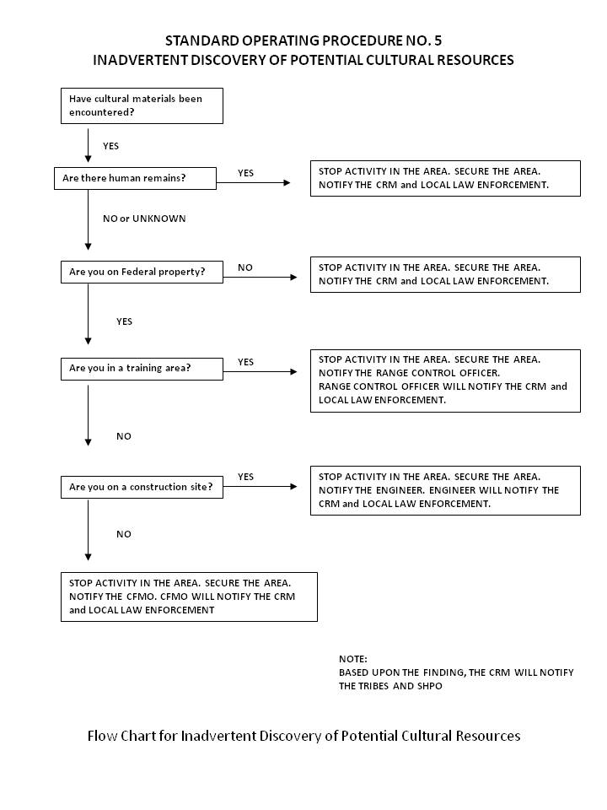

STANDARD OPERATING PROCEDURE NO. XX
for
Add other SOPs as required for your State

Contact: Cultural Resources Manager
XX Army National Guard
Address
Phone:
DSN:
Fax:
Email

Scope:

Statutory Reference(s):

- Native

Applicability:

THIS PAGE INTENTIONALLY LEFT BLANK

APPENDIX F
Installation-Specific
Cultural Resources Management Projects, (Historical and proposed) 20XX-20XX

THIS PAGE INTENTIONALLY LEFT BLANK

APPENDIX G
XXARNG 20XX-20XX ICRMP
RECORD OF ENVIRONMENTAL CONSIDERATION

THIS PAGE INTENTIONALLY LEFT BLANK

APPENDIX H
ANNUAL REPORTS AND UPDATES

