
Commonwealth of Pennsylvania

Pennsylvania Game Commission

Northcentral Region

Northcentral Region
1566 South RT 44 Hwy
Jersey Shore, PA 17740

September 22, 2023

REQUEST FOR BIDS
ROAD IMPROVEMENT PROJECT
PA GAME COMMISSION
NORTHCENTRAL REGION

Prospective Bidders:

The Northcentral Region of the Pennsylvania Game Commission (PGC) in conjunction with the Pennsylvania Department of Conservation and Natural Resources (DCNR) Moshannon State Forest District, is soliciting bids for road improvement work on Moshannon State Forest located in Clearfield County. The locations of the projects are depicted on the attached maps. Specifications are detailed in Attachment 1.

Bids are to be submitted electronically through the Commonwealth’s “PA Supplier Portal” system by July 31, 2024. If you have not registered as a vendor with the state, you must first complete this at www.pasupplierportal.state.pa.us prior to submitting an electronic bid. Any questions regarding this may be directed to Bobbi Mercer ( bmercer@pa.gov ) at 717 787-6594.

The bid shall be awarded on a single contract basis. The unit price shall include the cost of labor, materials, insurance, and all miscellaneous expenses necessary for the completion of the tasks. Prices bid shall be in dollar and cents only. Payment will be dispersed based on the amount of work completed as per the required specifications. The work may begin after PO is received by the contractor and performance bond is provided to the PGC. Work must be completed by October 25, 2024. No extension of time will be awarded.

The attached documents provide all necessary specifications, instructions, contact information, maps, etc.

Questions can be directed to:

Shawn Seeley
State Game Warden / Land Management Group Supervisor
(814) 505-9059
Email: shseeley@pa.gov

GENERAL SPECIFICATIONS
Fairview Savanna Improvement Project

- SCOPE OF WORK:

- The Pennsylvania Game Commission (PGC), Northcentral Region, requires services to improve approximately .88 miles of administrative road on Moshannon State Forest, Clearfield County. Services shall include, but not be limited to, the furnishing of all labor, superintendence, tools, equipment, stone, culverts, and seed for the entire project as per Attachment 1. All Purchase Orders require the contractor to provide the equipment, materials, labor, insurance, and all miscellaneous expenses to complete the operation.

- This project is being bid as one contract.

Any questions concerning the technical aspects of this project should be directed to the Land Management Group Supervisor (LMGS):

Shawn Seeley
State Game Warden / Land Management Group Supervisor
Pa Game Commission, Northcentral Region
1566 South Rt. 44 HWY
Jersey Shore, PA 17740
(814) 505-9059
shseeley@pa.gov

- PROJECT LOCATION:

Moshannon State Forest in Huston Twp. Clearfield County. Access to Project location is off Tyler Road. Coordinates: N 41.20811/ W -78.49385. See attached map.

- CONTRACT TASKS:

- The contractor will supply all necessary equipment to complete culvert installations as well as delivery, application, grading and compaction of specified stone. Contractor will deliver and install specified culvert pipes and apply stone. Contractor shall comply with Attachment 1, Fairview Savanna Project

- SITE INSPECTION AND ASSISTANCE:

The PGC and DCNR will not be conducting a tour of this project. Coordinates are listed under Section II. PGC recommends potential operators visit project site location.

- CONTRACT REQUIREMENTS:

- The project will begin within 10 days of the contractor’s receipt of the Purchase Order that includes a notice to proceed (weather permitting). All work must be completed by October 25,2024. No extensions will be granted.

- Bid Package Line Items

    - Clearing, Grading, and Ditching- 4646 Feet
      - Bid per Linear Foot
    - Excavating and hauling aggregate from DCNR Pit within 10 miles
      - 1 Price for all removal and hauling
    - Geo-Class 4A Non-Woven geotextile conforming to the requirements of Section 735 of PennDOT Pub. 408. - 69,690 sq. ft.
      - Bid per square foot
    - 15-inch Corrugated Smooth Bore Plastic Pipe- 300 Feet
      - Bid price per Linear Foot
    - Pipe bedding and backfill with 2RC-150 Tons
      - Bid Price per Ton
    - Rock lined Race/Plunge pool-2 tons of R-4 at each location-15 locations
      - Bid per each
    - Install one gate provided by the PGC
      - Bid price for all install
    - Seeding and E&S Controls-One item for project areas
      - Bid one price for all

- The contractor agrees to comply with all attachments. The Commission reserves the right to reject any or all bids.

- The Operator is obligated to furnish equipment, materials, support equipment, and personnel necessary to complete the project as specified. The Operator maintains responsibility for the entire project even if another organization/subcontractor is providing part of the equipment and/or personnel.

- As further guarantee of faithful performance of the conditions set forth in this Contract, the successful bidder hereby agrees to furnish the PGC with a cashier’s, treasurer’s, or certified bank check, payable to the “Pennsylvania Game Commission”, as bond in the amount of $5,000.00, within 7 days of receiving notice and prior to commencing work on the State Forest Lands. The check shall be mailed to the address stated above in Section 1. The contractor agrees that said deposit, upon failure on the part of the contractor to fulfill all and singular the conditions and requirements herein set forth or made a part hereof, shall be retained by the Commission to be applied to satisfy the contractors obligations assumed hereunder.

- Failure to comply with any of the terms or conditions of the Contract may result in cancellation of the agreement.

- The contractor shall comply with all State Forest Lands regulations.

- An emergency spill kit must be available on site at all times during active operations on the project site.

- Prevailing minimum wages apply to this project. Refer to the wage rate attachment to the specifications.

- INSURANCE REQUIREMENTS:

  - The contractor will provide Worker’s Compensation insurance sufficient to cover all the employees of contractor working to fulfill this contract.

  - Comprehensive General Liability Insurance, including bodily injury and property damage insurance, to protect the Commonwealth and the contractor from claims arising out of the performance of the contract. The amount of Bodily Injury Insurance shall not be less than $300,000.00 for injury to or death of persons per occurrence. The amount of Property Damage Insurance shall not be less than $300,000.00 per occurrence.

Such policies shall name the Commonwealth as an additional insured. Prior to the commencement of work under this contract, the contractor must provide the Commonwealth with current Certificates of Insurance. These Certificates shall contain a provision that coverage afforded under the policy shall not be canceled or changed until at least thirty (30) days prior written notice has been given to the Commonwealth.

HOLD HARMLESS: The contractor shall be responsible for and agrees to indemnify and hold harmless the Commonwealth from and against damages to property or injuries (including death) to any persons and other losses, damages, expenses, claims, demands, suits, and actions by any party against the Commonwealth.

- BID AWARD:

Bidders must offer prices for all items as listed in the electronic bid form.

The bid will be awarded to the bidder with the lowest total price for the project. One purchase order will be awarded for the project.

Bids are to be submitted electronically through the Commonwealth’s “PA Supplier Portal” system by July 31, 2024 @ 2:30 PM If you have not registered as a vendor with the state, you must first complete this at www.pasupplierportal.state.pa.us prior to submitting an electronic bid. Any questions regarding this may be directed to Bobbi Mercer (bmercer@pa.gov) at 717-787-6594.

The Commission reserves the right to reject any and all bids and to choose the bid that, in its sole opinion, best meet the needs of this project.

ALL VENDORS WHO CONDUCT BUSINESS WITH THE PENNSYLVANIA GAME COMMISSION MUST HAVE A VENDOR NUMBER ASSIGNED TO THEM IN ORDER TO RECEIVE PAYMENT FROM THE COMMONWEALTH.

Vendors may access the website www.pasupplierportal.state.pa.us or phone (877) 435-7363 or (717) 346-2676 or email ra-srmhelp@state.pa.us for assistance to register as a new vendor or, if you are an existing vendor, to change a main or remit to address. This is a Dept of General services (DGS) website, so you need to contact them directly if you have any problems with the website.

- CONTRACT TERM:

The contract term shall commence upon receipt of required bond, certificate of insurance, signed General Specifications page, and terminate October 25, 2024. No extensions will be granted.

- PAYMENT TERMS:

Payment for road improvement contract: The price shall include all labor, equipment, tools, stone, insurance and all items necessary for the completion of the project.

The contractor shall be paid on a reimbursement basis after the final inspection verifies work was successfully completed to the terms and specifications outlined in the contract.

ATTACHEMNTS:
Attachment 1 – Project General Specifications
Attachment 2 – Road Project Location Map
Attachment 3 – Cross pipe and Tail Race
Attachment 4 – Curwensville Conservation Mix
Attachment 5 – Prevailing wages

Attachment 1:

Fairview Savanna Road Project

- GENERAL SPECIFICATIONS:

- Approximately .88 miles of existing DCNR road will be improved by grading with a dozer with a six-way blade or road grader to a 12-foot running surface, crowned three inches at the centerline or out-sloped (according to topography), side ditches established, and positively drained.

- Any materials used for Haul Road improvement and/or construction must be approved prior to use and applied as directed by the LMGS. Plowing of State Forest Roads is prohibited unless authorized in writing by the district forester. With the following exceptions the successful bidder may use all State Forest Roads that lead into and/or within the project area except:
      - Mud Run Rd. is closed to stone trucks and heavy hauling.
      - Caledonia Pike, between McGeorge Rd. and Shaggers Inn Rd., may be closed for a period of many days during construction work on a stream crossing.
      - All other State Forest Roads are closed from March 1 – May 1 to stone trucks and heavy hauling unless authorized in writing by the District Forester
- All State Forest Roads must be kept passable at all times for use by passenger automobiles except during periods when roads are covered with ice or snow or following other extreme weather-related events. The Department does not guarantee the successful bidder the use of roads maintained by the Pennsylvania Department of Transportation (PENNDOT), townships, or other agencies or owners. Buyer must contact the PENNDOT posted highway coordinator and officials of other said roads for possible weight or other restrictions that would prevent use

- Culverts will be installed as specified with 10 tons of 2RC stone per culvert. All existing culverts will be removed and disposed of by the contractor.

- The total amount of Geo-Class 1 Non-woven Fabric listed below will be supplied by the contractor and place on the running surface before sandstone application.

  - Geo-Class 4 Non-woven geotextile conforming to the requirements of Section 735 of PennDOT Pub. 408 --approx. 69,690 sq. ft.

- All road surface aggregate will be excavated by the contractor from a designated DCNR Pit within 10 miles of the project location and hauled to the project site. Overburden and tree cover may need to be removed and piled in the vicinity of the quarry area to access and excavate suitable pit stone. The pit will need to be re-sloped to avoid highwalls after completion. The preferred pit will be the Moose Grade Pit (coordinates 41.193741, -78.545701), but if culvert replacement work does not close the Caledonia Pike, the Shaggers Inn Pit may be used (coordinates 41.213240, -78.396300).

- The total amount limestone is listed below for all road sections to include culvert installation. It will be the responsibility of the contractor to deliver these materials as part of this contract.
    - 2RC – approx. 150 tons
    - R-4 - approx. 30 tons

- The total amount and size of culverts listed below will be supplied and delivered by the contractor on site. The contractor will install culvert pipes at locations designated by the LMGS. Each culvert will be bedded with 10 tons of 2RC.
    - 15-inch x 20 feet = 15

- One gate Provided by the PGC will be installed at a location designated by the LMGS.

- All existing water bars and turnouts will be cleaned out and opened.

- All work, including site cleanup, must be completed by the expiration date of the project.

- The Pennsylvania Game Commission and The Department of Conservation and Natural Resources reserves the right to inspect/evaluate the equipment which will be used to complete the contract. If in the opinion of the LMGS the equipment is not adequate to meet the specifications of the contract, the contractor will have two (2) options: Option 1 is to secure and utilize other equipment acceptable to the LMGS for the project. Option 2 is to decline the contract. If the contractor does not have adequate equipment to complete the project and does not obtain satisfactory equipment, the contract will be terminated. The decision of the LMGS as it relates to proper equipment and its ability to complete the work will be final.

- Damage to existing infrastructure (roads, trails, food plots, etc.), private or public, will be the responsibility of the contractor to repair, at their expanse, to the pre-existing or better condition. The need for repair will be determined by the LMGS prior to the conclusion of the project.

- The contractor is responsible for contacting PA One Call (8-1-1) at least three (3) business days prior to any earth moving activities or hauling to ensure all utility lines are clearly identified. For more information, visit www.pa1call.org. Failure to provide adequate lead time will delay the start of the project.

- All DCNR gates are to be kept closed at all times, except when the contractor is present on the site.

- The following will be “No-Work Days” during the contract period:
    - The opening day and on all Saturdays during spring gobbler season, including the youth spring gobbler hunt.
    - The first Day of Trout Season

- Attachment 1 contains maps that provides location and specific site information for the project areas.

- The contractor shall comply with all DCNR Lands regulations.

- Contractors will not remove anything from the property including flora, fauna, or artifacts.

- The contractor will remove all trash and garbage, personal and otherwise, generated from the work performed. Burning is not permitted on this project.

- An emergency spill kit, large enough for equipment being used, will be available at all times during active operations on the project site.

- The contractor will notify the LMGS three days (72 hours) prior to beginning and completion of the project work. The contractor may work at times other than the schedule of the LMGS.

- The LMGS will inspect the work and may direct contractor to rework certain road areas or other tasks to meet required specifications. Inspection of the project will occur during normal working hours.

- Final inspection of the project will be conducted by the LMGS. The contractor may be present at the final inspection. Upon successful completion of the required work, payment will be released to the contractor

- Failure to meet and follow the terms and conditions of the project will be grounds to terminate the contract and forfeiture of the bond to the Pennsylvania Game Commission.

- ROAD IMPROVEMENT: Moshannon State Forest (Fairview)

  - Approximately .88 miles of existing DCNR road will be improved by applying stone and grading with a dozer with a six-way blade or road grader to a 15-foot running surface, crowned three inches at the centerline or sloped (according to topography), side ditches established, culverts installed and positively drained with turnouts. Road must be crowned or sloped, as directed by the LMGS, to drain all water into the ditches, culverts, and/or turnouts.

  - Prior to surface stone application and final grading, the contractor will install with a backhoe or excavator the corrugated smooth bore double-walled culverts listed below:

    - 15-inch x 20 feet = 15

  - Culvert locations are marked with ORANGE flagging or steaks with the flagging on the headwall side of the roadway.

The project will require the construction of fifteen 20’ culverts.

  - The culvert installations will require approx. 10 tons of 2RC per culvert. As designated by the LMGS, some culvert pipe installations may require the contractor to install culverts using a shallow cross pipe installation. The culvert must be set in approx. 4 inches of compacted 2RC (jumping jack or similar device for compaction). This may vary due to site conditions. An additional 8 inches of 2RC must be compacted around the culvert. The remaining 2RC will need to be placed around and over the culvert and compacted. The contractor will cover the culvert pipe with the remaining 2RC, and specified road surface aggregate. There are no permits required for installation and/or replacement.

  - After culvert installation but prior to surface stone installation Geo-Class 1 Non-woven Fabric shall be laid on the entire stretch of road.

  - Surface aggregate to be applied:

    - Upon completion of any necessary grading, Geo-Class 1 Non-woven Fabric will be laid on the entire stretch of road and approximately 3,872 tons of pit excavated sandstone will be spread at a depth of 12 inches and a width of 15ft. Stone will be graded to establish positive drainage.

    - Obtain the road base material from a designated DCNR pit within 10 miles of the project location.

  - The road surface will be rolled and compacted using a 10-ton vibratory roller or similar roller after grade and crown has been established.

  - All freshly disturbed soil will be seeded with oats (spring) at a rate of 30 lbs./ac and Curwensville Conservation mix (Attachment 6) at a rate of 25 lbs./acre and mulched with straw at a rate of 1.25 tons/50 bales/ac. at the completion of the project.

  - Soil erosion and sedimentation (E&S) control measures shall be implemented in accordance with the provisions of the Clean Streams Law and 25 Pennsylvania Code Chapter 102. The Pennsylvania Department of Environmental Protection Erosion and Sediment Program Pollution Control Manual as well as the Commonwealth of Pennsylvania Department of Transportation Publication 408 are the sources for control measures.

Attachment 2:
Road Project Location Map

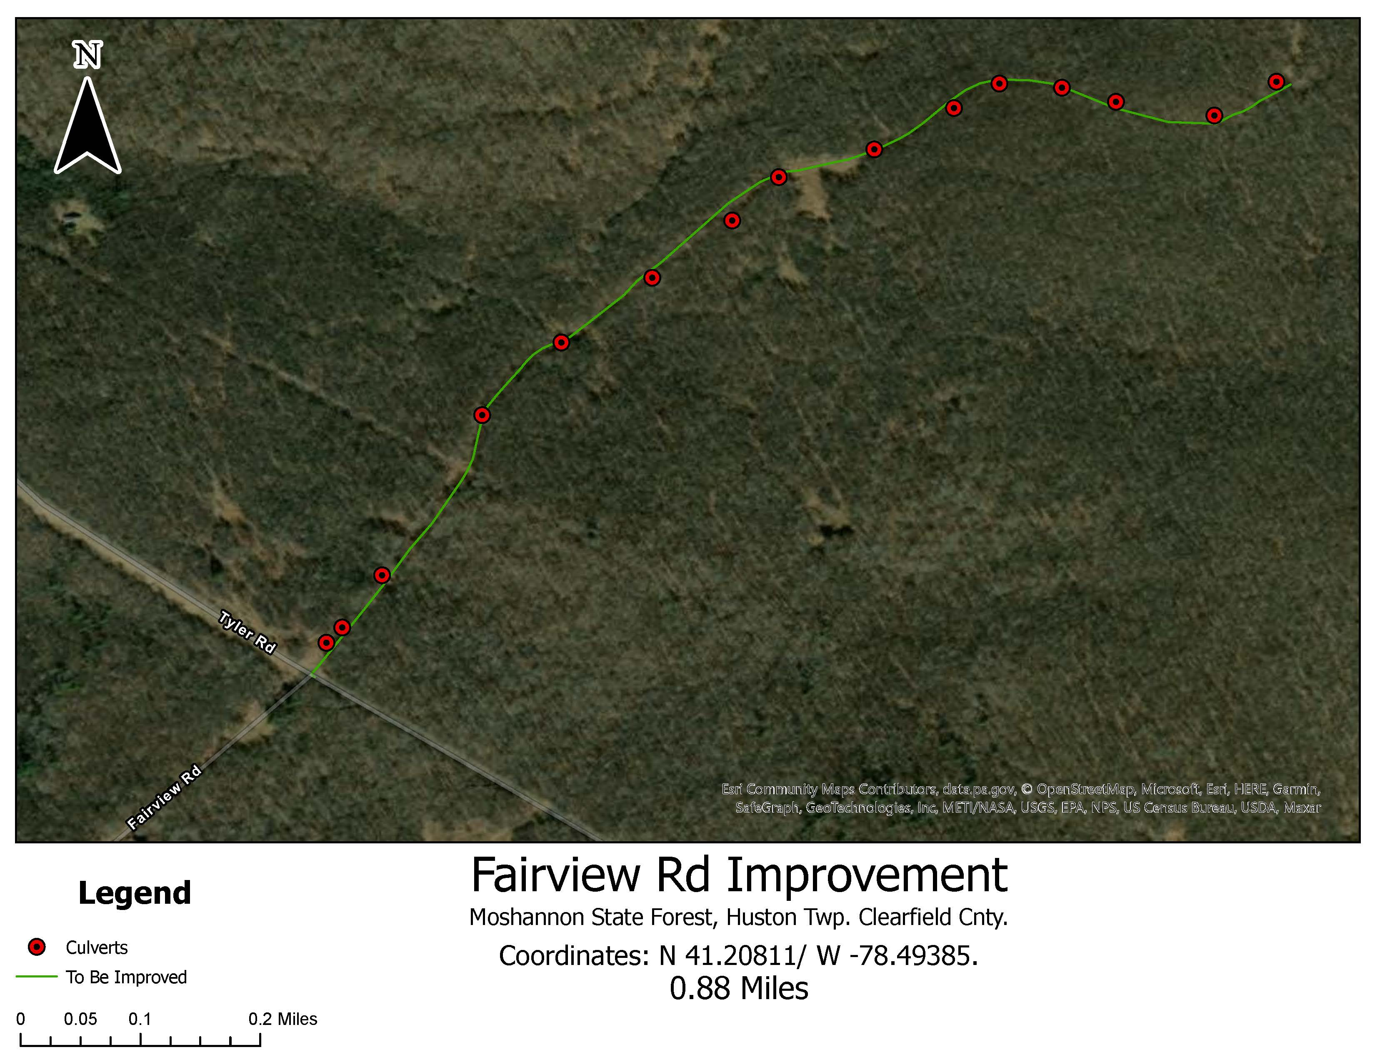

Attachment 3:
Cross-Pipe and Tail Race Installation

1. SCOPE
This work is installing cross-pipes as shown in Attachment 5 – Construction Drawings

2. MATERIALS
Cross-pipe shall be 15” Corrugated Smooth Bore Doubled walled polyethylene pipe meeting
AASHTO M294 Type S standards.

3. PROCEDURE:

A. Pipe trench depth will depend on inlet and outlet elevations. Where possible, outlet pipe at
natural ground elevation. Bottom of the pipe inlet should be at the same elevation as the ditch.
At some stations, the elevation of the ditch at the pipe inlet will be required to be raised to the
level of the adjacent ditch line using aggregate. The bottom of the pipe trench should have a
minimum 1% fall across the entire length.

B. Approximately 6” of 2RC aggregate (bedding material) shall be placed in the bottom of the
trench, smoothed, and tamped with a mechanical tamper to achieve proper slope. 6” lifts of
the 2RC material shall be compacted until the pipe is covered with a minimum of 6” of
compacted material over topping the pipe. Pipes should be seated as shallow as possible with
extra 2RC and excavation dirt being used and compacted on approach.

C. A tail race plunge pool shall be installed below each tail-wall. The race/pool shall be as close to the outflow grade as possible. The plunge pool shall be shallow and of approximate 8-feet wide and 12-feet long. They shall be designed to defuse the water flow and stop any erosion. Outflow shall be at grade level. Each should contain approximately 2 tons of R-4.

D. SHALLOW PIPE INSTALLATIONS
• Shallow pipe installations will be required at some stations depending on the
elevation of the inlet end of the ditch as well as the elevation of the area at the
outlet end of the pipe. Installation of shallow pipes requires the bottom of the
outlet end of the pipe to be at the natural ground elevation. In some cases, the
elevation of the existing tail ditch will suffice.

• This installation method will raise the elevation of the road through the addition of
12” of compacted fill over the top of the pipe. The fill should be tapered into the
existing road elevation on either side of the pipe. Transitions should be sufficiently
long to accommodate truck-trailer combinations. The amount of fill needed, and
length of taper will depend on pipe depth and road slope. Excess job site material,
2RC, or 2A may be used to create shallow cross pipe approaches.

4. MEASUREMENT AND PAYMNENT
Pipe, bedding and backfill per linear foot.

Attachment 4:
Curwensville Conservation Mix
Species | Percentage
Annual Ryegrass | 20%
Perrenial Ryegrass | 18%
Orchardgrass | 17%
Alsike Clover | 15%
Climax Timothy | 15%
Birdsfoot Trefoil | 10%
White Clover | 5%
Total | 100%

