
Commonwealth of Pennsylvania

Pennsylvania Game Commission

Northcentral Region

Northcentral Region
1566 South RT 44 Hwy
Jersey Shore, PA 17740

September 9, 2025

REQUEST FOR BIDS
ROAD IMPROVEMENT PROJECT
PA GAME COMMISSION
NORTHCENTRAL REGION

Prospective Bidders:

The Northcentral Region of the Pennsylvania Game Commission (PGC) in conjunction with the Pennsylvania Department of Conservation and Natural Resources (DCNR) Moshannon State Forest District, is soliciting bids for whole tree and stump removal on Moshannon State Forest located in Clearfield County. The locations of the projects are depicted on the attached maps. Specifications are detailed in Attachment 1.

Bids are to be submitted electronically thru the Commonwealth’s “PA Supplier Portal” system by October 31, 2024. If you have not registered as a vendor with the state, you must first complete this at www.pasupplierportal.state.pa.us prior to submitting an electronic bid. Any questions regarding this may be directed to Bobbi Mercer ( bmercer@pa.gov ) at 717 787-6594.

The bid shall be awarded on a single contract basis. The unit price shall include the cost of labor, materials, insurance, and all miscellaneous expenses necessary for the completion of the tasks. Prices bid shall be in dollar and cents only. Payment will be dispersed based on the amount of work completed as per the required specifications. The work may begin after PO is received by the contractor and performance bond is provided to the PGC. Work must be completed by June 24, 2026. No extension of time will be awarded.

The attached documents provide all necessary specifications, instructions, contact information, maps, etc.

Questions can be directed to:

Shawn Seeley
State Game Warden / Land Management Group Supervisor
(814) 505-9059
Email: shseeley@pa.gov

GENERAL SPECIFICATIONS
Fairview Savanna Improvement Project

- SCOPE OF WORK:

- The Pennsylvania Game Commission (PGC), Northcentral Region, requires services for the felling/whole tree removal, stump grinding, and Mulching of 25.5 acres on Moshannon State Forest, Clearfield County. Services shall include, but not be limited to, the furnishing of all labor, superintendence, tools, equipment, and seed for the entire project as per Attachment 1. All Purchase Orders require the contractor to provide the equipment, materials, labor, insurance, and all miscellaneous expenses to complete the operation.

- This project is being bid as one contract.

Any questions concerning the technical aspects of this project should be directed to the Land Management Group Supervisor (LMGS):

Shawn Seeley
State Game Warden / Land Management Group Supervisor
Pa Game Commission, Northcentral Region
1566 South Rt. 44 HWY
Jersey Shore, PA 17740
(814) 505-9059
shseeley@pa.gov

- PROJECT LOCATION:

Moshannon State Forest in Huston Twp. Clearfield County. Access to Project location is off Tyler Road. Coordinates: N 41.20811/ W -78.49385. See attached map.

- CONTRACT TASKS:

- The contractor will supply all necessary equipment and labor for felling and removing all unmarked trees and stumps within the project boundary.

Contractor shall comply with Attachment 1, Fairview Savanna Project
- SITE INSPECTION AND ASSISTANCE:

The PGC and DCNR will not conduct a tour of the work site. PGC recommends potential operators visit project site location. Coordinates are listed under Section II.

- CONTRACT REQUIREMENTS:

- The project will begin within 10 days of the contractor’s receipt of the Purchase Order that includes a notice to proceed (weather permitting). All work must be completed by June 24,2026. No extensions will be granted.

- Bid Package Line Items

    - Project bond-$5,000
      - Bid once
    - Felling and whole tree removal of all unmarked trees greater than 1” diameter-25.5 acres
      - Bid price per acre
    - Final Grading and Mulching -25.5 acres
      - Bid price per acre
    - Stump grinding all stumps 6” and greater-25.5 acres
      - Bid price per acre
    - Ag Lime and spreading entire project area at a rate of 2 tons/acre (51 tons)-25.5 acres
      - Bid price per acre
    - Seeding and E&S Controls-One item for project areas
      - Bid one price for all

- The contractor agrees to comply with all attachments. The Commission reserves the right to reject any or all bids.

- The Operator is obligated to furnish equipment, materials, support equipment, and personnel necessary to complete the project as specified. The Operator maintains responsibility for the entire project even if another organization/subcontractor is providing part of the equipment and/or personnel.

- As further guarantee of faithful performance of the conditions set forth in this Contract, the successful bidder hereby agrees to furnish the PGC with a cashier’s, treasurer’s, or certified bank check, payable to the “Pennsylvania Game Commission”, as bond in the amount of $5,000.00, within 7 days of receiving notice and prior to commencing work on the SGL. The check shall be mailed to the address stated above in Section 1. The contractor agrees that said deposit, upon failure on the part of the contractor to fulfill all and singular the conditions and requirements herein set forth or made a part hereof, shall be retained by the Commission to be applied to satisfy the contractors obligations assumed hereunder.

- Failure to comply with any of the terms or conditions of the Contract may result in cancellation of the agreement.

- The contractor shall comply with all State Forest Lands regulations.

- An emergency spill kit must be available on site at all times during active operations on the project site.

- INSURANCE REQUIREMENTS:

  - The contractor will provide Worker’s Compensation insurance sufficient to cover all the employees of the contractor working to fulfill this contract.

  - Comprehensive General Liability Insurance, including bodily injury and property damage insurance, to protect the Commonwealth and the contractor from claims arising out of the performance of the contract. The amount of Bodily Injury Insurance shall not be less than $300,000.00 for injury to or death of persons per occurrence. The amount of Property Damage Insurance shall not be less than $300,000.00 per occurrence.

Such policies shall name the Commonwealth as an additional insured. Prior to the commencement of work under this contract, the contractor must provide the Commonwealth with current Certificates of Insurance. These Certificates shall contain a provision that coverage afforded under the policy shall not be canceled or changed until at least thirty (30) days prior written notice has been given to the Commonwealth.

HOLD HARMLESS: The contractor shall be responsible for and agrees to indemnify and hold harmless the Commonwealth from and against damages to property or injuries (including death) to any persons and other losses, damages, expenses, claims, demands, suits, and actions by any party against the Commonwealth.

- BID AWARD:

Bidders must offer prices for all items as listed in the electronic bid form.

The bid will be awarded to the bidder with the lowest total price for the project. One purchase order will be awarded for the project.

Bids are to be submitted electronically thru the Commonwealth’s “PA Supplier Portal” system by October 31, 2024 @ 2:30 PM If you have not registered as a vendor with the state, you must first complete this at www.pasupplierportal.state.pa.us prior to submitting an electronic bid. Any questions regarding this may be directed to Bobbi Mercer (bmercer@pa.gov) at 717-787-6594.

The Commission reserves the right to reject any and all bids and to choose the bid that, in its sole opinion, best meet the needs of this project.

ALL VENDORS WHO CONDUCT BUSINESS WITH THE PENNSYLVANIA GAME COMMISSION MUST HAVE A VENDOR NUMBER ASSIGNED TO THEM IN ORDER TO RECEIVE PAYMENT FROM THE COMMONWEALTH.

Vendors may access the website www.pasupplierportal.state.pa.us or phone (877) 435-7363 or (717) 346-2676 or email ra-srmhelp@state.pa.us for assistance to register as a new vendor or, if you are an existing vendor, to change a main or remit to address. This is a Dept of General services (DGS) website, so you need to contact them directly if you have any problems with the website.

- CONTRACT TERM:

The contract term shall commence upon receipt of required bond, certificate of insurance, signed General Specifications page, and terminate June 24, 2026. No extensions will be granted.

- PAYMENT TERMS:

Payment for contract: The price shall include all labor, equipment, tools, insurance, and all items necessary for the completion of the project.

The contractor shall be paid on a reimbursement basis after the final inspection verifies work was successfully completed to the terms and specifications outlined in the contract.

ATTACHEMNTS:
Attachment 1 – Project General Specifications
Attachment 2 – Tree Clearing Map
Attachment 3 – Curwensville Conservation Mix
Attachment 4 – E&S Plan

Attachment 1:

Fairview Savanna Project

- GENERAL SPECIFICATIONS:

- Harvesting and Removal of Designated Trees
  - Block Boundaries are indicated by a Blue Two Stripe style marking facing into the designated cutting block.
  - All BLUE DOT trees are to be saved and remain uncut within the designated cutting block. All trees within island areas indicated by ORANGE BANDS are designated to remain uncut and left undisturbed in place.
  - Whole tree harvesting and removal of all above-ground tree products is mandatory for all non-blue painted trees greater than 1” DBH which are to be mulched in place. All pole wood and sawtimber trees not designated as a save tree must be cut, removed in entirety from the designated cutting block, and marketed or otherwise utilized. This is to include all flail debris created by chipping.

- Stump Grinding
  - All designated trees to be cut must have stumps ground to the following specifications. All designated trees to be cut greater than 6” diameter at ground level musts must have residual stump ground down to greater than 3” below the surrounding natural soil surface elevation contour. Stump grinding machine must be greater than 300 HP.

- Final Mulching and Grading
  - All harvested areas must have a final grading and multching to smooth the surface to the original land contour. All chip debris must be less than 4” in size left on site from the mulching process. All stumps must be ground to 3” below the soil surface. The machine operating attachment must be greater than 200 HP.

- Ag Lime Spreading
  - Upon completion of the final grading of the entire project area, ag lime shall be provided by the contractor, and spread, at a rate of 2 ton/acre over the entire project area (approximately 25.5 acres).

- Erosion and Sediment Control
  - Proper erosion and sedimentation control measures must be followed according to the Pennsylvania Department of Environmental Protection. See Attachment 4.
  - Any area requiring seeding and mulch shall use the seed type in Attachment 3 and straw mulch.
  - Rutting greater than 6” deep is prohibited. This depth is to be measured downward from the edge of the elevation of the natural surface of the adjacent land.
  - Wet weather cutting and skidding is prohibited. The PGC or DCNR designee has the authority to decide as to the suitability of the weather conditions, environmental concerns, and potential shutdown period.

- All existing water bars and turnouts will be cleaned out and opened.

- Safety: The Buyer, his employees and sub-contractors are required to perform all logging operations in a safe manner as required by applicable laws and regulations. The Department expects the Buyer to ensure that logging crewmembers dress in protective attire and perform their duties with equipment in accordance with standards established by the logging industry and the Occupational Safety and Health Administration (OSHA).

- Logger Certification: On-site crew leaders for all logging crews working on this project must be trained under the Pennsylvania Sustainable Forestry Initiative. Information relating to this training may be found on the Internet at www.sfiofpa.org. Each crew leader operating on the sale must present a valid PA SFI Core Level Training card as proof of training to the LMGS prior to beginning logging operations on the sale. Comparable training from other states may be accepted in lieu of Pennsylvania Sustainable Forestry Initiative training.

- All work, including site cleanup, must be completed by the expiration date of the project.

- The Pennsylvania Game Commission and The Department of Conservation and Natural Resources reserves the right to inspect/evaluate the equipment which will be used to complete the contract. If in the opinion of the LMGS the equipment is not adequate to meet the specifications of the contract, the contractor will have two (2) options: Option 1 is to secure and utilize other equipment acceptable to the LMGS for the project. Option 2 is to decline the contract. If the contractor does not have adequate equipment to complete the project and does not obtain satisfactory equipment, the contract will be terminated. The decision of the LMGS as it relates to proper equipment and its ability to complete the work will be final.

- Hauling Road Usage

  - All State Forest Roads must be kept passable at all times for use by passenger automobiles except during periods when roads are covered with ice or snow or following other extreme weather-related events. The Department does not guarantee the successful bidder the use of roads maintained by the Pennsylvania Department of Transportation (PENNDOT), townships, or other agencies or owners. Buyer must contact the PENNDOT posted highway coordinator and officials of other said roads for possible weight or other restrictions that would prevent use.

  - Plowing of State Forest Roads is prohibited unless authorized in writing by the district forester. With the following exceptions the successful bidder may use all State Forest Roads that lead into and/or within the project area except:

    - Mud Run Rd. is closed to stone trucks and heavy hauling
    - All other State Forest Roads are closed from March 1 – May 1 to stone trucks and heavy hauling unless authorized in writing by the District Forester, DCNR Designee, or LMGS.

  - Damage to existing infrastructure (roads, trails, food plots, etc.), private or public, will be the responsibility of the contractor to repair, at their expanse, to the pre-existing or better condition. The need for repair will be determined by DCNR & the LMGS prior to the conclusion of the project.

- The contractor is responsible for contacting PA One Call (8-1-1) at least three (3) business days prior to any earth moving activities or hauling to ensure all utility lines are clearly identified. For more information, visit www.pa1call.org. Failure to provide adequate lead time will delay the start of the project.

- All DCNR gates are to be kept closed at all times, except when the contractor is present on the site.

- The following will be “No-Work Days” during the contract period:
    - The opening day and on all Saturdays during small game season.
    - The first two days and all Saturdays and Sundays during rifle deer season
    - The first two days of rifle bear season

- Attachment 1 contains maps that provides location and specific site information for the project areas.

- The contractor shall comply with all DCNR Lands regulations.

- Contractors will not remove anything from the property including flora, fauna, or artifacts.

- The contractor will remove all trash and garbage, personal and otherwise, generated from the work performed. Burning is not permitted on this project.

- Oil Spills:

  - An emergency spill kit, for hydraulic fluids, lubricating oils, fuels, and other environmentally hazardous fluids large enough for equipment being used, will be available at all times during active operations on the project site. Spill kits must include pads and containment socks that are rated to absorb at least 8 gallons of petroleum-based fluids and containers (or heavy-duty bags) capable of holding an equivalent amount of contaminated soil and other absorbents. A shovel should also be available on-site. Pads must be capable of absorbing fluids in water as well as on the ground. Any leaks or spills shall be contained immediately. Soil and absorbents shall be properly disposed of through a landfill approved by the Department of Environmental Protection (DEP). All leaks that exceed 5 gallons in size or a leak of any size into water must be reported immediately to DEP and to the LMGS. 911 or DEP regional offices may be called directly 24-hours per day to report the spill to DEP: Northwest: (800) 373-3398 Northcentral: (570) 327-3636 Northeast: (570) 826-2511 Southwest: (412) 442-4000 Southcentral: (877) 333-1904 Southeast: (484) 250-5900 DEP should provide over the phone advice for smaller spills and for larger spills they may send someone to aid in directing the most cost-effective clean up and disposal of the oil spill.
  - Excessive Oil Leakage- Equipment must be maintained to minimize excessive fluid leakage. The LMGS may require equipment with excessive fluid leakage to be removed from the site and oil soiled areas to be excavated and properly disposed.
  - Oil drained from equipment shall be placed in suitable containers and disposed of as directed by the LMGS.
  - Equipment Parking- Equipment may not be parked overnight within 100 feet of sinkholes, streams, intermittent streams with a defined bed and banks, and any other water body where fluids can leak into them.

- The contractor will notify the LMGS three days (72 hours) prior to beginning and completion of the project work. The contractor may work at times other than the schedule of the LMGS.

- The LMGS will inspect the work and may direct contractor to rework certain road areas or other tasks to meet required specifications. Inspection of the project will occur during normal working hours.

- Final inspection of the project will be conducted by the LMGS. The contractor may be present at the final inspection. Upon successful completion of the required work, payment will be released to the contractor

- Failure to meet and follow the terms and conditions of the project will be grounds to terminate the contract and forfeiture of the bond to the Pennsylvania Game Commission.

- Forest Fire Prevention:

  - Buyer shall independently and in cooperation with the Department take all reasonable and practicable action to prevent and extinguish forest fires on or in the vicinity of the sale area and should require his employees, contractors, and employees of contractors to do likewise.
  - During periods of abnormal forest fire danger, LMGS may suspend all or part of operations on all or part of the sale area until the forest fire danger subsides. Suspensions and lifting of suspensions will be confirmed immediately in writing by the LMGS.
  - Operator must remove regularly all brush, twigs, leaves and other flammable material which accumulates around the engine, gearboxes and transmission pan, of rubber-tired skidders, stationary engines including chip harvesters, and crawler tractors.
  - All equipment must be parked at the end of each day’s operation in areas from which all brush, tops and other flammable debris have been removed, within a radius of 25 feet of the equipment.
  - A fire extinguisher for Class B and C fires must be carried at all times on all rubber-tired skidders, logging tractors, felling machines, mulching equipment, stump grinders and chippers.
- GREEN CERTIFICATION STATEMENT: # SCS-FM/COC-00011N FSC 100% and NSF-SFI-FM-C0435749 - SFI 100% Certified Forest Content indicate that the timber in this project comes from a forest that is well-managed according to strict environmental, social and economic standards. This forest has been independently inspected and evaluated according to the principles and criteria for forest management agreed and approved by the Forest Stewardship Council® and the Sustainable Forestry Initiative®.

Attachment 2:
Tree Felling Project Location Map
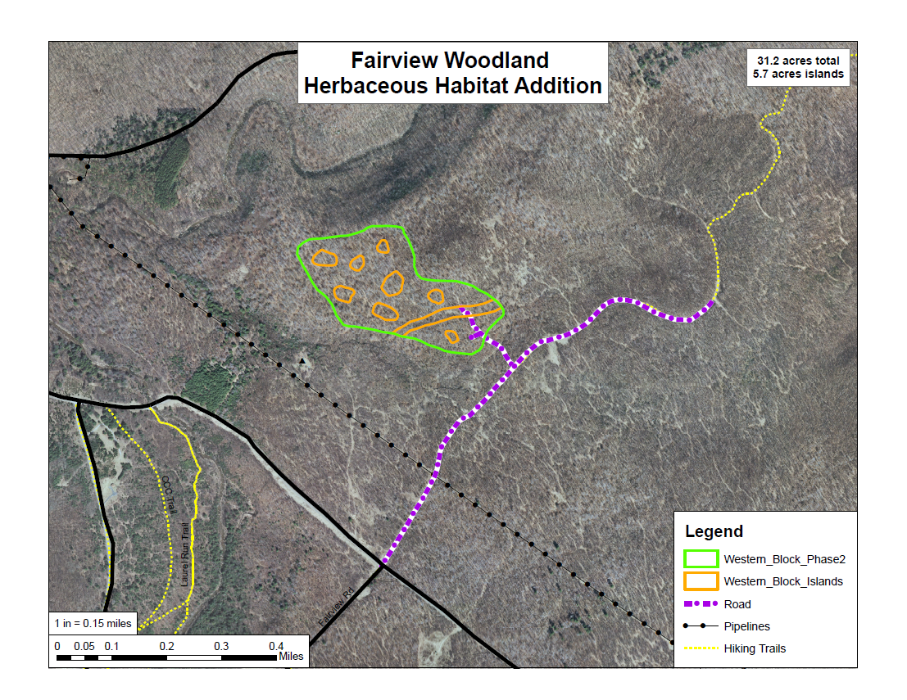

Attachment 3:
Curwensville Conservation Mix
Species | Percentage
Annual Ryegrass | 20%
Perrenial Ryegrass | 18%
Orchardgrass | 17%
Alsike Clover | 15%
Climax Timothy | 15%
Birdsfoot Trefoil | 10%
White Clover | 5%
Total | 100%

