
Commonwealth of Pennsylvania

Pennsylvania Game Commission

Southcentral Region

Southcentral Region
8627 William Penn Hwy
Huntingdon, PA 16652

June 8, 2023

REQUEST FOR BIDS
SGLs 49 and 104 HABITAT HAND FELLING PROJECT
PA GAME COMMISSION
SOUTHCENTRAL REGION

Prospective Bidders:

The Southcentral Region of the Pennsylvania Game Commission (PGC) is soliciting bids for habitat hand felling work on State Game Lands (SGL) 49 and 104 located in Bedford County. The location and specifications information of this project are on Attachments 1 through 7.

Bids are to be submitted electronically through the Commonwealth’s “PA Supplier Portal” system by 2PM on Thursday August 17, 2023. If you have not registered as a vendor with the state, you must first complete this at www.pasupplierportal.state.pa.us prior to submitting an electronic bid. Any questions regarding this may be directed to Bobbi Mercer ( bmercer@pa.gov ) at 717 787-6594.

The bid shall be awarded on a single contract basis. The unit price shall include the cost of labor, materials, insurance, and all miscellaneous expenses necessary for the completion of the tasks. Prices bid shall be in dollar and cents only. Payment will be dispersed based on the amount of work completed as per the required specifications. The work may begin after the Purchase Order (PO) is received by the contractor and performance bond is provided to the PGC. Work must be completed by Saturday June 29, 2024

The attached documents provide all necessary specifications, instructions, contact information, maps, etc.

Questions can be directed to:

Sergeant Jonathan S. Zuck
State Game Warden / Land Management Group Supervisor
(814) 251-2261
Email: jzuck@pa.gov

GENERAL SPECIFICATIONS
PENNSYLVANIA GAME COMMISSION

HABITAT HAND FELLING CONTRACT
SGL 49 AND SGL 104 HABITAT RESTORATION PROJECT

- SCOPE OF WORK:

- The Pennsylvania Game Commission (PGC), Southcentral Region, requires the services of an Operator to hand-cut interfering, non-native woody vegetation on a maximum of 109 acres of State Game Lands (SGL) in Bedford County. Total acres treated will be dependent on available funds.

Services shall include, but are not limited to, the furnishing of all materials, labor, equipment, tools, superintendence, miscellaneous items, and performing all work necessary to complete the project to the satisfaction of and subject to the approval of the Commission. All Purchase Orders require the contractor to provide the equipment, fuel, labor, insurance, and all miscellaneous expenses to complete the operation.

THIS PROJECT IS BEING BID AS ONE CONTRACT.

- Questions regarding technical and administrative aspects of this bid should be directed to Jonathan S. Zuck, Land Management Group Supervisor (LMGS), at telephone no. 814-251-2261.

- Bids are to be submitted electronically thru the Commonwealth’s “PA Supplier Portal” system by 2 PM, Thursday August 17, 2023. If you have not registered as a vendor with the state, you must do this first at www.pasupplierportal.state.pa.us before submitting an electronic bid. Any questions regarding this may be directed to Heather Lohr at 814-643-1831 x 402, helohr@pa.gov.

PROJECT LOCATIONS

Project areas are located on the following land tracts, listed by SGL number, tract name, gate number, road, and township.

SGL 49 - Shaffer Tract (56 acres)

Field, shrubland, and forest complex located behind gate 2, north and south of Tree Farm Road (T 359), Monroe Township. Maps – attachments 2, 3.

Coordinates at gate 2 parking area: 39.8926, -78.2837

SGL 49 - Judge Snyder Tract (22 acres)

Shrubland and forest complex located by gate by gate 15, south of Big Creek Road (SR 2007), Monroe Township. Maps – attachments 4, 5.

Coordinates at gate 15 parking area: 39.8025, -78.3143

SGL 104 - Tiger Valley Tract (31 acres)

Field, shrubland, and forest complex located behind gate 3, north of Tiger Valley Road (T 351), Londonderry Township. Maps – attachments 6, 7.

Coordinates at gate 3 parking area: 39.8894, -78.3294

CONTRACT TASKS:

- During the period of August 21, 2023 to June 29, 2024, hand cut or fell all targeted invasive species as detailed in Attachment 1 – ‘Cutting Specifications’ in the following treatment blocks:

TRACT BLOCK # ACRES
SGL 49 – Shaffer 1 47
SGL 49 – Shaffer 2 9

SGL 49 – Judge Snyder 1 11
SGL 49 – Judge Snyder 2 11

SGL 104 - Tiger Valley 1 31

- Contractor shall comply with Attachment 1, “Cutting Specifications”.

- Invasive species to be cut or felled include:

Autumn olive Bush (Tartarian) honeysuckle
Russian olive Multiflora rose
Japanese privet Japanese barberry
Oriental bittersweet

- SITE INSPECTION AND ASSISTANCE:

No tour will be offered for this project Potential bidders are highly encouraged to inspect all other treatment blocks prior to placing bids. Additional views and maps of the locations of the project areas can be obtained through the Pennsylvania Game Commission’s ‘Mapping Center” found at the following address: https://www.pgc.pa.gov/HuntTrap/StateGameLands/Pages/default.aspx. Shapefiles of all treatment blocks are available upon request. For additional information contact Land Management Group Supervisor Jonathan S. Zuck.

- COMMISSION PERSONNEL - The Commission will furnish personnel to supervise and direct the operation in the following capacities:

A. FIELD CONTRACT COORDINATORS - These persons are the Land Management Group Supervisor or their designee who serve as the Commission's field liaison with the Operator and are responsible for reviewing and approving/disapproving the operations plan and conducting quality control checks on the equipment and performance during the operations. This person is responsible for coordinating the activities of all people working on the contract within a region and communicating with the Operator's project supervisor concerning any operational problems or changes in plans. He/she also provides daily reports of the operation to the program supervisor.

- EQUIPMENT SPECIFICATIONS:

- Due to the specific cutting requirements of this project, this project is to be completed by hand felling / cutting only. Acceptable equipment includes chainsaws and brush saws on weed trimmer platforms. The Commission reserves the right to reject any piece of equipment that in its opinion will not safely and adequately complete the job.

- CONTRACT REQUIREMENTS:

- All employees must be able to identify all woody vegetative species to be hand cut as well as species to be retained.
- Woody material hand cut with clean cuts must have stumps that are parallel to the ground surface and shall be cut as close to ground level as possible but man not exceed six (6) inches in height measured on the side next to the highest ground or the diameter of the stump, whichever is smaller, except when in the opinion of the Field Contract Coordinator, said height is impractical.
- Cut trees must be removed from trails, roads, tail drains, streams, and a minimum of 10 feet from the SGL boundary (white paint marked trees).
- The Operator shall exercise care and caution in all operations to prevent damage to all vegetative species not specified for treatment.
- Damage to trails, roads, streams, or utility rights-of-way caused by the Operator’s equipment must be repaired by the Operator at their expense.
- Any trash resulting from the Operator’s operations must be removed from the area and properly disposed.
- The Operator shall not block any roads or trails in the area during performance of this contract. The Operator shall not in any way hinder the progress of any Timber Sale Contracts in these areas.
- All labor, equipment, tools, etc., needed to complete contracted projects are to be provided by the Operator.
- Timber Damages – when in the opinion of Field Contract Coordinator, damage to the residual stand becomes excessive, the Operator shall pay the Commission a fair base current value determined by the Field Contract Coordinator per unit of volume. If this value for damage due to Operator’s carelessness or negligence is less than $10.00 per tree, then a minimum charge of $10.00 per tree will be made whether the tree is commercial, non-commercial, merchantable, or non-merchantable. The Operator is responsible for the control and collection of fluids leading from any equipment used on the site. The Operator must have a spill containment and cleanup kit appropriate for the equipment being used. At a minimum, the kit will contain: plugs and clamps to control hydraulic line breaks, a container to collect leaking fluids, fluid absorbent pads and a shovel. Operating any equipment noticeably leaking fluids is prohibited. The Operator must collect and control fluids leaking from any equipment and dispose of properly.

INSURANCE REQUIREMENTS:

- The contractor will provide Workmen’s Compensation insurance sufficient to cover all the employees of contractor working to fulfill this contract.

- Comprehensive General Liability Insurance, including bodily injury and property damage insurance, to protect the Commonwealth and the contractor from claims arising out of the performance of the contract. The amount of bodily injury insurance shall not be less than $300,000.00 for injury to or death of persons per occurrence. The amount of Property Damage Insurance shall not be less than $300,000.00 per occurrence.

Such policies shall name the Commonwealth as an additional insured. Prior to the commencement of work under this contract, the contractor must provide the Commonwealth with current Certificates of Insurance. These Certificates shall contain a provision that coverages afforded under the policy shall not be canceled or changed until at least thirty (30) days prior written notice has been given to the Commonwealth.

The Commonwealth shall be under no obligation to obtain such certificates from the Operator(s). Failure by the Commonwealth to obtain the certificates shall not be deemed a waiver of the Operator’s obligation to obtain and furnish certificates. The Commonwealth shall have the right to inspect the original insurance policies.

- HOLD HARMLESS:

- The contractor shall be responsible for and agrees to indemnify and hold harmless the Commonwealth from and against damages to property or injuries (including death) to any persons and other losses, damages, expenses, claims, demands, suits, and actions by any party against the Commonwealth in connection with the work performed by the contractor.

BIDDING

- RECEIVING AND OPENING BIDS

The bid shall be awarded as one contract. The per acre price shall include the cost of labor, insurance, and all miscellaneous expenses necessary for the completion of the tasks. Prices bid shall be in dollar and cents only. Payment will be dispersed based on the number of acres completed as per the required specifications. Service Bid on the felling project should include the Unit Price ($/Acre) Payment will be by Unit (acre) completed to the specifications of Attachment 1.

Bid will be awarded on the lowest price per acre.

Bids are to be submitted electronically thru the Commonwealth’s “PA Supplier Portal” system by 2:00 PM, Thursday August 17, 2023 If you have not registered as a vendor with the state, you must do this at www.pasupplierportal.state.pa.us prior to submitting an electronic bid.
The Commission reserves the right to reject any or all bids.

ALL VENDORS WHO CONDUCT BUSINESS WITH THE PENNSYLVANIA GAME COMMISSION MUST HAVE A VENDOR NUMBER ASSIGNED TO THEM IN ORDER TO RECEIVE PAYMENT FROM THE COMMONWEALTH.

Vendors may access the website www.pasupplierportal.state.pa.us or phone (877) 435-7363 or (717) 346-2676 or email ra-srmhelp@state.pa.us for assistance to register as a new vendor or, if you are an existing vendor, to change a name or remit to address. This is a Dept of General services (DGS) website so you need to contact them directly if you have any problems with the website.

The unit price (acre) shall include all labor, equipment, tools, insurance and all items necessary for the completion of the project.

B. BID RESULTS - Bidders can obtain results at www.emarketplace.state.pa.us/bidtabs.aspx

The posted results will contain the information of the apparent bidders, and all bids are under review until final award of the purchase order.

Quantities herein are only estimates and may increase or decrease dependent upon the needs of the Commission. Operator shall be paid at the unit price bid for actual services performed.

The Commission reserves the right to reject any or all bids and award contracts as it determines to be in the best interest of the Commission.

- PERFORMANCE SECURITY:

  - As further guarantee of faithful performance of the conditions set forth in this contract, the Contractor hereby agrees to furnish the Commission with Certified Check, Savings Account, Irrevocable Letter of Credit, or other security acceptable to the Pennsylvania Game Commission, in the sum of 10% of the final bid price of total acres to be treated.

  - Performance Security is due no later than 30 days after written notice of the bid award. Time is of the essence with regard to the provision of Performance Security. At the option of the PGC, failure to provide an acceptable Surety within 30 days will result in cancellation of the contract and the PGC may declare the bidder ineligible on future projects.

  - It is further agreed that any performance bond guarantees the complete and faithful performance of this contract and full compliance with the conditions set forth herein, particularly as to construction repairs, restorations or other conditions to be performed and the Principal and Surety shall in no way be released or either of them, their executors, administrators, successors or assigns from their liability hereunder, notice to the Surety or Sureties of any such repair involving construction restoration and conditions to be performed, and extension or forbearance hereof being hereby waived.

  - Failure to comply with any of the conditions of the contract herein mentioned shall result in cancellation of the agreement and forfeiture of the performance bond to cover damages sustained by the Commission. The Commission may declare the Contractor ineligible to bid on future contracts.

CONTRACT TERM:

The Contract shall commence upon execution of PO, receipt of the performance bond and continue until June 29, 2024. Forfeiture of the performance bond may occur if the contract is not completed by June 29, 2024.

PAYMENT TERMS:

Payment shall be on a reimbursement basis for actual acres completed as measured by the Land Management Group Supervisor. A block will be deemed complete when all items listed in the specifications have been met for that block. Invoice must state the number of acres properly treated.

INVOICES:

Prior to invoice submission to the Commonwealth a copy of all invoice must be sent to:

Jonathan S. Zuck
Land Management Group Supervisor
Pennsylvania Game Commission
8627 William Penn Hwy
Huntingdon, PA 16652

Original invoices must be sent to:
Commonwealth of PA – PO Invoices
P.O.Box 69180
Harrisburg, PA 17106

All invoices must have the Purchase Order Number, as well as the Operator’s SAP Vendor Number on the invoice. The name and address listed on the purchase order must also be on each invoice. Failure to provide this information may result in a delay of payment.

Please Note: Vendors are reminded to NOT include employer identification numbers, Social Security Numbers, bank account information, or other personally identifiable information on their invoices. That information is uniquely tied to your SAP Vendor Number and, for security purposes, should not be explicitly stated on an invoice.

- PURCHASE ORDER(S) TERMINATION

The Commonwealth may terminate the Purchase Order(s) for its convenience if the Commonwealth determines termination to be in its best interest. Operator shall be paid for work completed.

Attachment 1---Cutting Specifications

    - This project requires the contractor to hand-cut (chainsaws, brush saws) invasive shrubs and vines in designated blocks (see attachments 2 – 7) to include:

Autumn olive Bush (Tartarian) honeysuckle
Russian olive Multiflora rose
Japanese privet Japanese barberry
Oriental bittersweet

    - Due diligence will be used by all personnel to protect non-target/desirable species.

    - After the successful bidder receives the PO and supplies the required bond, the contractor may begin work. Work must be completed by June 29, 2024.

    - The contractor shall notify the PGC LMGS Jonathan S. Zuck at least three business days prior to beginning the project. The contractor may work at times other than the schedule of the PGC representative.

    - The contractor and on-site crew supervisor or foreman will meet with a Habitat Management Representative before any work is done to review project specifics.

    - All stems greater than 2-feet in height must be cut off completely, as close to ground level as possible but to no more than 6 inches above ground level, lower is desired.

    - A representative of the contractor, with the ability to communicate easily and effectively with PGC representatives, both orally and in writing in the English language, and with the ability to communicate easily and effectively with all workers on the crew, shall be present at all times at the work site.

    - Damage to non-target species will be the responsibility of the contractor. When in the opinion of Program Supervisor, damage to the residual stand becomes excessive, the Operator shall pay the Commission a fair base current value determined by the Land Management Group Supervisor per unit of volume. If this value for damage due to Operator’s carelessness or negligence is less than $10.00 per tree, then a minimum charge of $10.00 per tree will be made whether the tree is commercial, non-commercial, merchantable, or non-merchantable.

    - Contractor will be responsible to repair excessive damage to roads, work areas, gates or other structures.

    - The contractor will remove all trash and garbage, personal and otherwise, generated from the completion of this contract and dispose in a proper manner.

    - The contractor shall comply with all SGL (State Game Lands) rules and regulations.

    - All equipment will be cleaned of soil and debris before being moved onto site to prevent spread of invasive species.

    - There are ‘No work’ days for the period of this contract. These days are:
All Saturdays beginning on September 29 through December 9
October 9 – Columbus Day holiday
October 16 – 20 – Muzzleloader deer and bear seasons
November 20 – 21 – Rifle bear season
November 27 – December 8 – Rifle deer season
December 26, 30 - Flintlock muzzleloader deer season
January 6, 13, 15, 2024 - Flintlock muzzleloader deer season
All Saturdays beginning April 20 through May 26, 2024 – Spring turkey season
May 27, 2024 – Spring turkey season (Memorial Day holiday)
    - The contractor shall notify the Land Management Group Supervisor or his designee upon completion of the work at each site to schedule a final inspection. Inspection will occur during normal working hours. All equipment used for the project will remain on site until the final inspection is completed.

Attachment 2 – SGL 49 – Shaffer Tract Location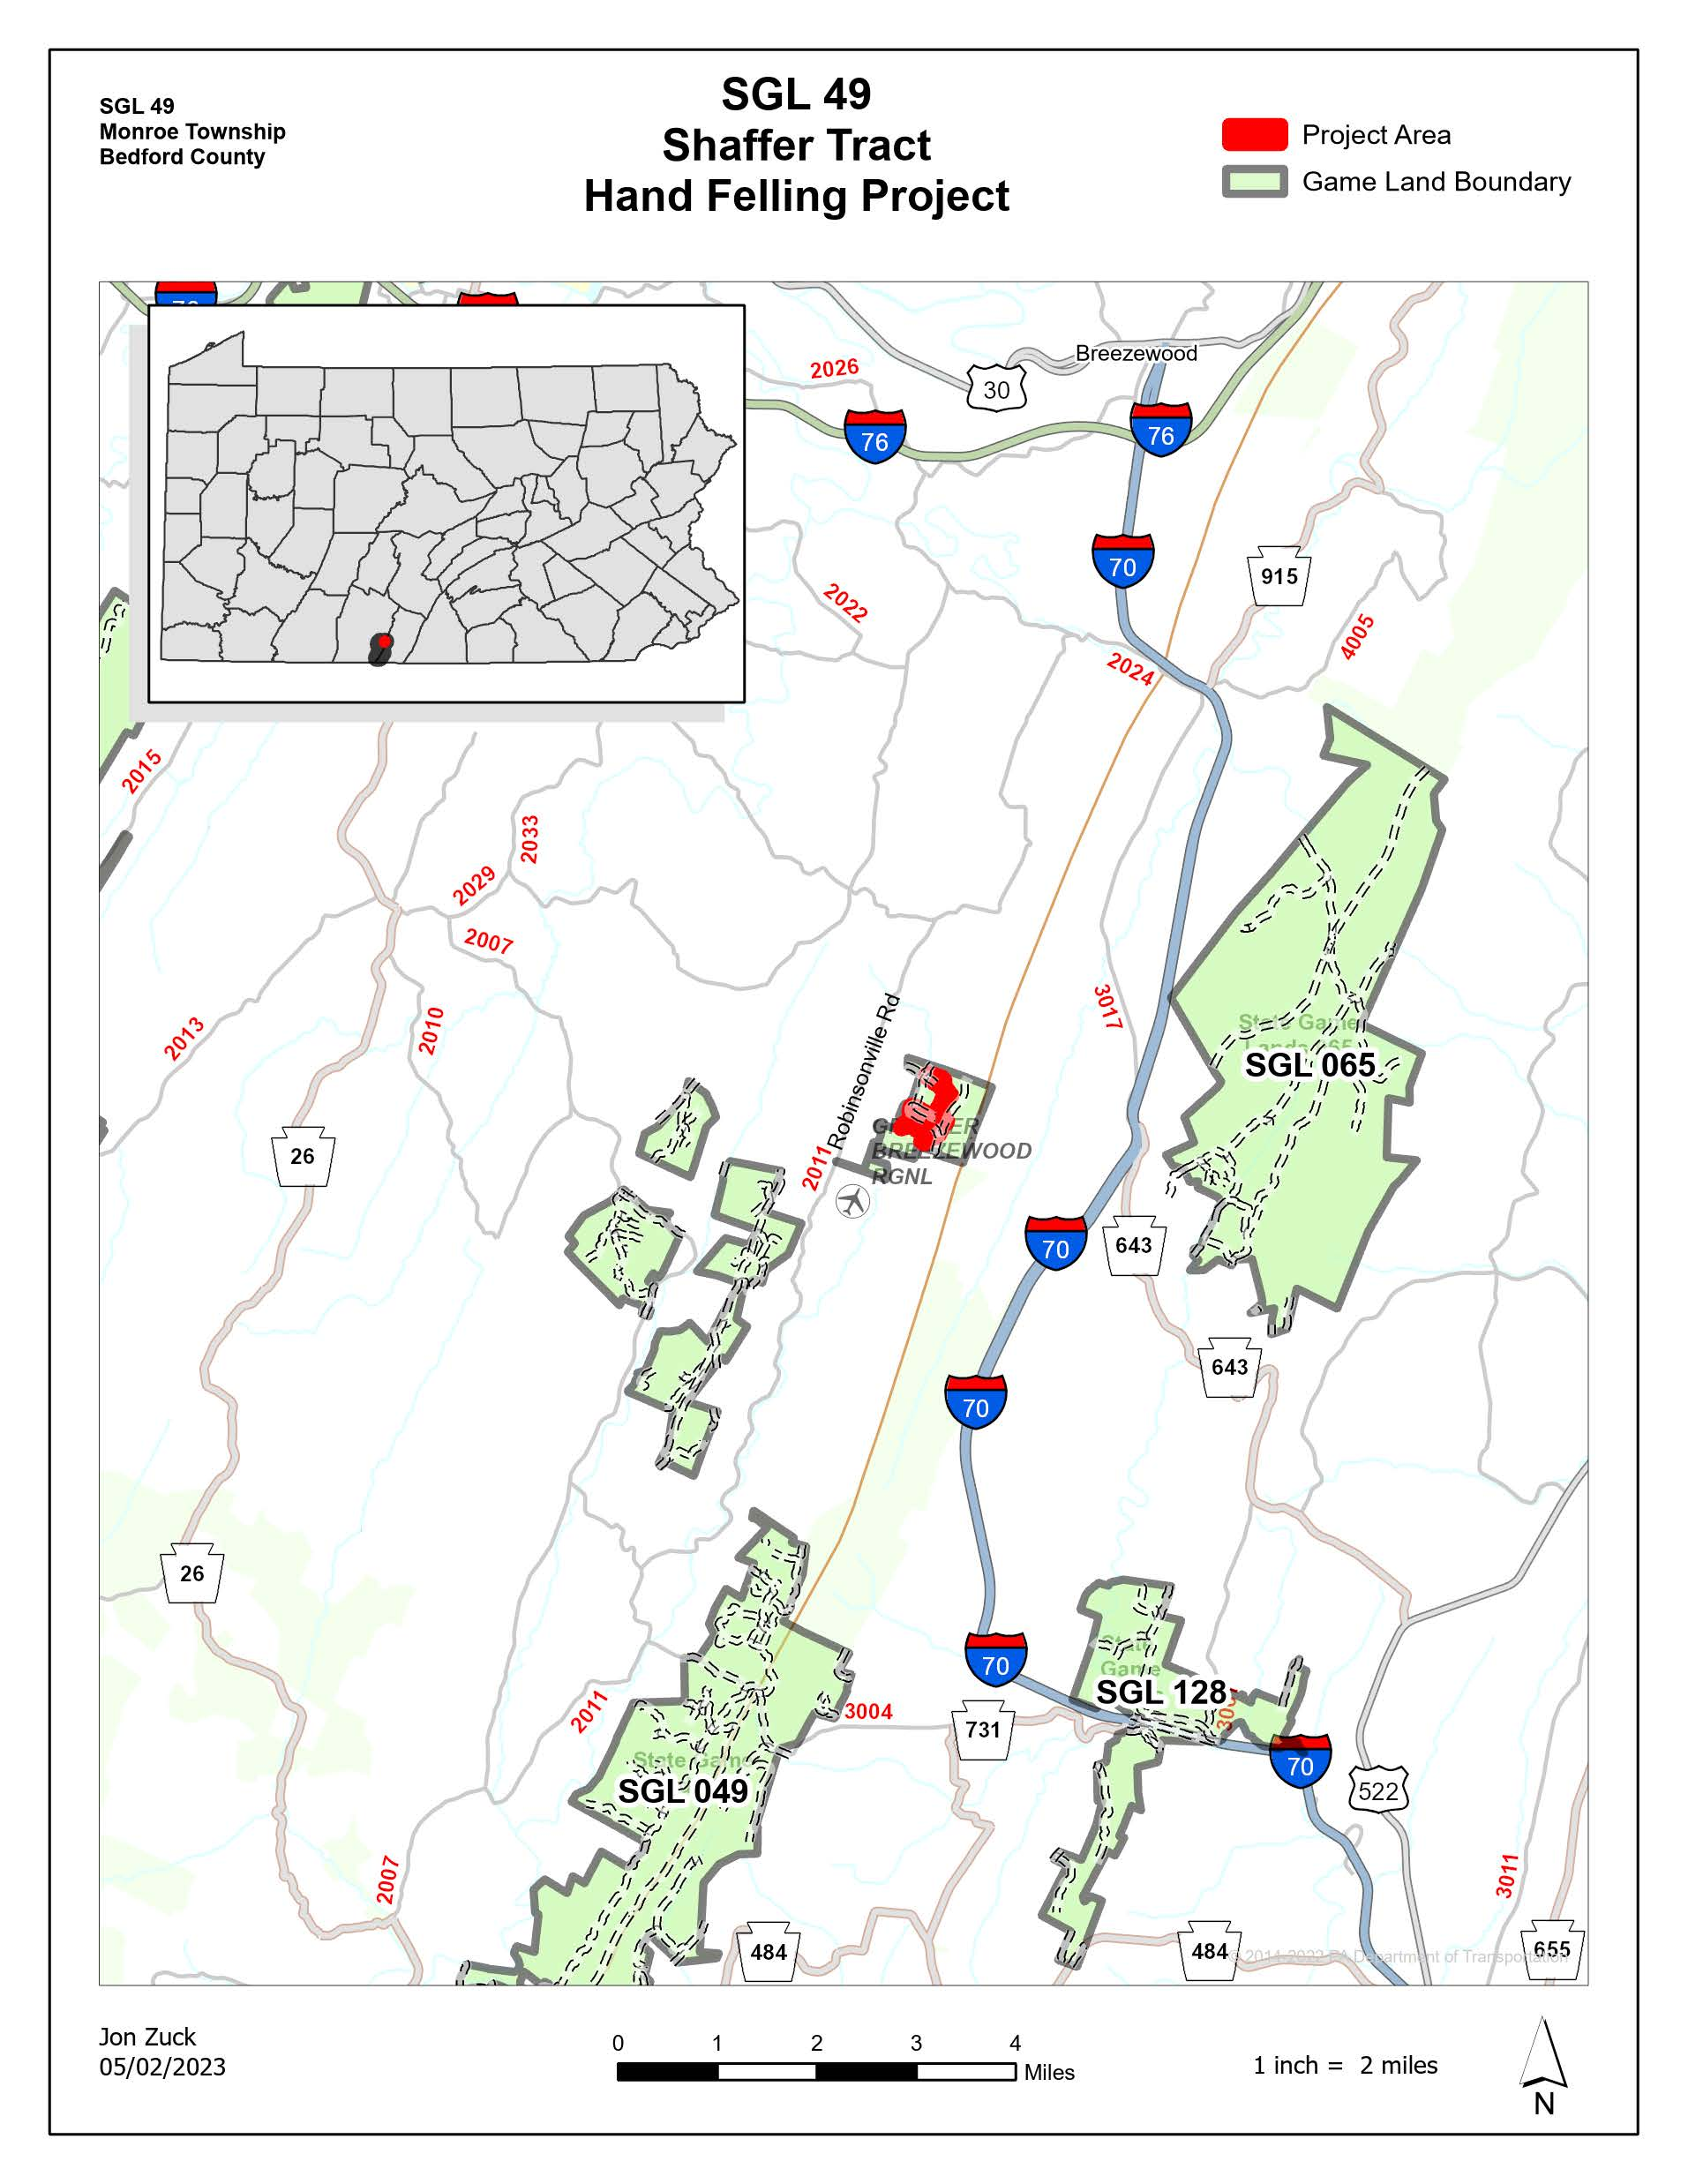

Attachment 3 – Shaffer Tract Felling Blocks
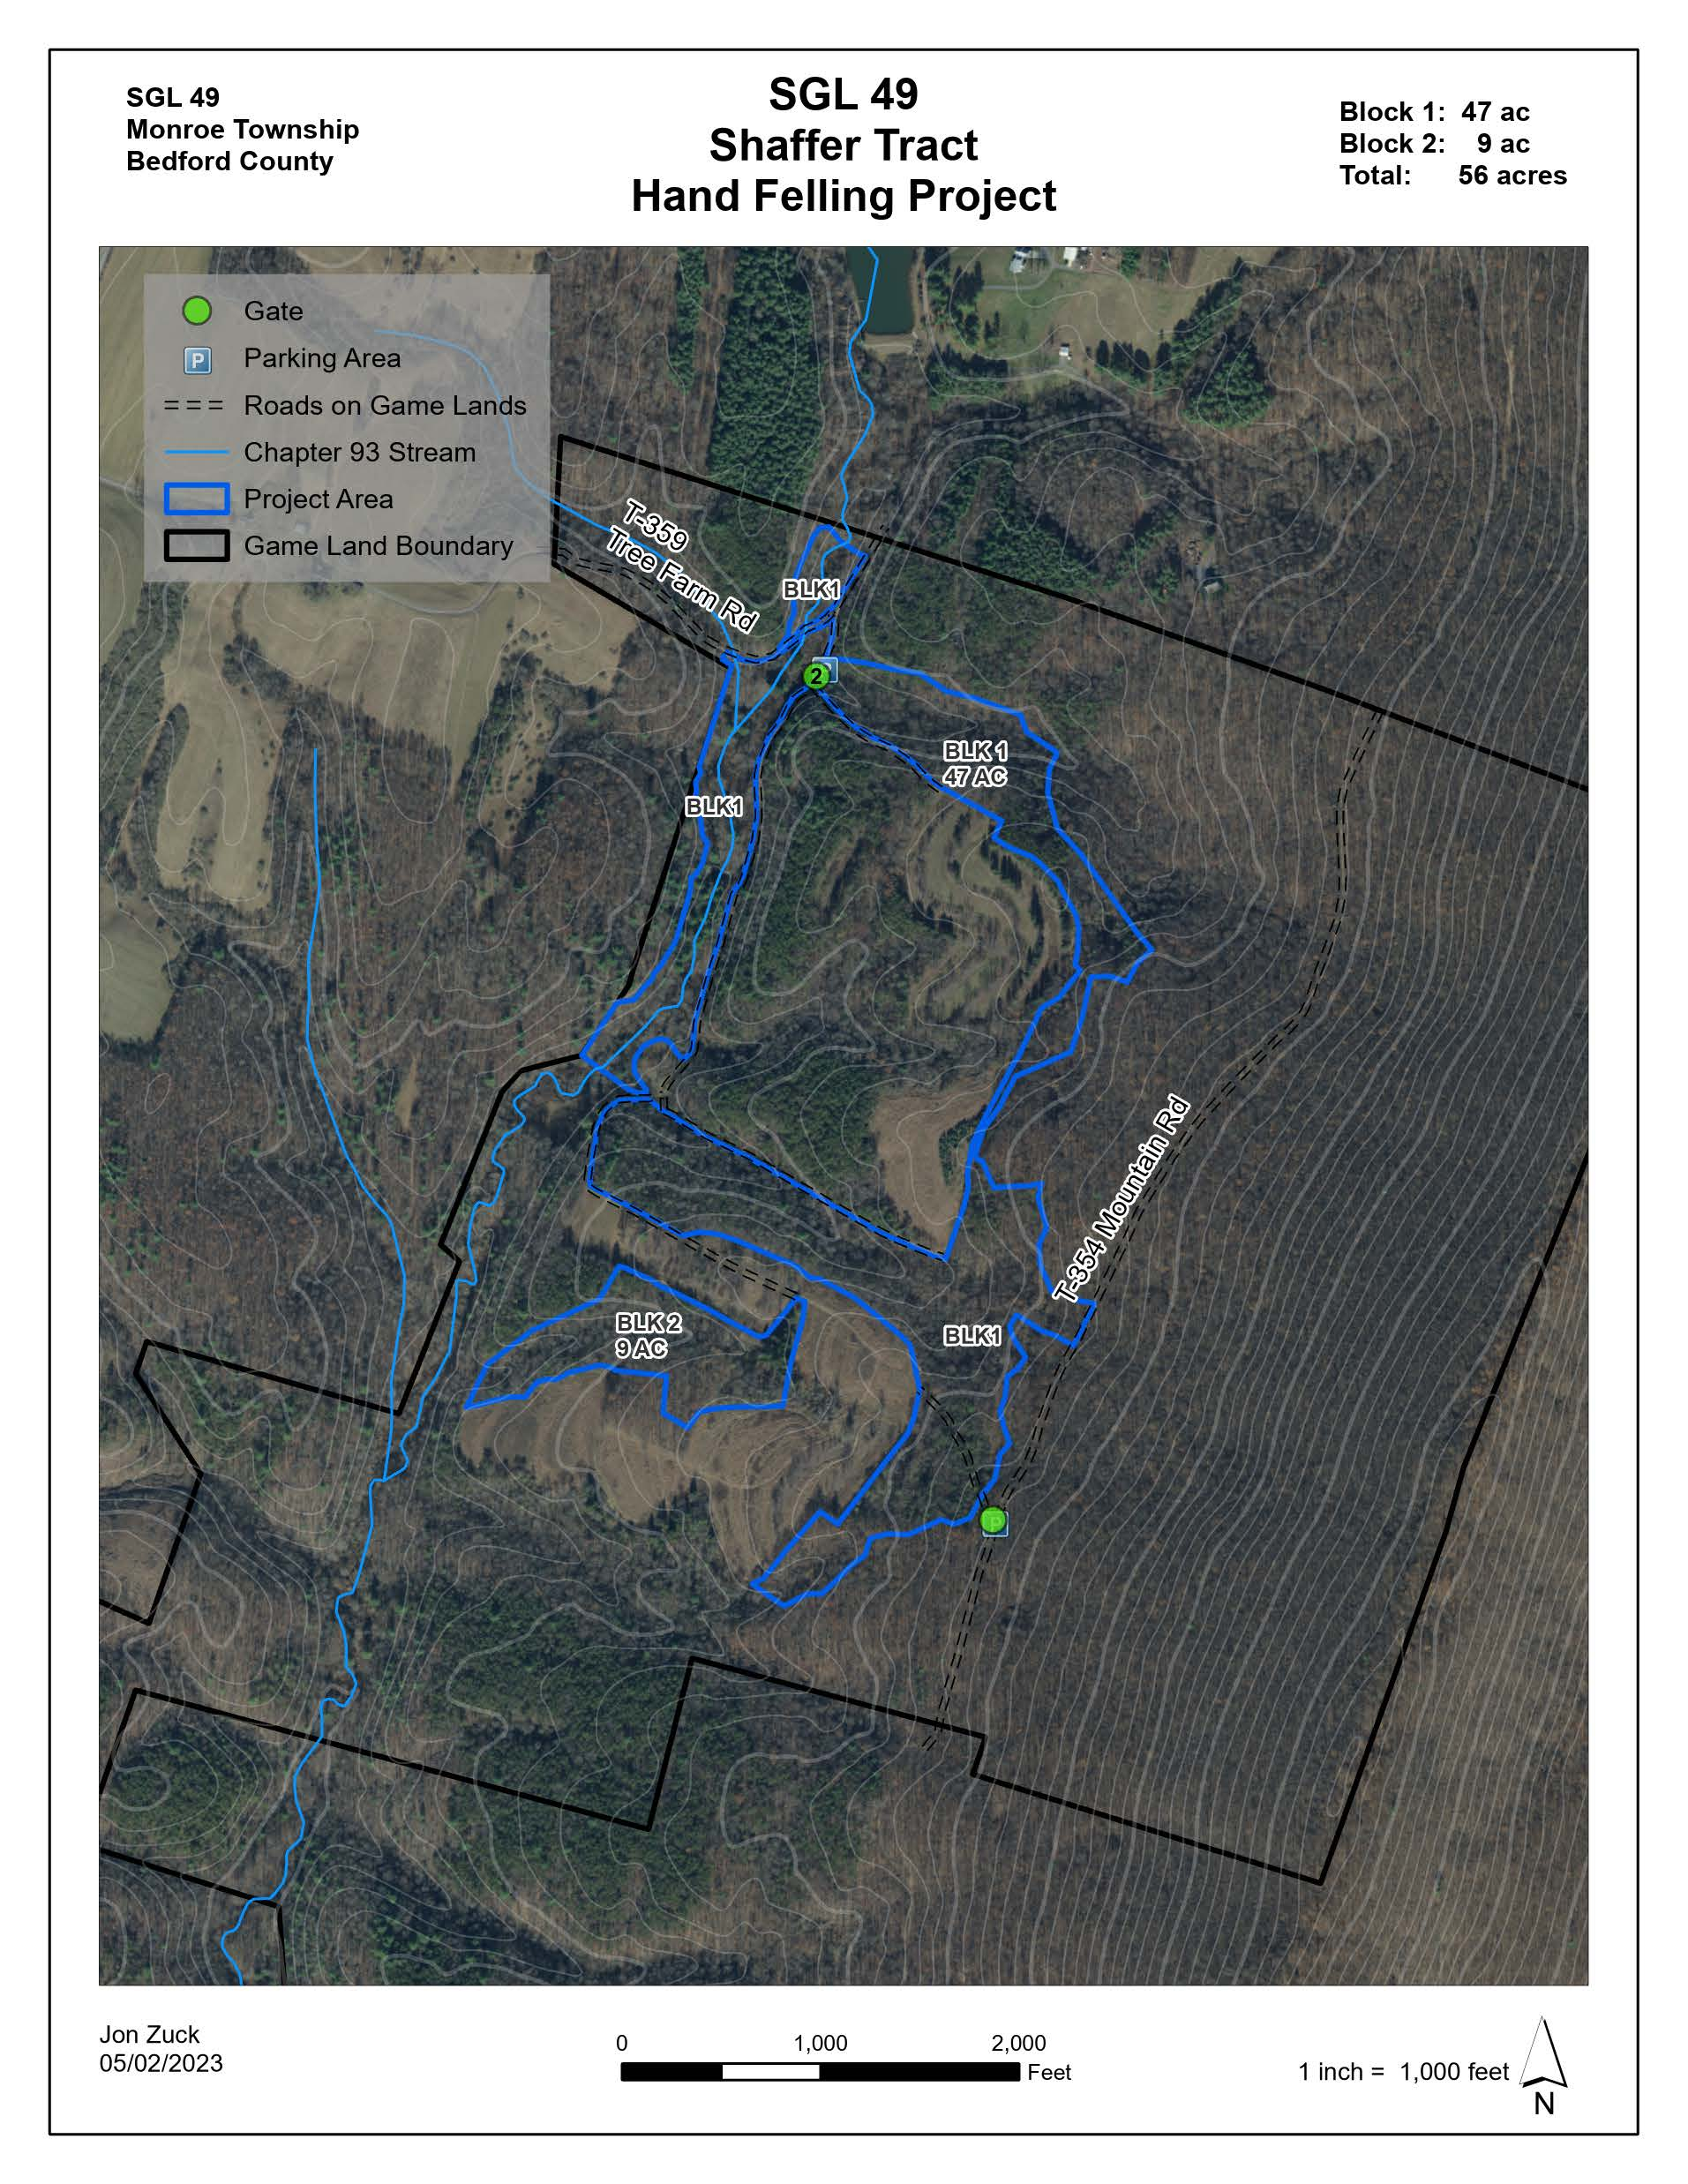

Attachment 4 – Judge Snyder Tract Location
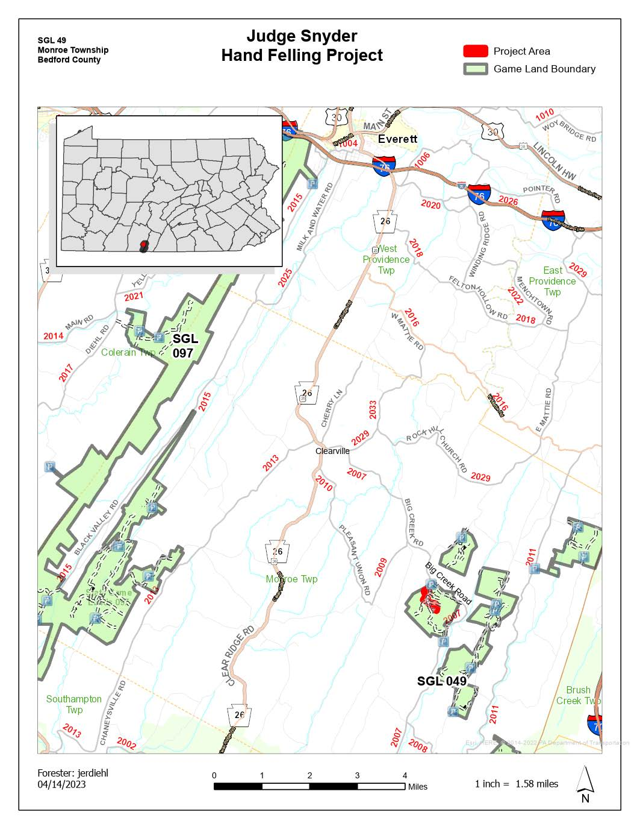

Attachment 5 – Judge Snyder Tract Hand Felling Blocks
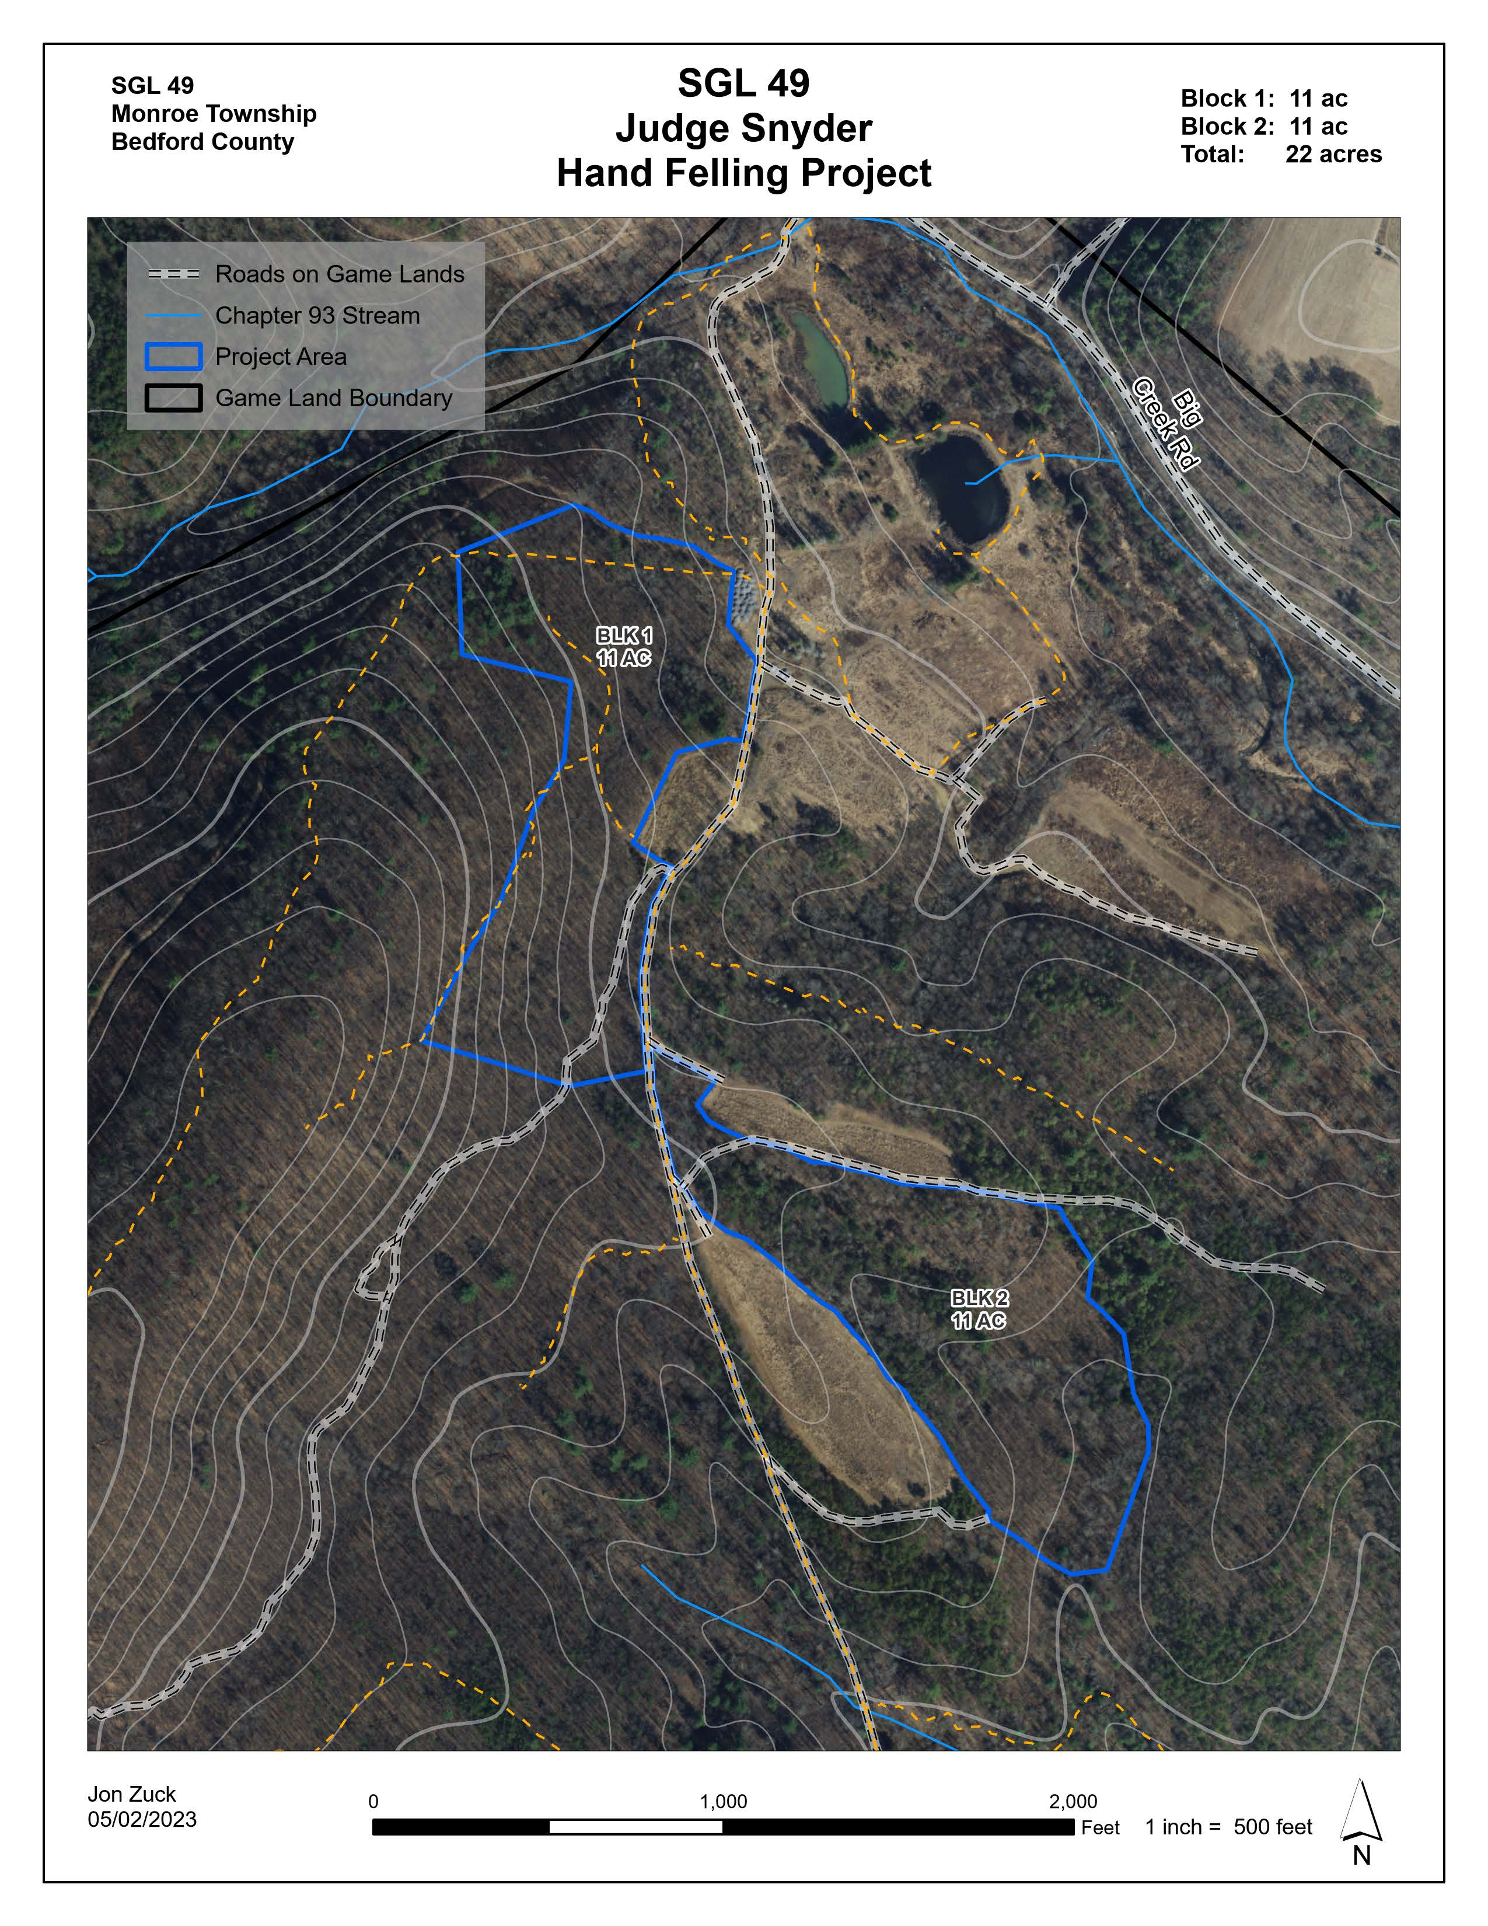
Attachment 6 – SGL 104 Tiger Valley Tract Hand Location
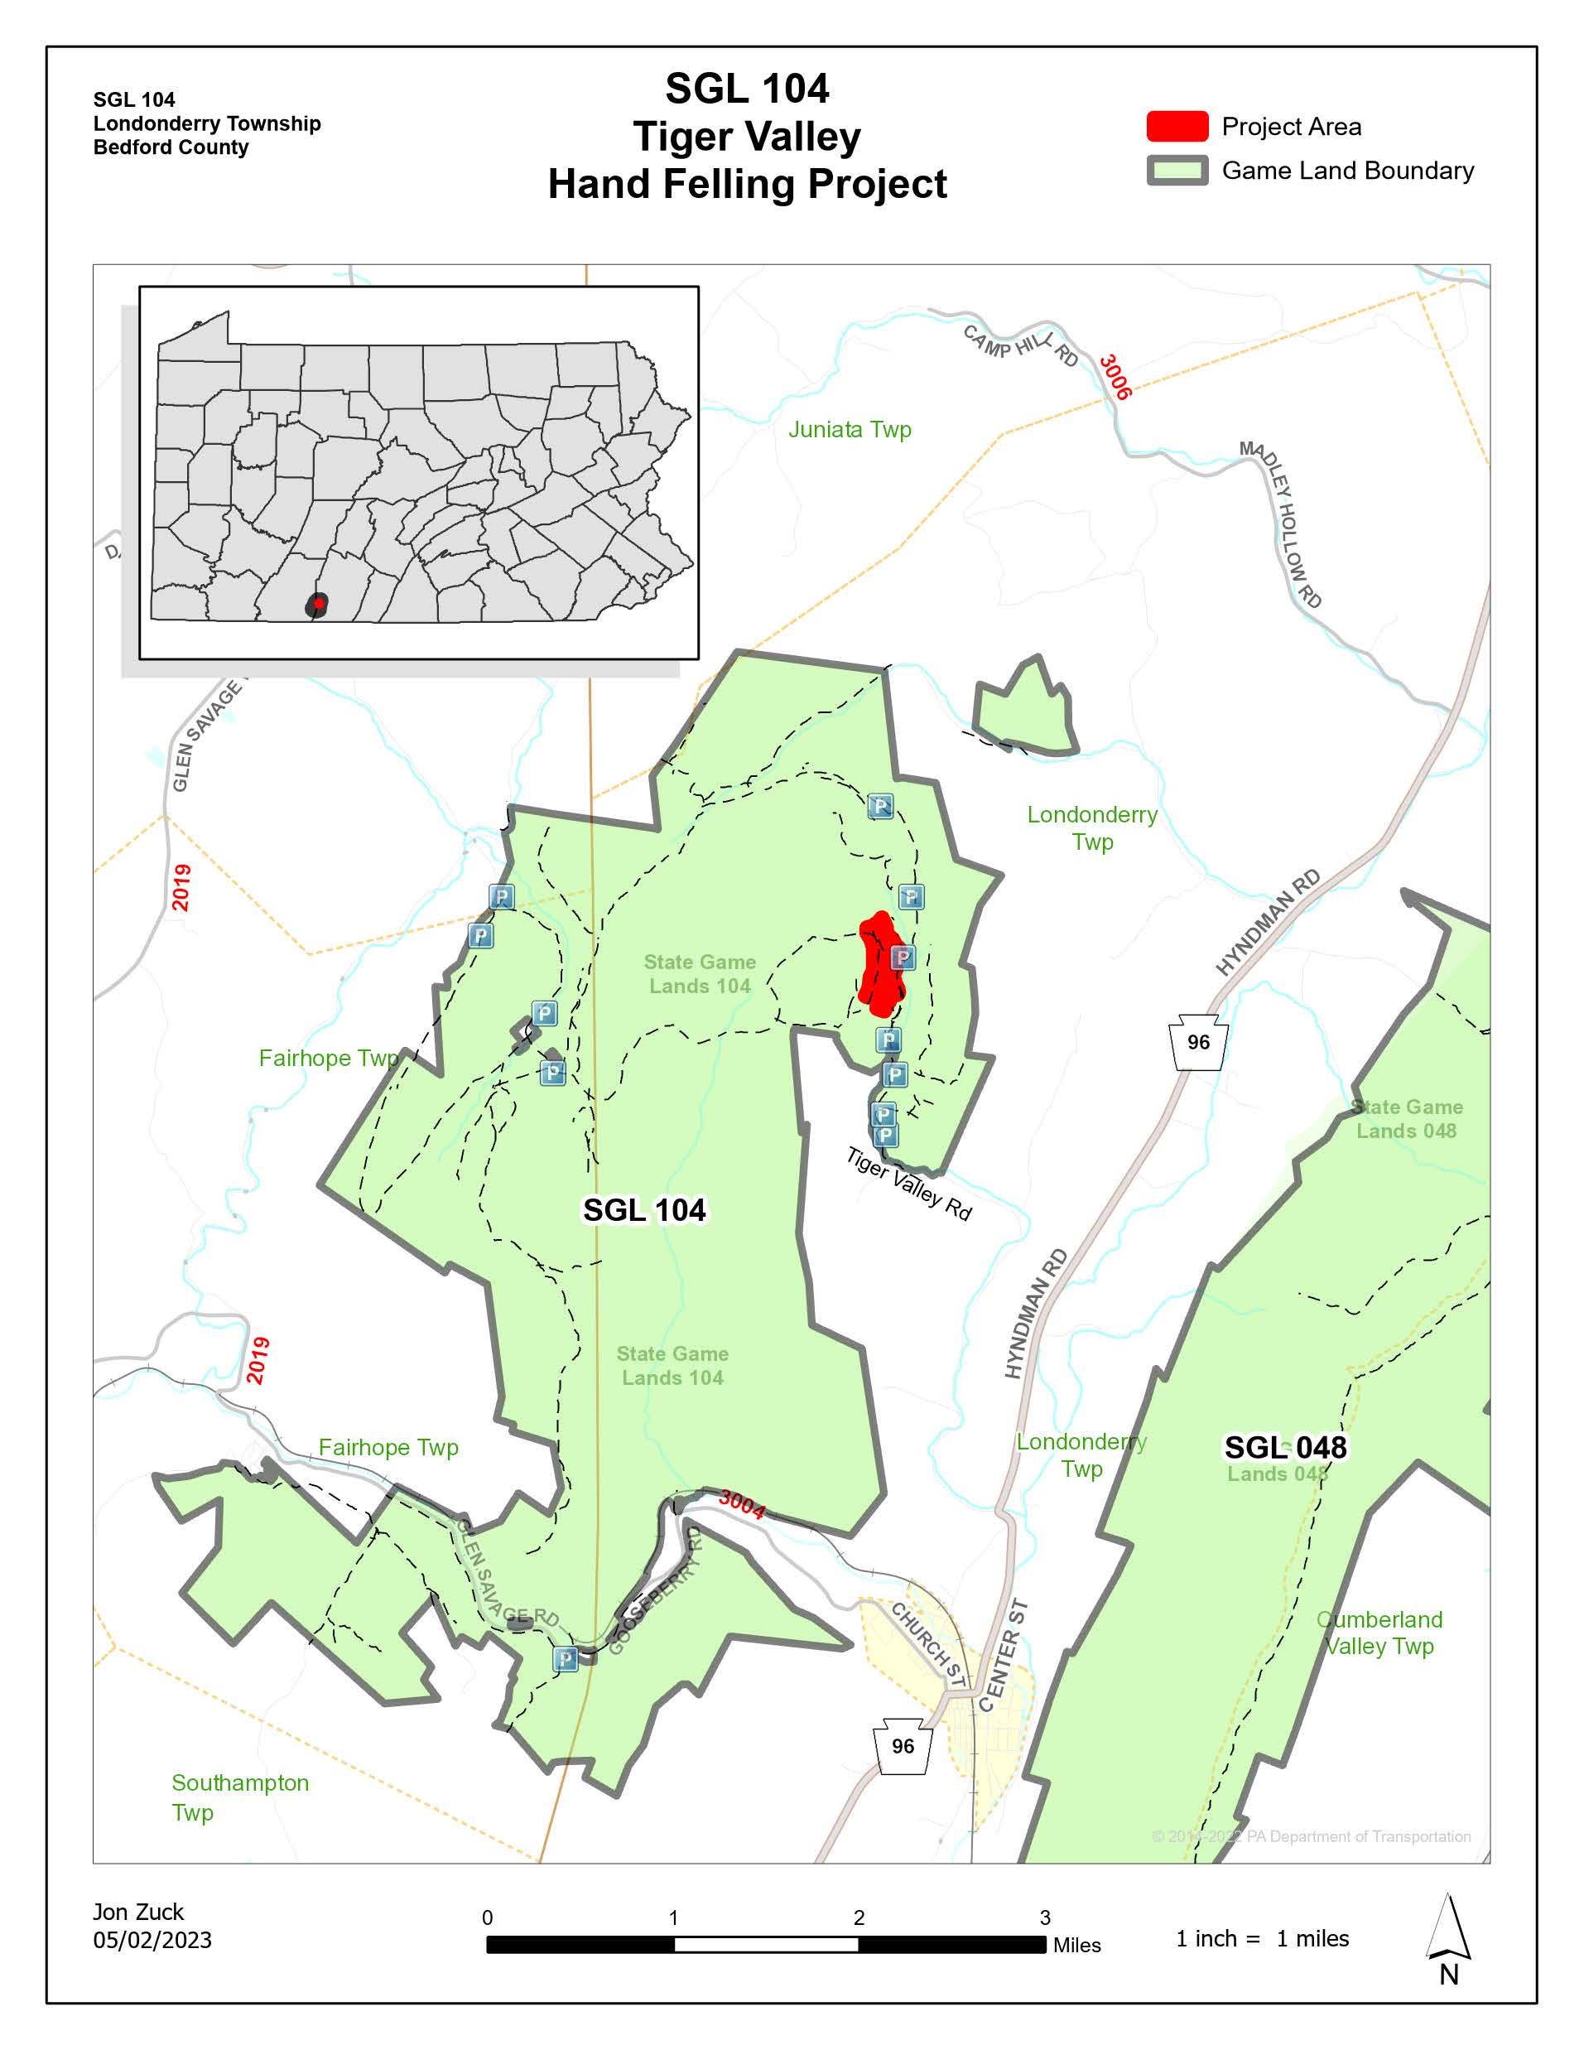

Attachment 7 – SGL 104 Tiger Valley Tract Hand Felling Block
