PA Game Commission, Northcentral Region
SGL 44 Devils Den 1 Tree Felling Contract 044-2023-01

GENERAL SPECIFICATIONS
I. SCOPE OF WORK:

The Pennsylvania Game Commission is implementing a habitat enhancement project to create late-successional oak forest conditions on SGL 44 located in Elk County, Pennsylvania. SGL 44 is located near the town of Ridgway, PA off US Route 219. The Devils Den 1 project site can be accessed via a PGC maintained haul road that connects with Snow Drift Road at 41.37117° N, 78.69080° W.

The Project will consist of hand felling undesirable trees including BLACK BIRCH, RED MAPLE, BLACK GUM, STRIPED MAPLE, and AMERICAN BEECH trees between 1’’ and 12.0’’ DBH on approximately 215 acres of STEEP TERRAIN. Black Birch greater than 12 inches DBH will be double girdled. Some black gum and American beech trees under 12.0’’ DBH have been marked with RED paint. These trees have been reserved because of their desirable qualities and are not to be cut or damaged. Utilization of felled material is not allowed, and no trees maybe removed from the project area.

There are an estimated 267 undesirable trees/acre within the project area. This number is an estimate based on data collected by PGC staff in June 2023. Stem density and size is highly variable throughout the stand, and all bidders are encouraged to walk the entire site prior to submitting a bid.

The Project area is divided into two units which are shown on the map in ATTACHMENT 2. The Project boundary is painted with BLUE diagonal slashes. Georeferenced PDF maps of the Project area will be made available to the awardee.

Purchase Orders require the contractor to provide the equipment, labor, insurance, and all miscellaneous expenses to complete the operation.
Any questions concerning the technical aspects of this bid should be directed to the Regional Forester:

Gary Glick

PGC, Northcentral Region
1566 PA Route 44
Jersey Shore, PA 17740

Phone: 570-660-9416
Email: gaglick@pa.gov

Any questions concerning the site characteristics and location of this project should be directed to Assistant Regional Forester:
Travis Weinzierl

Phone: 814-335-6470
Email: trweinzier@pa.gov

II. CONTRACT TASKS:
- Project Location:

State Game Lands No. 44

Ridgeway Township, Elk County.

B. Duties:
The contractor will be responsible for hand felling undesirable trees including BLACK BIRCH, RED MAPLE, BLACK GUM, and AMERICAN BEECH stems between 1’’ and 12.0’’ DBH within the project area unless marked as reserves. All Black Birch greater than 12 inches will be double girdled. The contractor must comply with all requirements stated in ATTACHMENT 1, Tree Felling Specifications.

C. Quantity:
Acreages of treatment area: 215 acres
D. Contractor Experience:

After bid opening and prior to awarding the Purchase Order(s), the Commission has the right to request three (3) references (name, addresses and telephone numbers) of similar work performed in the previous two (2) years as proof of qualifications to perform the work involved in the project(s).

III. SITE INSPECTION AND ASSISTANCE:
A tour of the project area will be held on September 1, 2023, at 10:00am. All prospective bidders should meet at the SGL 44 Parking Area along Snow Drift Rd. (41.37117° N, 78.69080° W). Site inspection can be done by prospective bidders at any time, but vehicle access off Snowdrift Road will only be provided on the tour date. The Project area can be accessed off Arkansas Lane, but it is a significantly longer walk. The gate lock combination for Arkansas Lane will be provided to prospective bidders upon request. Please see attachments 2 and 3 for detailed maps.

IV. CONTRACT ADMINISTRATIVE REQUIREMENTS:
All work must be completed by the termination date: June 14, 2024.
No contract extension will be approved.
The Commission reserves the right to evaluate the proposed equipment and operators and reject any part of the operation that in the Commission’s said opinion will result in unsatisfactory performance. The Commission reserves the right to reject any or all bids.

- As a further guarantee of faithful performance of the conditions set forth in this contract, the Successful bidder hereby agrees to furnish the Commission with Certified Check, Savings Account, Irrevocable Letter of Credit, or other security acceptable to the Pennsylvania Game Commission, in the sum of $2,000.

ANY SECURITY POSTED HEREUNDER MUST HAVE AN EXPIRATION DATE A MINIMUM OF ONE YEAR BEYOND THE EXPIRATION DATE OF THE CONTRACT.
Failure to comply with any of the terms of the conditions of the contract may result in cancellation of the agreement and claim may be made against the surety or the security for all or part of the damages sustained by such noncompliance.
Any extension of time under the Contract, or forbearance of cancellation and claim against the surety will not result in a release of the surety or the Principal from their obligations under the Contract and the surety.

V. PURCHASE ORDER TERM:
The contract term shall be for approximately 10 months; the starting date will be upon contractor’s receipt of the Purchase Order that includes a notice to precede which is estimated to be August 28, 2023 and ends June 14, 2024. The Commission will determine the exact application start date and the time period that application may take place depending upon the type of work required. The Commission reserves the right to alter the delivery starting and ending date by fifteen (15) days, but will in no case be more than fifteen (15) days either way of the above.

VI. INSURANCE REQUIREMENTS:
A. The contractor will provide Workmen’s Compensation insurance sufficient to cover all of the employees of contractor working to fulfill this contract.

B. Comprehensive General Liability Insurance, including bodily injury and property damage insurance, to protect the Commonwealth and the contractor from claims arising out of the performance of the contract. The amount of Bodily Injury Insurance shall not be less than $300,000.00 for injury to or death of persons per occurrence. The amount of Property Damage Insurance shall not be less than $300,000.00 per occurrence.
Such policies shall name the Commonwealth as an additional insured. Prior to the commencement of work under this contract, the contractor must provide the Commonwealth with current Certificates of Insurance. These Certificates shall contain a provision that coverage afforded under the policy shall not be canceled or changed until at least thirty (30) days prior written notice has been given to the Commonwealth.

VII. HOLD HARMLESS:
The contractor shall be responsible for and agrees to indemnify and hold harmless the Commonwealth from and against damages to property or injuries (including death) to any persons and other losses, damages, expenses, claims, demands, suits, and actions by any party against the Commonwealth in connection with the work performed by the contractor.

VIII. DAMAGE TO COMMONWEALTH PROPERTY: The Contractor shall be responsible for any damage to Commonwealth property resulting from the improper use of equipment for this fire break/road improvement operation. The Contractor will be given one (1) written warning that damage is becoming excessive and if the action continues damages will be assessed.
a. TIMBER DAMAGES –When, in the opinion of the Field Project(s) Coordinator, damage to the residual stand becomes excessive the Contractor shall pay the Commission a fair base current value determined by the Field Project(s) Coordinator per unit of volume. If this value for damage due to Contractor’s carelessness or negligence is less than $10.00 per tree then a minimum charge of $10.00 per tree will be made whether the tree is commercial, non-commercial, merchantable or non-merchantable.
b. COMMISSION FACILITIES - Contractor shall immediately repair, in a manner that meets with the approval of the Field Project(s) Coordinator, any damage to Game Land roads and other facilities, including access roads, resulting from their use for this felling operation, general wear and tear excepted. Field Project(s) Coordinator may notify the Contractor in writing to temporarily discontinue use of any of the above whenever, in their opinion, such action is necessary to prevent serious damage.

IX. BID AWARD:
THIS PROJECT SHAL BE BID ON A PRICE PER ACRE BASIS. BID WILL BE AWARDED TO THE BIDDER BASED ON COST AND CONTRACTOR’S EXPERIENCE AND ABILITY TO FULLFILL THE CONTRACT. NO PARTIAL BID WILL BE AWARDED.

Bids must be submitted via the PA Supplier Portal, to be found at www.pasupplierportal.state.pa.us Faxed bids and mailed bids will NOT be accepted.
Bids will be publicly opened on September 11, 2023 at 2:00 PM., at the Pennsylvania Game Commission, 2001 Elmerton Ave., Harrisburg, PA 17110-9797.

The price per acre shall include all labor, equipment, tools, insurance, materials disposal and all items necessary for the completion of the project. Prices bid shall be in dollar and cents only.

The Commission reserves the right to reject any or all bids.

X. BID RESULTS: Bidders can obtain results at www.emarketplace.state.pa.us/bidtabs.aspx
The posted results will contain the information of the apparent bidders, and all bids are under review until final award of the purchase order.
Quantities herein are only estimates and may increase or decrease dependent upon the needs of the Commission. Operator shall be paid at the unit price bid for actual services performed.
The Commission reserves the right to reject any or all bids and

XI. PAYMENT TERMS:
Payment shall be on a reimbursement basis for actual acres completed as measured by a Forestry Division employee. The project will be deemed complete when all items listed in the specifications have been met. Invoice must state the number of acres properly treated.

XII. PURCHASE ORDER(S) TERMINATION:
The Commonwealth may terminate the Purchase Order(s) for its convenience if the Commonwealth determines termination to be in its best interest. Operator shall be paid for work completed.

ATTACHMENT 1

TREE FELLING SPECIFICATIONS

Devils Den Tree Felling Project – SGL 044
Elk County, Ridgeway Township

1. The project consists of two (2) cutting blocks. The boundary is delineated with BLUE marked trees with two (//) slashes. Corners are marked with three (///) slashes. All BLUE boundary trees shall not be cut and remain standing.

2. All trees marked with RED paint shall be reserved and not be damaged.

3. Trees to be felled include BLACK BIRCH, RED MAPLE, BLACK GUM, STRIPED MAPLE, and AMERICAN BEECH stems between 1’’ and 12.0’’ DBH within the project area unless marked as reserves

4. Black Birch greater than 12 inches DBH will be double girdled.Girdling will consist of a minimum of 2 cuts 1 inch deep entirely around the bowl of the tree. The cuts will be separated by a minimum of 6 inches and maximum of 12 inches.

5. Access is limited in some of the project area. UTV machines to access the project will be permitted.

6. Trees must be felled with hand operated devices (chainsaws and brush cutting saws). Trees felled must be completely severed at the stump.

7. Stump heights must be not higher than 1 foot above the ground, or as close to ground level as possible.

8. All trees must be felled to ground level. Any leaning trees must be pushed or pulled
to ground level when possible.

9. All felled woody material must remain within the Project area

10. Trees may be felled across the blue painted project perimeter in areas where it does not coincide with the gameland boundary.

11. All care should be taken to directionally fell trees away from the gameland roads, herbaceous areas, stream channels, pipelines, well pads, and defined trails. If trees fall onto these areas, they must be cleared.

12. All felled stems must be removed from within 10’ of residual/desirable stems. Felled stems can be piled and moved to meet this requirement, but they cannot be removed from the Project area.

13. The contractor will remove all trash and garbage at the end of each workday generated from the completion of this contract. This is to include all materials generated from the support of felling tools and equipment, and items generated from personal use by the contractor’s employees.

14. The contractor will notify the Forestry Division representative three days prior to beginning the project. The contractor may work at times other than the schedule of the Forestry Division representative. The contractor may be present at the final inspection.

15. All contractors, subcontractors and consultants of the Operator must be pre-approved by the Commission. The Commission reserves the right to reject any subcontractor at its sole discretion. If the Contractor enters into any subcontract(s) not previously approved by the Commission, the Commission shall have the right to require the Contractor to terminate such contracts.

16. Except on Sundays, it is unlawful to be present on State Game Lands from November 15 through December 15 inclusive when not engaged in lawful hunting or trapping and fail to wear a minimum of 250 square inches of daylight fluorescent-orange material on the head, chest, and back combined, or in lieu thereof, a hat of the same colored material. The material shall be worn so it is visible in a 360-degree arc.

17. No operations will be permitted on the following days: All Saturdays in the months of October, November, December, and January and any Sundays open to hunting. The opening day and all Saturdays during spring turkey season, including the youth spring gobbler hunt. All the days of the general statewide bear season. The entire 2 weeks of the general firearms deer season. The opening day of the flintlock muzzleloader season. The contractor, employees, and sub-contractors may not hunt to, from, or at the job site when the work location is beyond a gated road that is closed to public traffic. The contractor may travel to and from the work location on no-work days to check on the condition of equipment.

18. Gates are always to be kept closed and locked except when the contractor is present on the site.

19. Final inspection of the habitat project will be conducted by the Regional Forester or designee. The contractor may be present at the final inspection. Upon successful completion of the required work, payment will be released to the contractor. The performance bond required for this project will be released upon successful completion of the Project.

20. Failure to meet and follow the terms and conditions of the project will be grounds to terminate the contract.

ATTACHMENT 2
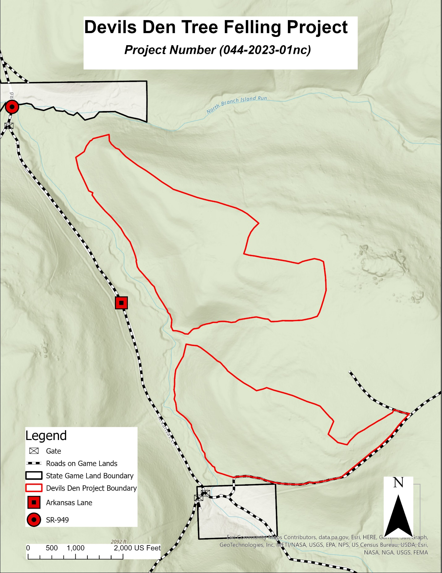

ATTACHMENT 3
