

Air Sampling Infrastructure Upgrades
Kittanning PA. (Armstrong County)

SPECIFICATIONS

I. SCOPE OF WORK

The Department of Environmental Protection (DEP), Bureau of Air Quality, requires upgrading to the electric service powering a DEP air monitoring station located Glade Dr. and Nolte Rd. Kittanning Pa. 16201 (“station” or “site”).

Questions: Any questions regarding the technical aspects of the Specifications should be directed to Carl Shaver at (717) 439-6981 or via e-mail at cshaver@pa.gov.

- General – The Pennsylvania Department of Environmental Protection (DEP), plans to replace the electrical service for an air monitoring station located in Kittanning (Armstrong County) The site, will consist of a shelter and a meteorological tower as shown in Exhibits A, B.

- Permits/Inspections/PA One Call/Erosion & Sediment (E&S) – Prior to construction, Contractor shall obtain an electrical permit (if needed) from the appropriate local authority. Contractor shall also be responsible for obtaining all other required permits and inspections to complete this project and must follow proper safety protocols (using PA One Call – see www.pa1call.org) before any excavations. Contractor shall follow any state-required, acceptable best management practices regarding E&S (Erosion & Sediment) control during construction.

- Electric - Contractor shall meet all local electric company requirements while providing these utility services to the station. All work and materials must comply with the requirements of the National Electrical Code and the local electric utility (WEST PENN). Additionally, the electrical equipment and service wire must be in accordance with standards approved by the Underwriter's Laboratory (see https://www.ul.com/). Contractor shall be responsible for arranging all required inspections of the electrical service.

The electric service to the site shall be a single-phase type and rated 120/240 VAC 100-amp. Service shall originate from Service Pole to a Drop Pole located behind the shelter. Contractor shall replace the Drop Pole if needed. Contractor shall provide electric service in an underground appropriately sized conduit to a metal-framed kiosk. All work shall be done to WEST PENN’s specifications. All disturbed areas shall be graded, returned to as found condition.

A breaker panel shall be mounted on the kiosk, with locking cover (as shown in Exhibits E & F, housing a properly sized breaker. Two, 20-amp GFI outlets with outdoor covers, shall also be mounted to the kiosk. Each outlet shall be on its own 20-amp circuit. All equipment shall be properly grounded with a ground rod installed at the kiosk and one next to the service entrance for the station. The station service entrance shall be located approximately 8-10 feet from the kiosk. A properly sized service entrance wire shall be run in conduit and buried at proper depth from the kiosk to the station. The wire shall be connected to the station’s electrical panel by Contractor.

At the completion of the electrical work, all work must be inspected by Contractor or its designated agent. In order for the electrical work to be deemed satisfactorily completed, DEP must confirm in writing that it accepts the results of the inspection.

The electric service route described above has been approved by the property owners. However, any proposed deviations from plans, should be brought to the attention of Carl Shaver at (717) 439-6981 or via e-mail at cshaver@pa.gov, who will consult with the property owners for approval.

II. CONTRACT REQUIREMENTS

Contractor agrees to comply with these Specifications, Exhibits A through D hereto and with the following attachments:

- Attachment A -SAMPLE BID AWARD
- Attachment B - West Penn Specifications West Penn Power--Customer Guide for Electric Service-Pennsylvania (firstenergycorp.com)
- Attachement C - Department of Environmental Protection Federal Requirements

- III. INSURANCE REQUIREMENTS

Contractor shall purchase, and maintain at its expense, the following type of insurance issued by companies acceptable to the Commonwealth.

A. Workers’ Compensation Insurance sufficient to comply with minimum coverage amounts established by Pennsylvania law and to cover all employees of Contractor working to fulfill this contract.

B. Comprehensive General Liability Insurance, including bodily injury and property damage insurance, sufficient to protect the Commonwealth and Contractor from claims arising out of the performance of the contract. The amount of bodily injury insurance shall not be less than $500,000 for injury to or death of persons per occurrence. The amount of property damage insurance shall not be less than $500,000 per occurrence. Such insurance shall be occurrence-based and claims-made policies are not acceptable.

C. Automotive Liability Insurance, including bodily injury and property damage insurance, sufficient to protect the Commonwealth and the Contractor from claims arising out of the performance of the contract. The amount of bodily insurance shall not be less than $500,000 for injury to or death of persons per occurrence. The amount of property damage insurance shall not be less than $500,000 per occurrence. Such insurance shall be occurrence-based and claims-made policies are not acceptable.

Such general liability and automotive policies shall name the Commonwealth as an additional insured. Prior to the commencement of the work under this contract, Contractor must provide the Commonwealth with current Certificates of Insurance. These Certificates shall contain a provision that coverage afforded under the policy shall not be cancelled or modified until at least thirty (30) days’ prior written notice has been given to the Commonwealth.

IV. BID AWARD:

  - Contract shall be awarded on a lump sum basis to the lowest responsive and responsible bidder meeting all the requirements contained in the Scope of Work. See Attachment A – Sample Bid Award for award of the bid.

- Awards under this solicitation have been funded by the Infrastructure Investment and Jobs Act (IIJA) of 2021 and/or the Inflation Reduction Act (IRA) of 2022. Should you receive funding because of your submission, your organization may be eligible for additional funding from the Commonwealth Workforce Transformation Fund (CWTF). For more information, visit www.pa.gov/newjobs or email newjobs@pa.gov.

  - After completion and inspection of the work, an invoice not to exceed the awarded amount shall be sent to the Commonwealth as specified in the Purchase Order. Payments can be made to Contractor by credit card (Master Card only) via phone. Alternatively, to receive a payment by check, Contractor must have an SAP Vendor ID. To obtain an SAP Vendor ID, call (877) 435-7363, choose option 1.

  - The online DGS Supplier Service Center is available to assist vendors with registration and account management.

V. PAYMENT TERMS

Payment shall be made within approximately 20 business days upon proper satisfactory completion of all items listed in Scope of Work and upon receipt of the invoice by the Comptroller.

VI. CONTRACT TERM

The DEP shall contact Contractor immediately following bid award to arrange start and end dates.

The contract quantities herein are estimated only and may increase or decrease depending on the needs of the Department. Contractor shall be paid at the unit price bid for actual work performed.

Questions concerning the technical aspects of this bid should be directed to Carl Shaver at (717) 439-6981 or via e-mail at cshaver@pa.gov.

ATTACHMENT A

SAMPLE BID AWARD

The bid shall be awarded on a lump sum basis to the lowest responsive and responsible bidder meeting all the requirements contained in the Scope of Work.

Electric Service Installation – Including 100-amp,single-phase service, using properly-sized and type cable in underground conduit from Drop Pole to the electrical kiosk; weather tight meter and breaker panel with locking cover and two outdoor GFI outlets, on separate 20-amp circuits; two separate 20-amp outdoor GFI outlets in the fenced area; service entrance wiring for station and fenced area wiring in buried conduit with connection fittings; as per WEST PENN specifications. Necessary permits for this work.  Replacement of Drop Pole – Only enter a Lump Sum  amount if it is determined that the Drop Pole needs  replaced. | $_____________  Lump Sum  $____________  Lump Sum
TOTAL - BID AWARD | $_____________  Lump Sum

ATTACHMENT B
- West Penn Specifications West Penn Power--Customer Guide for Electric Service-Pennsylvania (firstenergycorp.com)

ATTACHMENT C
- See attached File - Department of Environmental Protection Federal Requirements

EXHIBIT A
Street View of the air sampling site location in Kittanning, PA. There may be underground structures, so PA One Call shall be utilized.
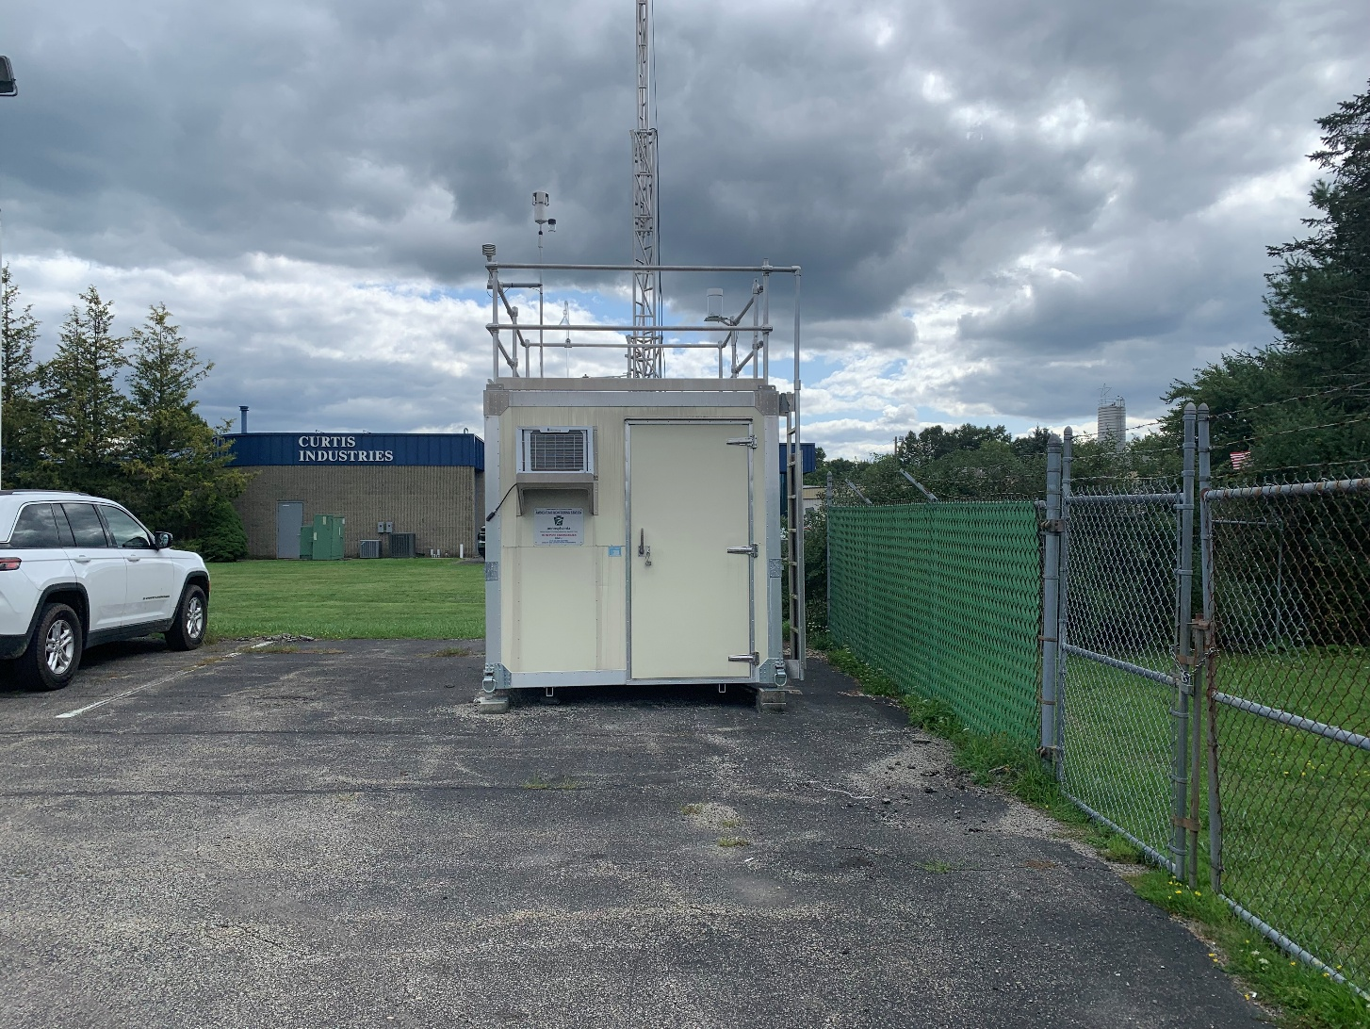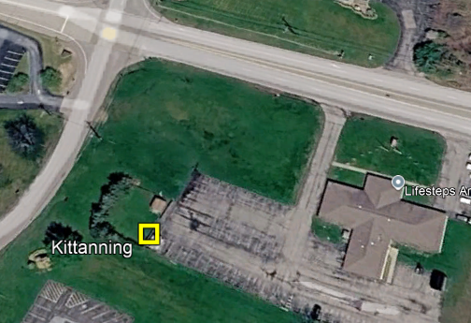
EXHIBIT B
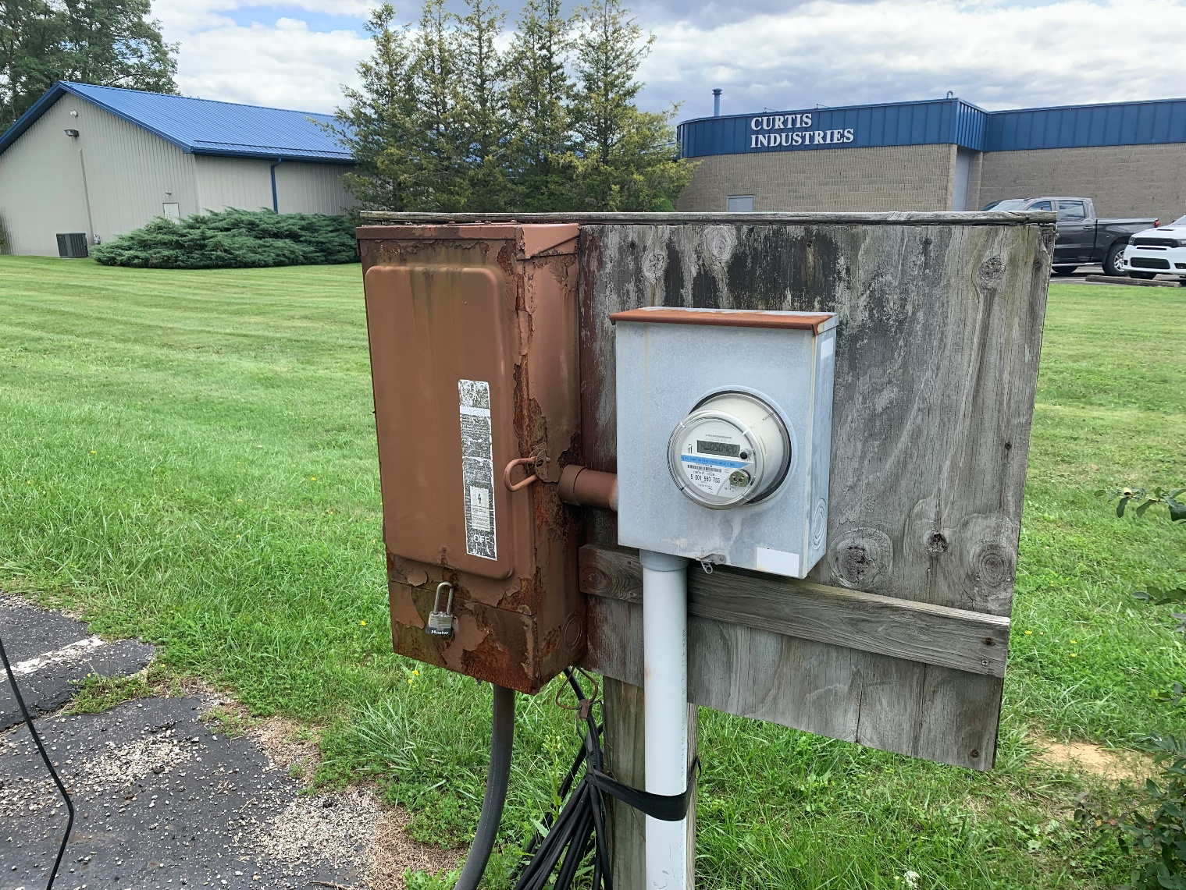

EXHIBIT C
Proposed site layout.
Top-down view. Underground conduit to panel location. (May change due to shelter configuration.)
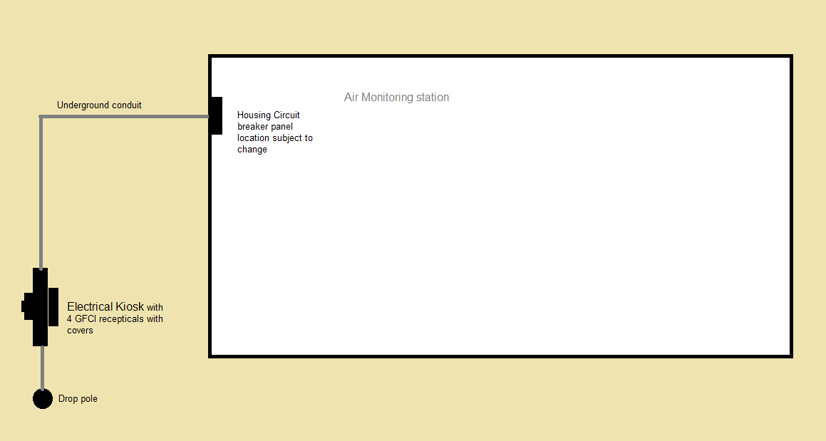

EXHIBIT D

Proposed electric schematic.

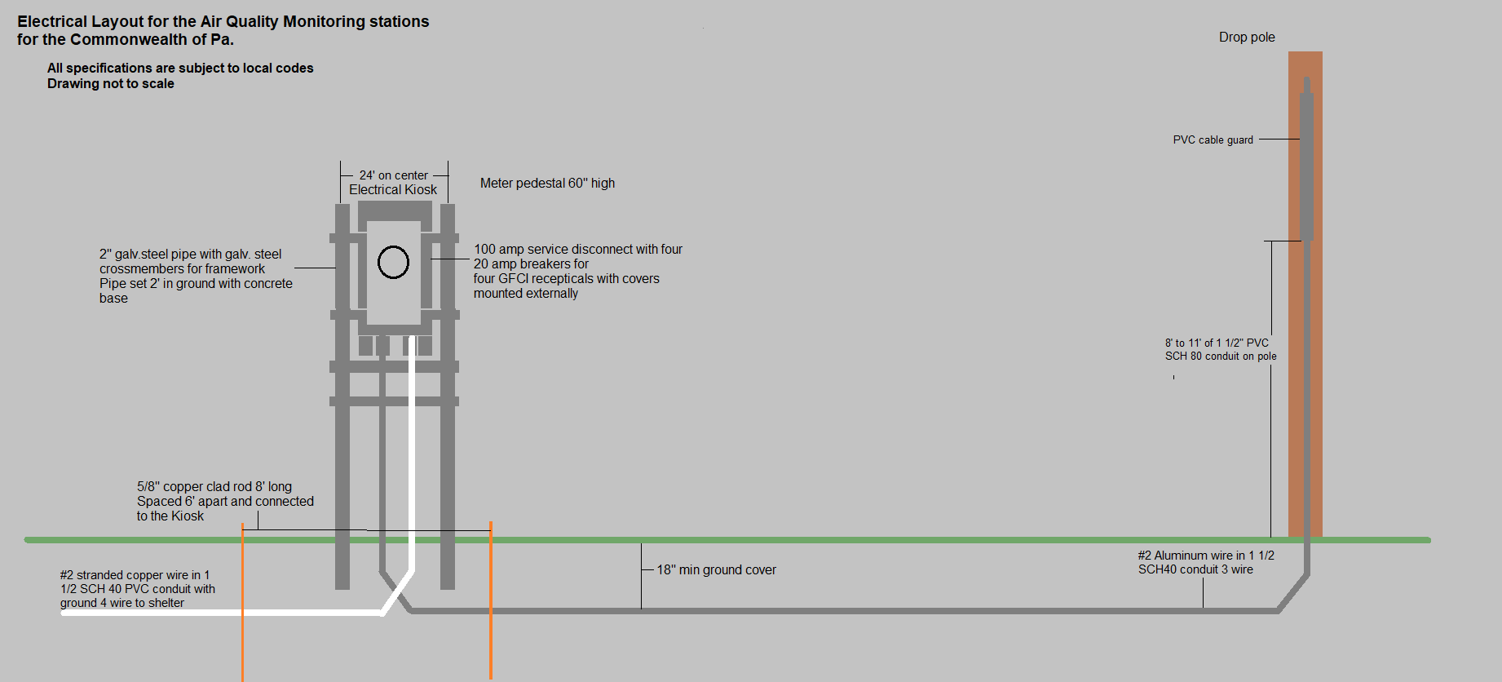

EXHIBIT E

Example of meter/breaker cabinet kiosk. Note: Four, 20-amp outlets on separate circuits needed. Structure must meet code.

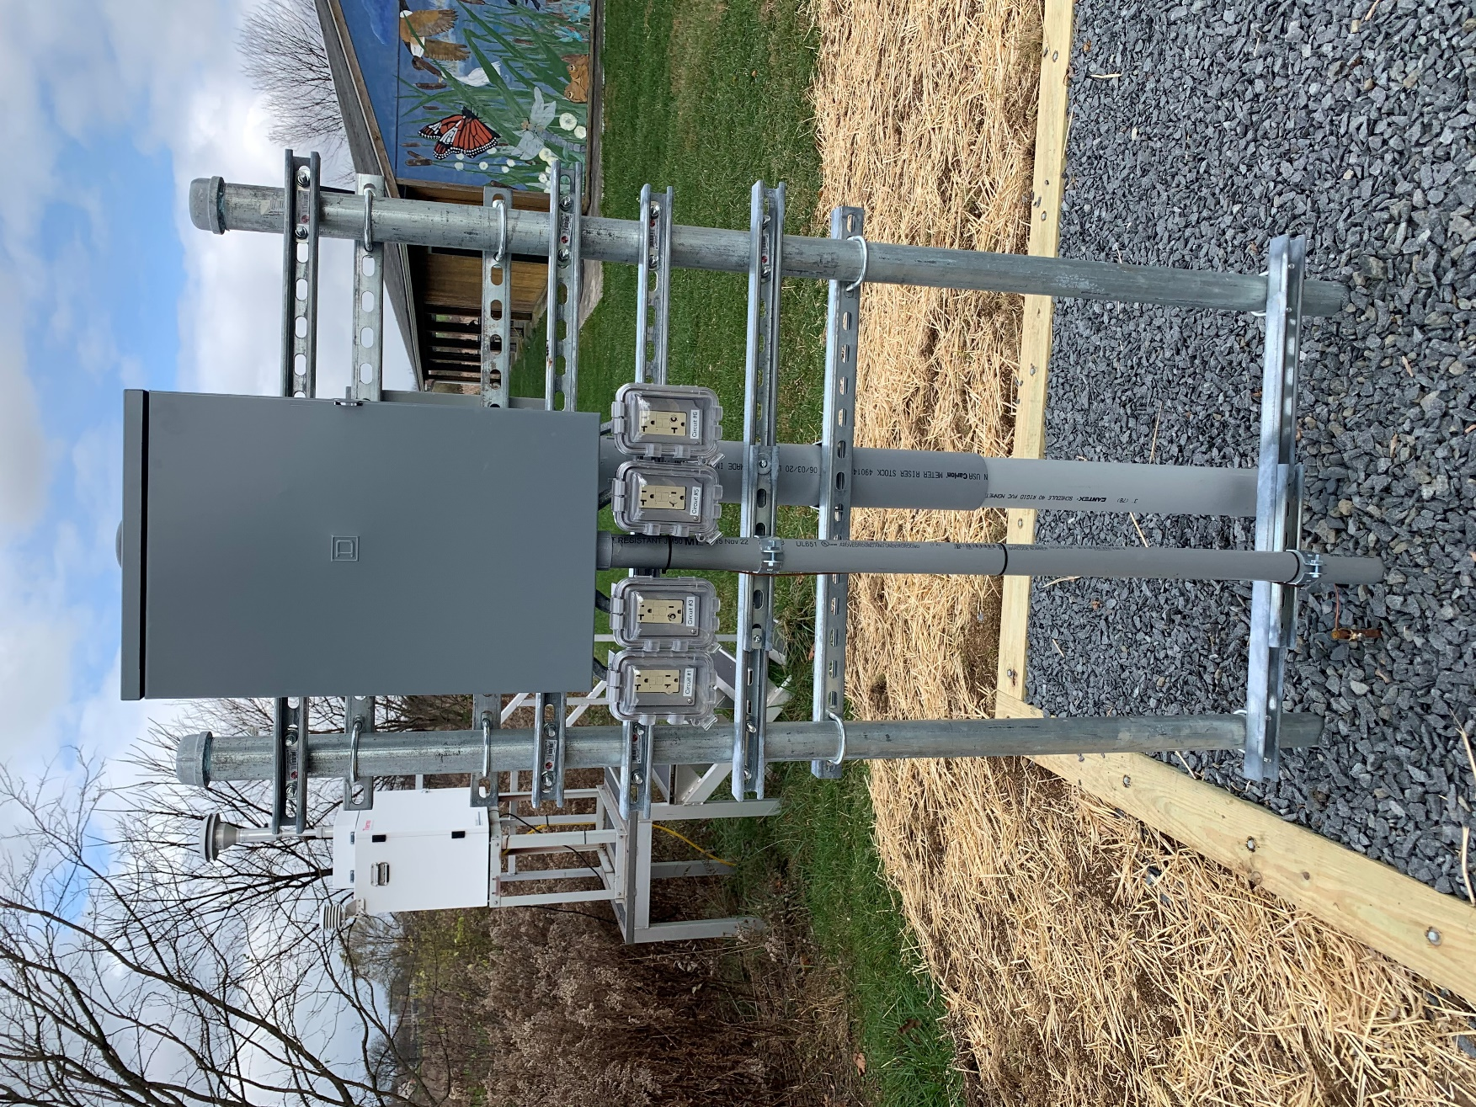

EXHIBIT F

Example of meter side of electrical kiosk.

