Appendix N

Change Management Process

RFP 2 Commonwealth Enterprise Network (EN) and Shared Services

RFP NUMBER
6100039273

Table of Contents
Scope 1
Acronyms 1
Definitions 2
Policies 4
Roles and Responsibilities 5
RACI: 11
Service Model 12
Process Flow Overview: 12
Normal Change: 13
Expedite Change: 15
Standard Change: 16
Emergency Change: 18
Supplemental Process Flow 21
Cancelled Changes: 21
Rejected Changes: 21
Unauthorized Changes: 21
Appendix 23
CAB Structure: 23
Risk Assessment: 25
Revision History 25

Scope

This document provides a unified process which shall be used by all Service Owners within the OA-OIT organization. Its purpose is to align the OA-OIT Change Management process with ITIL standards for consistency and to improve service delivery.

Objectives:
- Provide a structured process for planning, prioritizing, reviewing and implementing changes
- Reduce incidents, disruptions and re-work
- Allow for auditability

Acronyms

ASC – Agency Specific Change
CAB – Change Advisory Board
CI – Configuration Item
CM – Change Management
CR – Change Record
ECAB – Emergency Change Advisory Board
FSC – Forward Schedule of Change
ITSCM - Information Technology Service Continuity Management
ITSM - Information Technology Service Management
KPI- Key Performance Indicator
MAC – Multi-Agency Change
PIR – Post Implementation Review
RFC - Request for Change

Definitions

Term | Definition
Agency Specific Change | A change that affects only a single agency. Processed through the Agency CAB only.
Back-out Plan | A contingency plan of step-by-step instructions with defined success criteria (with sufficient detail to allow an individual with similar skills to execute the plan and is understood by all reviewers) to minimize any disruption of service if a change implementation does not go as planned.
Blackout | Submitted to Change Management to request a freeze on all or certain types of changes for business reasons. Also referred to as Change Freeze.
Change Advisory Board | A group of people that support the assessment, prioritization, authorization and scheduling of changes. This board is usually made up of representatives from all areas within the IT Service Provider, the Business, the business, and Third Parties, such as Suppliers.
Change | The addition, modification or removal of anything that could have an effect on IT services. The scope should include changes to all architectures, processes, tools, metrics and documentation, as well as changes to IT services and other configuration items.  Examples include a service, hardware, software, network, IT security, application, desktop build, associated documentation, configuration item or asset. Changes include those that are service affecting and non-service affecting.
Change Window | A regular, agreed time when changes may be implemented with minimal impact on services.
Closure Reason | Documentation of the change's success. Each of the below three reasons can also be considered as an Unauthorized Change.  Successful – CI’s have been modified successfully; Documented process was followed  Successful with Issues – Most or all CI’s have been modified successfully; Process was not followed or most CI’s were not modified successfully; Process was followed successfully  Unsuccessful - CI’s were not modified; Process was not followed  Unauthorized – Successful (same as above & without approval)  Unauthorized – Successful with issues (same as above & without approval)  Unauthorized - Unsuccessful (same as above & without approval)
Change Management | The process responsible for controlling the lifecycle of all changes, enabling beneficial changes to be made with minimum disruption to IT services.
Change Record | A record containing the details of a change. A change record is created for every request for change that is received, even those that are subsequently rejected. Change records should reference the configuration items that are affected by the change. A change record may be stored in a Configuration Management System or in another agreed upon way.

 |  | Communication Plan |  | Information on how and when the proposed change will be communicated to stakeholders. Level of detail must be sufficient for a person with similar skill to execute the plan successfully and be understood by all reviewers/approvers.
 |  | Configuration Item |  | Any component or service asset that needs to be managed in order to deliver an IT service. Information about each configuration item is recorded in a configuration record within the configuration management system and is maintained throughout its lifecycle by service asset and configuration management. Configuration items are under the control of change management. They include but are not necessarily limited to IT services, hardware, software, buildings, people, and formal documentation such as process documentation and service level agreements.
 |  | Conflicts |  | Any Change or Blackout already approved for the same day and time, agency and/or configuration items.
 |  | Enterprise CAB |  | A group of people that support the assessment, prioritization, authorization and scheduling of Enterprise Changes. A change advisory board is usually made up of representatives from: all areas within the IT service provider; the business; and third parties such as suppliers.
 |  | Enterprise Change |  | A change that affects all agencies (usually a service). Processed through the Agency level CAB and then the Enterprise CAB.
 |  | Emergency CAB |  | A group of people that exists (as a subset to the CAB) to make decisions about emergency changes. Membership may be decided at the time a meeting is called, and depends on the nature of the emergency change.
 | Forward Schedule of Changes |  |  | The schedule of all approved changes and their scheduled implementation date and start time.
 | Implementation Plan |  |  | A step-by-step set of instructions detailing information on how the proposed change will be implemented. Level of detail must be sufficient for a person with similar skill to execute the implementation successfully and be understood by all reviewers/approvers.
 | Information Technology Service Continuity Management |  |  | The process for managing risks that could seriously affect IT services and ensures that the IT service provider can always provide minimum agreed service levels, by reducing the risk to an acceptable level and planning for the recovery of IT services
 | Information Technology Service Management |  |  | The implementation and management of quality IT services that meet the needs of the business. IT service management is performed by IT service providers through an appropriate mix of people, process and information technology. See also service management.
Key Performance Indicator |  |  | A metric that is used to help manage an IT service, process, plan, project or other activity. Key performance indicators are used to measure the achievement of critical success factors. Many metrics may be measured, but only the most important of these are defined as key performance indicators and used to actively manage and report on the process, IT service or activity. They should be selected to ensure that efficiency, effectiveness and cost effectiveness are all managed.
Multi-Agency Change |  |  | A change that affects two (2) or more agencies. Processed through the Agency level CAB and then the Enterprise CAB.
 |  | OA Change Advisory Board |  | This Agency level CAB has the authority to approve the implementation of changes for OA that do not qualify as Enterprise Changes. The CAB may be broken into several service towers as need for processing.

Post Implementation Review | A review that takes place after a change or a project has been implemented. It determines if the change or project was successful, and identifies opportunities for improvement. If needed a formal document and meeting will be requested to discuss the review and to identify opportunities for improvement.
Request for Change | A formal proposal for a change to be made. It includes details of the proposed change, and may be recorded on paper or electronically. Also sometimes called a Change Request, but should not be confused with a Change Record or the Change itself.
Stakeholders  ​ | A person who has an interest in an organization, project, IT service etc. Stakeholders may be interested in the activities, targets, resources or deliverables. Stakeholders may include customers, partners, employees, shareholders, owners etc. (Commonwealth role of Business Process Owner (BPO) will also be considered a stakeholder in this process.)
Test Plan | A step-by-step set of instructions detailing information on how the proposed change will be tested. Level of detail must be sufficient for a person with similar skill to execute the testing successfully and be understood by all reviewers/approvers.
Timeline | A specific schedule of when each part of the plan (implementation, test, back-out, communication) will occur.
Technical Reviewer Group | Group of individuals authorized and responsible for the technical review and approval of Change Requests.
Unauthorized Change | A change that was performed prior to obtaining appropriate approvals.

Policies

A steering committee will address ITSM policy concerns in consultation with the Change Management Process Owner. All changes made to OA-OIT supported services are subject to the Change Management Process. Exceptions to the Change Management Policy require authorization.

Policy Statements:

- All Changes must be documented in a Change Record.
- All Changes must be evaluated for performance and risk prior to approval.
- All Changes must be approved prior to implementation.
- All Changes must adhere to the approved maintenance windows.
- All Changes must adhere to the approved plans and timelines.

Supporting IT Policies:

- Change Window
To maintain availability and reliability of provided services, OA-OIT has established predetermined dates and times for implementing changes.

To ensure service excellence, changes defined as enterprise will be scheduled for implementation during an Enterprise Change Window or as negotiated within the affected service(s). Systems or servers may be unavailable during the Enterprise Change Window. The dates and times for implementation of Enterprise changes are defined in ITP-SYM010.

Additional non-enterprise windows may be defined and documented within each Agency level CAB.

To implement Enterprise changes in a non-Enterprise window, the Change Submitter is to email their Emergency CAB the brief description of the change, impact of the change, change window timeframe and justification. An ECAB reviewer will reply to the request and copy the Change Manager with approval or rejection.

- Blackout / Change Freeze
Per ITP-SYM010, an agency or a vendor may request a Blackout / Change Freeze. Changes requested during a blackout / change freeze require a full risk assessment. The responsible individual may either document that there is no potential impact to a blackout / change freeze or obtain a waiver from the blackout / change freeze contact.

Roles and Responsibilities

The following roles are associated with the Change Management process.
- A single individual may have one or more roles they perform based on the change request and situation. However, Submitter/Requester, Approvers, Change Owner, and Implementer roles must be filled by unique individuals on a single change record.
  - Requester and Submitter may be the same person.
- Any OA-OIT staff employed as a contractor may not act as technical reviewer for changes submitted or implemented by that contracting company.
- All OA-OIT staff are responsible to ensure the Change Process is followed for OA supported services.

Change Requester

Profile | Asks for a change to happen.
Responsibilities | - Makes general request of what is needed. Usually initiated through another process (incident, problem, service request, etc.).  - Requester and Submitter may be the same person.
Authority | - None

Change Submitter

Profile | Plans and documents the change record and provides necessary details for processing.
Responsibilities | - Defines success criteria.  - Identifies tasks and resource group required to accomplish tasks, assigns as appropriate.  - Identifies and assigns resource group appropriate to own the change.  - Ensures appropriate documentation, based on the change type, has been provided.  - Determines the impact and risk for implementing the change.  - Determines the urgency and classification for the change.  - Checks for potential conflicts.  - Confirms there is no potential impact to a Blackout / Change Freeze in effect.  - Associates related configuration items (CIs), incidents, and services to the change request.  - Coordinates communication, as needed.  - Documents all implementation, test, back-out and communication plans and timeline.
Authority | - Contact reviewers and/or Change Manager to address processing time concerns.  - Recommends process improvement.

Change Owner

Profile | Manages and provides guidance for a specific change record. Ensures the record processes timely and appropriately.
Responsibilities | - Ensures all approvals received outside of the process are included in the change record.  - Ensures the change processes appropriately and contacts reviewers as needed.  - Assigns change tasks to appropriate implementers and/or ensures all change tasks are created and assigned before implementation.  - Assists the Change Manager as needed.
Authority | - Contact reviewers and/or Change Manager to address processing time concerns.  - Creates and assigns change tasks.  - Recommends process improvement.

Technical Reviewer

Profile | One of a group (Technical reviewer group) responsible for reviewing a change request.
Responsibilities | - Responsible for assuring the total quality of all requests including all documentation requirements.  - Reviews changes per defined work instructions.  - Identifies tasks and resource group required to accomplish tasks if necessary and assigns as appropriate.  - Notifies Change Manager when technical reviewer group modifications are needed.
Authority | - Approve or reject changes.  - Recommends process improvement.

CAB member

Profile | Includes people with a clear understanding across the whole range of stakeholder needs. Some members will be permanent members of the CAB, others will be invited to participate when they are needed because of the particular changes that are being discussed.
Responsibilities | Bases decisions on the scope of the CAB being represented.  - Ensures that all changes are fully assessed for risk, impact, funding, and funding approval.  - Approves, rejects, or requests further analysis on all changes after full consideration of the information required/available.  - Prioritizes approved changes and approves the group forward schedule of change (FSC), once scheduling conflicts have been resolved.  - Supports determination of whether or not a change needs Enterprise CAB review.  - Suggests, reviews and approves changes for Standard change classification.  - Reviews and approves Blackout requests.
Authority | - Approve or reject changes, standard nominations and blackout requests.  - Escalate concerns to the Change Manager.  - Recommends process improvement.

Agency Representative

Profile | Authorized staff from a commonwealth agency that participates in the OA change management process.
Responsibilities | - Invited to participate in appropriate Enterprise CAB meetings.  - Reviews changes that may affect the agency represented.  - Approves or rejects changes on the agency’s behalf.  - Submits blackout requests as needed.  - Reviews changes and issues blackout waiver approvals as needed.
Authority | - Provide input to approve or reject changes.  - Submit blackout requests through the documented process.  - Approve or reject blackout waivers regarding approved blackouts that affect the agency represented.  - Escalate concerns to the Change Manager.  - Recommends process improvement.

OA Change Manager

Profile | - Manages and provides guidance on the change management process based on the scope of the group being managed.
Responsibilities | - Reviews all open changes for compliance.  - Processes all Blackouts / Change Freezes through the CAB per procedures.  - Tracks all open group changes.  - Prepares the CAB meeting agenda, chairs the CAB meeting.  - Provides the FSC for review in the CAB meeting.  - As needed, documents reason(s) for rejection.  - Cancels changes as needed.  - Performs final review of each OA (non-Enterprise) change to assess the change results and determine closure type or cancellations.  - Change assessment is performed on a case-by-case basis.  - Ensures Post Implementation Reviews (PIRs) are completed.  - Supports identification of process improvement opportunities identified during PIRs.  - Monitors CAB participation and escalates non-participation as appropriate.  - Interpret and quantify KPI reports for Process Owner.  - Coordinates annual review of all Standard changes.
Authority | - Escalate to the Change Process Owner any process conflict or non-compliance  - Assist other roles with the Change process.  - Request PIR review and documentation as necessary.  - Recommends process improvement.

Enterprise Change Manager

Profile | Manages and provides guidance on the change management process for all changes classified as Enterprise.
Responsibilities | - Represents Enterprise change management in OA CAB meetings.  - Participates in OA CAB meetings as a means by which to monitor adherence to the Change Management process.  - Reviews all open changes (as available and needed) for compliance.  - Prepares the Enterprise CAB meeting agenda, chairs the Enterprise CAB meeting.  - As needed, documents reason(s) for rejection.  - Cancels changes as needed.  - Provides the FSC for review in the CAB meeting.  - Ensures the FSC calendar includes all scheduled Enterprise changes.  - Performs final review of each Enterprise Production change to assess the change results and determine closure type or cancellations.  - Oversees OA Change Manager and Change Owner Responsibilities to ensure they are completed appropriately.  - Ensures Post Implementation Reviews (PIRs) are completed at all levels.  - Supports identification of process improvement opportunities identified during PIRs.  - Chairs the PIR meetings for Enterprise changes.  - Reports Enterprise change PIR results to stakeholders and management.  - Interpret and quantify KPI reports for Process Owner.
Authority | - Escalate to the Change Process Owner any process conflict or non-compliance.  - Assist other roles with the Change process.  - Request PIR review and documentation as necessary.  - Recommends process improvement.

OA-OIT Change Process Owner

Profile | Ensures the Change process is fit for purpose.
Responsibilities | - Owns the change management process.  - Provides education and guidance on the change management process.  - Responsible for sponsorship, design and ongoing process improvements.  - Ensures changes follow the agreed and documented change management process.  - Maintains the process model.  - Ensures the process aligns with the business strategy.  - Conducts process audits and communicates results.  - Monitors KPIs and PIR results to identify process improvements.
Authority | - Review, facilitate and document process improvements as suggested by others.  - Ensure Process Managers are performing documented responsibilities. Escalate as needed.  - Review, consolidate, interpret and distribute KPI reports.  - Escalate strategy and business alignment concerns.  - Recommends process improvement.

Change Implementer

Profile | Technical Staff assigned to perform implementation tasks as documented in the Change Plan.
Responsibilities | - Implements approved changes, as documented in the implementation plan.  - Coordinates testing and/or works with the tester as needed.  - Performs back-out plan as planned if necessary.  - Notifies customers and Change Manager of completion of installation and testing results.  - Updates change record with results of implementation.
Authority | - Back-out change as needed.  - Contact ECAB for permissions to perform tasks outside of the documented and approved change record.  - Escalate concerns to the Change Manager.  - Recommends process improvement.

Change Tester

Profile | Technical and non-technical staff assigned to perform testing tasks as documented in the Change Plan.
Responsibilities | - Executes testing for approved changes, as documented in the test plan.  - Notifies Change Implementer of test results.  - Verifies the change was successful and was not harmful to other services.  - If testing shows the change was unsuccessful, assist with determining and/or make recommendations regarding the need to back-out the change.  - If the Change Tester differs from the Change Implementer, the Change Tester does not have any responsibilities in regard to updating the change record.
Authority | - Escalate concerns to the Change Manager.  - Recommends process improvement.

Emergency CAB member

Profile | A subset of the main CAB, responsible for evaluation and approving emergency changes when urgent major problems arise and there is no time to convene the full CAB.
Responsibilities | Bases decisions on the scope of the CAB being represented.  - Available after hours.  - Ensures that all changes are fully assessed for risk, impact, funding, and funding approval.  - Approves, rejects, or requests further analysis on all changes after full consideration of the information required/available.  - Ensures that all changes meet the definition of an Emergency Change and are documented as such.  - Supports determination of whether or not a change needs Enterprise CAB review.
Authority | - Approve or reject changes.  - Escalate concerns to the Change Manager.  - Recommends process improvement.

RACI:

This RACI model is used to clarify operational roles, responsibilities, and relationships; define levels of accountability; and coordinate participation in the Change Management Process.

R – Responsible – Those who perform an activity or make a decision to complete an activity. Responsibilities may be shared.
A – Accountable – The individual who is ultimately accountable for the correct and thorough completion of an activity. There is only one person accountable for each activity.
C – Consulted – Those who need to be consulted or provide input before an activity is performed or a decision is made.
I – Informed – Those who need to be informed as or after an activity is performed or a decision is made. For example, they may receive outputs from an activity or need to be kept up-to-date on progress or completion of an activity.

Activity | CM Process Owner | CM Process Manager | Technical Reviewer | Change Advisory Board | Change Submitter | Tester/ Implementer | Change Owner | Stakeholders
Provide vision and Enforce Process | R, A | C | I | I | I | I | I | I
Plan and Document Change |  | I | C |  | R, A | C |  | C
Review Change |  | R, A | R | R | I | C |  | C
Implement and Test Change |  | I |  |  | I | R, A |  | I
Review and Close Change |  | R, A | C | C | C | C | C | I
Metrics | R, A | R |  |  |  |  |  | C, I
Process Improvements | R, A | R | C | C | C | C | C | C

Service Model

Process Flow Overview:

The goal of the change management process is to increase awareness and understanding of proposed changes across an organization and ensure that all changes are made in a thoughtful way that minimizes negative impact to services and customers.

Change management includes the following steps:
  - Planning: Plan the change, including the implementation design, scheduling, communication plan, testing plan and back-out plan; consult stakeholders as needed.
  - Documentation: Document the change per procedures.
  - Reviewing: Evaluate the change, including determining the priority level of the service and the risk of the proposed change.
  - Approving: Obtain approval as needed by change type.
  - Communication: Notification of change plan with the appropriate stakeholders.
  - Implementation: Implement and test the change per documented and approved plan, back-out if needed.
  - Post-implementation review assessment: Review the change to determine successes, failures and process improvements, document as needed.
  - Closure: Change record is closed.

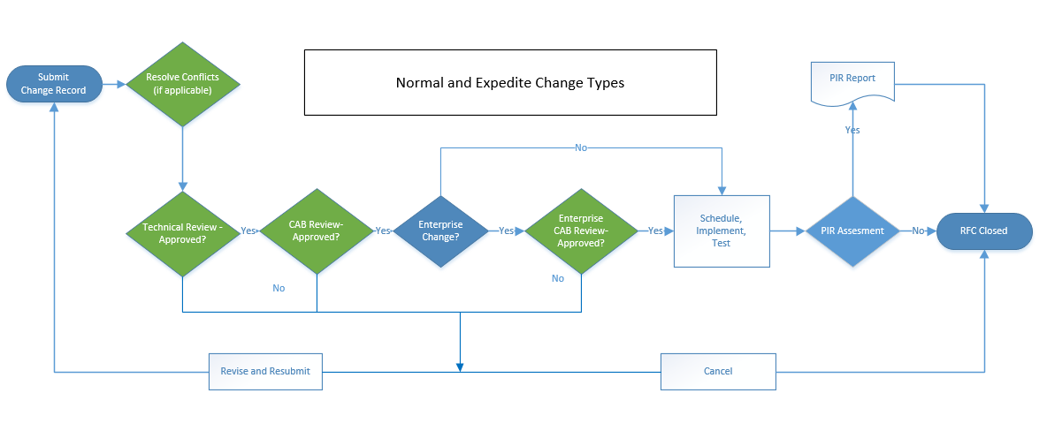

Normal Change:

Definition – A Normal change requires technical and CAB review. The CAB review and processing can occur within just the OA CAB or both Agency and Enterprise levels. A normal change requires 5 business days between submission for approval and implementation.

Characteristics of a normal change include any of the following:
- Tasks are not well-known and proven.
- Is not executed using a predefined template.
- Does not qualify as another type of change.

Step | Description | Owner
1 | Process Starts  Document the change record to include:  - Unique Identifier  - Brief summary  - Risk  - Impact and Urgency  - Implement, test, back-out and communication plans  - Justification for implementation  - Affected/related items (configuration items/assets)  - Affected Agencies (based on affected items)  - Environment (based on affected items)  - Start and End date and time  - Implement, test and back-out task assignment(s) and timelines | Change Submitter
2 | Resolve Blackout Conflicts (if applicable) | Change Submitter
3 | Review change record for:  - Technical validity  - Accuracy  - Affected Agencies  - Task(s) assigned to the appropriate groups (add if applicable/not completed)  - Implement, test, back-out and communications plans appropriateness  Approve or reject the change - document reason  - If the change is rejected, go to Step 1 for resubmission or Step 10 for cancelled  Notify Affected Agencies of planned change for their input | Technical Reviewer(s)  (Approval required by 1 member)
4 | Review change record for:  - Accuracy  - Schedule conflicts (including other changes and blackouts)  - Communication plan  - Alignment with business need/justification  - Funding approval (if applicable)  Approve or reject the change - document reason  - If the change is rejected by the OA CAB, go to Step 1 or Step 10  - If the change is rejected by an Agency Representative, document reason and go to the next step | OA CAB Members/ Agency Liaisons  (Approval required by all CAB members)
4a | Review change record at the OA CAB meeting (if timing allows before implementation) to address Agency questions or issues  - If the change is rejected, document reason and go to Step 1 or Step 9  Notify the submitter and assigned group is that the Change is approved and can proceed as planned. | OA Change Manager
5 | Assess change record for number of Affected Agencies:  If change record affects only 1 agency (Agency Specific)  - OA Change Manager is responsible for Steps 8 & 9  - Proceed to Step 7  If change record affects 2 or more agencies (Multi-Agency or Enterprise)  - Enterprise Change Manager is responsible for Steps 8 & 9  - Proceed to next step | OA Change Manager
6 | Review change record for:  - Accuracy  - Schedule conflicts (including other changes and blackouts)  - Alignment with business need/justification  Approve or reject the change  - If the change is rejected, go to Step 1 for resubmission or Step 9 for cancelled | Enterprise CAB  (Approval required by all CAB members)
6a | Review change record at the Enterprise CAB meeting (if timing allows) to address questions or issues  - If the change is rejected, document reason and go to Step 1 or Step 9  Notify the submitter and assigned group that the Change is approved and can proceed as planned. | Enterprise Change Manager
7 | At the start of the scheduled window, record the actual Start Date/Time and implement the approved change as documented  Test the change as documented  - If the testing is not successful, rollback as documented  Record Actual End Date/Time and results of implementation  Notify Change Manager and Stakeholders. Mark change as complete. | Implementer
8 | Review the completed change for process compliance and success  - If necessary, coordinate PIR document and review | Change Manager *
9 | Process Ends  Close the change record and document closure reason | Change Manager *

* Responsibility is based on Enterprise, Multi-Agency or Agency-Specific Classification

Expedite Change:

Definition – An Expedite change follows all defined steps of the Normal change management process, but in a quicker time frame. It requires technical and CAB review. The CAB review and processing can occur within just the OA CAB or both Agency and Enterprise levels. An expedite change requires one (1) business day between submission for approval and implementation.

Characteristics of an Expedite change include any of the following:
- Tasks are not well-known and proven.
- Is not executed using a predefined template.
- Requires faster approval processing – may not be discussed in CAB meetings.
- Steps the same as a Normal Change.
- Justification for Expedite
  - Customer/business need
  - Insufficient lead time
  - Known error correction
  - Scheduling conflict
- Can be done via email approvals instead of the usual approval system.
  - Change Submitter is responsible for gathering approvals.
- Must be documented and all approvals gained per procedures before implementation.
Step | Description | Owner
All Steps the same as Normal Request

Standard Change:

Definition – A Standard change is pre-authorized Change that is low risk, relatively common and follows a procedure or work instruction. The CAB review and processing can occur within just the OA CAB or both Agency and Enterprise levels. A standard change requires two (2) business days between submission for approval and implementation. Many steps are the same as a normal, except that less approvers are required at the CAB level allowing it to process quicker.

Each CAB maintains a list of changes that it has approved to be classified as Standard changes. Standard changes must be nominated and pre-approved before submission as an approved standard. Once approved they no longer require authorization from Technical approvers or approval from the full CAB on a request-by-request basis.

Characteristics of a standard change include all of the following:
- A defined trigger to initiate the change.
- The type of change occurs frequently.
- Tasks are well known, documented and proven.
- Risk is low and always well understood.

Nomination
- A change can be nominated as a Standard by providing a completed Change Request template to the appropriate Change Manager. The template must be provided with all repeatable steps to install, test and back-out the change. A general notification, if needed, is to be included in the template. Any special conditions, such as a defined window, are to be included in the template. The Change Manager coordinates review and approval by the CAB. Unapproved nominations should be discussed at a CAB meeting as needed.
- Provided a technical review is done and all CAB members approve, the change is then logged as a Standard change, given a unique identifier and individual change requests follow the Standard Change review. The Standard plan template and a list or log of approved Standard changes is maintained by each CAB Change Manager.
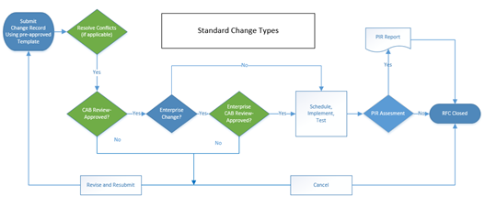
Step | Description | Owner
1 | Process Starts  Submit change using a preapproved and defined Standard Change template.  Document Planned Start and End date and time  Notify Affected Agencies of planned change for their input. | Change Submitter
2 | Resolve Blackout Conflicts | Change Submitter
3 | Review change record for:  - Accuracy  - Schedule conflicts (including other changes and blackouts)  - Communication plan  - Alignment with business need/justification  - Funding approval (if applicable)  Approve or reject the change - document reason  - If the change is rejected by the CAB, go to Step 1 or Step 8  - If the change is rejected by an Agency Representative, document reason and go to the next step | OA CAB Members/ Agency Liaisons  (Approval required by 1 CAB member)
3a | Review change record (at the OA CAB meeting if timing allows) to address Agency questions or issues  - If the change is rejected, document reason and go to Step 1 or Step 8  Notify the submitter and assigned group is that the Change is approved and can proceed as planned. | OA Change Manager
4 | Assess change record for number of Affected Agencies:  If change record affects only 1 agency (Agency Specific)  - OA Change Manager is responsible for Steps 7 and 8  - Proceed to Step 5  If change record affects 2 or more agencies (Multi-Agency or Enterprise)  - Enterprise Change Manager is responsible for Steps 7 and 8  - Proceed to next step | OA Change Manager
5 | Review change record for:  - Accuracy  - Schedule conflicts (including other changes and blackouts)  - Alignment with business need/justification  Approve or reject the change  - If the change is rejected, go to Step 1 for resubmission or Step 8 for cancelled | Enterprise CAB/  Enterprise Change Manager  (Approval required by 1 CAB member)
5a | Review Change record at the Enterprise CAB meeting (if timing allows before implementation) to address questions or issues  - If the change is rejected, document reason and go to Step 1 for resubmission or Step 8 to end the process  Notify the submitter and assigned group is that the Change is approved and can proceed as planned. | Enterprise Change Manager
6 | At the start of the scheduled window, record the actual Start Date/Time and implement the approved change as documented  Test the change as documented  - If the testing is not successful, rollback as documented  Record Actual End Date & Time and results of implementation  Notify Change Manager and Stakeholders. Mark change as complete. | Implementer
7 | Review the completed change for process compliance and success  - If necessary, coordinate PIR document and review | Change Manager*
8 | Process Ends  Close the change record and document closure reason | Change Manager*

Emergency Change:

Definition – An Emergency change usually requires implementation as soon as possible to restore a service, implement a proactive measure to prevent imminent disruption of a business critical service, or to address a security breach. The emergency classification is reserved for service repair that, if not implemented, will potentially or negatively impact the business to a high degree. The CAB review and processing can occur within just the OA CAB or both Agency and Enterprise levels.

The number of Emergency changes proposed should be kept to an absolute minimum, because they are generally more disruptive and prone to failure.

Requirements
- An emergency change must be associated to a valid incident or problem.
- Documentation may be deferred, with justification, typically until normal working hours.
  - Must be submitted within 24 hours of the change implementation.
- Authorization is documented to ensure that formal agreement from the appropriate Emergency CAB has been received, and to provide proper records for audits of the process.

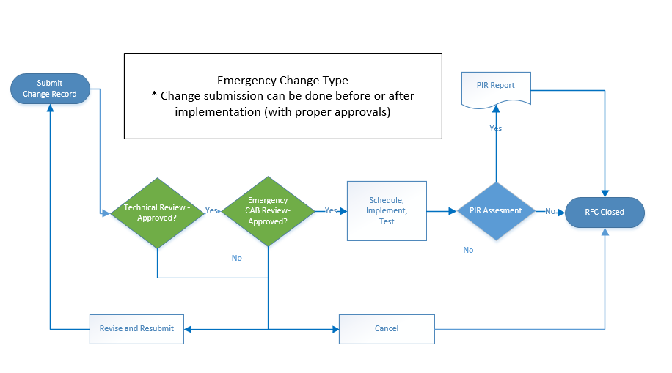
Step | Description | Owner
1 | Process Starts  Document the change record to include:  - Unique Identifier  - Brief summary  - Environment  - Risk, Impact and Urgency  - Implement, test, back-out and communications plans  - Justification for implementation  - Reason for Emergency  - Correct an identified incident  - Correct an imminent incident  - Security threat  - Management directed  - Affected Agencies  - Affected/related item(s) - (configuration items/assets)  - Start and End Date/Time  - Implement, test and back-out task assignment(s) and timelines | Change Submitter
2 | Review change record for:  - Technical validity  - Accuracy  - Affected Agencies  - Task(s) assigned to appropriate group (add if applicable/not completed)  - Implement, test, back-out and communication plans appropriateness  Approve or reject the change - document reason  - If the change is rejected, go to Step 1 for resubmission or Step 7 for cancelled  Notify Affected Agencies of planned change for their input. | Technical Reviewer(s)
3 | Review change record for:  - Accuracy  Communication plan  - Alignment with business need/justification  - Funding approval (if applicable)  Approve or reject the change - document reason  - If the change is rejected by the CAB, go to Step 1 for resubmission or Step 7 for cancelled | Emergency CAB Members
4 | Notify the submitter, assigned group and stakeholders that the Change is approved and can proceed as planned. | Emergency CAB Members
5 | At the start of the scheduled window, record the actual Start Date/Time and implement the approved change as documented  Test the change as documented  - If the testing is not successful, rollback as documented  Record Actual End Date/Time and results of implementation  Notify Change Manager and stakeholders and mark change as complete. | Implementer
6 | Review the completed change for process compliance and success  - If necessary, coordinate PIR document and review | Change Manager *
7 | Process Ends  Close the change and document closure reason | Change Manager *

* Responsibility is based on Enterprise or Non-Enterprise Classification

Supplemental Process Flow

Cancelled Changes:
Cancellations are to be communicated to the appropriate Change Manager, prior to the start of the approved maintenance window. The cancelled change will be closed.

If a change is to be cancelled after the start of the approved maintenance window, ECAB approval must be attached to the change request. Cancellation requests received after the approved maintenance window, and without Emergency CAB approval attached, will be closed as unsuccessful.

Any cancelled change that needs to be rescheduled shall be submitted as a new change request. The new change request shall reference the original change request.

Rejected Changes:

Rejected changes may be updated and resubmitted or they may be cancelled. Change type (Normal, Expedite, Standard, and Emergency) may not be modified once submitted for approvals.

Unauthorized Changes:

Any Change submitted for processing after implementation requires documentation showing that all review and approvals were done prior to implementation. If this cannot be provided the change will be considered Unauthorized.

Changes submitted as any type before implementation but implemented before approval will be marked as unauthorized in the closure reason. Unauthorized Changes submitted after implementation are processed through the Emergency Change process and marked as unauthorized in the closure reason. These changes also require an unauthorized reason – Unaware of Change Management Process; Human error; Planning issues.

Metrics

The following metrics will be measured and reported to help manage the process and show alignment of business objectives.

- Change Management Process owner shall consolidate the following Key Performance Indicators (KPI’s) captured by individual Change Management Coordinators/Mangers for their assigned CAB

Classification | Metric | Calculation | Frequency | KPI
Management | % Closed Unsuccessful | # of changes “Close Unsuccessful”/total number of closed changes | Monthly | x
Management | # PIR | Shows the total number of change requests that required Post Implementation Review (PIR) | Monthly | x
Management | % Unauthorized | # of changes “Unauthorized”/total number of closed changes | Monthly | x
Management | % Expedite | # of changes classified as Expedite/total number of closed changes | Monthly | x
Management | % Emergency | # of changes classified as Emergency/total number of closed changes | Monthly | x
Operational | Total # of Changes | Shows the total number of submitted change requests | Monthly
Operational | Total # of Implemented Changes | Shows the total number of implemented change requests | Monthly
Operational | Tasks by Group | Shows the number of tasks by implementation group | Monthly
Operational | # Rejected | Total # of rejections | Monthly
Operational | # Cancelled | # of changes that are in “Cancelled” status | Monthly
Operational | Changes by Type | Changes grouped by classification type (Standard, Normal, Expedite, Emergency)  - All submitted changes | Monthly

Appendix

CAB Structure:

Change Advisory Board (CAB)
A CAB is a body that exists to support the authorization of changes and to assist Change Management in the assessment, prioritization, and scheduling of changes.

CABs will be the vehicle for approving changes before they are implemented. When a CAB meeting occurs, meeting attendees shall be chosen who are capable of ensuring that all changes within the scope of the CAB are adequately assessed from both a business and a technical viewpoint. The CAB will approve the schedule for each change request. Once a change has been scheduled by a CAB, the scheduled dates will be reflected on the Forward Schedule of Changes (FSC).

The OA-OIT organization uses a “collaborative” and multi-tier CAB model, which includes Agency Level CABs, Emergency CABs, and an Enterprise CAB. Each service area within OA potentially has its own CAB within the OA CAB (necessary until maturity of the process occurs). Each CAB has its own set of work instructions which define its members, stakeholders, change scope, change criteria, deadlines and schedules. There are specific criteria defined for the types/classifications of changes that agency level CAB has the authority to approve vs. those changes that must be approved by the Enterprise CAB prior to implementation. Based on the defined criteria, the CAB review can occur within just the OA CAB or both Agency and Enterprise levels.

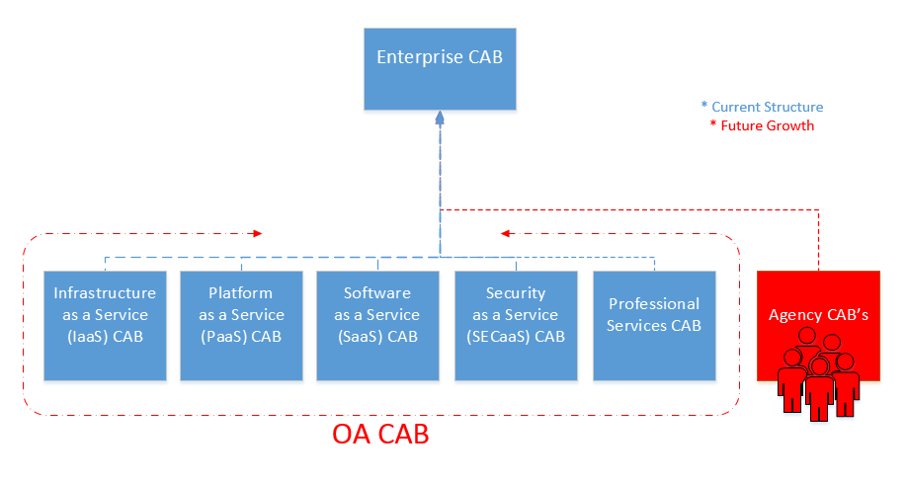

Enterprise Change Advisory Board (CAB)
The Enterprise CAB will consist of the Commonwealth Chief Technology Officer (CTO), other OA management and Agency Representatives. The Enterprise CAB will meet weekly on a recurring basis, as coordinated and chaired by the Enterprise Change Manager.

Participation in the weekly meeting is mandatory for Enterprise CAB members. In cases where an Enterprise CAB member cannot attend in person, arrangements should be made with the Enterprise Change Manager for a conference line or the designated alternate should be asked to participate in the meeting.

In addition to reviewers for specific contested changes to be discussed, others may be required to participate in CAB meetings as the need arises, such as to answer questions about specific changes that are up for discussion. The following roles will be represented in the Enterprise CAB meeting on an as-needed basis:

- Change Owner
- Technical Support Manager
- Service Level Manager
- Problem Manager
- Request Manager
- IT Continuity Manager
- Financial Manager
- Capacity Manager
- Availability Manager
- Security Manager
- Release Manager
- Authorized Agency representative(s)
- Agency Point(s) of Contact
- Applications developers/maintainers
- Specialists/technical consultants
- Services and Operations staff
- Facilities/office services staff (where changes may affect moves/accommodation and vice versa) and /or Contractors’ or third parties’ representatives

OA CAB
The OA CAB structure will be based on the Service Catalog structure. Until such time that all groups utilize the same process, separate CAB work instructions, meetings and staff may be needed to facilitate each Service tower CAB.

Emergency CAB (ECAB)
An ECAB is a subset of the CAB that exists to support the authorization of Emergency Changes and to assist Change Management in the assessment, prioritization, and scheduling of Emergency Changes. ECABs will be the vehicle for approving emergency changes before they are implemented. ECABs are defined in each CABs Work Instructions.

Risk Assessment:

The change submitter will be prompted to answer a series of questions to assess risk when opening a change record. The risk of the change will be calculated from the answers to these questions. Risk options are Low, Medium, High and Critical and will be populated by the Risk calculation.

Revision History

Version | Date | Description | Author
1.0 | 11/20/2015 | Initial Draft | Katherine Hann
1.1 | 12/22/2015 | Steering Committee comments | Katherine Hann
1.2 | 1/19/2016 | Final Draft removing/approving comments and updating file name | Katherine Hann
2.0 | 3/23/2016 | Maturity (including CAB Structure, Standard Change, Blackout, Submission thresholds, approvals in tool and not via meetings, risk assessment) and process details clarity  Core Team input and clarification on Agency Level CAB, Unauthorized and Change Owner | Katherine Hann
2.1 | 3/29/2016 | Steering Committee questions and updates (role overlap, end time extension details and expedite metric addition) | Katherine Hann
2.2 | 4/1/2016 | Additional Steering committee updates (unauthorized change details, risk assessment clarification) | Katherine Hann
2.3 | 4/6/2016 | Removal of Window extension section, per 4/5/16 ITSM Steering Committee Meeting | Katherine Hann

