Appendix L: PAMS Data Usage and Exchange
The illustration below provides a basic overview of PennDOT’s current repositories of data used for pavement management

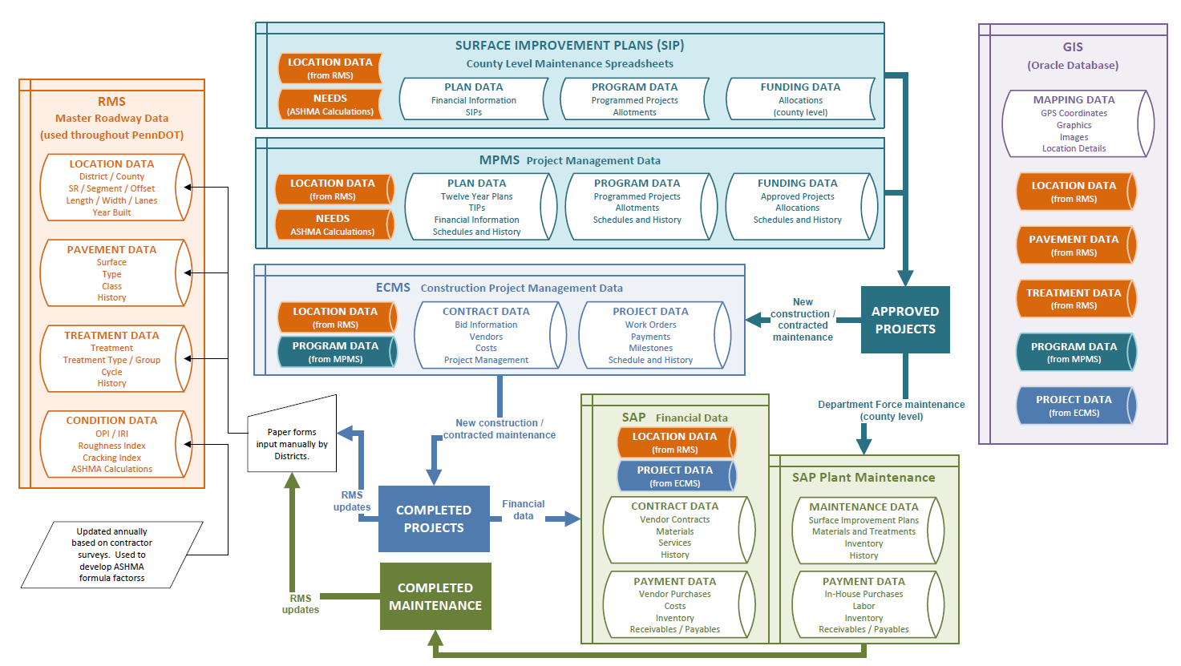

Description
PennDOT currently uses several software applications to analyze and track pavement condition and ongoing projects. These processes are not integrated and often not automated. A wealth of data is available but remains unused or underused due to lack of an automated tool. One of the primary goals of the Pavement Asset Management System is to improve the overall management of available data and streamline the preparation and manipulation of data for pavement management activities.
The software defined in this statement of work shall interface directly with or use database tables retrieved from the primary systems listed below. In most cases, real-time transfer or update of data shall not be required: much of the PAMS data used for planning shall be imported on a regular schedule.
- Roadway Management System (RMS)
The main storehouse of PennDOT information, RMS contains extensive data on roadways, geometry information, traffic information, pavement and shoulder history, municipal and legislative boundaries, intersections, roadside features, structure locations, railroad crossings information, pavement testing, condition survey information (including guide rail and drainage features) and posting/bonding information. RMS also houses Location Referencing System (LRS) information for the state highway network that PennDOT uses to define roadway lengths, locations and route connectivity. RMS serves as the basis for the collection, storage, and integration of roadway information.
- Multimodal Project Management System (MPMS)
This enterprise application currently stores data on transportation projects. It contains the 12-year long-range plans and Transportation Improvement Plans, key milestone dates, cost estimates, project types, and other pertinent data. All contracted projects must be created in MPMS regardless of the funding source.
- Engineering and Construction Management System (ECMS)
ECMS stores project information for PennDOT’s contracted highway engineering and construction projects. ECMS manages all details of contracted projects: project development, advertisement, bidding, contract administration, contractor payment and finalization. Milestone dates in ECMS trigger updates to RMS’s Pavement History and New Pavement Roughness Testing.
- Geographic Information System (GIS)
PennDOT’s GIS system contains data from other systems, with geographic reference information in database and graphic formats used for integration, reporting and mapping. Location data are retrieved from RMS using regularly scheduled batch updates. A series of standard pavement condition maps is generated from RMS data. In addition, the MPMS GIS IQ tool enables review of planned projects against base pavement data. The Oracle database is normalized and may be a viable candidate for populating the PAMS system.
- SAP – Plant Maintenance
In addition to managing financial transactions, PennDOT’s SAP system stores data on maintenance activities, workforce, materials and equipment. Counties use the Plant Maintenance module in SAP to create and schedule local maintenance projects (treatments) and track expenses and materials.
- PennDOT Data Integration Facility (PDIF)
PennDOT developed PDIF to retrieve and normalize data from other systems. Currently, PDIF contains a wide range of data culled for various business needs and used for a variety of applications throughout PennDOT. Batch updates from the host systems are scheduled at regular intervals. Because the interface with SAP has been established, PDIF may be a viable candidate for consolidating PAMS data.
- Bridge Management System (BMS2)
BMS2 stores data on bridge condition, management and programming, with interfaces to RMS, MPMS and SAP. For example, fields in MPMS are populated with BMS2 information automatically based on project limits; bridge locations are defined in RMS; notifications for necessary maintenance are posted in SAP based on bridge inspection results in BMS2.

