- Policy. The Commonwealth’s Digital Accessibility Policy (ITP-ACC001) outlines requirements and standards (latest version of the Web Content Accessibility Guidelines, revised Section 508 standards, etc.) for accessible digital content and services for employees and citizens. Digital content and services include, but are not limited to:

- Electronic content: Websites and web-based materials (Internet & Intranet), Microsoft Office (Word, Excel, PowerPoint), Adobe InDesign & PDF documents, email, training materials (e.g., online training materials, tests, online surveys), multimedia (video/audio), digital materials (e.g., documents, templates, forms, reports, surveys), maps and infographics, electronic emergency notifications, and subscription services (e.g., news feeds, alert services, professional journals);

- Software: Web, desktop, server, and mobile client applications, authoring tools, associated infrastructure, and service offerings (Software as a Service (SaaS), Platform as a Service (PaaS), Infrastructure as a Service (IaaS));

- Hardware: Computers & laptops, servers, tablets, printers and copiers, scanners, peripheral equipment (e.g., keyboards, mice), kiosks and mobile phones;

- Support documentation and services: Training services, help desk or call center, automated self-service & technical support, and product informational materials.

- Policy Driven Adoption for Accessibility (PDAA) Assessment. The Offeror shall describe its accessibility capabilities and provide a completed Appendix L.1, CWDS PDAA Assessment Template.

- Personnel. The Offeror shall staff the project with individuals who have experience in digital accessibility.

- Project Management: The Offeror shall include accessibility activities in project timelines, milestones, and deliverables (requirements, design deliverables, accessibility test plans, etc.).

- SDLC. The Offeror shall have incorporated accessibility throughout its SDLC. This includes but is not limited to the following Accessibility requirements:
- People with disabilities in research studies
- Accessibility information in design specs
- Accessibility content
- Designing & writing for diverse users
- Coding for accessibility (good syntax, aria, etc.)
- Testing [manual & automated (~30%)]
- Monitoring in production (automated testing, feedback)
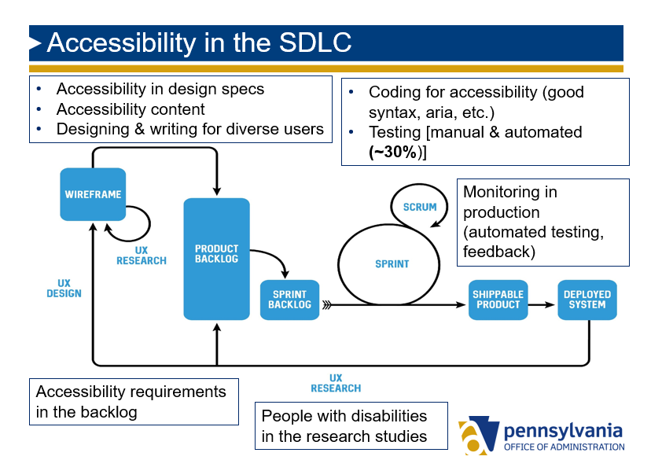
Figure 1: Accessibility in the Software Development Lifecycle

- Testing. The Offeror shall:
- Have an accessibility testing methodology that includes testing with the most common screen readers and browser combinations as listed in WebAim’s most recent Screen Reader Survey Results in addition to automated and manual testing (user testing and WCAG).
- Use the Commonwealth’s recommended automated testing tool.
- Maintain an accessibility roadmap outlining a plan for fixing accessibility issues identified through testing by the Offeror or the Commonwealth and/or customer feedback.
- Perform accessibility audits on pages to be enhanced to identify improvement opportunities that will be prioritized by the Commonwealth.
- The Commonwealth will have the option of testing the website and documents for accessibility at any time.

- The selected Offeror shall provide deliverables as described in Section VIII. Tasks.

- Complaints. Selected offeror must agree that if the Commonwealth receives a complaint that the website and/or documents are inaccessible to an applicant with a disability, the Commonwealth will notify the selected offeror in writing and the selected offeror will have 30 days, or a date agreed to by the Commonwealth, to correct the problem and advise the Commonwealth in writing of the corrective steps taken.

