Appendix K: Terms and Definitions

American Association of State Highway and Transportation Officials (AASHTO)
AASHTO has sponsored extensive research on asset management programs, available at http://assetmanagement.transportation.org/tam/aashto.nsf/home.

Average Daily Traffic (ADT)
ADT data for each roadway and segment are maintained in the Roadway Management System (RMS). Counts are updated annually with traffic information supplied by the PennDOT Bureau of Planning and Research.

Bridge Management System (BMS2)
Information from the BMS2 is retrieved for roadway project plans that may be affected by or completed in conjunction with bridge projects.

Bureau of Maintenance and Operations (BOMO)
The bureau within the Pennsylvania Department of Transportation comprising Roadway Management, Fleet Management and Maintenance. BOMO will be the owner of the pavement asset management system.

dotGrants
PennDOT’s enterprise grants management system. It manages all aspects of grants, including the application processes, agreement processes, payment processes, reporting processes and closeout.

Engineering and Construction Management System (ECMS)
ECMS stores project information for the commonwealth’s engineering and construction activities.

FHWA
Federal Highway Administration

Geographic Information System (GIS)
PennDOT’s GIS system contains geographic reference information in database and graphic formats.

IRI (International Roughness Index)
The IRI is a statistic used to measure the amount of roughness in a measured longitudinal profile.

ISTO
Information Systems and Technology Office.

Long Range Transportation Plan (LRTP)
A regional transportation plan that spans a minimum of 20 years. Both the federal government and the state require an LRTP. The first four years of each LRTP is known as the TIP.
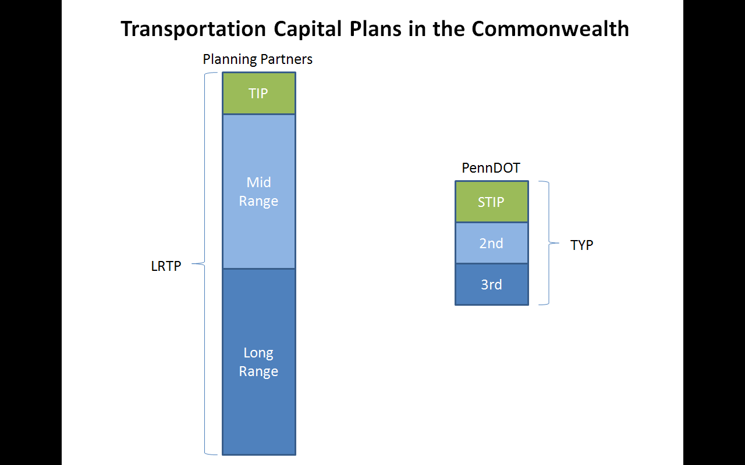

MEPDG
Mechanistic-Empirical Pavement Design Guide.

Multimodal Project Management System (MPMS)
This enterprise application currently stores data on commonwealth transportation projects. It contains the 12-year long-range plans and Transportation Improvement Plans.

MPMS Project
An MPMS project has a unique MPMS number. An MPMS project can consist of one or more capital projects.

Pavement Asset Management System (PAMS)
The working name given to the proposed web-based solution for PennDOT’s pavement asset management efforts.

Pavement Testing and Asset Management Section (PTAMS)
The subdivision of BOMO responsible for specialized pavement data collection, analysis and reporting. PTAMS is responsible for all pavement testing and condition assessment programs, and management of the Roadway Management System. PTAMS performs analysis of needs to develop recommendations to districts and counties for the most cost-effective and appropriate mix of maintenance, preservation and capital improvements. PTAMS also assists with preparation of pavement policy and specifications for the development of statewide guidelines for pavement management and project selection.

PennDOT Data Integration Facility (PDIF)
The Oracle-based PDIF was created to consolidate data from separate PennDOT systems and databases. Updated from the host systems on a scheduled basis, sets of data tables are created to accommodate IT development projects when needed.

PMC
Program Management Committee

Roadway Management System (RMS)
The main storehouse of information related to PennDOT’s roadway system, RMS contains extensive data on roadways, pavement history and traffic history.

SAP – Plant Maintenance
In addition to managing financial transactions, PennDOT’s SAP system is the enterprise solution used for planning and managing maintenance activities, manpower, materials, and equipment.

Statewide Transportation Improvement Program (STIP)
The first four years of PennDOT’s twelve year program. The STIP is updated every two years. For example, the 2009-2012 STIP will be replaced with the 2011-2014 STIP. It is an aggregation of the 23 planning partner TIPs.

Surface Improvement Plan (SIP)
Each year, the districts prepare Surface Improvement Plans based on needs and available funding. BOMO is required to consolidate and report the planned and completed SIP work.

Transportation Improvement Program (TIP)
The first four years of an LRTP. Every two years, the TIPs are updated and combined into the STIP.

