

Appendix H

COPANET Overview
Updated 12/16/16

RFP 2 Commonwealth Enterprise Network (EN) and Shared Services

RFP NUMBER
6100039273

The purpose of this appendix is to provide an overview of the Commonwealth’s Harrisburg metro fiber network.

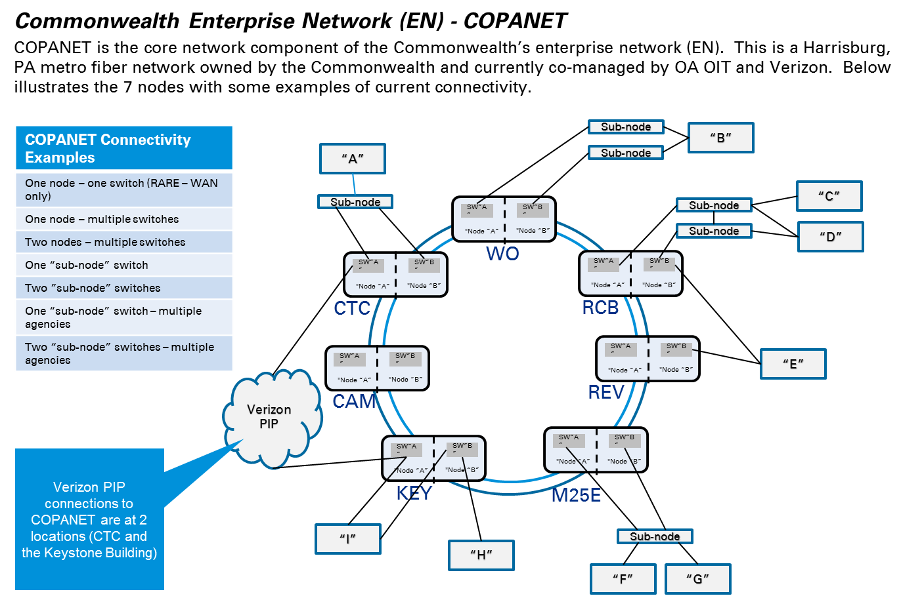
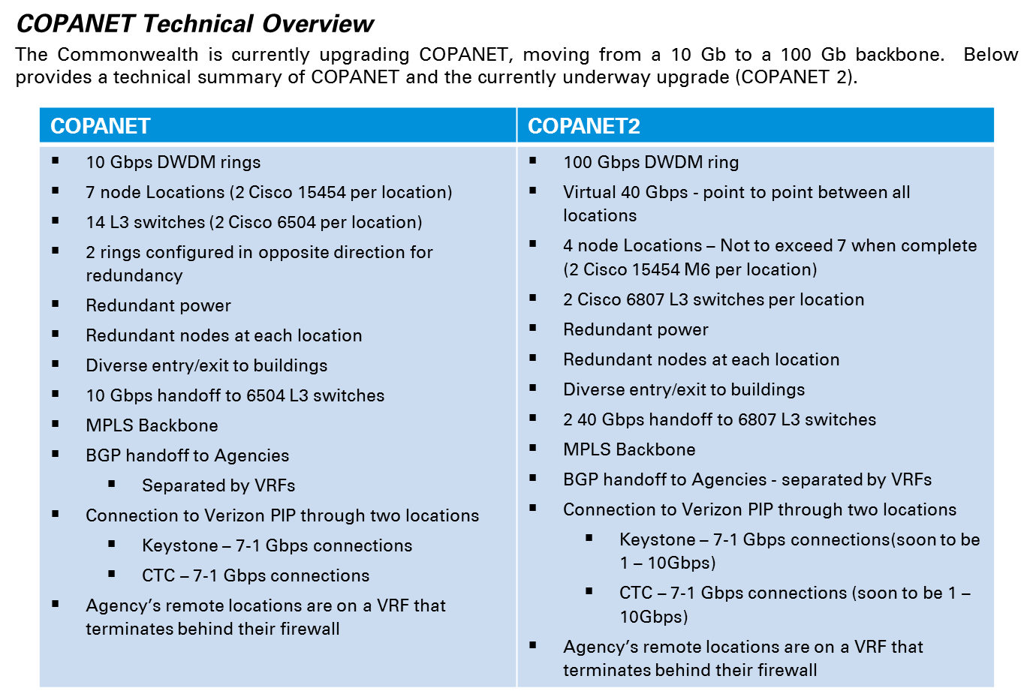
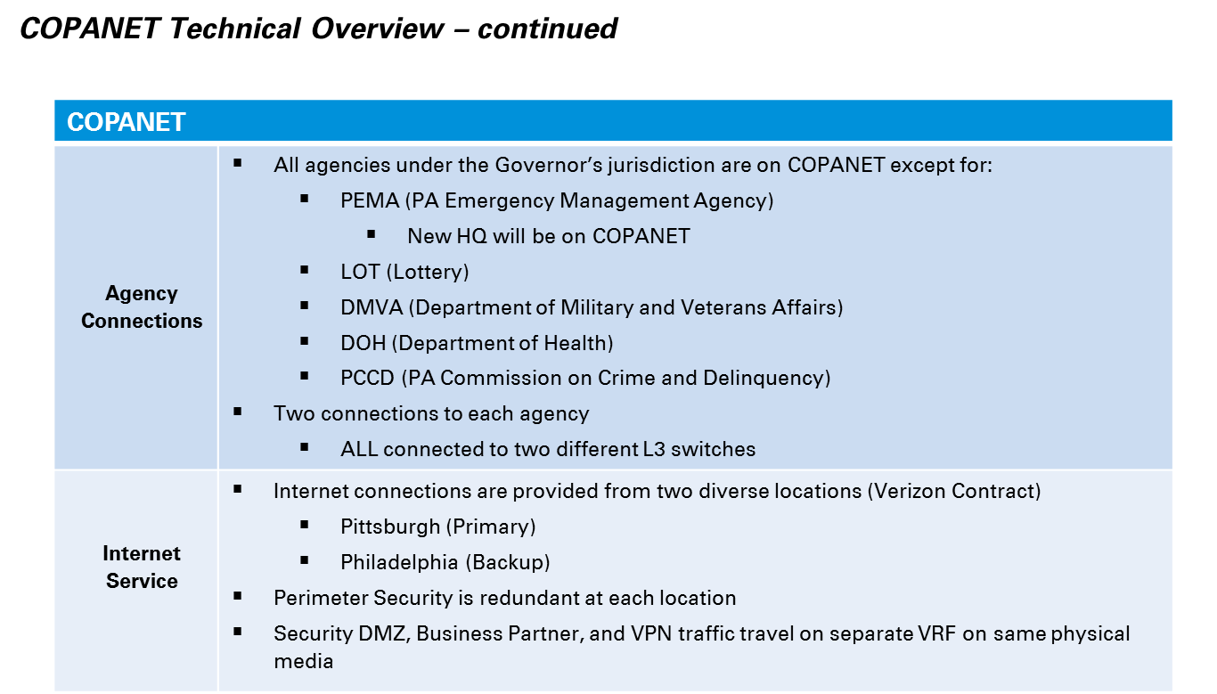

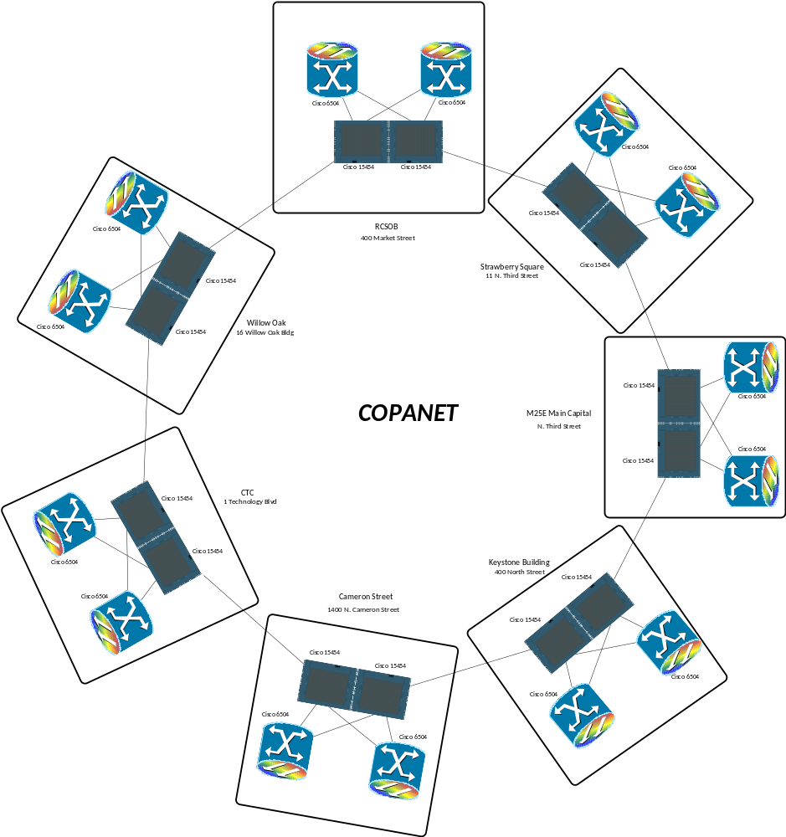
COPANET Diagram
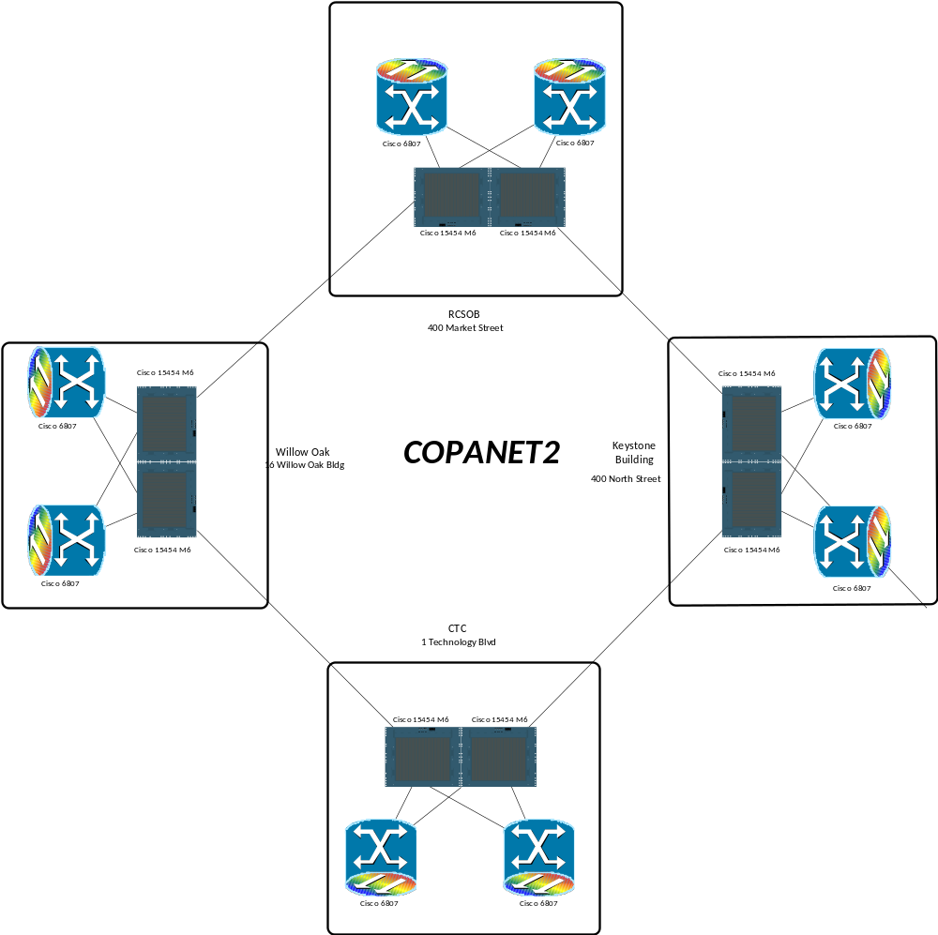
COPANET 2 Diagram

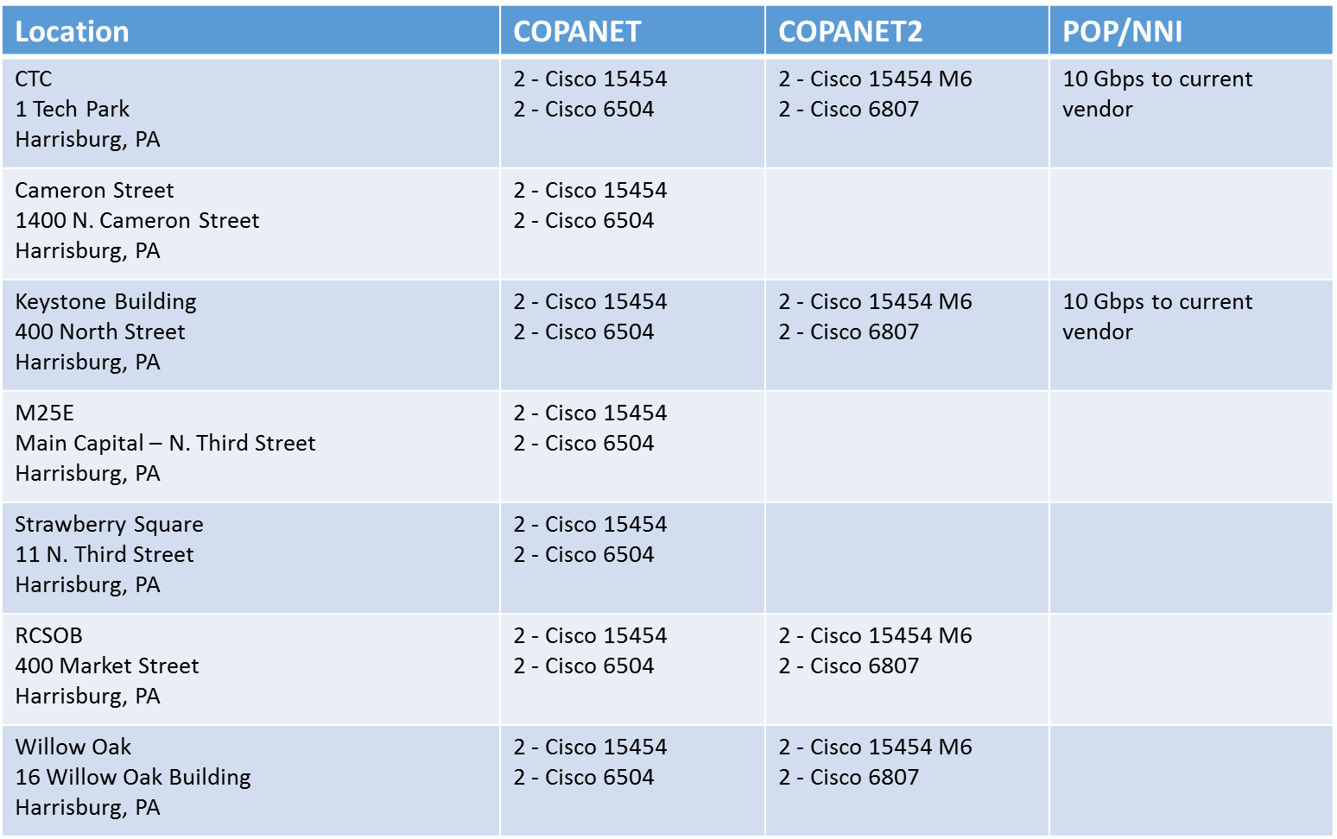
COPANET Equipment List

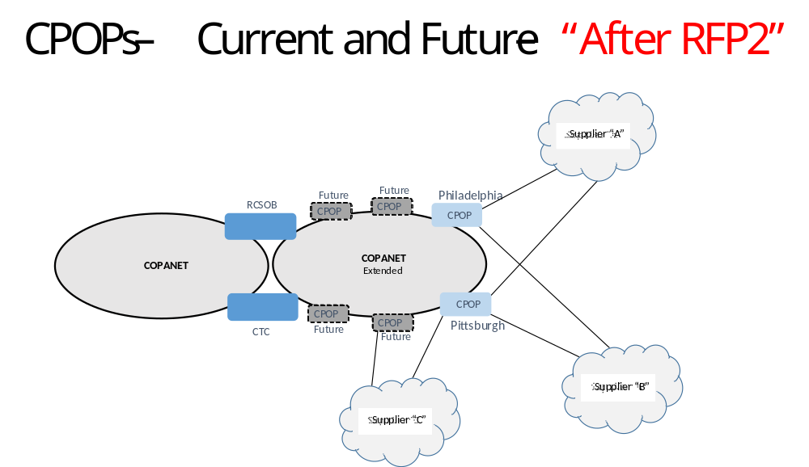

The following equipment should be considered within the primary management domain of COPANET and enterprise NOC services.
Asset Inventory
COPANET
Device | Model | Category
 | ONS-15454 | switch
 | ONS-15454 | switch
 | ONS-15454 | switch
 | ONS-15454 | switch
 | ONS-15454 | switch
 | ONS-15454 | switch
 | ONS-15454 | switch
 | catalyst296024TT | switch
 | catalyst296024TT | switch
 | WS-C6509-E | switch
 | WS-C6509-E | switch
 | WS-C6504-E | switch
 | WS-C6504-E | switch
 | WS-C6504-E | switch
 | WS-C6504-E | switch
 | WS-C6504-E | switch
 | WS-C6504-E | switch
 | WS-C6504-E | switch
 | WS-C6504-E | switch
 | WS-C6504-E | switch
 | WS-C6504-E | switch
 | WS-C6504-E | switch
 | WS-C6504-E | switch
 | C6807-XL | router
 | C6807-XL | router
 | C6807-XL | router
 | C6807-XL | router
 | WS-C3560G-24TS | switch
 | WS-C3560G-24TS | switch
 | WS-C3560G-24TS | switch
 | WS-C2960G-8TC-L | switch
 | WS-C2960G-8TC-L | switch
 | WS-C3560X-24 | switch
 | WS-C3560X-24 | switch
 | WS-C3560X-24 | switch
 | WS-C3560X-24 | switch
 | C3850-NM-2-10G | router
 | C3850-NM-2-10G | router
 | WS-C3560G-24TS | switch
 | WS-C3560G-24TS | switch
 | C3850-NM-2-10G | router
 | C3850-NM-2-10G | router
 | WS-C2960G-8TC-L | switch
 | WS-C2960G-8TC-L | switch
 | WS-C3560G-24TS | switch
 | WS-C3560G-24TS | switch
 | WS-C3560X-24 | switch
 | WS-C3560X-24 | switch
 | WS-C3560G-24TS | switch
 | C3850-NM-2-10G | router
 | C3850-NM-2-10G | router
 | catalyst2960G8TC | switch
 | WS-C3560G-24TS | switch
 | catalyst2960G8TC | switch
 | WS-C3560G-24TS | switch
 | WS-C3560G-24TS | switch
 | catalyst2960G8TC | switch

Asset Inventory
MAN & State Office Buildings
Device | Model | Category
 | C3900-SPE100/K9 | router
 | C3900-SPE100/K9 | router
 | C3900-SPE100/K9 | router
 | C3900-SPE100/K9 | router
 | C3900-SPE100/K9 | router
 | C3900-SPE100/K9 | router
 | C3900-SPE100/K9 | router
 | CISCO3925-CHASSIS | router
 | CISCO3925-CHASSIS | router
 | CISCO3925-CHASSIS | router
 | C3900-SPE100/K9 | router
 | CISCO3925-CHASSIS | router
 | C3900-SPE100/K9 | router
 | CISCO2921/K9 | router
 | CISCO3925-CHASSIS | router
 | WS-C3850-12S-E | router
 | WS-C3850-12S-E | router
 | C3850-NM-4-1G | router
 | WS-C3850-12S-E | router

Asset Inventory
Business Partner Co-Lo
Device | Model | Category
 | WS-C3850-24T-E | router
 | WS-C3850-48T-E | router

Asset Inventory
CCN (DOS Sure/Election Support, DHS, JNET)
Device | Model | Category
 | CISCO2901/K9 | router
 | CISCO2901/K9 | router
 | CISCO2901/K9 | router
 | CISCO2901/K9 | router
 | CISCO2901/K9 | router
 | CISCO2901/K9 | router
 | CISCO2901/K9 | router
 | CISCO2901/K9 | router
 | CISCO2901/K9 | router
 | CISCO2901/K9 | router
 | CISCO2901/K9 | router
 | CISCO2901/K9 | router
 | CISCO2901/K9 | router
 | CISCO2901/K9 | router
 | CISCO2901/K9 | router
 | CISCO2901/K9 | router
 | CISCO2901/K9 | router
 | CISCO2901/K9 | router
 | CISCO2901/K9 | router
 | CISCO2901/K9 | router
 | CISCO2901/K9 | router
 | CISCO2901/K9 | router
 | CISCO2901/K9 | router
 | CISCO2901/K9 | router
 | CISCO2901/K9 | router
 | CISCO2901/K9 | router
 | CISCO2901/K9 | router
 | CISCO2901/K9 | router
 | CISCO2901/K9 | router
 | CISCO2901/K9 | router
 | CISCO2901/K9 | router
 | CISCO2901/K9 | router
 | CISCO2901/K9 | router
 | CISCO2901/K9 | router
 | CISCO2901/K9 | router
 | CISCO2901/K9 | router
 | CISCO2901/K9 | router
 | CISCO2901/K9 | router
 | CISCO2901/K9 | router
 | CISCO2901/K9 | router
 | CISCO2901/K9 | router
 | CISCO2901/K9 | router
 | CISCO2901/K9 | router
 | CISCO2901/K9 | router
 | CISCO2901/K9 | router
 | CISCO2901/K9 | router
 | CISCO2901/K9 | router
 | CISCO2901/K9 | router
 | CISCO2901/K9 | router
 | CISCO2901/K9 | router
 | CISCO2901/K9 | router
 | CISCO2901/K9 | router
 | CISCO2901/K9 | router
 | CISCO2901/K9 | router
 | CISCO2901/K9 | router
 | CISCO2901/K9 | router
 | CISCO2901/K9 | router
 | CISCO2901/K9 | router
 | CISCO2901/K9 | router
 | CISCO2901/K9 | router
 | CISCO2901/K9 | router
 | CISCO2901/K9 | router
 | CISCO2901/K9 | router
 | CISCO2901/K9 | router
 | CISCO2901/K9 | router
 | CISCO2901/K9 | router
 | CISCO2901/K9 | router
 | CISCO3925-CHASSIS | router
 | CISCO2901/K9 | router
 | CISCO2901/K9 | router
 | CISCO2901/K9 | router

