Appendix C Historical System Metrics
The following historical information is to help the Offeror estimate the number of staff needed. This information is to be used in combination with the Background information in the RFP.

User Growth
This is historical user information.
Count | 2018 | 2019 | 2020 | 2021 | 2022 | 2023
Both Employer & Provider | 833 | 885 | 915 | 941 | 957 | 962
Staff | 7,259 | 7,789 | 8,551 | 9,068 | 10,304 | 11,499
Provider | 44,122 | 45,746 | 47,035 | 48,389 | 50,070 | 50,805
Employer | 279,607 | 297,565 | 312,316 | 330,410 | 345,515 | 352,109
Participant | 4,751,290 | 4,946,803 | 5,228,872 | 5,471,614 | 5,616,753 | 5,687,072
Total Registered Users | 5,083,111 | 5,298,788 | 5,597,689 | 5,860,422 | 6,023,599 | 6,102,447

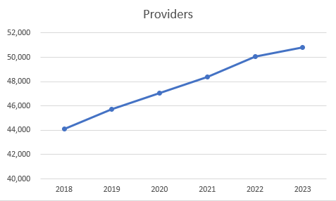 | 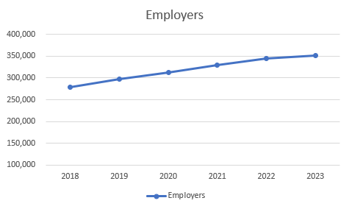
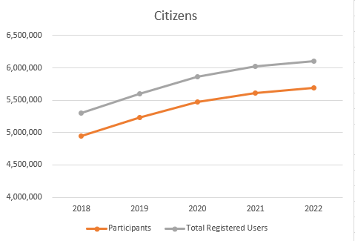 | 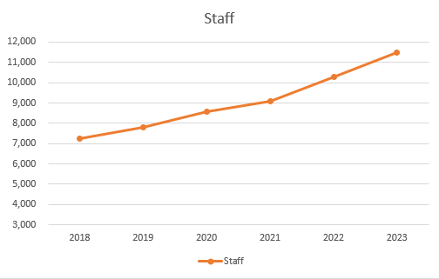

Screen Growth
Approximate number of screens in CWDS and PA CareerLink®
Count | 2018 | 2019 | 2020 | 2021 | 2022 | 2023
Screens | 1,172 | 1,172 | 1,249 | 1,477 | 1,604 | 1,697

Growth - Year over Year (YoY) Percent Change
User and screen information above was used to create this table. Please note, this is an arithmetic average for the series of years (not a weighted average).
Count | 2018-19 YoY % Change | 2019-20 YoY % Change | 2020-21 YoY % Change | 2021-22 YoY % Change | 2022-23 YoY % Change | Average  2018-2023 % Change
Both Employer & Provider | 6% | 3% | 3% | 2% | 1% | 3%
Staff Users | 7% | 10% | 6% | 14% | 12% | 10%
Provider Users | 4% | 3% | 3% | 3% | 1% | 3%
Employer Users | 6% | 5% | 6% | 5% | 2% | 5%
Participant Users | 4% | 6% | 5% | 3% | 1% | 4%
Total Registered Users | 4% | 6% | 5% | 3% | 1% | 4%
Number of Screens | 0% | 7% | 18% | 9% | 6% | 8%

CWDS Technical Statistics
Stat | CWDS
DB size (includes all 10 CWDS production databases: CWDS, New Hire, Reports, Documents, Archive, etc.) | 1,776 GB
Total Source Code Line | 12,375,360
Total Files | 54,391
Number of Standard Reports | 147
Batches | 129
Interfaces | 48
Application Roles | 122

Staffing Metrics
The data below includes the current Contractor maintenance and support staff for the base contract plus the approximate average Contractor staff working on Change Requests. Also, it has been broken into two teams: Business Support and Technical Support to further help the Offeror estimate staff size.
The Change Request average was attained by 1) parsing the Change Requests into Business Support and Technical Support type work (using the nature of the work), 2) averaging the number of staff working on the Change Requests in each month, and then 3) averaging the monthly number across a calendar year. The data is in Full Time Equivalents (FTEs) as of June 2023.
Please note, there are also 16 Commonwealth of Pennsylvania (COPA) staff assigned to CWDS.
COMBINED Base +CR
 | 2020 | 2021 | 2022 | 2023
Vendor Business Support | 17 | 18 | 17 | 24
Vendor Technical Support | 26 | 42 | 43 | 38
COPA | 16 | 16 | 16 | 16

Base Contract Only
Role | Vendor | Vendor | Total
Role | Business Support | Technical Support | Vendor
PM/OIT Lead | 0.5 | 0.5 | 1
Application Leads | 0.5 | 2.5 | 3
System/Infrastructure Admin/ Architects |  | 3 | 3
UX/UI |  | 1 | 1
Application Developers |  | 8 | 8
Reports Developers |  |  | 0
Business Analysts | 2 |  | 2
Quality Assurance/Testing | 6 |  | 6
Database Administrators |  | 1 | 1
Total | 9 | 16 | 25

Full List of Programs Supported by Workforce Program Area (WPA)
These are active programs. Please note there are deactivated programs that may come back online. Also note, this is not an exhaustive list but primary programs.
- Department of Human Services (DHS)
  - Employment, Advancement and Retention Network (EARN)
  - KEYS PROGRAM
  - EARN Center
  - REFUGEE RESETTLEMENT
  - ELECT
  - SPECIAL INITIATIVE
  - WORK READY
  - SNAP KEYS
  - SNAP Special Initiative
  - SNAP Earn Center Program
  - SNAP EARN PROGRAM
  - CPP (Contractor partner Program)
- New Hire (NH)
- Office of Vocational Rehabilitation (OVR)
  - Bureau of Blind & Visual Services (BBVS) – Vocational Rehabilitation
  - Bureau of Vocational Rehabilitation Services (BVRS) – Vocational Rehabilitation
  - Independent Living
  - Orientation and Mobility
  - Pre-Employment Transition Services (Pre-ETS)
  - Specialized Services – Adult
  - Specialized Services – Child
  - Vision Rehabilitation Therapy
- Workforce (WF)
  - Title I Adult, Dislocated Worker and Youth services
  - TANF Youth
  - Wagner-Peyser (Labor Exchange) services
  - Trade Act Services
  - Registered Apprenticeship
  - Work Opportunity Tax Credit (WOTC)
  - Foreign Labor Council (FLC) Programs
  - Rapid Response
  - Federal Reporting

Number of Offices Supported by Workforce Program Area (WPA)
This information is only to show the breadth of support CWDS provides providers, employers and citizens across the Commonwealth. Note, Offerors will not be required to have a presence in these locations unless otherwise indicated in the RFP.
WPA | Approximate Number of Offices | Additional Information
Department of Human Services (DHS) | 121 offices statewide providing services | Actively providing services
New Hire (NH) | 1 | New Hire Program office is at the PA DLI building, with a third-party vendor providing staffing and customer services for both the internal and public-facing new hire screens within CWDS.
Office of Vocational Rehabilitation (OVR) | 15 – Bureau of Vocational Rehab. Services (BVRS)  6 – Bureau of Blind & Visual Services (BBVS)  1 – Hiram G. Andrews Center (HGAC) | BBVS offices are co-located within a BVRS office. HGAC is located in Johnstown, PA.
Workforce (WF) | 100+ comprehensive affiliate and access points

Additional Considerations
- CWDS is Pennsylvania’s workforce system of record and therefore houses all financial, grant and oversight functionality and is the mechanism used for federal performance reporting
- Workforce is responsible for managing and administering one-off and ad-hoc grants such as National Dislocated Worker Grants (NDWG) and other emergency grants which may require system enhancements.

Other Supporting Applications
CWDS utilizes other applications. See the RFP document and the “Shared and Nonshared Product Lists” appendix for details.
- External/Supporting Applications:
  - Big Interview (Available for PACL registered users)
  - Metrix Learning (Available for PACL registered users)
  - TORQ (Available for PACL registered users)
  - PA CareerZone
  - Future Road Builders
- The PA CareerLink® chatbot and New Hire chat tool are integrated within the system

Other Information
CWDS is subject to audits, including state and federal audits. The Offeror is expected to support and participate in all audit activities.
- Audits
  - Single Audit FYE 06-30-2021-WIOA-IT-1- IT General Controls (2021)
  - OIG Audit Report Number TO-50-21-011 (2021)
  - SSA Single Audit for OVR (2021)
  - RSA Monitoring Visit (2019)
  - Single Audit for OVR (2017, 2018, 2019, 2020)
  - Single Audit FYE 06-30-2020-OVR-IT-1-IT Control (2020)
  - Single Audit 6/30/2019 - L&I-IT-1 (2019)
  - Single Audit FYE 6/30/18 - L&I-IT-11-Case Services Report - RSA 911 Change Management Procedures (2019)
- Federal Reports
  - Workforce: Participant Individual Record Layout (PIRL) – annual and quarterly
  - OVR: Rehabilitation Services Administration's Case Service Report (RSA-911) quarterly; annual report = ETA-9169
- Data Sharing Agreements maintained outside CWDS
  - MOU with Pennsylvania Department of Community and Economic Development (DCED)
  - MOU with Registered Apprenticeship Partners Information Database System (RAPIDS)
  - MOU with PA Office of Developmental Programs (ODP)
  - Reports for Employment Oversight Commission (EFOC)

