SOLICITATION ADDENDUM

Date: | April 29, 2016
Subject: | Sodium Chloride (Bulk Road Salt)
Solicitation Number: | 6100037974
Due Date/Time: | May 3, 2016 @ 3:30 PM
Addendum Number: | 1

To All Suppliers:

The Commonwealth of Pennsylvania defines a solicitation “Addendum” as an addition to or amendment of the original terms, conditions, specifications, or instructions of a procurement solicitation (e.g., Invitation for Bids or Request for Proposals).

List any and all changes:
1). The Commonwealth has provided responses to the following questions that were received in relation to this solicitation:
Question 1:
We have gone to the pa supplier portal, and although we can see all of the documents there are some that are password protected (such as exhibit 4) that we are not able to print out or access. How are we supposed to provide pricing on the Initial Reverse Auction Bid Sheet? Apparently we are having the same issue with the Final Reverse Auction Sheet as well.
Answer:
The “Exhibit 4 to Specifications - Initial Reverse Auction Bid Sheet” is locked however; the column highlighted in yellow where you enter pricing is not. The same applies to the Final Reverse Auction Bid Sheet. In order to enter information into the spreadsheet after you have saved it to your computer, you will need to hit the “enable editing” option. 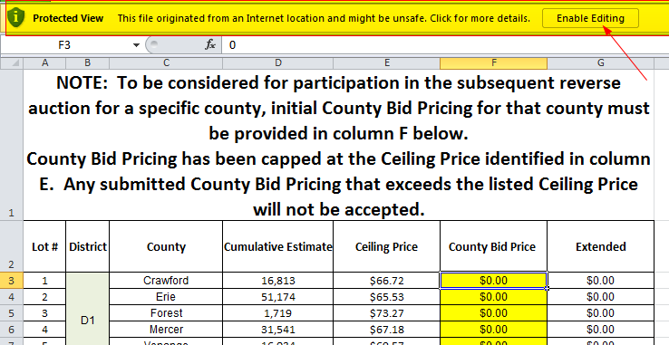

Question 2:
On page two of the Specifications. Tab 2: Do you require 24/7 access to supplier stockpiles for customer pick-ups regardless of whether or not a State emergency has been declared?
Answer:
No, source pick up pricing should be based upon normal business hours.

Question 3:
Will we have to be entering both DL and pick-up pricing for each county during the bid or will for example a .05 cent reduction to a lot affect both DL and CO pricing?
Answer:
Pick up pricing will not be part of the reverse auction or used in evaluations for award.

Question 4:
To confirm any pricing that we enter on the Initial Reverse Auction Bid Sheet must me equal or lower than the current county price?
Answer:
Yes

Question 5:
On page 18 of the contract under section v10 indicates that quantities are “estimated only and may be increased or decreased in accordance with the actual requirements….” Would I be correct in assuming this language does not super cede the min./max. obligations as outlined in the specifications portion ?
Answer:
No, section V.10 CONTRACT-007.02 Estimated Quantities (Nov 30 2006) does not supersede the min/max obligations as outlined in the contract Specifications.

Question 6:
How soon after the close of the bid will award information be available?
Answer:
We do not post a bid tab for the initial IFB results, we only post a bid tab within a reasonable amount of time upon receipt of the Final Reverse Auction Bid Sheets.

Question 7:
Can a vendor cap their award amount (i.e. bid on multiple counties with the understanding that our total award amount will not exceed a pre-established maximum)?
Answer:
No, a supplier will be obligated to fulfill the requirements of all awarded lots for which they have been determined to be the lowest responsive and responsible bidder, whether it be through the IFB or reverse auction.

Question 8:
When last year’s bid came out initially there were 1,880,175 tons on the bid. When actually finalized by our account there were only 1,274,344 tons awarded. How comfortable are you that the bid ton number on this year’s bid represent the tons that will actually be awarded ?
Answer:
All tons that were bid last year were awarded. It is the intent of the Commonwealth to award the total tonnage as listed on the IFB.

Question 9:
Can you provide an estimate of the number of tons that will require tri-axel delivery or if not can a vendor who is quoting based upon full truck load deliveries pass along the additional charges to those customers who require Tri-axle delivery.
Answer:
No, an estimate cannot be provided. No, additional delivery charges cannot be assessed.

Question 10:
Are we quoting one price per county for both Early Fill and Seasonal requirements or can different prices for each be offered.
Answer:
Suppliers will bid one price per lot/county which will apply to both Initial and Winter fill.

2). The following documents have been modified and attached to the solicitation in the PA Supplier Portal:

Exhibit 4 to Specifications - Initial Reverse Auction Bid Sheet – calculation formula in column G was corrected. No other changes were made.
Attachment B - Final Reverse Auction Bid Sheet - calculation formula in column G was corrected. No other changes were made.
Exhibit 2 to Specifications - Sodium Chloride Estimates 2016-2017 – document was modified to allow copy and paste functionality. No other changes were made.

Type of Solicitation: Electronic Bid (SRM) - Review the Questions section of your solicitation response to ensure you have responded, as required, to any questions relevant to solicitation addenda issued subsequent to the initial advertisement of the solicitation opportunity.

Except as clarified and amended by this Addendum, the terms, conditions, specifications, and instructions of the solicitation and any previous solicitation addenda, remain as originally written.

Respectfully,

Name: Jean Halbleib
Title: Commodity Specialist
Phone: 717-346-8188
Email: jhalbleib@pa.gov

