March 2015

L&I currently uses Computer Associates (CA) Identity and Access Management (IAM) E-Trust suite for application security. The IAM system provides single sign-on into applications for Commonwealth employees, and the ability to have a single account to be used by Business Partners and Citizen Users of web applications. It also provides our external customers with self-registration and password reset functionality, to limit the administration overhead.

L&I shares common Business Partner and Citizen repositories with several other state agencies in an effort to provide a single account that can be used with numerous services offered by the Commonwealth.

The IAM infrastructure is made up of three key components:

- SiteMinder Policy Servers (Windows Server 2008 R2, SiteMinder 12.5)

  - Enforces application security (coarse-grain and/or fine-grain approach) specified by the project working with the business area using Role Based Access Controls.

- IdentityMinder Servers (Windows Server 2008 R2, Websphere 7.0, Identity Manager 12.5)

  - Provides the User Administration screens for Enterprise Security Administrators as well as delegated business area administrators.
  - Provides the user registration, password reset functionality and base profile edit capabilities for all Business Partner and Citizen Users.
    - Business Partner users are segregated in the Active Directory by Organizational Units that are based on unique identifiers.

- Active Directory Servers (Windows Server 2008 R2)

  - User repositories for Commonwealth Employees, Business Partner and Citizen Users.
  - The Authentication & Authorization domains are outlined below with the IAM environments.

Several of the IAM components are shared throughout the multiple environments, while others are required to be configured independently:

- SiteMinder Policy Servers:

  - The Project will require a Virtual Machine (VM) policy server of its own for every environment other than User Acceptance Testing (UAT) and Production.
  - UAT and Production will require the Project to provide two physical servers for each of these environments to provide redundancy and high availability for the application.

- IdentityMinderServers:

  - The Project will require a VM IdentityMinder server of its own for the Development environment only.
  - In CIT, Training, Test for Production, User Acceptance Testing and Production the application will share the IdentityMinderServers with other applications utilizing the IAM solution.

- Active Directory Servers

  - Active Directory servers are shared by all projects in all environments. Production has its own set of domains while all pre-production environments share a common set of domain controllers.

See the table in Appendix U, DLI Shared Product Standard Environments for available Shared Product software for use in the Project.
IAM Diagrams, Hardware/Software Requirements & Authentication and Authorization Directories

The following diagrams depict the IAM infrastructure. The size and set up of the VM’s in the lower environments vary, but generally each Policy Server has 80GB hard drive space and 4GB RAM allocated to it. The IdentityMinder servers for these environments run 80GB of hard drive space and 4GB RAM. The physical boxes for UAT and Production (a total of 4 servers, two for each environment) are currently 2.66GHz six-core processors, 12GB RAM, RAID 5 array with ~300GB’s of usable hard drive space and two dual-port NIC’s.

DEV (Development)
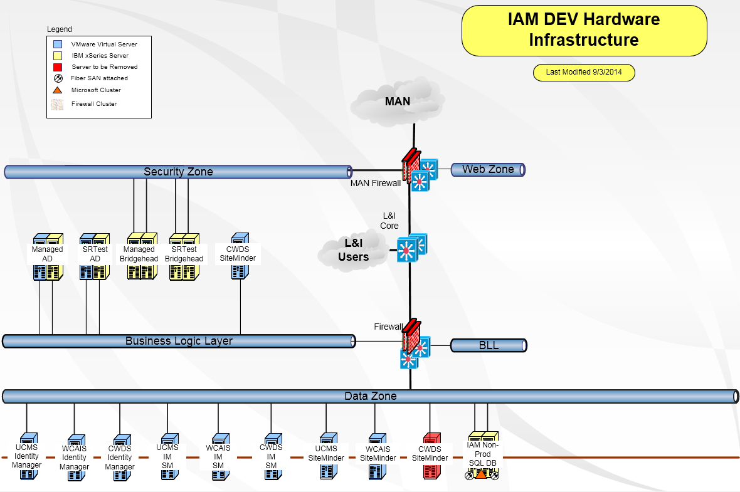

CIT (Component Integration Testing)
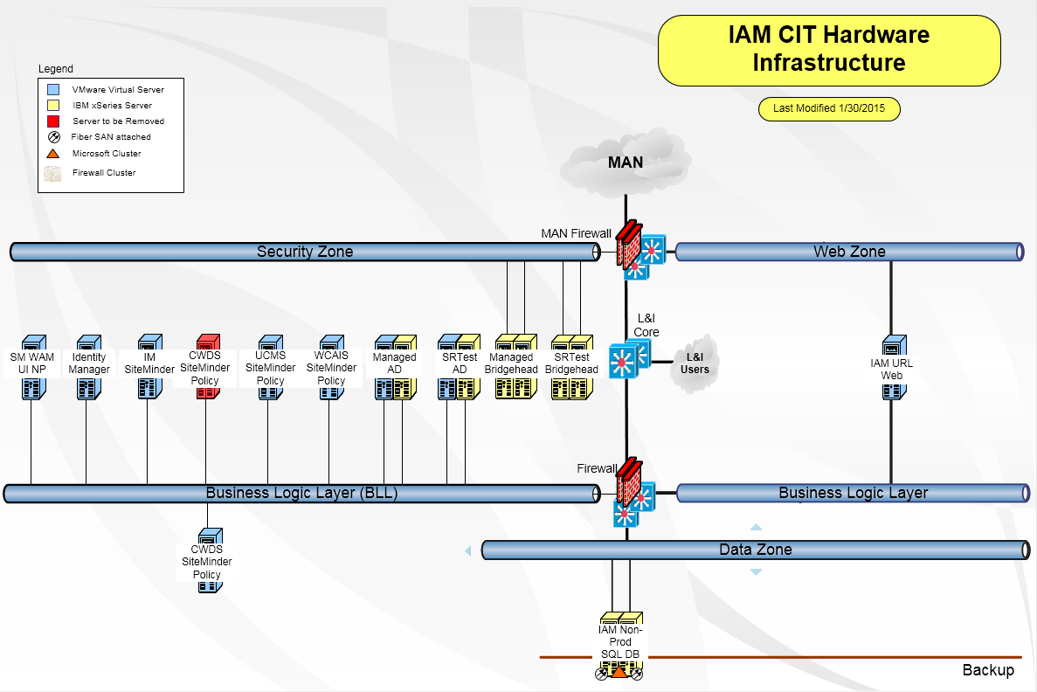

Training
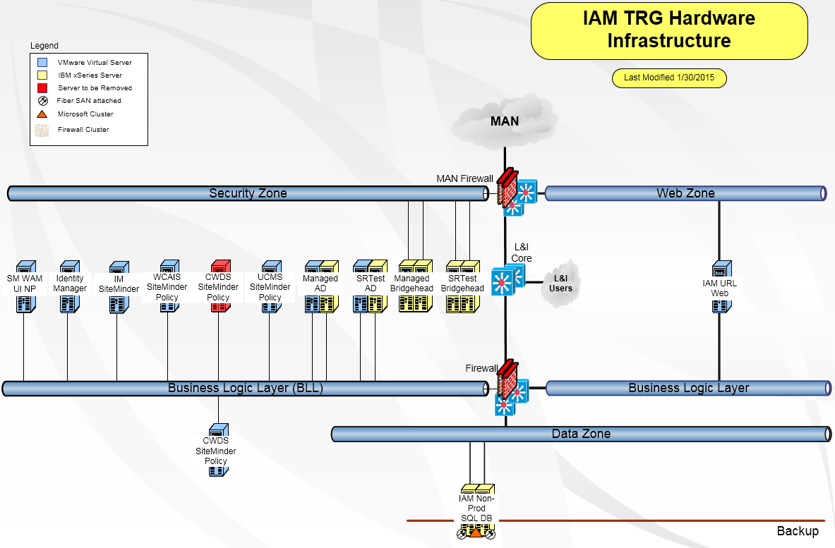

UAT - User Acceptance Testing (this region is identical to production, and resides at the disaster recovery site in Scranton).
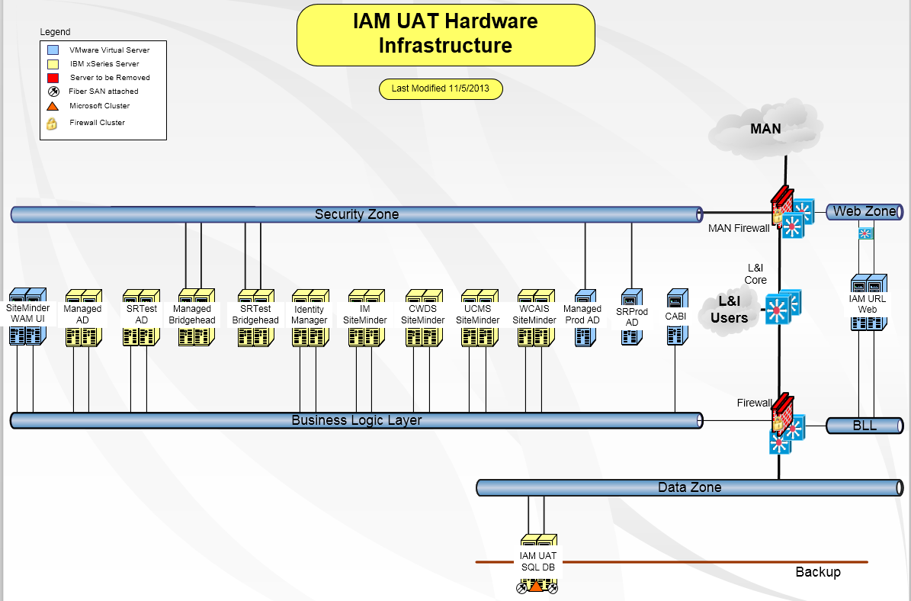

PROD (Production)
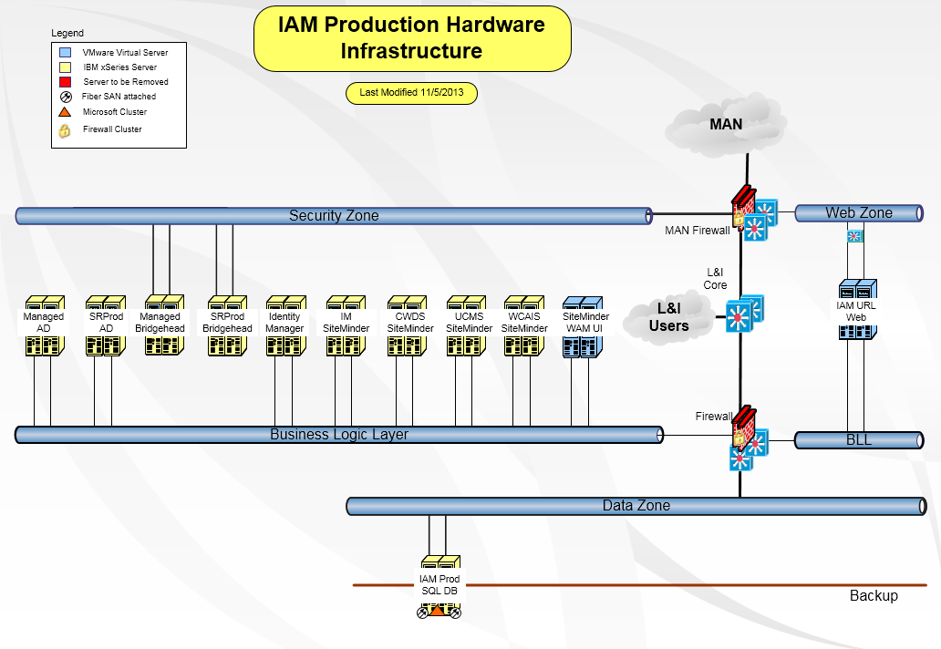

TFP (Test for Production)
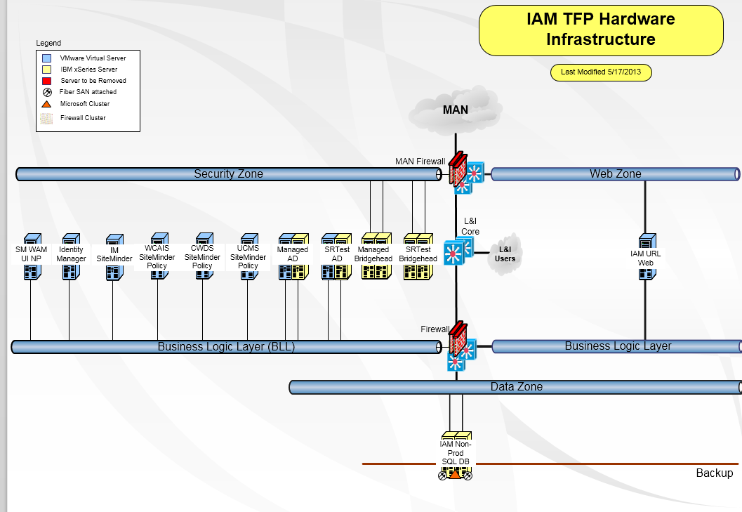
Currently, the only additional physical servers that would be required by the Offeror are the two aforementioned Policy Servers for both the UAT and Production environments (4 total). The Offeror will also be responsible for any required VM space that will need to be allocated/purchased to accommodate the lower environment policy and identity servers.

L&I is currently covered under the Commonwealth licensing for the CA SiteMinder & Identity Manager software and the required Websphere licenses for the Identity Manager software covering internal and external users of the systems. The vendor will be expected to cover any additional licensing that their proposed solution incurs above and beyond that of the covered users under the Commonwealths agreement. (e.g., Our current licensing covers web agents for solutions hosted on web servers such as Microsoft’s IIS, other platforms such as Websphere Application Server require CA’s Application Server Agent (not covered in our current licensing) to utilize the implemented IAM solution)

The IAM system utilizes three distinct Active Directories as shown in the above diagrams. Commonwealth employees are the only ones whose Authentication and Authorization domains differ. This has allowed L&I to utilize several Active Directory features (namely attributes) for application information that was not permissible in the more restrictive CWOPA domain. Below is an illustration of how Authentication and Authorization is broken down across the IAM domains:

