IBM FileNet P8 is the DLI standard for Enterprise Content Management (ECM), and is used to organize, manage, store, and secure documents/images. The shared FileNet installation is currently being leveraged by the Unemployment Compensation Modernization System (UCMS), the Workers’ Compensation Automation Integration System (WCAIS), and the Office of Vocation rehabilitation (OVR). As of February 2016 there are an estimated 63 million documents in production. FileNet is running on Windows 2008 R2 servers, with an Oracle 11gR2 database and it is running on WebSphere Application Server (WAS) version 7.0. DataCap is running on Windows 2012 R2 servers with an SQL 2008 database and uses IIS. FileNet is configured with federated security allowing authentication and authorization to occur against three Active Directory (AD) domains. Listed below are the components that make up DLI’s ECM solution along with version numbers.

- Content Process Engine version 5.2
  - Manages the document/image storage within the FileNet solution, and provides the management of security, and controls document insertion and retrieval.
  - FileNet business rule management system and workflow component
- Application Engine / Workplace Application version 4.0
  - FileNet user interface for inserting, searching, and viewing documents.
- WorkplaceXT version 1.1.5
  - FileNet user interface for inserting, searching, and viewing documents.
- IBM Content Navigator 2.0.3
  - New enhanced user interface for inserting, searching, and viewing documents.
- Content Search Engine version 5.2
  - Content base retrieval component for enhanced search capabilities.
- Datacap version 9.0.1
  - Central and remote scanning solution. Datacap is the current DLI standard.
- Capture Desktop 5.2.1
  - Remote scanning solution. This component is in containment will not be used by any new projects.
- IBM Content Collector for Files version 4.0
  - Automated document insertion component for FileNet, used to process documents created via batch jobs.
- CYA SmartRecovery version 4.1
  - Integrates with Tivoli Storage Management (TSM) to back-up documents within FileNet. SmartRecovery allows DLI to back-up FileNet hot (without having to take FileNet offline).

The DLI FileNet team will assist in performing all FileNet work associated with the project. A “Certified FileNet Technician,” also known as a Lead FileNet Specialist, is recommended for all development work to ensure consistency with DLI, IBM, and industry standards and best practices. There are multiple ways to interface with the FileNet product; it is the responsibility of the Offeror to work with DLI staff to develop an interface solution that best meets the project and DLI requirements. It is also the responsibility of the Offeror to work with DLI staff to develop a scanning solution if one is needed.

The DLI FileNet infrastructure and environments diagrams are shown below.
DEV (Development)

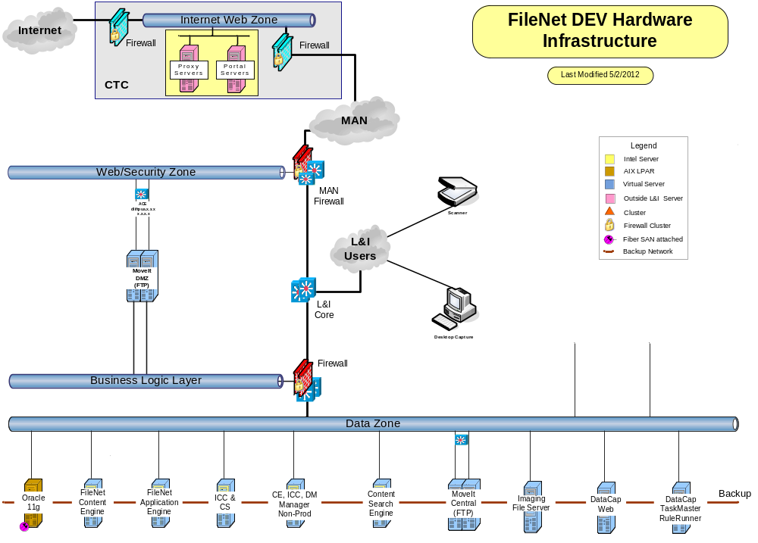

CIT (Component Integration Testing)

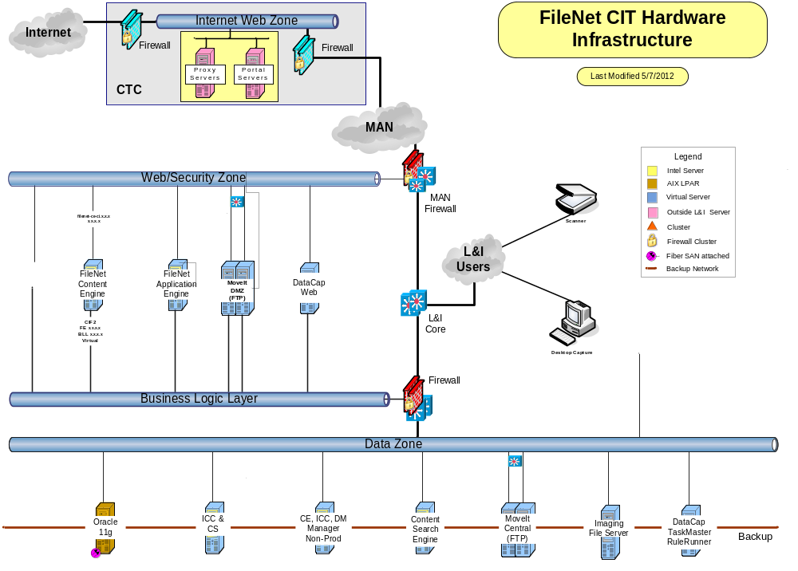

Training and TFP (Test For Production)

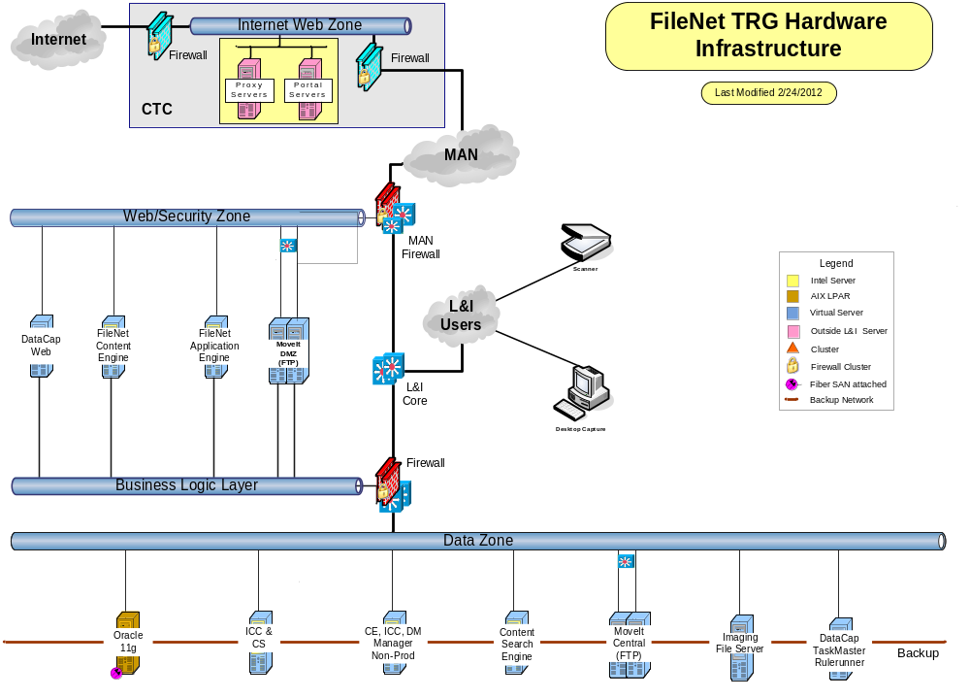

UAT – User Acceptance Testing (this region is identical to production, and resides at the disaster recovery site in Scranton).

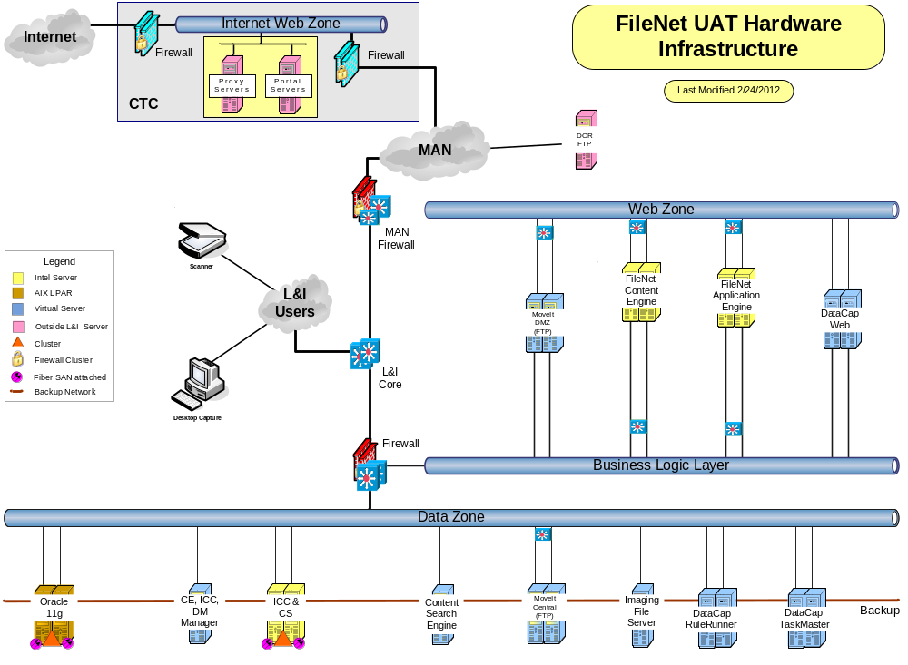

PROD (Production)

