The UC Benefits Modernization Project governance structure is the basis for accountability and decision-making. The governance structure provides authority, and supports the collaboration of the project teams and stakeholders to meet the overall goals of the project.

Governance Role | Members | Responsibility
Executive Sponsor | - Secretary of Department of Labor and Industry | - Provides executive sponsorship at the highest level for the PA UC Benefits Modernization Project
Steering Committee | - Project Sponsor  - Project Executive  - Project Technical Executive  - UC Business Project Manager  - CSG Client Executive (non-voting) | - Provides policy direction and advice on the development of the PA UC Benefits Modernization Project  - May make recommendations for strategy changes and significant critical project issues  - Directs areas of DLI to support the project
Project Sponsor | - Deputy Secretary Unemployment Compensation Programs | - Provides guidance and oversight to ensure the success of the PA UC Benefits Modernization Project  - Responsible for Contract Management and executive buy-in  - Removal of project barriers
Project Executive | - Deputy Secretary Office of Administration | - Provides guidance and oversight to ensure the success of the PA UC Benefits Modernization Project  - Responsible for OIT, Administrative, Financial and Procurement Management guidance to ensure the success
Project Technical Executive | - CIO | - Provides the DLI technical guidance to ensure the success of the PA UC Benefits Modernization Project
UC Business Project Manager | - UC Business Project Manager | - Is the primary point of contact for the UC Benefits Modernization Project  - Provides the primary day-to-day management and oversight of the PA UC Benefits Modernization Project  - Coordinates the review and approval of deliverables  - Escalates issues regarding schedule, scope, and budget to the Steering Committee following Project Sponsor review
UC Bureau Directors | - Office of Unemployment Compensation Benefits Policy (OUCBP)  - Unemployment Compensation Benefits Board of Review (UCBR)  - Office of Unemployment Compensation Benefits Service Centers (OUCSC) | - Provides advisory and policy direction
CSG PMO Project Manager | - CSG PMO Project Manager | - Provides oversight and management of the PA UC Benefits Modernization Project
UC Functional Business Core Team | - TBD | - Lead SMEs for the PA UC Benefits functional areas
UC Business SMEs | - TBD | - Responsible for participating in the functional requirements gathering sessions, providing additional expertise, and review of functional requirements
DLI OIT Project Manager | - OIT | - Responsible for the DLI OIT project management processes
Technical Lead | - OIT, Director Bureau of Enterprise Architecture | - Provides the lead technical expertise to the PA UC Benefits Modernization Project
UC Technical Core Team | - TBD | - Lead SMEs for the PA UC Benefits technical areas
UC Technical SMEs | - TBD | - Responsible for participating in the technical requirements gathering sessions, providing additional expertise, and review of non functional and technical requirements

The figure below depicts the governance structure for the Project.

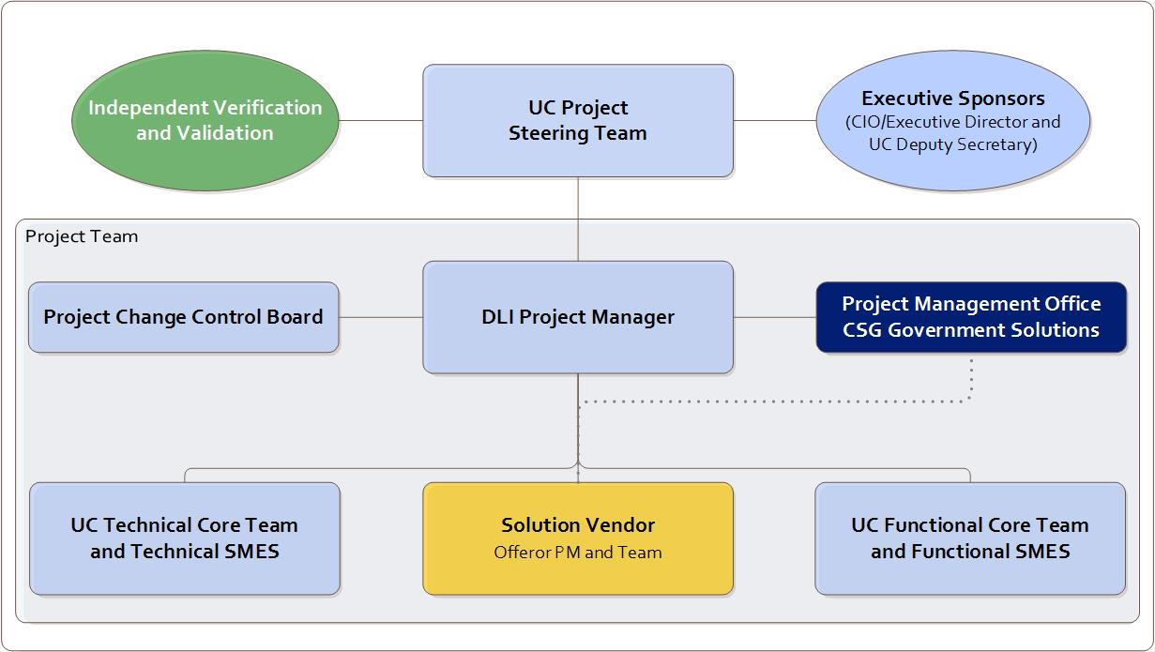
Figure 1: UC Benefits Modernization Project Governance Chart

