HIGH-LEVEL DLI ORGANIZATION CHART

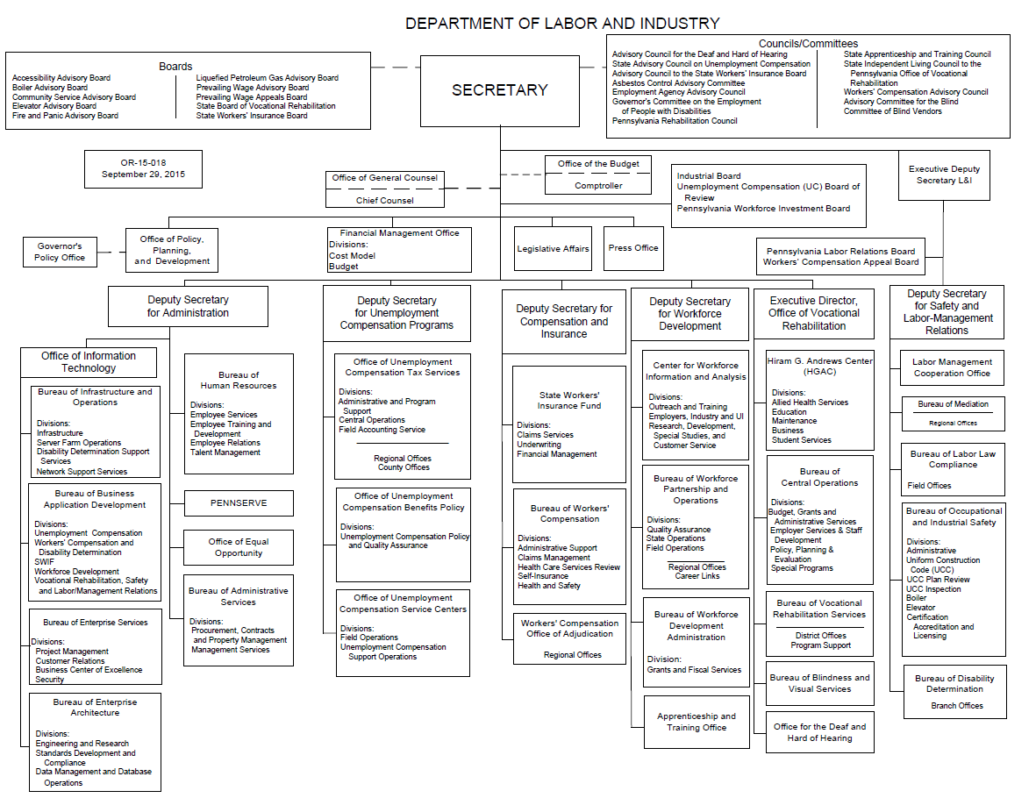

UNEMPLOYMENT COMPENSATION PROGRAM OFFICES

Office of Unemployment Compensation Benefits Policy
Bureau Overview

The Office of UC Benefits Policy (OUCBP) plans, organizes and directs all activities for the taking, processing and payment of claims for unemployment compensation filed by Pennsylvania’s unemployed workers. OUCBP develops the policies, procedures, standards and monitoring systems to ensure the UC program operates in accordance with federal and state laws, ensures the most efficient application of current technology in the provision of UC services, administers federal grants and provides training, support and guidance on claims processing and adjudication to UC service center staff.

OUCBP is responsible for:
- Administering the delivery of UC benefits in accordance with applicable federal and state laws, regulations and policies.
- Administering the delivery of UC benefits within the criteria established by the United States Department of Labor (USDOL) through the Unemployment Insurance (UI) Performs performance management system.
- Developing, implementing, modifying and overseeing UC benefit delivery system and payment procedures for the statewide payment of UC benefits.
- Conducting special policy and procedural studies regarding the UC benefit program, including the analysis of proposed legislation and regulations.
- Coordinating with the Pennsylvania Treasury Department, the Comptroller's Office and the Debit Card vendor regarding the issuance of UC benefit funds.
- Planning, directing and controlling overpayment activities on a statewide basis in accordance with the standards established by the USDOL.
- Coordinating data exchanges with other agencies to prevent and detect overpayments.
- Reviewing, monitoring and evaluating the detection, recovery and prosecution processes for overpayments.
- Coordinating with other states and the federal government to resolve issues with claimants who have worked in a state other than Pennsylvania and/or for the federal government in military or civilian roles.
- Providing policy and procedural oversight for UC programs that are partly or wholly federally funded, including benefits payable under the Trade or Disaster programs.
- Coordinating eligibility of individuals under the Federal Health Coverage Tax Credit (HCTC) program.
- Administering the Benefit Accuracy Measurement (BAM) program as required by USDOL to assess the accuracy of UI payments. The BAM program used to be called the Quality Control (QC) program.
- Performing collection activities for overpayments, including coordinating with the Office of Chief Counsel, Commonwealth Magistrates and Philadelphia District Attorney’s office for collection activities, such as prosecutions and liens.
- Responding to inquiries from employers, including disclosure requests and subpoenas for information.
- Training staff on UC claims processing, adjudications, and UC-related initiatives.

Bureau Structure

Under the leadership of the Director, OUCBP has four core program areas and three specialty units that cover all aspects of the UC program and provide support and direction to the UC service centers.

OUCBP UC Program Areas

UC Claims - Develops, tests and implements new and improved initial and continued claim methods and procedures; monitors current claims activity to ensure a high level of statewide performance; quality controls claim processes; and provides related technical assistance and training to the UC service center staff.

INITIAL CLAIMS - This unit develops, tests and implements new and improved initial claim methods and procedures; monitors first payment time lapse to ensure a high level of statewide performance; quality controls the telephone and Internet initial claim processes and monetary determination process; provides technical assistance and training.
CONTINUED CLAIMS - This unit develops, tests and implements new and improved continued claim and benefit payment methods and procedures; monitors continued benefit payments to ensure a high level of statewide performance; quality controls the benefit payment and PA Teleclaims (PAT) and Internet continued claim processes to improve customer service and system efficiency; provides technical assistance and training.
Adjudication - Provides interpretation of UC law and UC regulations, investigates unique and complicated UC issues and cases for resolution, develops and monitors UC adjudication procedures and forms related to the adjudication of UC benefits, develops and maintains the Expert Assistant System for Examiners (EASE) used in issuing eligibility determinations, analyzes proposed legislation for its impact on the UC program and identifies potential conformity issues, obtains fact-finding and issues determinations on labor disputes within the state, conducts quarterly quality reviews of UC determinations issued as mandated by USDOL, reviews UC Referee and Board of Review decisions for potential further appeals, and develops and provides training for adjudicators.

Benefit Payment Control & Benefit Integrity - Promotes and maintains the integrity of the UC program through prevention, detection, investigation, establishment, recovery and prosecution of UC overpayments made to claimants; prevents or limits fraud overpayments using sophisticated computer cross-matches with state and federal databases, return-to-work reports, and tips from the public; audits detected potential overpayments; and recovers overpayments.

BENEFIT PAYMENT CONTROL - This unit is responsible for pursuing and collecting all overpayments to claimants. Generally, this unit is also responsible for the Treasury Offset Program (TOP), deceased claimant crossmatch, and the cancelled claim crossmatch. It provides: overpayment procedures training; bankruptcy reviews; adjustments for back wage awards; sheriff sales recovery; GAAP Audit information; Amnesty program recovery; coordination of the web-based version of the Systematic Alien Verification for Entitlements (SAVE) Program (invoices, statistics and procedures); coordination of UC-325 billing statements; lien payoff recovery; and recovery through Interstate Reciprocal Overpayment Recovery Arrangement (IRORA) processes. Most importantly, BPC monitors state and federal UC claims - past and present - to make sure benefits are properly paid. Through detection programs and random audits, BPC establishes overpayments and, when applicable, identifies and prevents acts of fraud by both claimants and employers.
BENEFIT INTEGRITY - This unit is responsible for UC benefit integrity programs including: the Department of Corrections and County Justice Network crossmatches; the unpinned debit card program; National and State Directory of New Hires crossmatches; multiple claimants at a single address crossmatch; quarterly intrastate, interstate and border checkwriting/wage record crossmatch (UC-756); prosecution cases, including Philadelphia prosecution case reconciliation; PENNDOT address update crossmatch to obtain updated addresses; and audit alert crossmatches. This unit heads the Commonwealth’s UI Integrity Workforce and regularly cooperates with the USDOL on integrity issues. Efforts by this unit help the UC program meet the federally-acceptable levels of achievement on a regular basis, and develop and implement new integrity initiatives to prevent, detect and recover improper benefit payments. This unit also provides quality control of procedures and policies to ensure that they are continuously monitored and, as required, modified to ensure compliance with the USDOL standards. This unit coordinates with the Internal Audits Division (IAD) to resolve fraud cases, including third party fraud and phishing scam cases.
Federal & Interstate Programs – This unit administers and monitors federal UC programs, implemented and operated in accordance with federal law, regulations, procedures and guidance; develops, tests and implements new and improved federal program methods and procedures; troubleshoots issues with federal claims filed and paid; and reviews UC Referee, Board of Review and Commonwealth Court appeal determinations related to federal program issues for possible appeal. This unit also administers, coordinates and evaluates Agent State, Liable State, and Interstate Connection (ICON) operations related to the Interstate Benefit (IB) and Combined Wage Claim (CWC) programs, and all the interstate arrangements, plans and agreements as established by the federal government in conjunction with state programs to ensure effective methods for the exchange of information among states and Canada to support UC benefit determinations and Workforce Security objectives.

FEDERAL PROGRAMS - This unit administers, coordinates, evaluates and provides technical assistance and training for all federal UC programs in Pennsylvania in accordance with state and federal law, USDOL rules and regulations and other federal mandates, including: Unemployment Compensation for Federal Employees (UCFE), Unemployment Compensation for Ex-Service members (UCX), Extended Benefits (EB), Emergency Unemployment Compensation (EUC), Trade Readjustment Allowances (TRA), eligibility for Alternate Trade Adjustment Assistance (ATAA) or Reemployment Trade Adjustment Assistance (RTAA) under the Trade Adjustment Assistance (TAA) Program, and Disaster Unemployment Assistance (DUA).
INTERSTATE PROGRAM - This unit administers Interstate Benefit (IB) and Combined Wage Claim (CWC) filing, in accordance with state and federal law, regulations and procedures; interprets and implements new and existing IB/CWC laws, regulations, procedures and guidance; develops/modifies IC/CWC system procedures; coordinates and provides training for UC service center and central office staff; regularly reviews current IB/CWC procedures/forms for quality control purposes; develops and implements required improvements; and troubleshoots IB/CWC claims filed and paid.
Special Projects
This unit coordinates special projects such as the yearly State Quality Service Plan, federal grant proposals and audits. This unit also handles the review and distribution of all UC policies and procedures in the form of Informational Memorandum to UC service center staff and the creation of the new Manual of Operations. This unit handles requests for disclosure of UC information and all memorandum of understanding among UC and other bureaus and state agencies. This unit provides technical support to all bureau staff, as well as coordinating the priority of IT projects. It also analyzes UC data and provides various statistical reports to management and executive staff.

Benefit Accuracy Measurement (BAM)
This unit is responsible for the federally mandated audit of randomly selected paid and denied unemployment claims. This unit audits the claims and provides those results to USDOL to formulate Pennsylvania’s Improper Payment Rate. BAM staff also participate in case reviews with staff from other states.

Training & Staff Development
Develops, revises and delivers necessary training to UC service center staff based on standardized plans established by central office, new policies and procedures, law changes and initiatives to address quality performance. Participates in the development and administration of follow-up evaluations, as well as After Action Reviews for delivered training.

Office of Unemployment Compensation Service Centers
Bureau Overview

The mission of the Pennsylvania Department of Labor and Industry’s (DLI) Office of Unemployment Compensation Service Centers (OUCSC) is to provide temporary, partial income replacement, funded by federal government payments and employer and employee contributions, to workers who are unemployed through no fault of their own.

Plans, organizes and directs all activities for taking, processing and payment of all UC claims filed. Develops procedures and monitors systems to ensure the UC program is operated in accordance with federal and state laws and ensure the most efficient application of available technology in the provision of UC services. Provides UC information in varied languages and formats. Integrates UC services available through the UC service centers with the workforce system, one-stop initiatives and other workforce development initiatives. Serves as consultant to departmental officials on all matters pertaining to the UC program. Represents UC service centers in the development of a new computerized system for handling all aspects of UC claims taking and processing.

OUCSC Core Business Functions
OUCSC’s business functions are designed to accept, process, pay and accurately account for UC claims. Individuals have the option to file their claim via telephone, Internet and in some cases on paper. In addition, an Interactive Voice Response (IVR) is available to apply for continued claims. UCSC utilizes an Automated Call Distribution (ACD) System to manage calls.

The benefit processes include:

- Establish an initial claim for benefits
- Determine financial eligibility
- Determine nonmonetary eligibility
- Pay benefits
- Process a continued claim for benefits
- Process appeals to determinations to the UC Board of Review
- Conduct benefit claim audits
- Establish overpayments of benefits
- Process reemployment information

The UCSC staff is responsible for:

- Processing all UC claims and providing a full range of services for state and federal UC programs including taking initial applications for benefits, determining eligibility, processing biweekly claims and connecting claimants to reemployment services.
- Acquiring, implementing, and maintaining new technologies to enhance UC claim processing in a call center environment.
- Coordinating UC policy and procedural implementation with OUCBP.
- Monitoring budget, personnel, training, labor relations, property management, purchasing, and other support services.
- Managing staffing by predicting and adjusting the utilization of Intermittent Intake Interviewers during the peak workload periods.
- Providing services to persons with limited English proficiency.
- Developing marketing and survey materials to acquire and analyze customer feedback.
- Implementing corrective action plans, as needed, to meet the USDOL quality and timeliness requirements.
- Reviewing and issuing determinations on employers’ inquiries regarding benefit charges, processing relief from charge appeals, verifying that the proper charges are made to employers’ accounts and making adjustments as necessary to maintain accurate benefit charge balances for the calculation of individual employer contribution rate.

Bureau Structure
OUCSC is represented by three divisions: UC service centers (UCSC), which are field offices located across Pennsylvania and are the first contact with claimants who are filing for unemployment benefits; UC Support Operations, which is located in the DLI building in Harrisburg and provides direction, planning and program support; and UC Operations which provides additional claimant and employer services.

UC Service Centers
Directs, evaluates, and recommends improvements to the consolidated statewide system of UCSCs that takes and processes applications for payment of unemployment benefits. Directs all UC benefit services to Pennsylvania’s unemployed workers utilizing a UCSC network through the application of new technologies including telephone, telecommunications, personal computers, interactive voice response and other technical areas.

UC Support Operations
Working in conjunction with the OUCBP, Support Operations plans, designs, implements and evaluates the delivery of unemployment claims services including automated claims system, interstate claims, initial and continued claims for state UC programs. Integrates changes in federal UC benefit regulations to existing automated claims system. Provides the director and management team with human resource, training, labor relations, property management, purchasing and other management services. Coordinates and disburses communications with the federal government, state legislature, employers, stakeholders, claimants and other interested parties.

Provides UC publications in varied languages and formats. Plans, develops, executes, and reports on customer feedback initiatives. Coordinates contracts related to customer services. Performs liaison work regarding service delivery with other bureaus in the UC deputate. Directs UC claim data linkages with the workforce system and other resources to ensure the legal requirements of eligibility for benefits and the reemployment of claimants. Directs the participation of OUCSC in one-stop initiatives and other workforce development initiatives as the UC partner.

The UC Support Operations Division is separated into three sections:
- Administrative Support Section
- Integration & Program Support Section
- Customer Services Section

UC Operations

Claimant Services - This unit processes weekly benefits to claimants whenever manual processing is required, and ensures the wage records of claimants are correct. This unit also deposits overpayment monies when collected through benefit offset or direct payments, and adjusts the overpayment and claim balances accordingly. Some of the special services handled in this unit include child support intercept, processing of liens, and the coordination of other agency payments with UC payments.

Employer Services - This unit adjudicates employer requests for relief from charge, granting or denying those requests and making the applicable changes to the employer’s account. This unit processes appeals to relief from charge determinations; credits and debits employer accounts for benefits monies paid; processes transfers of employers’ benefit charge accounts; maintains employer addresses; and tracks interstate billing. The unit also verifies wage inconsistencies submitted by the employer.

Employers Information Center – This unit includes a contact center that handles calls from employers who are seeking information about the eligibility of claimants to receive benefits, the appeal process, specific debits and credits to employer accounts and relief from charge. This unit also coordinates with UC Tax Services on the tax rate appeal process.

Unemployment Compensation Board of Review
The Unemployment Compensation Board of Review (Board) has the responsibility to adjudicate appeals of determinations regarding claimant eligibility for unemployment compensation benefits and employer’s entitlement to relief from charges. There are two levels of appeal that are divided into lower and higher authority.

The lower level of authority, commonly referred to as the Referee level, is responsible for conducting appeal hearings of UCSC determinations. After a hearing, the Referee issues a decision affirming, reversing, or modifying the determination issued by the UCSC. The Referee can also remand the case to the UCSC for further investigation and to issue a new determination.

The higher level of authority, commonly referred to as the Board level, is responsible for adjudicating appeals from Referee decisions, based upon the record made at the Referee hearing. The Board consists of three members, appointed by the Governor, a chairman and two members. The Board staff in the central office process all appeals from Referee decisions from receipt of the appeal to the mailing of a decision. The Office of Chief Counsel provides legal support, including providing the Board members with draft decisions. The Board members presently meet every two to three weeks to discuss cases for which a consensus has not been reached or a question has been raised.

Referee Level

The Board has 20 Referee offices statewide. They are divided into four sectors, the Eastern Sector, Central Sector, Capital Sector and Western Sector. Each sector has an Unemployment Compensation Appeals Program Manager who supervises the Referees and clerical staff and manages the Referee offices in their assigned sector. For the most part, each Referee supervises a clerk typist 3 who handles the Referee’s schedule, mail, typing, phone calls and acts as receptionist.

After an appeal to a department determination is received by the UCSC, the UCSC sends the appeal documents to the appropriate Referee office by e-mail. The Referee office schedules an appeal hearing, notifies the parties of the hearing date and time, and after the hearing is held by the Referee, a decision is prepared and mailed to the parties, including the UCSC and OUCBP’s adjudication unit.

The Referee offices are transitioning from the process of printing and mailing decisions from the local Referee office to a process which utilizes the preferred option to print and mail decisions from the DLI mailroom in Harrisburg. This time and cost saving process also includes the automated e-mailing of referee decisions to the appropriate UCSC and to OUCBP’s adjudication unit.

Board Level

The Board has an Appeals System Administrator and an Assistant Administrator who also is the Capital Sector Program Manager. It has an administrative unit that handles all of the Board’s human resources, timekeeping, labor relations and procurement matters. An Administrative Officer 4 also supervises three program analysts who handle the Board’s statistical work and work on IT issues and projects.

The Board has an Appeal Preparation unit, which is divided into four parts, to handle second level appeals. There is an Appeals Intake unit that processes appeals to the Board and an Appeals Support unit that prepares the appeal files, which includes having the transcripts prepared by a vendor. This unit then sends the completed files to the Office of Chief Counsel, UCBR Division (Legal), who reviews the files and prepares draft decisions.

The Decision Processing unit receives the files back from Legal, prepares and ships the appeal documents to the Board members, receives the appeal files back from the Board members and either sends them to the Appeals Release unit to be processed and mailed, holds and processes them for the next Board meeting to be discussed, or sends them back to Legal. The Board is in the process of modernizing this operation to improve processing time and reduce costs through implementation of the Board Electronic Files (BEF) system. Rather than mailing boxes of appeal files to the Board members through the postal or package delivery systems, the Board members will be able to view the appeal files electronically. Transcripts, together with a copy of the Referee decision will be received from the vendor electronically. Legal will also provide an electronic copy of the draft Board decision to the Board’s staff through this new system. These documents will be posted on a secure website and assigned for the Board members to review. The Board members will access the documents and indicate, through the secure website, what action is to be taken regarding the appeal. The BEF system will save costs on photocopying and mailing, and will also save the time involved in sending and receiving hard copies of the appeals to and from the Board members. Workflow for the Board, including the BEF system, is not part of the scope of the UC Ben Mod Project.

The Decision Processing unit also receives all phone calls to the Board, responds to correspondence and processes requests for reconsideration, including sending them to Legal, and preparing and sending out the response indicated by Legal.

Once the Board approves a decision or order, the appeal file is sent to the Appeals Release unit to be processed. This process includes updating the Board’s computer records, proofing parts of the approved Board decision, and mailing the approved Board decisions to the required parties. This unit is also responsible for records retention and purging of Referee and Board files that are housed at the central office. This is an important function due to the volume of Referee decisions and Board appeal files that are stored in the central office.

DLI OFFICE OF INFORMATION TECHNOLOGY (OIT)
OIT plans, develops, implements and manages a comprehensive information technology shared service organization for DLI, the purpose of which is to ensure the coordinated, effective, and efficient utilization of information resources in support of DLI and Commonwealth enterprise business goals and objectives. OIT provides department-wide services for IT infrastructure, operations, network support, project management, enterprise application development and architecture, business application development, customer support, training and resource management.
OIT supports all DLI locations, including all central and remote sites as well as coordinating services with business partners from other Commonwealth and federal agencies, along with private employers. In order to perform these functions, OIT is comprised of four bureaus: the Bureau of Business Application Development (BBAD), the Bureau of Enterprise Architecture (BEA), the Bureau of Enterprise Services (BES) and the Bureau of Infrastructure and Operations (BIO).

Bureau of Business Application Development
This bureau applies emerging and existing technology to the business processes of DLI, enabling the program office staff to work more efficiently and effectively in delivering services to customers. The Bureau provides planning, analysis, and programming support for the Department’s information systems. Application systems administration is provided for implementation, maintenance and change control of business applications and integration of third party software products. Technical support is provided for the development of applications and training of end users on client/server, web-based, and mainframe platforms.

Bureau of Enterprise Architecture
This bureau is responsible for the development of an enterprise architectural model for all of DLI, which consists of networking, computer systems, application, data/information, infrastructure, security, and standards components. The Bureau ensures both fiscal and physical accountability for all DLI IS/IT resources are achieved and maintained throughout their useful lifecycle. The Bureau develops comprehensive blueprints to guide the transformation from business strategies into value-added systems solutions. The Bureau facilitates and supports the system manifestation, physical implementation of resources, testing, validation, and associated change/re-engineering phases for the subsequent release into operational environments. The Bureau provides life cycle management strategies regarding the recycling, decommissioning, or disposal of the operational systems at the ending of its use in the enterprise operation.

Bureau of Enterprise Services
This bureau performs enterprise wide IT applications development, web page development, and Commercial-Off-The-Shelf (COTS) product administration. The Bureau handles security administration, password administration, change management processes, enterprise project management, continuity of government and disaster recovery oversight. The Bureau is also responsible for the coordination of help desk services and customer service.

Bureau of Infrastructure and Operations
This bureau provides the operations for DLI’s business processing systems and infrastructure. The Bureau ensures the communications network and computing infrastructures are maintained in a state of high reliability, availability, and serviceability. It provides continuous processing services and support to customers and users throughout DLI, managing capacity and performance to maximize operational efficiency. The Bureau manages changes to hardware, software, and systems to ensure continuity and reliability of services, maintains and updates mission critical processing systems as the business and informational needs change. The Bureau provides installation, configuration, security, management and administrative support for all centralized computing platforms, systems and networks within DLI.

