APPENDIX L, DLI CURRENT infrastructure ENVIRONMENT
Network Architecture
The following network architecture diagram shows how DLI, Commonwealth and external infrastructures work together to provide claimants, employers and staff access to the applications that support DLI’s business processes.

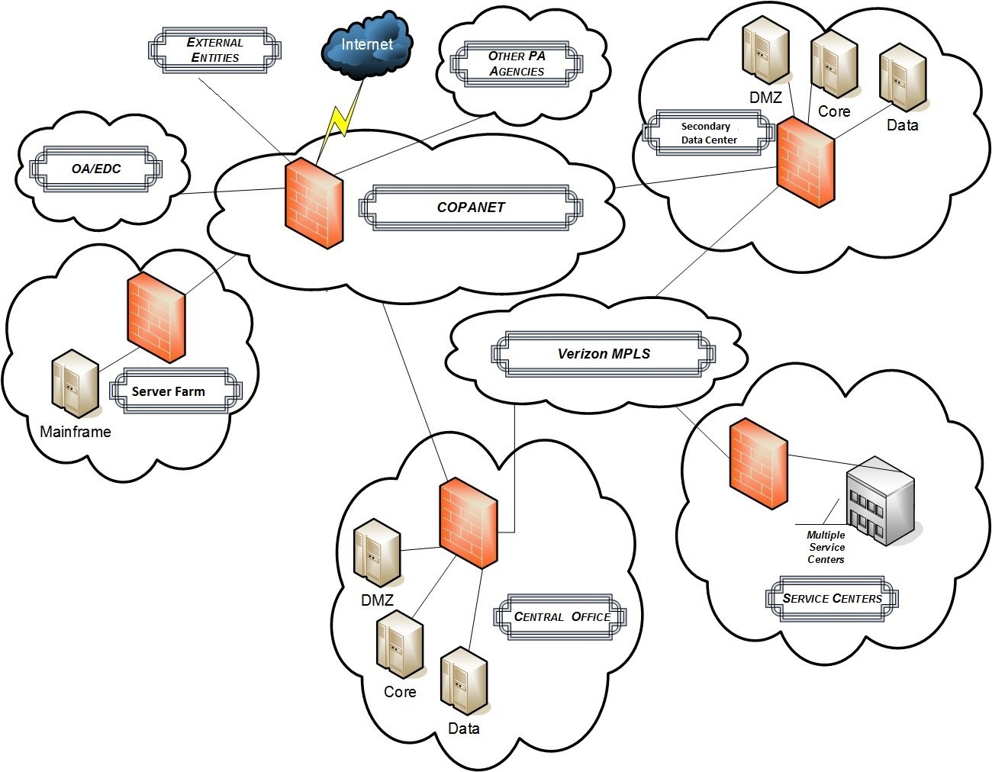
Network Environment
The central office and DLI’s secondary data site share the same server setup. Central office contains the production servers while the secondary data site houses the UAT/staging servers. The DMZ servers communicate to outside entities (e.g., web servers). Core servers manage staff network (e.g. LAN for desktops and connection to WAN). Data servers are the secured servers (e.g., database servers).
Copanet is the Commonwealth Ring that has firewalls at the perimeter and provides connection to the internet through Verizon. The Verizon MPLS is used to connect the service centers to Copanet through the central office or Scranton. Phone service is provided by Verizon. The relationship with Verizon is managed by OA OIT.
There are seven service centers that connect to the network with 50 Mb Ethernet access circuits. These access circuits are divided into two (2) separate MPLS port speeds, 6 Mb for Data and 40 Mb for VoIP to support the call centers.
The servers are in the process of being migrated from Windows 2003 to Windows 2008. Currently the web servers and database servers have been updated.
OA OIT manages Microsoft Exchange for the Commonwealth at the OA Enterprise Data Center (OA EDC).
Mainframe
Management of the mainframe is outsourced to Unisys. The mainframe is hosted and managed by Unisys.
All mainframe applications are maintained by a combination of agency staff and contractors. The users of the mainframe applications are agency staff. The mainframe environment and related expenses are shared with other Commonwealth agencies.
PCOMM, IBM Communication Server and MQ are used to connect to the mainframe. Attachmate is only used by the PAT/IVR application. IBM Personal Communications 3270 is used by business and support staff to connect to the mainframe.
Web Environment
DLI has its own web servers located at the DLI Server Farm. The DLI OIT staff is responsible for managing all aspects of the web servers including the hardware and software updates.
Database Environment
The mainframe database environment uses DB2, IMS, VSAM and flat files to store data. DLI is responsible for maintaining the database environments. There is a contracted Database Administrator (DBA) who is part of the legacy application support division that manages the DB2 and IMS databases. VSAM and flat files are maintained by the developers. Additional databases are controlled by Center for Workforce Information & Analysis (CWIA).
SQL Server databases are hosted at the DLI Server Farm. Installation and maintenance of the SQL Server databases are installed and configured by the DLI OIT data group team.
IVR
IVR uses Sip trunking provided by Verizon and has SBC’s and Vmware servers. Enghouse is the current vendor. It uses screen scraping to get information from the mainframe via a special 3270 screen designed for use by the IVR system.
The IVR system has the ability (not currently in use) to communicate via web services or database integration. In addition, the IVR system has a feature (currently disabled) that allows a claimant to transfer out of the IVR to a live operator at one of the UC Service Centers.
Correspondence/Printing
Currently correspondence is printed on DLI high speed printers that receive information through QDirect. QDirect is able to put electronic copies of the correspondence in FileNet. Although remote printing isn’t generally used by DLI, there is a vendor that prints 1099s.
Reporting
Cypress is used to view mainframe reports online and send to local printers. Crystal Reports is used to send information to local printers from web and client server applications.
Imaging
There is currently limited imaging in DLI. Most of the imaging that does occur for DLI is done by the Department of Revenue. In April, a service center started scanning forms with Datacap that go into FileNet. FileNet is housed at the central office and maintained by DLI.
Security
The mainframe security is managed by Resource Access Control Facility (RACF). OA OIT creates the accounts and associates them with DLI. DLI then provides appropriate permissions for the UC applications and environment.
There are three active directory repositories: Managed, Self-Registration and CWOPA. Managed is for employers, Self-Registration for claimants and CWOPA for staff. The Managed and Self-Registration active directories are synched with the Department of Human Services (DHS).
For new external facing websites, SiteMinder and Active Directory are used to manage authentication. For internal websites, custom authentication is built within the application.
For the older external facing websites, the application manages the authentication information for users. Maintenance of claimant passwords can be updated via self-service through PAT and Internet Claims.
Backup and Recovery
Backups for the mainframe are managed by IBM. Backups for servers and databases are managed by DLI. All backups go to virtual tapes via batch jobs. The tapes are shipped offsite.
Unisys and IBM manage an off-site disaster recovery environment which will continue to be the disaster recovery environment for the mainframe. The disaster recovery environment is tested twice a year.

