This appendix shows the current systems and whether or not they will be replaced by the new system.
System Architecture
DLI has mainframe, web and client server components to support its UI benefits and appeals applications. Each of the systems and major components are described in more detail in the following sections. The following diagram shows an overview of the system architecture.
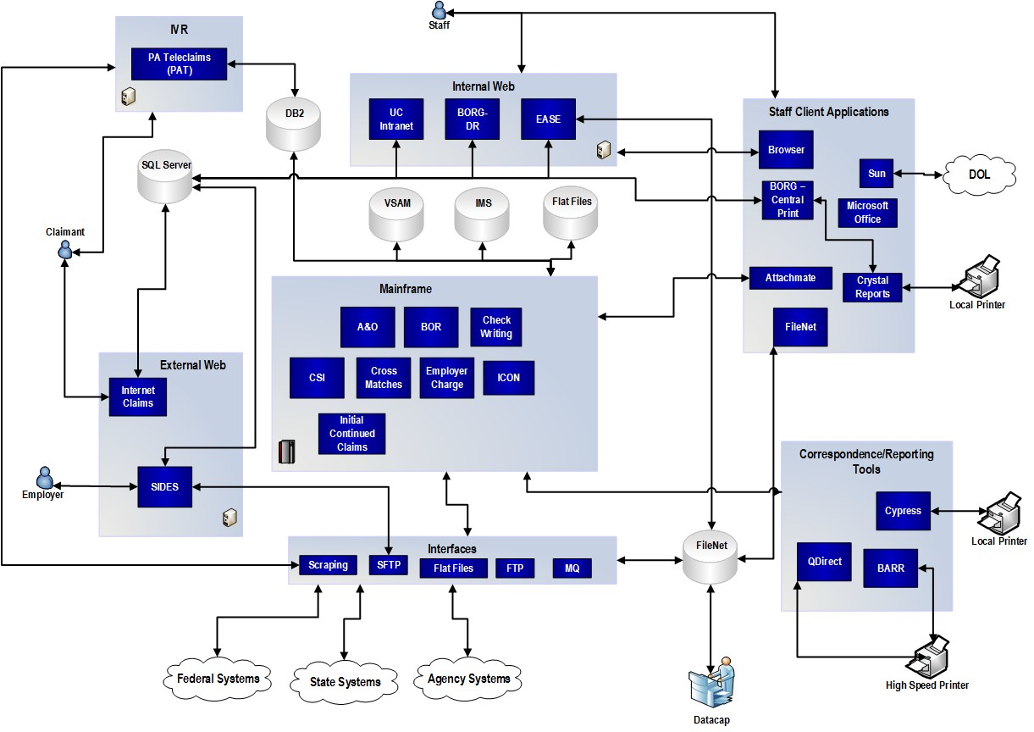

Current Systems
Those systems that have a status of “Replaced by Future System” will be retired and the functionality will be considered in scope for the future System. Those systems that have a status of “System Remains in Use” will NOT be considered in scope for the future System (the legacy system will remain in use).

  - Mainframe Applications
Application Name | Description | Status
Adjustments and Overpayments (A&O) | UC Benefits Claim Adjustments and Overpayment Tracking and Collection application. | Replaced By New System
Board of Review (BOR) – Menu BR | UC Board of Review Appeal Processing - managing and tracking appeal related information. Data is stored and tracked for three appeal levels: Referee, Board and Court. | Replaced By New System
Check Writing | 1) Benefit Payment allocation ledger for State or Federal Extended UC Benefit Payments, TRA payments, DUA payments, Regular UC payments  2) UC Benefit Consolidated Accounting-daily summary of all UC payments made (Regular UC, EUC, EB, Child Support, Federal Withholding, etc.)  3) Federal Tax Withholding from Benefit payments. Collection, daily remittance & Reporting to IRS and yearly reporting to claimants (currently off)  4) Federal Tax Withholding from Benefit payments 1099s | Replaced By New System
Child Support Intercept (CSI) (code within UC Benefits Legacy) | Mandated Support Collections-court ordered garnishment of claimant benefits | Replaced By New System
Cross-Match Systems (Cross-matches) | Systems used to detect fraudulent activity and unreported earnings by identifying potential ‘hits’. | Replaced By New System
Employer Charge (EC) | 1) Charges to employers when benefits are paid to one of their separated employees  2) Charges to group of reimbursable employers that share the costs of unemployment benefits. Used within 640 process | Replaced By New System
ICON (code within UC Benefits Legacy) | Common Interstate connection/hub to pass wages and other claim information between states | Replaced By New System
Initial / Continued Claims | 1) Initial claim intake processing, manages the availability of compensable weeks to claimants (includes the separating employer database).  2) Federal Program authorized to pay unemployment benefits to claimants affected by a disaster  3) Claimants employment profiling.  4) Claimants employment history is profiled and based on score may be provided services to start their own business. Done on a county basis when funding is available. Currently not funded.  5) Sends a request for separation information for IC claimants to employers participating in SIDES. This request is a hardcopy, and is mailed for non-SIDES employers.  6) Trade Readjustment Act Claims. Another type of claim for citizens who lost employment due to jobs moving out of the country.  7) Manages UC claims. All claim notes are kept here, stops on claims, payments can be made, and payments can be pended and released from here.  8) Used as part of the Wage Investigation system if claimant is missing wages from an employer or there is a dispute in the wages for a claim determination. Any that are 'found' are stored in WR file and feeds the IC Process.  9) Wage Records. Currently UCMS sends wages from PA employers to legacy Wage Records.  10) Calculation of financial determinations (benefit determination processing)  11) IVR. Initial/Continued Claims exchanges data with the IVR system for certifications.  NOTE: Initial Claims uses a web services which gets info from Office of Administration (OA)'s Geocoder service. | Replaced By New System

  - Web Applications
Application Name | Description | Status
Admin Home Page | BES-Fraud Forms or IAFRTS or Internal Audits Division Fraud Report Tracking System | Replaced By New System
Board of Electronic Files (BEF)/UCBR-2nd Level Approvals | Used for second level appeals with an intranet and internet version. | System Remains In Use
Case Assignment Tracking System (CATS) | Use to track case assignments.  NOTE: Data for active investigations will be converted to the new system, images and attachments will NOT be converted. Completed cases will need to be retained in the legacy system according to the record retention policies. | Replaced By New System
Expert Adjudication System for Examiners (EASE) | Expert Adjudication System for Adjudicators - Appeals. Used to determine claimant eligibility. | Replaced By New System
Internet Claims | 1) Internet Initial Claims - Claimants file for Initial claims via the web to view Internet Claims data  2) Internet Bi-Weekly Claims - Claimants file for their bi-weekly payments via the web  3) Claim Status Web application to view the status of a claim  4) Payment information from mainframe and UC Treasury  5) Request/Change Federal Tax Withholding  6) Change address, telephone, email  7) Form 1099 | Replaced By New System
SIDES | PA’s SIDES implementation of the Federally backed, multi-state application that provides separated employer information. | Replaced By New System
UC Intranet | Used by internal staff to view internet information to which claimant has access. | Replaced By New System
Unemployment Compensation Board of Review Digital Record application (BORG-DR) | Stores digital recordings of hearings. Note: Digital recordings will not be required to be transferred from the existing application to the Solution. | Replaced By New System

  - Client Server Applications
Application Name | Description | Status
Unemployment Compensation Board of Review (BORG - Central Print) | Schedule hearings and issue decisions for appeals. | Replaced By New System

  - Other Technologies
System/Technology | Technology Type | Description | Status
Attachmate | Terminal Emulator | Used by PAT to connect to the mainframe | Replaced By New System
Business Objects | Reporting Tool | Enterprise standard | System Remains In Use
CA Identity Manager | Authentication Manager | Used to coordinate authentication activities across multiple applications. Uses Active directory as repository. | System Remains In Use
CA SiteMinder | Authorization Manager | Manages the authorization | System Remains In Use
Cover Your Assets (CYA) | Backup | Used to manage hot backups of FileNet by coordinating data and file backups | System Remains In Use
Crystal Reports | Reporting Tool | Used by EASE and BORG | Replaced By New System
Cypress | Reporting Tool | Direct report output from mainframe | Replaced By New System
Dollar Universe | Scheduler | Used to manage batch jobs | Replaced By New System
Dragon® NaturallySpeaking | Desktop Productivity Tool; Voice Recognition | Used by UCBR to dictate decisions | System Remains In Use
Elixir | Correspondence | Used for management of mainframe forms | Replaced By New System
FileNet | Document Management System | Used to manage documents (e.g. PDFs). | System Remains In Use
Geocode | Address verification | Used to verify that addresses are real | System Remains In Use
HP Loadrunner | Stress/Load testing |  | System Remains In Use
HP Unified Functional Tester | Regression testing | Automated testing tools | System Remains In Use
IBM Pcomm | Terminal Emulator | Used by staff to connect to mainframe | Replaced By New System
IP2Location | IP Address Verification | Used to determine the geographical location of an IP address | Replaced By New System-Assume functionality is in PACS to block foreign addresses
Learning Management System (LMS) | Training Tracking | Run by OA. DLI provides the content. | System Remains In Use
Lien Fee Database | Access Database | Maintained by Office of Chief Counsel. | Replaced By New System
Microsoft Active Directory | Directory Service | LDAP based directory service | System Remains In Use
Microsoft Exchange | Email Server | Email system used across Commonwealth | System Remains In Use
Microsoft Office | Desktop Productivity Tool | Word, Excel, Outlook and Access databases are used. | System Remains In Use
Microsoft Sql Server Integration Services (SSIS) | ETL/Data Conversion |  | System Remains In Use
Microsoft Team Foundation Server | Source code management/Defect management/automated build tool | Used to manage source code for .Net projects | System Remains In Use
Microsoft Visual Studio 2013 | Development tool | Used to develop .Net applications | System Remains In Use
MoveIt | File Transfer | Used for SFTP | System Remains In Use
MQ | Messaging system | Used to move information between systems | Replaced By New System
Olympus | Voice Recording | Used to record digital voice recordings by the Board of Review | System Remains In Use
PA Teleclaims (PAT) | IVR | Used for filing continued claims, benefit inquiry, 1099G information. | System Remains In Use
QDirect | Print Manager | Current print manager | System Remains In Use
SQL Server 2015 | Relational Database |  | System Remains In Use
TopTeam Analyst™ Software | Document Repository | Used to keep track of requirement documents | System Remains In Use
uPerform | Training Content Development | Run by OA. DLI provides the content | System Remains In Use
WebMethods | System Integration and Batch Processing | Used to manage integration of applications. Used by BORG-DR | System Remains In Use

