GENERAL SPECIFICATIONS
PENNSYLVANIA GAME COMMISSION
FORESTRY DIVISION

141-2022-01 Broad Break
MECHANICAL CUTTING CONTRACT
(Tree Removal)
- SCOPE OF WORK:

- The Pennsylvania Game Commission, Northeast Region, requires the services of an Operator to cut and remove trees. Services shall include, but not be limited to, the furnishing of all labor, superintendence, tools, and equipment for the cutting and removal of trees on 123 acres of SGL 141. Detailed specifications are attached. All Purchase Orders require the contractor to provide the equipment, labor, insurance, and all miscellaneous expenses to complete the operation.

- All contractors, subcontractors and consultants of the Buyer must be pre-approved by the Commission. The Commission reserves the right to reject any subcontractor at its sole discretion. If Contractor enters any subcontract(s) not previously approved by the Commission, the Commission shall have the right to require the Contractor to terminate such contracts.

- Any questions concerning the technical aspects of this bid should be directed to the Regional Forester or Assistant Regional Forester:

Warren Harris Brian Williamson
Regional Forester Assistant Regional Forester
PGC, Northeast Region PGC, Northeast Region
3917 Memorial Highway 3917 Memorial Highway
Dallas, PA 18612 Dallas, PA 18612
Phone: 570-675-1143 - Ext 55011 Phone: 570-351-3910
Email: wharris@pa.gov Email: brianwilli@pa.gov

CONTRACT TASKS:

- Project Location: N 40.9026587 W -75.8195103

    - Packer Township, Lehigh Township, and Nesquehoning Borough, Carbon County

    - NE Region

    - A map of the location and treatment area is included in the packet.

- The contractor will cut all designated trees. All material must be removed from the site.

- SITE INSPECTION AND ASSISTANCE:

- The PGC will conduct tours of the work site for prospective bidders by appointment only. Contractors are permitted to visit the project site on any date on their own time to further inspect the site. Bidders are strongly encouraged to attend a site tour or visit the project area on their own prior to bidding.

- COMMISSION PERSONNEL

- The Commission will furnish personnel to supervise and direct the operation in the following capacities:

- PROGRAM SUPERVISOR - The Chief of the Forestry Division in the Bureau of Wildlife Habitat Management is responsible for the overall operation of the vegetation control program and represents the Commission in settling minor contractual matters.

- FIELD CONTRACT COORDINATORS - These persons are Regional Foresters or their designee who serve as the Commission's field liaison with the Operator and are responsible for reviewing and approving/disapproving the operations plan and conducting quality control checks on the equipment and performance during the operations. This person is responsible for coordinating the activities of all people working on the contract within a region and communicating with the Operator's project supervisor concerning any operational problems or changes in plans. He/she also provides daily reports of the operation to the program supervisor

- CONTRACT REQUIREMENTS:

- Work may begin on or after July 1, 2023. Contract signing and approval is required before any work begins. The contract must be completed by the termination date: October 30th, 2023. No contract extensions will be approved.
- Work Specifications
- Tree cutting on 123 acres

- Block 1 is 115 acres. Block boundaries are marked by 2 blue stripes, except for places where the road is the block boundary. Reserve trees are marked with red paint. All trees 1” DBH and over, except for red and blue marked trees are to be cut. All conifers are also reserved. All felled material must be chipped and removed from the game land.

- Block 2 is 8 acres and is located on land owned and managed by the PA DCNR bureau of State Parks. Block boundaries are marked by 2 blue stripes, except for places where the road is the block boundary. Cut all yellow marked trees within the block boundary. Felled trees will not be removed.

  - All trees must be pulled back 25 feet from the existing road.

  - All trees must be felled to ground level. Any leaning trees must be pushed or pulled to ground level. Slash shall be lopped to no higher than 4’ and pulled apart as directed by the Regional Forester

- Trees must be felled with clean cuts and have stumps that are parallel to the ground surface and shall not exceed six (6) inches in height measured on the side next to the highest ground or the diameter of the stump, whichever is smaller, except when in the opinion of the Field Contract Coordinator, said height is impractical.

- Operator shall exercise care and caution in all operations to prevent damage to all trees not specified for treatment.

- Damage to trails, roads, streams, or utility rights-of-way caused by the Operator’s equipment must be repaired by the Operator at their expense.

- Any trash resulting from the Operator’s operations must be removed from the area and properly disposed.

- The Operator shall not block any roads or trails in the area during performance of this contract. The Operator shall not in any way hinder the progress of any Timber Sale Contracts in these areas.

- All labor, equipment, tools, etc., needed to complete contracted projects are to be provided by the Operator.

- Timber Damages – when in the opinion of Field Contract Coordinator, damage to the residual stand becomes excessive, the Operator shall pay the Commission a fair base current value determined by the Field Contract Coordinator per unit of volume. If this value for damage due to Operator’s carelessness or negligence is less than $10.00 per tree, then a minimum charge of $10.00 per tree will be made whether the tree is commercial, non-commercial, merchantable, or non-merchantable.

- The contractor agrees to comply with all attachments.

- Failure to comply with any of the terms or conditions of the Contract will result in cancellation of the agreement.

INSURANCE REQUIREMENTS:

- The contractor will provide Workmen’s Compensation insurance sufficient to cover all the employees of contractor working to fulfill this contract.

- Comprehensive General Liability Insurance, including bodily injury and property damage insurance, to protect the Commonwealth and the contractor from claims arising out of the performance of the contract. The amount of bodily injury insurance shall not be less than $300,000.00 for injury to or death of persons per occurrence. The amount of Property Damage Insurance shall not be less than $300,000.00 per occurrence.

- Such policies shall name the Commonwealth as an additional insured. Prior to the commencement of work under this contract, the contractor must provide the Commonwealth with current Certificates of Insurance. These Certificates shall contain a provision that coverages afforded under the policy shall not be canceled or changed until at least thirty (30) days prior written notice has been given to the Commonwealth.

- The Commonwealth shall be under no obligation to obtain such certificates from the Operator(s). Failure by the Commonwealth to obtain the certificates shall not be deemed a waiver of the Operator’s obligation to obtain and furnish certificates. The Commonwealth shall have the right to inspect the original insurance policies.

- HOLD HARMLESS:

- The contractor shall be responsible for and agrees to indemnify and hold harmless the Commonwealth from and against damages to property or injuries (including death) to any persons and other losses, damages, expenses, claims, demands, suits, and actions by any party against the Commonwealth in connection with the work performed by the contractor.

BIDDING

- RECEIVING AND OPENING BIDS

- The bid shall be awarded on a per acre basis.

- Bids must be submitted via the PA Supplier Portal, to be found at www.pasupplierportal.state.pa.us

- Faxed bids and mailed bids will NOT be accepted.

- The price per acre shall include all labor, equipment, tools, insurance, materials disposal and all items necessary for the completion of the project. Prices bid shall be in dollar and cents only.

BID RESULTS – are available at www.emarketplace.state.pa.us/bidtabs.aspx

- The posted results will contain the information of the apparent bidders, and all bids are under review until final award of the purchase order.

- Quantities herein are only estimates and may increase or decrease dependent upon the needs of the Commission. Operator shall be paid at the unit price bid for actual services performed.

- The Commission reserves the right to reject any or all bids and award contracts as it determines to be in the best interest of the Commission.

- PERFORMANCE SECURITY:

- As further guarantee of faithful performance of the conditions set forth in this contract, the Contractor hereby agrees to furnish the Commission with Certified Check, Irrevocable Letter of Credit, or other security acceptable to the Pennsylvania Game Commission, in the sum of $5,000.00.

- ANY SECURITY POSTED MUST HAVE AN EXPIRATION DATE A MINIMUM OF ONE YEAR BEYOND THE EXPIRATION DATE OF THE CONTRACT.

- Performance Security is due no later than 30 days after written notice of the bid award. Time is of the essence with regard to the provision of Performance Security. At the option of the PGC, failure to provide an acceptable Surety within 30 days will result in cancellation of the contract and the PGC may declare the bidder ineligible on future projects.

- It is further agreed that any performance bond guarantees the complete and faithful performance of this contract and full compliance with the conditions set forth herein, particularly as to construction repairs, restorations or other conditions to be performed and the Principal and Surety shall in no way be released or either of them, their executors, administrators, successors or assigns from their liability hereunder, notice to the Surety or Sureties of any such repair involving construction restoration and conditions to be performed, and extension or forbearance hereof being hereby waived.

- Failure to comply with any of the conditions of the contract herein mentioned shall result in cancellation of the agreement and forfeiture of the performance bond to cover damages sustained by the Commission. The Commission may declare the Contractor ineligible to bid on future contracts.

- OPERATOR REFERENCES:

- After the bid opening and prior to awarding of the contract, the Commission has the right to request 3 references (names, addresses, and telephone numbers) of similar work performed by the Operator within the previous two (2) years as proof of qualifications to perform the work involved in this contract. Similar work is defined here as proof that the bidder has successfully completed at least 150 acres of machine and/or hand cut mowing in a forested environment in a single calendar year.

- CONTRACT TERM:

- Work may begin on or after July 1, 2023. Contract signing and approval is required before any work begins. The contract must be completed by the termination date: October 30th, 2023.

- If site conditions, as determined by the Commission, are unfavorable to proceed, the start may be delayed. Work must then commence within ten (10) days of the onset of favorable conditions, as determined by the Commission.

- The start date may also be postponed if the Operator is actively working on another Commission contract.

- PAYMENT TERMS:

- Payment shall be on a reimbursement basis for actual acres completed as measured by a Forestry Division employee. A block will be deemed complete when all items listed in the specifications have been met for that block. Invoice must state the number of acres properly treated.

- INVOICES:

- Original invoices must be sent to:

Commonwealth of PA – PO Invoices
P.O. Box 69180
Harrisburg, PA 17106

- A copy of all invoices must be sent to:

Warren Harris, Regional Forester
3917 Memorial Highway
Dallas, PA 18612
570/675-1143 EXT 55011
wharris@pa.gov

- All invoices must have the Purchase Order Number, as well as the Operator’s SAP Vendor Number on the invoice. The name and address listed on the purchase order must also be on each invoice. Failure to provide this information may result in a delay of payment.

- Please Note: Vendors are reminded to NOT include employer identification numbers, Social Security Numbers, bank account information, or other personally identifiable information on their invoices. That information is uniquely tied to your SAP Vendor Number and, for security purposes, should not be explicitly stated on an invoice.

- OPERATIONS AND NON-WORKDAYS:

- No woods operation will be permitted on the following days:

- All Saturdays in the months of October, November, December, and January and any Sundays open to hunting.

- The opening day and all Saturdays during spring turkey season, including the youth spring gobbler hunt.

- All the days of the general statewide bear season

- The entire 2 weeks of the general firearms deer season

- The opening day of the flintlock muzzleloader season

- No woods operation will be permitted from March 15 thru May 1, without the permission of the Regional Forester

- The contractor, employees, and sub-contractors may not hunt to, from, or at the job site when the work location is beyond a gated road that is closed to public traffic. The contractor may travel to and from the work location on no-work days to check on the condition of equipment.

- The contractor is responsible for the control and collection of fluids leaking from any equipment used on the site. The contractor must have a spill containment and cleanup kit appropriate for the equipment being used. At a minimum, the kit will contain plugs and clamps to control hydraulic line breaks, a container to collect leaking fluids, fluid absorbent pads and a shovel. Operating any equipment noticeably leaking fluids is prohibited. The contractor must collect, and control fluids leaking from any equipment and dispose of properly.

- It is unlawful to be present on State Game Lands from November 15 through December 15 inclusive when not engaged in lawful hunting or trapping and fail to wear a minimum of 250 square inches of daylight fluorescent-orange material on the head, chest, and back combined, or in lieu thereof, a hat of the same-colored material. The material shall be worn so it is visible in a 360-degree arc.

- PURCHASE ORDER(S) TERMINATION

- The Commonwealth may terminate the Purchase Order(s) for its convenience if the Commonwealth determines termination to be in its best interest. Operator shall be paid for work completed.

Attachments:

Attachment 1: Project matrix
Attachment 2: Treatment map
Attachment 3: Location map

Attachment 1 – Project Matrix

 |  |  |  | Description of Work | Stem Count  Estimate | Volume Estimate
Region | SGL | Project Name | Acres | Description of Work | Assessed via 10 BAF variable plot cruise
NE | 141 | Broad Break– Block 1 | 115 | Cut, Chip, and Remove all unmarked trees 1” DBH and greater | 1-4” – 189 trees/ac  6” – 157 trees/ac  8” - 102 trees/ac  10” – 25 trees/ac  >12” – 8 trees/ac  Total – 381 trees/acre | 45 tons/acre
NE | 141 | Broad Break– Block 2 | 8 | - Cut all yellow marked trees | 2”– 68 (8 trees/ac)  4” - 362 (45 trees/ac)  6” - 512 (64 trees/ac)  8” - 227 (28 trees/ac)  10” – 102 (13 trees/ac)  12” – 53 (7 trees/ac)  14” – 27 (3 trees/ac)  16” – 13 (1 tree/ac)  Total – 1,364 Trees (170 trees/acre) | No Removal Permitted

Attachment 2 – Treatment Map
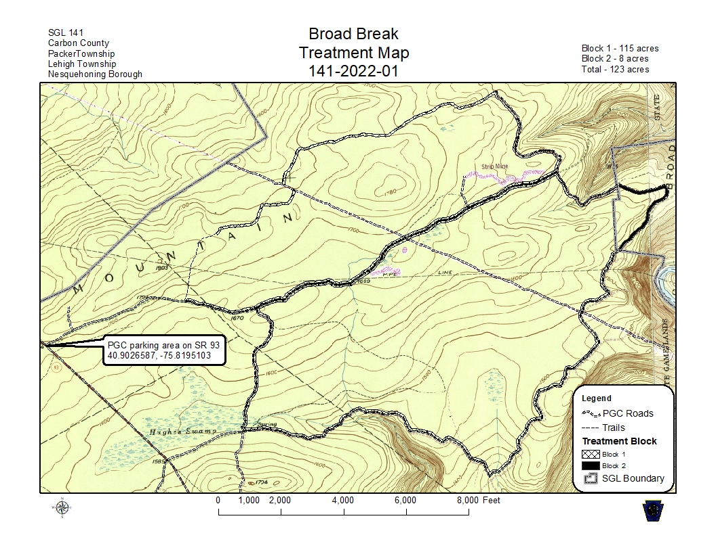
Attachment 3 – Location Map
