INFORMATION TECHNOLOGY SERVICES ITQ

REQUEST FOR QUOTATIONS FOR

Stratigraphic Information Data

Management System

ISSUING OFFICE

DEPARTMENT CONSERVATION AND NATURAL RESOURCES
Bureau of Administrative Services
Division of Procurement and Supply
400 Market Street, 7th Floor
Harrisburg, PA 17105

RFQ NUMBER: DCNR-38-11-02

DATE OF ISSUANCE

March 29, 2012

The Department of Conservation and Natural Resources (DCNR), Bureau of Administrative Services, Division of Procurement and Supply has posted solicitation RFQ #DCNR-38-11-02 for Stratigraphic Information Data Management System. Please go to the eMarketplace Website to view and download all documentation pertaining to this solicitation.

This is a restricted solicitation, only those contractors qualified in one (1) or more of the following service category(ies) under the Commonwealth’s Information Technology (IT) Services Invitation to Qualify (ITQ) Contract, 4400004480, prior to the bid opening date may respond.

- SOFTWARE, DEVELOPMENT,SERVICES,IT,ITQ
- SOFTWARE, DEVELOPMENT, TIME & MATERIALS

Organizations interested in doing business with the Commonwealth through this contract must begin by registering with the Commonwealth as a Procurement Supplier. For more information about registration, please view the Registration Guide.

Once an organization is registered with the Commonwealth, they must develop and submit a bid through the PASupplierPortal Website in order to qualify for one, all, or any combination of the service categories associated with this contract. The Commonwealth will evaluate the bid along with all supporting documentation to determine whether the organization meets the minimum eligibility requirements.

For more information about the Commonwealth’s Invitation to Qualify contracts and their policies, please visit the ITQ Website.

TABLE OF CONTENTS

CSA
CALENDAR OF EVENTS .………………………………………………………………………….4
PART I - GENERAL INFORMATION 5
PART II - PROPOSAL REQUIREMENTS 15
PART III - CRITERIA FOR SELECTION 24
PART IV - STATEMENT OF WORK 28
APPENDIX A - PROPOSAL COVER SHEET 50
APPENDIX B - DOMESTIC WORKFORCE UTILIZATION CERTIFICATION 51
Appendix C - Cost Matrix for Services 52
APPENDIX D - TRADE SECRET/CONFIDENTIAL PROPRIETARY INFORMATION NOTICE 55
APPENDIX E - RockIT Stratigraphic Information Data Management System, System Requirements Specification (SRS)

APPENDIX F - ERD

CALENDAR OF EVENTS

The Commonwealth will make every effort to adhere to the following schedule:

Activity | Responsibility | Date
Deadline to submit Questions via email to:  mflynn@pa.gov | Contractors | April 19, 2012 3:00PM
Preproposal Conference –  DCNR  Bureau of Topographic & Geologic Survey  3240 Schoolhouse Road  Middletown, PA 17057-3534  Directions: http://intradcnr/intratopogeo/tgsdirmdt.pdf | Issuing Office/  Contractors | May 1, 2012  10:00AM
Answers to Potential Contractor questions posted to the DGS website no later than this date. | Issuing Office | May 10, 2012  4:00PM
Please monitor the DGS website for all communications regarding the RFQ. | Contractors | On-Going
Sealed proposal must be received by the Issuing Office at 400 Market Street, 7th Floor  Harrisburg, PA 17101  Attn: Michelle Flynn | Contractors | May 31, 2012  2:30PM

PART I - GENERAL INFORMATION

- Purpose
This Request for Quotes ("RFQ") provides to those interested in submitting proposals for the subject procurement ("Contractors") sufficient information to enable them to prepare and submit proposals for the Department of Conservation and Natural Resources’ (DCNR) consideration on behalf of the Commonwealth of Pennsylvania ("Commonwealth") to satisfy a need for Stratigraphic Information Data Management System ("Project").

- Issuing Office
The DCNR, Bureau of Administrative Services, Division of Procurement and Supply ("Issuing Office") has issued this RFQ on behalf of the Commonwealth. The sole point of contact in the Commonwealth for this RFQ is Michelle Flynn, Bureau of Administrative Service, Division of Procurement & Supply, 400 Market Street, 7th Floor, Harrisburg, PA 17101, the Issuing Officer for this RFQ. Please refer all inquiries to the Issuing Officer.

- Scope
This RFQ contains instructions governing the requested proposals, including the requirements for the information and material to be included; a description of the service to be provided; requirements which Contractors must meet to be eligible for consideration; general evaluation criteria; and other requirements specific to this RFQ.

- Problem Statement
The purpose of this RFQ is to solicit the aid of a contractor in providing ON-SITE Data Repository Development services at the Topographic and Geologic Survey (T&G), Middletown Office. In April 2005, DCNR’s Bureau of Topographic and Geologic Survey (T&G) secured a staff augmentation contract. Under this contract, a Requirements Phase was mostly completed and a database was designed. An interface was developed to aid in the entry of outcrop data. In March 2009, an additional staff augmentation was done to look at an Outcrop pilot and current business needs, and finalize the requirements. The scope of this effort is to complete the implementation of the finalized model for a Stratigraphic Information Data Management System (RockIT). Interested contractors are to read the RockIT Stratigraphic Information Data Management System, System Requirements Specification (SRS) for a full understanding of the project as a whole. After which, review of this RFQ’s Statement of Work will provide clarity of the specific tasks required under this RFQ.

NOTE: Currently, there are a number of initiatives which are running in parallel, and others that will need to leverage the outcome of this RFQ. One is a data cleanup effort for all well data. Some of that data is being positioned for compliance with this repository. There will also be a series of Request for Quotes (RFQs) for wells systems, which will contain some Stratigraphic data.

Additional detail is provided in Part IV of this RFQ.

- Preproposal Conference
The Issuing Office will hold a preproposal conference as specified in the Calendar of Events. The purpose of this conference is to provide opportunity for clarification of the RFQ. Contractors should forward all questions to the Issuing Office in accordance with Part I-6 to ensure adequate time for analysis before the Issuing Office provides an answer. Contractors may also ask questions at the conference. In view of the limited facilities available for the conference, Contractors should limit their representation to two (2) individuals per Contractor. The preproposal conference is for information only. Any answers furnished during the conference will not be official until they have been verified, in writing, by the Issuing Office. All questions and written answers will be posted on the Department of General Services’ (“DGS”) website (www.emarketplace.state.pa.us) as an addendum to, and shall become part of, this RFQ. Attendance at the Preproposal Conference is optional.

- Questions and Answers
If a Contractor has any questions regarding this RFQ, the Contractor must submit the questions by email (with the subject line "IT ITQ RFQ DCNR-38-11-02 Question") to the Issuing Officer. If the Contractor has questions, they must be submitted via email no later than the date and time specified in the Calendar of Events. The Contractor shall not attempt to contact the Issuing Officer by any other means. The Issuing Officer will post the answers to the DGS website. A Contractor who submits a question after the deadline date for receipt of questions indicated on the Calendar of Events assumes the risk that its proposal will not be responsive or competitive because the Commonwealth is not able to respond before the proposal receipt date or in sufficient time for the Contractor to prepare a responsive or competitive proposal. When submitted after the deadline date for receipt of questions indicated on the Calendar of Events, the Issuing Officer may respond to questions of an administrative nature by directing the questioning Contractor to specific provisions in the RFQ. To the extent that the Issuing Office decides to respond to a non-administrative question after the deadline date for receipt of questions indicated on the Calendar of Events, the answer will be provided to all Contractors through an addendum.

All questions and responses as posted on the DGS website are considered as an addendum to, and part of, this RFQ. Each Contractor shall be responsible to monitor the DGS website for new or revised RFQ information. The Issuing Office shall not be bound by any verbal information nor shall it be bound by any written information that is not either contained within the RFQ or formally issued as an addendum by the Issuing Office. The Issuing Office does not consider questions to be a protest of the specifications or of the solicitation.

- Addenda to RFQ
If the Issuing Office deems it necessary to revise any part of this RFQ before the proposal response date, the Issuing Office will post an addendum to the DGS website. Answers to the questions asked during the questions and answer period will also be posted to the DGS website as an addendum to the RFQ.

- Electronic Version of RFQ
This RFQ is being made available by electronic means. The Contractor acknowledges and accepts full responsibility to insure that no changes are made to the RFQ. In the event of a conflict between a version of the RFQ in the Contractor's possession and the Issuing Office's version of the RFQ, the Issuing Office's version shall govern.

- Response Date
To be considered, proposals must arrive at the Issuing Office on or before the time and date specified in the RFQ Calendar of Events. Contractors which mail proposals should allow sufficient mail delivery time to ensure timely receipt of their proposals. If, due to inclement weather, natural disaster, or any other cause, the Issuing Office location to which proposals are to be returned is closed on the proposal response date, the deadline for submission shall be automatically extended until the next Commonwealth business day on which the office is open, unless the Contractors are otherwise notified by the Commonwealth. The time for submission of proposals shall remain the same. Late proposals will not be considered.

- Incurring Costs
The Issuing Office is not liable for any costs the Contractor incurs in preparation and submission of its proposal, in participating in the RFQ process or in anticipation of award of a purchase order.

- Economy Of Preparation
Contractors should prepare proposals simply and economically, providing a straightforward, concise description of the Contractor's ability to meet the requirements of the RFQ.

- Disadvantaged Business Information
The Issuing Office encourages participation by Small Disadvantaged Businesses as prime contractors, joint ventures and subcontractors/suppliers and by socially disadvantaged businesses as prime contractors.

Small Disadvantaged Businesses are small businesses that are owned or controlled by a majority of persons, not limited to members of minority groups, who have been deprived of the opportunity to develop and maintain a competitive position in the economy because of social disadvantages. The term includes:

- Department of General Services Bureau of Minority and Women Business Opportunities (BMWBO)-certified minority business enterprises (MBEs) and women business enterprises (WBEs) that qualify as small businesses; and

- United States Small Business Administration-certified 8(a) Small Disadvantaged Business concerns.

Small businesses are businesses in the United States that are independently owned, are not dominant in their field of operation, have no more than 100 full-time or full-time equivalent employees, and earn less than $20 million in gross annual revenues ($25 million in gross annual revenues for those businesses in the information technology sales or service business).

Socially disadvantaged businesses are businesses in the United States that BMWBO determines are owned or controlled by a majority of persons, not limited to members of minority groups, who are subject to racial or ethnic prejudice or cultural bias, but which do not qualify as small businesses. In order for a business to qualify as “socially disadvantaged,” the Contractor must include in its proposal clear and convincing evidence to establish that the business has personally suffered racial or ethnic prejudice or cultural bias stemming from the business person’s color, ethnic origin or gender.
Questions regarding this Program can be directed to:

Department of General Services
Bureau of Minority and Women Business Opportunities
Room 611, North Office Building
Harrisburg, PA 17125
Phone: (717) 783-3119
Fax: (717) 787-7052
Email: gs-bmwbo@state.pa.us
Website: www.dgs.state.pa.us

A database of BMWBO-certified minority- and women-owned businesses can be accessed at http://www.dgsweb.state.pa.us/mbewbe/VendorSearch.aspx.

The federal vendor database can be accessed at http://www.ccr.gov by clicking on Dynamic Small Business Search (certified companies are so indicated).

- Information Concerning Small Businesses in Enterprise Zones
The Issuing Office encourages participation by small businesses, whose primary or headquarters facility is physically located in areas the Commonwealth has identified as Designated Enterprise Zones, as prime contractors, joint ventures and subcontractors/suppliers.

The definition of headquarters includes, but is not limited to, an office or location that is the administrative center of a business or enterprise where most of the important functions of the business are conducted or concentrated and location where employees are conducting the business of the company on a regular and routine basis so as to contribute to the economic development of the geographical area in which the office or business is geographically located.

Small businesses are businesses in the United States that are independently owned, are not dominant in their field of operation, employ no more than 100 full-time or full-time equivalent persons and earn less than $20 million in gross annual revenues ($25 million in gross annual revenues for those businesses in the information technology sales or service business).

There is no database or directory of small businesses located in Designated Enterprise Zones. Information on the location of Designated Enterprise Zones can be obtained by contacting:

Aldona M. Kartorie
Center for Community Building
PA Department of Community and Economic Development
4th Floor, Commonwealth Keystone Building
400 North Street
Harrisburg, PA 17120-0225
Phone: (717) 720-7409
Fax: (717) 787-4088
Email: akartorie@state.pa.us

- Proposals
To be considered, Contractors must submit a complete proposal to this RFQ using the format provided in Part II. An official authorized to bind the Contractor to its proposal must sign the proposal. If the official signs the Proposal Cover Sheet (Appendix A to this RFQ) and the Proposal Cover Sheet is attached to the Contractor’s proposal, the requirement will be met. Each proposal page should be numbered for ease of reference.

Each Contractor must provide the following:

- Two (2) paper copies of the Technical Submittal
- Two (2) paper copies of the Cost Submittal
- Two (2) paper copies of the Disadvantaged Business Submittal
- Two (2) complete and exact copies of the entire proposal (Technical, Cost and Disadvantaged Business Submittals, along with all requested documents) on separate CD-ROMs or flash drives

The electronic copies must be a mirror image of the paper copy and must be in Microsoft Office and Adobe .pdf format. The Cost Submittal must be in Microsoft Excel. Each submittal (Technical, Cost and Disadvantaged Business) should be in a separate folder on the CD or flash drive. Contractors may not lock or protect any cells or tabs. Contractors should ensure that there is no costing information in the technical submittal. Contractors should not reiterate technical information in the cost submittal. The CD or Flash drive should clearly identify the Contractor and include the name and version number of the virus scanning software that was used to scan the CD or Flash drive before it was submitted. The Contractor shall make no other distribution of its proposal to any other Contractor or to any other Commonwealth official or Commonwealth consultant.

Proposals must remain valid for one hundred and twenty (120) days or until a purchase order is executed. Each Contractor submitting a proposal specifically waives any right to withdraw or modify it, except that the Contractor may withdraw its proposal by written notice received at the Issuing Office’s address for proposal delivery prior to the exact hour and date specified for proposal receipt. A Contractor or its authorized representative may withdraw its proposal in person prior to the exact hour and date set for proposal receipt, provided the withdrawing person provides appropriate identification and signs a receipt for the proposal. A Contractor may modify its submitted proposal prior to the exact hour and date set for proposal receipt only by submitting a new sealed proposal or sealed modification which complies with the RFQ requirements.

If the Issuing Office selects the Contractor’s proposal for award, the contents of the selected Contractor’s proposal will become, except to the extent the contents are changed through Best and Final Offers or negotiations, contractual obligations.

- Alternate Proposals
The Issuing Office has identified the basic approach to meeting its requirements, allowing Contractors to be creative and propose their best solution to meeting these requirements. The Issuing Office will not accept alternate proposals.

- Proposal Contents

- Confidential Information. The Commonwealth is not requesting, and does not require, confidential proprietary information or trade secrets to be included as part of Contractors’ submissions in order to evaluate proposals submitted in response to this RFQ. Accordingly, except as provided herein, Contractors should not label proposal submissions as confidential or proprietary or trade secret protected. Any Contractor who determines that it must divulge such information as part of its proposal must submit the signed written statement described in subsection c. below and must additionally provide a redacted version of its proposal, which removes only the confidential proprietary information and trade secrets, for required public disclosure purposes.

- Commonwealth Use. All material submitted with the proposal shall be considered the property of the Commonwealth of Pennsylvania and may be returned only at the Issuing Office’s option. The Commonwealth has the right to use any or all ideas not protected by intellectual property rights that are presented in any proposal regardless of whether the proposal becomes part of a contract. Notwithstanding any Contractor copyright designations contained on proposals, the Commonwealth shall have the right to make copies and distribute proposals internally and to comply with public record or other disclosure requirements under the provisions of any Commonwealth or United States statute or regulation, or rule or order of any court of competent jurisdiction.

- Public Disclosure. After the award of a contract pursuant to this RFQ, all proposal submissions are subject to disclosure in response to a request for public records made under the Pennsylvania Right-to-Know-Law, 65 P.S. § 67.101, et seq. If a proposal submission contains confidential proprietary information or trade secrets, a signed written statement to this effect must be provided with the submission in accordance with 65 P.S. § 67.707(b) for the information to be considered exempt under 65 P.S. § 67.708(b)(11) from public records requests (See Appendix D, Trade Secret/Confidential Proprietary Information Notice). Financial capability information submitted in response to Part II, Section II-8 of this RFQ is exempt from public records disclosure under 65 P.S. § 67.708(b)(26).

- Contractor’s Representations and Authorizations
By submitting its proposal, each Contractor understands, represents, and acknowledges that:

- All of the Contractor’s information and representations in the proposal are material and important, and the Issuing Office may rely upon the contents of the proposal in making an award. The Commonwealth shall treat any misstatement, omission or misrepresentation as fraudulent concealment of the true facts relating to the proposal submission, punishable pursuant to 18 Pa. C.S. § 4904.

- The Contractor has arrived at the price(s) and amounts in its proposal independently and without consultation, communication, or agreement with any other Contractor or potential Contractor.

- The Contractor has not disclosed the price(s), the amount of the proposal, nor the approximate price(s) or amount(s) of its proposal to any other firm or person who is a Contractor or potential Contractor for this RFQ, and the Contractor shall not disclose any of these items on or before the proposal submission deadline specified in the Calendar of Events of this RFQ.

- The Contractor has not attempted, nor will it attempt, to induce any firm or person to refrain from submitting a proposal on this contract, or to submit a proposal higher than this proposal, or to submit any intentionally high or noncompetitive proposal or other form of complementary proposal.

- The Contractor makes its proposal in good faith and not pursuant to any agreement or discussion with, or inducement from, any firm or person to submit a complementary or other noncompetitive proposal.

- To the best knowledge of the person signing the proposal for the Contractor, the Contractor, its affiliates, subsidiaries, officers, directors, and employees are not currently under investigation by any governmental agency and have not in the last four years been convicted or found liable for any act prohibited by State or Federal law in any jurisdiction, involving conspiracy or collusion with respect to bidding or proposing on any public contract, except as the Contractor has disclosed in its proposal.

- To the best of the knowledge of the person signing the proposal for the Contractor and except as the Contractor has otherwise disclosed in its proposal, the Contractor has no outstanding, delinquent obligations to the Commonwealth including, but not limited to, any state tax liability not being contested on appeal or other obligation of the Contractor that is owed to the Commonwealth.

- The Contractor is not currently under suspension or debarment by the Commonwealth, any other state or the federal government, and if the Contractor cannot so certify, then it shall submit along with its proposal a written explanation of why it cannot make such certification.

- The Contractor has not made, under separate contract with the Issuing Office, any recommendations to the Issuing Office concerning the need for the services described in its proposal or the specifications for the services described in the proposal.

- The Contractor, by submitting its proposal, authorizes Commonwealth agencies to release to the Commonwealth information concerning the Contractor's Pennsylvania taxes, unemployment compensation and workers’ compensation liabilities.

- The selected Contractor shall not begin to perform until it receives a fully executed purchase order from the Commonwealth.

- Restriction Of Contact
From the issue date of this RFQ until the Issuing Office selects a proposal for award, the Issuing Officer is the sole point of contact concerning this RFQ. Any violation of this condition may be cause for the Issuing Office to reject the offending Contractor's proposal. If the Issuing Office later discovers that the Contractor has engaged in any violations of this condition, the Issuing Office may reject the offending Contractor's proposal or rescind its purchase order award. Contractors must agree not to distribute any part of their proposals beyond the Issuing Office. A Contractor who shares information contained in its proposal with other Commonwealth personnel and/or competing Contractor personnel may be disqualified.

- Prime Contractor Responsibilities
The selected Contractor will be required to assume responsibility for all services offered in its proposal whether it produces them itself or by subcontract. The Issuing Office and Project Manager will consider the selected Contractor to be the sole point of contact with regard to contractual and purchase order matters.

- Resources
Contractors shall provide all services, supplies, facilities, and other support necessary to complete the identified work, except as otherwise provided in this Part I-20.

The Commonwealth will provide the following:

- Workspaces for all development team members will be made available for the duration of the project.
  - Workspace will include all office supplies and needed hardware and software.
- Participation in User-Developer Meetings
- Participate in User Acceptance Testing.
- Review revisions to all System Training Manuals.
- Provide required training facilities for consultant to train users.
- A DCNR training environment.

- Rejection Of Proposals
The Issuing Office reserves the right, in its sole and complete discretion, to reject any proposal received in response to this RFQ, or to negotiate separately with competing Contractors.

- Discussions for Clarification
Contractors may be required to make an oral or written clarification of their proposals to the Issuing Office to ensure thorough mutual understanding and contractor responsiveness to the solicitation requirements. The Issuing Office will initiate requests for clarification. Clarifications may occur at any stage of the evaluation and selection process prior to issuance of a purchase order.

- Best and Final Offer (BAFO)

- While not required, the Issuing Office reserves the right to conduct discussions with Contractors for the purpose of obtaining “Best and Final Offers.” To obtain Best and Final Offers from Contractors, the Issuing Office may do one or more of the following, in combination and in any order:

- Schedule oral presentations;

- Request revised proposals;

- Conduct a reverse online auction; and
- Enter into pre-selection negotiations.

- The following offerors will not be invited by the Issuing Office to submit a Best and Final Offer:

- Those Contractors which the Issuing Office has determined to be not responsible or whose proposals the Issuing Office has determined to be not responsive.

- Those Contractors, which the Issuing Office has determined in accordance with Part III, Section III-4, from the submitted and gathered financial and other information, do not possess the financial capability, experience or qualifications to assure good faith performance of the contract.

- Those Contractors whose score for their technical submittal of the proposal is less than 70% of the total amount of technical points allotted to the technical criterion.

The Issuing Office may further limit participation in the Best and Final Offers process to those remaining responsible Contractors which the Issuing Office has, within its discretion, determined to be within the top competitive range of responsive proposals.

- Evaluation Criteria found in Part III, Section III-3, shall also be used to evaluate the Best and Final Offers.

- Price reductions offered through any reverse online auction shall have no effect upon the Contractor’s Technical Submittal. Dollar commitments to Disadvantaged Businesses and Enterprise Zone Small Businesses can be reduced only in the same percentage as the percent reduction in the total price offered through any reverse online auction or negotiations.

- Notification of Selection

  - Negotiations. The Issuing Office will notify all offerors in writing of the Contractor selected for negotiations after the Issuing Office has determined, taking into consideration all of the evaluation factors, the proposal that is the most advantageous to the Issuing Office.

  - Award. Offerors whose proposals are not selected will be notified when negotiations have been successfully completed and the Issuing Office has received the final negotiated contract signed by the selected Contractor.

- Purchase Order
The successful Contractor will be issued a purchase order with reference to IT ITQ Contract #4400004480. The term of the purchase order will commence on the Effective Date and will end in two (2) years. No work may begin or be reimbursed prior to issuance of the purchase order. The selected Contractor will be paid after submitting invoices, provided it is in accordance with the work plan and approved by the Commonwealth Project Manager. Final payment will not be made until all Project work has been successfully completed.

- Debriefing Conferences
Upon notification of award, Contractors whose proposals were not selected will be given the opportunity to be debriefed. The Issuing Office will schedule the debriefing at a mutually agreeable time. The debriefing will not compare the Contractor with other Contractors, other than the position of the Contractor’s proposal in relation to all other Contractor proposals.

- News Releases
Contractors shall not issue news releases, internet postings, advertisements or any other public communications pertaining to this Project without prior written approval of the Issuing Office, and then only in coordination with the Issuing Office.

- Terms and Conditions
The requirements and terms and conditions of IT ITQ Contract #4400004480 shall govern the purchase order issued as a result of this RFQ.

- Information Technology Bulletins
This RFQ is subject to the Information Technology Bulletins (ITB’s) issued by the Office of Administration, Office for Information Technology (OA-OIT). ITB’s may be found at http://www.portal.state.pa.us/portal/server.pt?open=512&objID=416&PageID=210791&mode=2

All proposals must be submitted on the basis that all ITB’s are applicable to this procurement. It is the responsibility of the Contractor to read and be familiar with the ITB’s. Notwithstanding the foregoing, if the Contractor believes that any ITB is not applicable to this procurement, it must list all such ITB’s in its technical response, and explain why it believes the ITB is not applicable. The Issuing Office may, in its sole discretion, accept or reject any request that an ITB not be considered to be applicable to the procurement. The Contractor’s failure to list an ITB will result in its waiving its right to do so later, unless the Issuing Office, in its sole discretion, determines that it would be in the best interest of the Commonwealth to waive the pertinent ITBs.

PART II - PROPOSAL REQUIREMENTS

- General Requirements
Contractors must submit their proposals in the format, including heading descriptions, outlined below. The proposal must respond to all requirements in this part of the RFQ. Contractors should provide any other information thought to be relevant, but not applicable to the enumerated categories, as an appendix to the Proposal. All cost data relating to this proposal and all Disadvantaged Business cost data should be kept separate from and not included in the Technical Submittal. Each Proposal shall consist of the following three separately sealed submittals:

- Technical Submittal, which shall be a response to RFQ Part II, Sections II-2 through II-9;

- Disadvantaged Business Submittal, in response to RFQ Part II, Section II-10; and

- Cost Submittal, in response to RFQ Part II, Section II-11.

The Issuing Office reserves the right to request additional information which, in the Issuing Office’s opinion, is necessary to assure that the Contractor’s competence, number of qualified employees, business organization, and financial resources are adequate to perform according to the RFQ.

The Issuing Office may make investigations as deemed necessary to determine the ability of the Contractor to perform the Project, and the Contractor shall furnish to the Issuing Office all requested information and data. The Issuing Office reserves the right to reject any proposal if the evidence submitted by, or investigation of, such Contractor fails to satisfy the Issuing Office that such Contractor is properly qualified to carry out the obligations of the RFQ and to complete the Project as specified.

- Statement of the Problem
State in succinct terms your understanding of the problem presented or the service required by this RFQ.

- Management Summary
Include a narrative description of the proposed effort and a list of the items to be delivered or services to be provided.

- Work Plan
Describe in narrative form your technical plan for accomplishing the work. Use the task descriptions in Part IV of this RFQ as your reference point. Modifications of the task descriptions are permitted; however, reasons for changes should be fully explained. Indicate the number of person hours allocated to each task. Include a Program Evaluation and Review Technique (PERT) or similar type display, time related, showing each event. If more than one approach is apparent, comment on why you chose this approach.When developing your overall project schedule, use the breadth of the RockIT Stratigraphic Information Data Management System, System Requirements Specification (SRS) and the supplied Entity Relationship Diagram (ERD – data migration purposes) to determine level of effort needed to complete this RFQ.

- Prior Experience
Include experience in database design, repository development, Oracle and geology. Experience shown should be work done by individuals who will be assigned to this project as well as that of your company. Studies or projects referred to must be identified and the name of the customer shown, including the name, address, and telephone number of the responsible official of the customer, company, or agency who may be contacted.

- Personnel
Include the number of executive and professional personnel, analysts, auditors, researchers, programmers, consultants, etc., who will be engaged in the work. Show where these personnel will be physically located during the time they are engaged in the Project. For key personnel (such as project manager, lead DBA, or team lead geologist), include the employee’s name and, through a resume or similar document, the Project personnel’s education and experience in geology and database repository development. Indicate the responsibilities each individual will have in this Project and how long each has been with your company. Identify by name any subcontractors you intend to use and the services they will perform.

Resumes are not to include personal information that will, or will be likely to, require redaction prior to release of the proposal under the Right to Know Law. This includes home addresses and phone numbers, Social Security Numbers, Drivers’ License numbers or numbers from state ID cards issued in lieu of a Drivers’ License, financial account numbers, etc. If the Commonwealth requires any of this information for security verification or other purposes, the information will be requested separately and as necessary.

Include a project organizational chart for your proposed team.

Additionally, summary information about all the personnel resources must be shown in the table formats provided:

Resource Name | Years with company | Total years IT experience | Certifications?
John Smith | 5 | 18

Skill | John Smith | Sally Smith | Jane Doe | John Doe |  |  |  |  | Total
MS Visual Basic.Net | 2 | 2 | 1 | 0 |  |  |  |  | 5
MS ASP. Net, C+, etc. | 2 | 1 | 0 | 1 |  |  |  |  | 4
CSS | 1 | 3 | 1 | 0 |  |  |  |  | 4
HTML | 5 | 4 | 4 | 4 |  |  |  |  | 17
XML | 4 | 2 | 2 | 1 |  |  |  |  | 9
Oracle (11g) | 4 | 5 (1) | 5 (2) | 1 |  |  |  |  | 15 (3)
Oracle SQL Developer Data Modeler | 0 | 4 | 4 | 0 |  |  |  |  | 8
Project Management | 2 | 0 | 0 | 8 |  |  |  |  | 10
Geologic | 5 | 6 | 1 | 0 |  |  |  |  | 12

Indicate the responsibilities each individual will have in this project, how long each individual has been with your company and their experience on projects similar to this engagement. The Commonwealth project team reserves the right to interview and/or reject any and all resources proposed by the selected contractor. Provide a summary synopsis of each proposed candidate, what skills they will bring to the project and what their role will be.

Describe the company’s proposed approach to coordinating the efforts of the various subcontractors proposed. DCNR reserves the right to interview and approve any contractor staffing changes. For such changes, the Contractor is responsible for providing 2-week transition between old resources and new resources, etc.

- Training
If appropriate, indicate recommended training of agency personnel. Include the agency personnel to be trained, the number to be trained, duration of the program, place of training, curricula, training materials to be used, number and frequency of sessions, and number and level of instructors.

- Financial Capability
Describe your company’s financial stability and economic capability to perform the Project requirements. Provide your company’s financial statements for the past two (2) fiscal years. If your company is a publicly traded company, please provide a link to your financial records on your company website; otherwise, provide two (2) years of your company’s financial documents such as audited financial statements. Financial statements must include the company’s Balance Sheet and Income Statement or Profit/Loss Statements. Also include a Dun & Bradstreet comprehensive report if available. The Commonwealth reserves the right to request additional information it deems necessary to evaluate a Contractor’s financial capability.

- Emergency Preparedness.
To support continuity of operations during an emergency, including a pandemic, the Commonwealth needs a strategy for maintaining operations for an extended period of time. One part of this strategy is to ensure that essential contracts that provide critical business services to the Commonwealth have planned for such an emergency and put contingencies in place to provide needed goods and services.

- Describe how it is anticipated such a crisis will impact Contractor’s operations.
- Describe Contractor’s emergency response continuity of operations plan. Attach a copy of the plan, or at a minimum, summarize how the plan addresses the following aspects of pandemic preparedness:
    - Employee training (describe Contractor’s training plan, and how frequently the plan will be shared with employees)
    - Identified essential business functions and key employees (within Contractor’s organization) necessary to carry them out
    - Contingency plans for:
  - How Contractor will handle staffing issues when a portion of key employees are incapacitated due to illness.
  - How Contractor employees will carry out the essential functions if contagion control measures prevent them from coming to the primary workplace.
    - How Contractor will communicate with staff and suppliers when primary communications systems are overloaded or otherwise fail, including key contacts, chain of communications (including suppliers), etc.
    - How and when Contractor’s emergency plan will be tested, and if the plan will be tested by a third-party.

- Disadvantaged Business Submittal

- Disadvantaged Business Information.

    - To receive credit for being a Small Disadvantaged Business or a Socially Disadvantaged Business or for entering into a joint venture agreement with a Small Disadvantaged Business or for subcontracting with a Small Disadvantaged Business (including purchasing supplies and/or services through a purchase agreement), a Contractor must include proof of Disadvantaged Business qualification in the Disadvantaged Business Submittal of the proposal, as indicated below:

      - A Small Disadvantaged Business certified by BMWBO as an MBE/WBE must provide a photocopy of its BMWBO certificate.

      - A Business certified by the U.S. Small Business Administration pursuant to Section 8(a) of the Small Business Act (15 U.S.C. § 636(a)) as an 8(a) Small Disadvantaged Business must submit proof of U.S. Small Business Administration certification. The owners of such business must also submit proof of United States citizenship.

      - A business claiming Small Disadvantaged Business status, whether as a result of BMWBO certification, or U.S. Small Business Administration certification as an 8(a) Small Disadvantaged Business, must attest to the fact that the business has no more than 100 full-time or full-time equivalent

      - A business claiming Small Disadvantaged Business status, whether as a result of BMWBO certification, or U.S. Small Business Administration certification as an 8(a) Small Disadvantaged Business, must submit proof that its gross annual revenues are less than $20,000,000 ($25,000,000 for those businesses in the information technology sales or service business). This can be accomplished by including a recent tax return or audited financial statement.

    - A business claiming status as a Socially Disadvantaged Business must include in the Disadvantaged Business Submittal of the proposal clear and convincing evidence to establish that the business has personally suffered racial or ethnic prejudice or cultural bias stemming from the business person’s color, ethnic origin or gender. The submitted evidence of prejudice or bias must:

      - Be rooted in treatment that the business person has experienced in American society, not in other countries.

      - Show prejudice or bias that is chronic and substantial, not fleeting or insignificant.

      - Indicate that the business person’s experience with the racial or ethnic prejudice or cultural bias has negatively impacted his or her entry into and/or advancement in the business world.

BMWBO shall determine whether the Contractor has established that a business is socially disadvantaged by clear and convincing evidence.

    - In addition to the above verifications, the Contractor must include in the Disadvantaged Business Submittal of the proposal the following information:

      - A Small Disadvantaged Business submitting a proposal as the prime Contractor, must include a numerical percentage which represents the total percentage of the work (as a percentage of the total cost in the Cost Submittal) to be performed by the Contractor and not by subcontractors and suppliers.

      - A Small Disadvantaged Business submitting a proposal as a part of a joint venture partnership, must include a numerical percentage which represents the total percentage of the work (as a percentage of the total cost in the Cost Submittal) to be performed by the Small Disadvantaged Business joint venture partner and not by subcontractors and suppliers or by joint venture partners who are not Small Disadvantaged Businesses. The Contractor must also provide:

- The amount of capital, if any, each Small Disadvantaged Business joint venture partner will be expected to provide.

- A copy of the joint venture agreement signed by all parties.

- The business name, address, name and telephone number of the primary contact person for the Small Disadvantaged Business joint venture partner.

      - All Contractors must include a numerical percentage which represents the total percentage of the total cost in the Cost Submittal that the Contractor commits to paying to Small Disadvantaged Businesses as subcontractors. To support its total percentage Disadvantaged Business subcontractor commitment, the Contractor must also include:

- The dollar amount of each subcontract commitment to a Small Disadvantaged Business.

- The name of each Small Disadvantaged Business. The Contractor will not receive credit for stating that it will find a Small Disadvantaged Business after the purchase order is awarded.

- The services or supplies each Small Disadvantaged Business will provide, including the timeframe for providing the services or supplies.

- The location where each Small Disadvantaged Business will perform services.

- The timeframe for each Small Disadvantaged Business to provide or deliver the goods or services.

- A signed subcontract or letter of intent for each Small Disadvantaged Business. The subcontract or letter of intent must identify the specific work, goods or services the Small Disadvantaged Business will perform and how the work, goods or services relates to the project.

- The name, address and telephone number of the primary contact person for each Small Disadvantaged Business.

      - The total percentages and each subcontractor commitment will become contractual obligations once the contract is fully executed.

      - The name and telephone number of the Contractor’s project (contact) person for the Small Disadvantaged Business information.

    - The Contractor is required to submit two (2) copies of its Disadvantaged Business Submittal. The submittal shall be clearly identified as Disadvantaged Business information and sealed in its own envelope, separate from the remainder of the proposal.

    - A Small Disadvantaged Business can be included as a subcontractor with as many prime contractors as it chooses in separate proposals.

    - A Contractor that qualifies as a Small Disadvantaged Business and submits a proposal as a prime contractor is not prohibited from being included as a subcontractor in separate proposals submitted by other Contractors.

  - Enterprise Zone Small Business Participation

    - To receive credit for being an enterprise zone small business or entering into a joint venture agreement with an enterprise zone small business or subcontracting with an enterprise zone small business, a Contractor must include the following information in the Disadvantaged Business Submittal of the proposal:

      - Proof of the location of the business’ headquarters (such as a lease or deed or Department of State corporate registration), including a description of those activities that occur at the site to support the other businesses in the enterprise zone.

      - Confirmation of the enterprise zone in which it is located (obtained from the local enterprise zone office).

      - Proof of United States citizenship of the owners of the business.

      - Certification that the business has no more than 100 full-time or full-time equivalent employees.

      - Proof that the business’ gross annual revenues are less than $20,000,000 ($25,000,000 for those businesses in the information technology sales or service business). This can be accomplished by including a recent tax return or audited financial statement.

      - Documentation of business organization, if applicable, such as articles of incorporation, partnership agreement or other documents of organization.

    - In addition to the above verifications, the Contractor must include in the Disadvantaged Business Submittal of the proposal the following information:

      - The name and telephone number of the Contractor’s project (contact) person for the Enterprise Zone Small Business.

      - The business name, address, name and telephone number of the primary contact person for each Enterprise Zone Small Business included in the proposal. The Contractor must specify each Enterprise Zone Small Business to which it is making commitments. The Contractor will not receive credit for stating that it will find an Enterprise Zone Small Business after the contract is awarded or for listing several businesses and stating that one will be selected later.

      - The specific work, goods or services each Enterprise Zone Small Business will perform or provide.

      - The total cost amount submitted in the Contractor’s cost proposal and the estimated dollar value of the contract to each Enterprise Zone Small Business.

      - Of the estimated dollar value of the contract to each Enterprise Zone Small Business, the percent of the total value of services or products purchased or subcontracted that each Enterprise Zone Small Business will provide.

      - The location where each Enterprise Zone Small Business will perform these services.

      - The timeframe for each Enterprise Zone Small Business to provide or deliver the goods or services.

      - The amount of capital, if any, each Enterprise Zone Small Business will be expected to provide.

      - The form and amount of compensation each Enterprise Zone Small Business will receive.

      - For a joint venture agreement, a copy of the agreement, signed by all parties.

      - For a subcontract, a signed subcontract or letter of intent.

    - The dollar value of the commitment to each Enterprise Zone Small Business must be included in the same sealed envelope with the Disadvantaged Business Submittal of the proposal. The following will become a contractual obligation once the contract is fully executed:

      - The amount of the selected Contractor’s Enterprise Zone Small Business commitment;

      - The name of each Enterprise Zone Small Business; and

      - The services each Enterprise Zone Small Business will provide, including the timeframe for performing the services.

- Cost Submittal

The information requested in this Part II-11 and Appendix C (Cost Matrix) shall constitute the Cost Submittal. The Cost Submittal shall be placed in a separate sealed envelope within the sealed proposal and kept separate from the technical submittal. The total proposed cost must be broken down into the components listed on Appendix C.

Contractors should not include any assumptions in their cost submittals. If the Contractor includes assumptions in its cost submittal, the Issuing Office may reject the proposal. Contractors should direct in writing to the Issuing Office pursuant to Part I, Section I-6 of this RFQ, any questions about whether a cost or other component is included or applies. All Contractors will then have the benefit of the Issuing Office’s written answer so that all proposals are submitted on the same basis.

The Commonwealth will reimburse the selected Contractor for work satisfactorily performed after execution of a purchase order and the start of the purchase order term, in accordance with Contract requirements.

- Domestic Workforce Utilization
Contractors must complete and sign the Domestic Workforce Utilization Certification attached to this RFQ as Appendix B. Contractors who seek consideration for the Domestic Workforce Utilization Certification criterion must complete, sign, and submit the Domestic Workforce Utilization Certification Form in the same sealed envelope with the Technical Submittal.

PART III - CRITERIA FOR SELECTION

- Mandatory Responsiveness Requirements
To be eligible for evaluation, a proposal must:

- Be timely received from a Contractor; and

- Be properly signed by the Contractor.

- Technical Nonconforming Proposals
The Mandatory Responsiveness Requirements set forth in Part III-1 above (a-b) are the only RFQ requirements that the Commonwealth will consider to be non-waivable. The Issuing Office reserves the right, in its sole discretion, to (1) waive any other technical or immaterial nonconformities in a Contractor's proposal, (2) allow the Contractor to cure the nonconformity, or (3) consider the nonconformity in the scoring of the Contractor’s proposal.

- Evaluation Criteria
The following criteria will be used in evaluating each proposal.

- Technical: The Issuing Office has established the weight for the Technical criterion for this RFQ as 50% of the total points. Evaluation will be based upon the following: Soundness of Approach (including Understanding the Problem, Work Plan & Training), Experience (including Prior Experience & Personnel), Financial Capability, Management Summary, and Emergency Preparedness.

- Cost: The Issuing Office has established the weight for the Cost criterion for this RFQ as 30% of the total points.

- Disadvantaged Business Participation:
BMWBO has established the weight for the Disadvantaged Business (DB) Participation criterion for this RFQ as 20 % of the total points. Evaluation will be based upon the following in order of priority:

Priority Rank 1 Proposals submitted by Small Disadvantaged Businesses.

Priority Rank 2 Proposals submitted from a joint venture with a Small Disadvantaged Business as a joint venture partner.

Priority Rank 3 Proposals submitted with subcontracting commitments to Small Disadvantaged Businesses.

Priority Rank 4 Proposals submitted by Socially Disadvantaged Businesses.
Each DB participation submittal will be rated for its approach to enhancing the utilization of Small Disadvantaged Businesses and/or Socially Disadvantaged Businesses. Each approach will be evaluated, with Priority Rank 1 receiving the highest score and the succeeding options receiving scores in accordance with the above-listed priority ranking. To the extent that there are multiple DB Participation submittals that offer subcontracting commitments to Small Disadvantaged Businesses, the proposal offering the highest total percentage commitment shall receive the highest score in the Priority Rank 3 category and the other proposal(s) in that category shall be scored in proportion to the highest total percentage commitment offered.

To qualify as a Small Disadvantaged Business or a Socially Disadvantaged Business, the Small Disadvantaged Business or Socially Disadvantaged Business cannot enter into subcontract arrangements for more than 40% of the total estimated dollar amount of the contract. If a Small Disadvantaged Business or a Socially Disadvantaged Business subcontracts more than 40% of the total estimated dollar amount of the contract to other contractors, the Disadvantaged Business Participation scoring shall be proportionally lower for that proposal.

- Enterprise Zone Small Business Participation:
In accordance with the priority ranks listed below, bonus points in addition to the total points for this RFQ, will be given for the Enterprise Zone Small Business Participation criterion. The maximum bonus points for this criterion is 3% of the total points for this RFQ. The following options will be considered as part of the final criteria for selection:

Priority Rank 1 Proposals submitted by an Enterprise Zone Small Business will receive a three percent bonus for this criterion.

Priority Rank 2 Proposals submitted by a joint venture with an Enterprise Zone Small Business as a joint venture partner will receive a two percent bonus for this criterion.

Priority Rank 3 Proposals submitted with a subcontracting commitment to an Enterprise Zone Small Business will receive a one percent bonus for this criterion.

Priority Rank 4 Proposals with no Enterprise Zone Small Business Utilization will receive no points under this criterion.

To the extent that a Contractor is an Enterprise Zone Small Business, the Contractor cannot enter into contract or subcontract arrangements for more than 40% of the total estimated dollar amount of the contract in order to qualify as an Enterprise Zone Small Business for purposes of this RFQ.

- Domestic Workforce Utilization: Any points received for the Domestic Workforce Utilization criterion are bonus points in addition to the total points for this RFQ. The maximum bonus points for this criterion is 3% of the total points for this RFQ. To the extent permitted by the laws and treaties of the United States, each proposal will be scored for its commitment to use domestic workforce in the fulfillment of the contract. Maximum consideration will be given to those Contractors who will perform the contracted direct labor exclusively within the geographical boundaries of the United States or within the geographical boundaries of a country that is a party to the World Trade Organization Government Procurement Agreement. Those who propose to perform a portion of the direct labor outside of the United States and not within the geographical boundaries of a party to the World Trade Organization Government Procurement Agreement will receive a correspondingly smaller score for this criterion. Contractors who seek consideration for this criterion must submit in hardcopy the signed Domestic Workforce Utilization Certification Form in the same sealed envelope with the Technical Submittal. The certification will be included as a contractual obligation when the contract is executed.

- Contractor Responsibility
To be responsible, a Contractor must submit a responsive proposal and possess the capability to fully perform the contract requirements in all respects and the integrity and reliability to assure good faith performance of the Project.

In order for a Contractor to be considered responsible for this RFQ and therefore eligible for selection for Best and Final Offers or selection for negotiations:

- The total score for the technical submittal of the Contractor’s proposal must be greater than or equal to 70% of the available technical points.

- The Contractor’s financial capability information must demonstrate that the Contractor possesses the financial capability to assure good faith performance of the Project. The Issuing Office will assess each Contractor’s financial capacity based on industry standard analysis of the Contractor’s financial statements requested with the technical submittal. This may include:

- ratio, horizontal or vertical analysis;
- industry comparison using Dun & Bradstreet’s Key Business Ratios to measure Contractor’s solvency, efficiency and profitability;
- the ratio of the Contractor’s annual sales revenue to the expected annual spend for this Project;
- the percentage of the Contractor’s annual sales revenue attributed to the Commonwealth; and
- the Contractor’s sustainable growth rate.

The Issuing Office reserves the right, in its sole discretion, to reject the proposal of any Contractor who fails to achieve acceptable scores on the Dun & Bradstreet’s Key Business Ratios or has a sustainable growth rate which does not support the addition of the expected annual spend for this Project.

Further, the Issuing Office will award a purchase order only to a Contractor determined to be responsible in accordance with the most current version of Commonwealth Management Directive 215.9, Contractor Responsibility Program.

- Evaluation
The Issuing Office has selected a committee of qualified personnel to review and evaluate timely submitted proposals. Independent of the committee, BMWBO will evaluate the Disadvantaged Business Submittal and provide the Issuing Office with a rating for this component of each proposal. After taking into consideration all of the evaluation factors, the Issuing Office will determine which proposal offers the best value to the Commonwealth. The Issuing Office will notify in writing the responsible Contractor selected for negotiations.
PART IV - STATEMENT OF WORK

- Objectives

  - General. This project involves the creation of a stratigraphic database repository.

  - Specific. While the tasks described within this RFQ are focused on specific modules, it is to be clearly understood that the RockIT Stratigraphic Information Data Management System, System Requirements Specification (SRS) document as a whole is to be honored. The application of geologic data types will be created in a hierarchical “tree like” data architecture which in general terms includes the following tiers / levels: Subject Matter Details / Analysis Results, Geologic Features / Events / Samples, Stations, and projects.

- Nature and Scope of the Project

This project involves the creation of a stratigraphic database repository for a state-wide view of Pennsylvania’s geology. A sound project management methodology will be used on this project, which will require the development of formal design specifications, work breakdown structure, project tracking, and regular project management/status reports. This is a highly scientific application; hence a carefully planned workflow and an elegant design for which the differing elements are represented will be a necessity to ensure the efficiency and usability of the final product.

The first responsibility will be for the successful Contractor to fully understand the RockIT Stratigraphic Information Data Management System, System Requirements Specification (SRS). During a previous contract, an overall framework of the data to be supported by this database was documented. For expediency and focus, a draft requirements document was developed with the outcrop information and a sample database was created. However, the science of stratigraphic usage has changed drastically because of new drilling practices, leaving this older design ineffective. While T&G are no longer interested in leveraging this design, the data will need to be ported into the new repository arena.

In spring 2010, the Requirements document was completed, allowing T&G and BITS to formulate a game plan for how this tool was to be implemented. Below are the pertinent exerts from that document which frame the work to be accomplished under the purchase order. While the tasks described within this RFQ are focused on specific modules within the RockIT concept, it is to be clearly understood that the RockIT Stratigraphic Information Data Management System, System Requirements Specification (SRS) document as a whole is to be honored. By example, while not directly referenced within this RFQ, the Database Integrity & Change Tracking requirements are to be honored for all developed modules.

- Requirements

IV-3.1 Data Architecture

IV-3.1.1 As mentioned above, as a result of our comprehensive survey DCNR arrived at a data architecture which organizes data in terms of the nature of its content rather than the workflows that produce it.

To comply with this model, the concept of “what the data is” has to be clearly isolated from other concepts such as “what location in space is described by this data”, “how is this data grouped” and “who owns the data.”

This is important because it will allow data categories to be defined with a minimum of conceptual redundancies or ambiguities so that:
- Once the system is implemented, it must be possible to extend it to capture new types of geologic features and descriptive details without having to re-architect the entire system / code foundation.
- Applications written to deal with individual data categories will be more or less independent of each other and contain a minimum of redundant functionality, resulting in code that is slimmer, more modular and easier to maintain.
- Procedures and applications created to handle this data can be standardized and reused, minimizing the need to create special code for every situation.
- A system with clearly defined components also becomes easier to master and has a better chance of being adopted within the organization it is meant to serve.
IV-3.1.2. The application of this philosophy to a review of geologic data types has resulted in a hierarchical “tree like” data architecture which in general terms includes the following tiers / levels (graphically depicted in Figure IV-1):
- Subject Matter Details / Analysis Results:
  - This level represents the actual geologic data / content (“what the data is”) that describes every geologic feature / event / sample stored in this system.
  - This level consists of multiple specialized tables which would typically contain items such as rock descriptions, lithologic interpretations, geochemical analyses and other lab results, special data types such as XRD, SEM and thin-sections, sinkhole descriptions, landslide descriptions, field and sample pictures, etc. These are described in more detail in the “Geologic Features / Events / Samples and Analysis Results” section 4.2, of the RockIT Stratigraphic Information Data Management System, System Requirements Specification (SRS).
- Geologic Features / Events / Samples:
- This level represents the actual geologic entities that are being described by the aforementioned Subject Matter Details / Test Results. The term features will henceforth be used to imply geologic features, geologic events or geologic samples.
- This level consists of multiple tables defined for individual types of geologic features. These are described in more detail under “Geologic Features / Events / Samples and Analysis Results” section 4.2, of the RockIT Stratigraphic Information Data Management System, System Requirements Specification (SRS).
- This level exists primarily to allow for the association of multiple types of details / results with a single feature, as well as to make possible the existence of adjacent features (of the same or different type) such that each feature is associated with its own set of details and results.
- A particular set of details or results, for its part, can belong to only one geologic feature / event / sample.
- Stations:
- Stations represent geometric placeholders that serve to reference geologic Features to distinct locations in space.
- A Station may group many adjacent or coincident Geologic Features; however, a Geologic Feature / Event / Sample may belong to only one station.
- Additionally, “Survey data” may be associated with a station if it represents a drill hole or a measured section.
- The design is to provide for three types of tables for stations:
    - Stations Table: Includes the primary header data and origin coordinates
    - Survey Table: Includes survey data for drill holes and measured sections
    - Station Type Tables: Include specialized data required for specific types of stations.
These are described in more detail under “Spatial Reference and Stations” below.
- Projects:
- The Projects level represents groupings of data based on user-defined criteria (geographic extent, research methodology or date of incident, for example).
- Projects are an aggregate unit, grouping all data content: features / events and samples. If a geologic feature belongs to a project, so do all of the subject matter details and test results that belong to the feature.
- A project can have many geologic features but a geologic feature can belong to only one project.
- Projects also represent the basic unit of data by which security is managed in this system.
- Project information is stored in two tables, a main projects table and a PROJECT_PERMISSIONS table. These are described in more detail under “Security and Data Integrity based on Projects and Users” Section 2.2, with additional information in the System Administration, Section 6, of the RockIT Stratigraphic Information Data Management System, System Requirements Specification (SRS).
- Users:
- Users represent “logins” into the geologic information system.
- Logins will be assigned an edit permission level: read, edit, none (for logins that have been retired).
- A user shall own or have a set of permissions to one or more complete projects but not to part of a project. There shall be only one owner for a project.
- A user shall be able to own one or more stations. There shall, however, be only one owner for a station.
- User information is stored in a “USERS” table
- User ownership over projects is implemented by means of the aforementioned PROJECT_PERMISSIONS table. The main USERS table and the PROJECT_PERMISSIONS table are described in more detail under “Security and Data Integrity based on Projects and Users” in Section 2.2, of the RockIT Stratigraphic Information Data Management System, System Requirements Specification (SRS).
- Ownership over stations shall be implemented by including a “user id” foreign key in the main stations table.
IV-3.1.3 - Additional basic rules regarding overall data organization:
- User ids/names must be unique system wide.
- Projects shall have two identifier columns:
- User defined project name, does not have to be unique system-wide but the system shall alert a user trying to create a project with a name that already exists. Project listing functions of RockIT shall include user names where project names are non-unique.
- Machine generated project id guaranteed to be unique system wide.
- Stations shall also have two identifier columns:
- User define station name, does not have to be unique system-wide but the system shall alert a user trying to create a station with a name that already exists. Station listing functions of RockIT shall include user names where station names are non-unique.
- Machine generated station id guaranteed to be unique system wide.
- Stations are a special case in that they are associated users directly, rather than to projects. This provision makes it easy for stations to be shared by geologic features belonging to multiple projects. This means that stations can be employed by users who do not own them in order to reference new geologic features to pre-defined locations in space.
- Stations may only be modified by their owners. Modifications to stations may include updates to the header information as well as adjustments to spatial positions in cases where coordinates might include errors.
- It shall be possible to re-assign specific geologic features from one station to another in order to improve spatial accuracy where required.
- In order to protect information representing the historical origin of the data, it shall not be possible to move geologic features from one project to another.
It shall be possible to create a virtual association of geologic events / features / samples to projects other than the ones in which they were created. This shall be implemented by means of a join table which shall store the association of project ids to event / feature / sample ids.
- It shall be possible to transfer ownership of a project from one user to another. This shall be a system administrator function. A chain of ownership shall be preserved by implementing fields for starting and ending dates of ownership within the PROJECT_PERMISSIONS table.

Figure IV-1 Conceptual Data Architecture for Geologic Information System

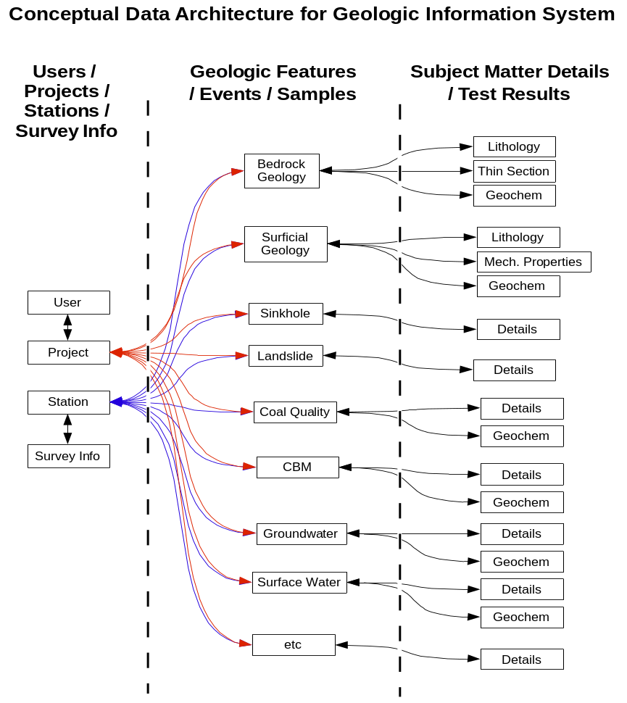

Depicts areas to be addressed via this RFQ.

IV-3.2 Typical Linear Station Scenarios

The data model described in the previous sections has been structured to be flexible enough to handle a wide variety of real world situations. While many of the ways in which this system should function can be inferred from the previously described requirements, we consider it necessary to provide explicit examples to insure that the design and development phases of RockIT proceed based on a clear understanding of the intent of this data model with regards to linear stations.
The following table and descriptions outline a set of assumptions and procedures for various envisioned scenarios:

Table IV-2 Data Input Required for Typical Linear Station Scenarios
Stations |  |  | Geologic Features / Events / Samples |  |  |  |  | Planar Element
Linear Station Type | Survey Data |  | Lengths Not Reduced | Lengths Reduced | Thickness Not Reduced | Thickness Reduced |  | Planar Element Orientation
Non Surveyed Measured Section | Assumed Perpendicular to Layering |  | N/A | N/A | N/A | Values |  | OPTIONAL
Non Surveyed Measured Section | Assumed Perpendicular to Layering |  | N/A | Values | N/A | Calculated directly from Reduced Lengths |  | OPTIONAL
Surveyed Measured Section | REQUIRED |  | N/A | N/A | Values | Calculated from Planar Element Orientation & Thickness Not Reduced. If no Planar Element, assumed equal Thickness Not Reduced |  | OPTIONAL
Surveyed Measured Section | REQUIRED |  | Values | N/A | N/A | Calculated from Planar Element Orientation & Lengths Not Reduced. If no Planar Element, calculated directly from Lengths Not Reduced |  | OPTIONAL
Non Surveyed Drill Hole | If No Value Assumed Vertical |  | Values | N/A | N/A | This value is calculated as before. Left blank if Planar Element Orientation is unknown |  | OPTIONAL
Non Surveyed Drill Hole | If No Value Assumed Vertical |  | N/A | N/A | Values | This value is calculated as before. Left blank if Planar Element Orientation is unknown |  | OPTIONAL
Surveyed Drill Hole | REQUIRED |  | Values | N/A | N/A | This value is calculated as before. Left blank if Planar Element Orientation is unknown |  | OPTIONAL
Surveyed Drill Hole | REQUIRED |  | N/A | N/A | Values | This value is calculated as before. Left blank if Planar Element Orientation is unknown |  | OPTIONAL

- Measured section with no survey information whatsoever:
  - Using Thickness Values:
    - Thickness values are assumed to represent measurements perpendicular to the orientation of lithologic layering (representative of “true” thickness), thus are populated in the “Thickness Reduced” field
    - For lithologic units described along measured sections a planar element orientation should be given. If it is omitted the unit is assumed to have no planar fabric or structure. (Exception – Where true thickness has been measured directly.)
    - In general, for measured sections the sequence of units should be maintained. In this case, because only thicknesses are used, maintaining the sequence of units is required. The system cannot enforce the correct sequence because it has no prior knowledge of the geology, however it shall notify the user that in this case the sequence is critical.
    - XYZ coordinates are not calculated for features associated with non-surveyed measured sections. Three fields for X, Y and Z coordinate values: This is the spatial location for a point like station. For a drill hole (linear station) this would be the location of the collar. Coordinate System & Precision: Horizontal values shall be stored as lat long in decimal degrees using double precision floating point numbers and shall conform to the NAD 83 coordinate system. Vertical coordinates shall by default be expressed in feet above mean sea level conforming to the North American Vertical Datum of 88 (NAVD 88). It shall be possible to enter horizontal and vertical coordinates in different coordinate systems and units and have the software transform these into the default units. This functionality can be implemented through a variety of freely available OGC and USGS software libraries (for example Proj4, Vertcon). This functionality should also make it possible to obtain coordinates for points on assumed grids based on sets of control points and azimuths. Optionally, it shall also be possible to use Lidar data to extract/replace vertical coordinates for stations located on the surface from Lidar data. This is highly desirable because Lidar data currently has the best available vertical accuracy and already conforms to the NAVD 88 vertical datum.
    - Total thickness is defined by the sum of all thickness values.
  - Using Length Values
    - Length values are assumed to represent measurements perpendicular to the orientation of lithologic layering (representative of “true” thickness), thus a re populated in the “Length Reduced” fields.
    - For lithologic units described along measured sections a planar element orientation should be given. If it is omitted the unit is assumed to have no planar fabric or structure. (Exception – Where true thickness has been measured directly.)
    - In general, for measured sections the sequence of units should be maintained. In this case, because length values are entered, maintaining the sequence of units is not critical.
    - XYZ coordinates are not calculated for features associated with non-surveyed measured sections. Three fields for X, Y and Z coordinate values: This is the spatial location for a point like station. For a drill hole (linear station) this would be the location of the collar. Coordinate System & Precision: Horizontal values shall be stored as lat long in decimal degrees using double precision floating point numbers and shall conform to the NAD 83 coordinate system. Vertical coordinates shall by default be expressed in feet above mean sea level conforming to the North American Vertical Datum of 88 (NAVD 88). It shall be possible to enter horizontal and vertical coordinates in different coordinate systems and units and have the software transform these into the default units. This functionality can be implemented through a variety of freely available OGC and USGS software libraries (for example Proj4, Vertcon). This functionality should also make it possible to obtain coordinates for points on assumed grids based on sets of control points and azimuths. Optionally, it shall also be possible to use Lidar data to extract/replace vertical coordinates for stations located on the surface from Lidar data. This is highly desirable because Lidar data currently has the best available vertical accuracy and already conforms to the NAVD 88 vertical datum
    - Total thickness is defined by the maximum length reported for a geologic feature.
- Measured section with survey information.
- Every survey record must have depth as well as angular information otherwise it cannot be counted as a survey record (note that where the vertical angle is 90º the azimuth is undefined). If only depth information is present: Treat as if no survey information whatsoever is present.
- Measured section is assumed to describe a polygonal path with straight segments between survey points where every azimuth and vertical angle pair correspond to a straight segment starting at the distance value of the current survey point and ending at the distance value of the next survey point. The last survey point does not require angular information.
- Using Thickness Values:
    - Thickness values are not assumed to represent measurements perpendicular to the orientation of lithologic layering (representative of “apparent” thickness), thus they are populated in the “Thickness Not Reduced” field. Thickness could be assumed to be true if it is known that the measured section survey line is precisely perpendicular to lithologic layering, or if a “No Visible Layers” planar element is chosen.
    - For lithologic units described along measured sections a planar element orientation should be given. If it is omitted the unit is assumed to have no planar fabric or structure. (Exception – Where true thickness has been measured directly.)
    - In general, for measured sections the sequence of units should be maintained. In this case, because only thicknesses are used, maintaining the sequence of units is required. The system cannot enforce the correct sequence because it has no prior knowledge of the geology, however it shall notify the user that in this case the sequence is critical.
    - XYZ coordinates are calculated for all features associated with a surveyed measured section. Three fields for X, Y and Z coordinate values: This is the spatial location for a point like station. For a drill hole (linear station) this would be the location of the collar. Coordinate System & Precision: Horizontal values shall be stored as lat long in decimal degrees using double precision floating point numbers and shall conform to the NAD 83 coordinate system. Vertical coordinates shall by default be expressed in feet above mean sea level conforming to the North American Vertical Datum of 88 (NAVD 88). It shall be possible to enter horizontal and vertical coordinates in different coordinate systems and units and have the software transform these into the default units. This functionality can be implemented through a variety of freely available OGC and USGS software libraries (for example Proj4, Vertcon). This functionality should also make it possible to obtain coordinates for points on assumed grids based on sets of control points and azimuths. Optionally, it shall also be possible to use Lidar data to extract/replace vertical coordinates for stations located on the surface from Lidar data. This is highly desirable because Lidar data currently has the best available vertical accuracy and already conforms to the NAVD 88 vertical datum
    - True (reduced) thickness could be calculated from survey information, apparent thickness and the orientation of a planar element describing lithologic layering. If the unit is assumed to have no planar fabric or structure, the true thickness is assumed to be equal to the non-reduced thickness.
- Using Length Values
    - Length values are not assumed to represent measurements perpendicular to the orientation of lithologic layering (representative of “apparent” thickness), unless it is known that the measured section survey line is precisely perpendicular to lithologic layering, or if a “No Visible Layers” planar element is chosen. In any case length values should be populated in the “Length Not Reduced” fields.
    - For lithologic units described along measured sections a planar element orientation should be given. If it is omitted the unit is assumed to have no planar fabric or structure. (Exception – Where true thickness has been measured directly.)
    - In general, for measured sections the sequence of units should be maintained. In this case because length values are entered, maintaining the sequence of units is not critical.
    - XYZ coordinates are calculated for all features associated with a surveyed measured section. Three fields for X, Y and Z coordinate values: This is the spatial location for a point like station. For a drill hole (linear station) this would be the location of the collar. Coordinate System & Precision: Horizontal values shall be stored as lat long in decimal degrees using double precision floating point numbers and shall conform to the NAD 83 coordinate system. Vertical coordinates shall by default be expressed in feet above mean sea level conforming to the North American Vertical Datum of 88 (NAVD 88). It shall be possible to enter horizontal and vertical coordinates in different coordinate systems and units and have the software transform these into the default units. This functionality can be implemented through a variety of freely available OGC and USGS software libraries (for example Proj4, Vertcon). This functionality should also make it possible to obtain coordinates for points on assumed grids based on sets of control points and azimuths. Optionally, it shall also be possible to use Lidar data to extract/replace vertical coordinates for stations located on the surface from Lidar data. This is highly desirable because Lidar data currently has the best available vertical accuracy and already conforms to the NAVD 88 vertical datum
    - True thickness could be calculated from survey information, apparent thickness and the orientation of a planar element describing lithologic layering. If the unit is assumed to have no planar fabric or structure, the true thickness can be calculated directly from the non-reduced lengths.
- Drill-hole with no survey information whatsoever:
- Using Thickness Values:
- Drill hole is assumed to be vertical and straight
- Thickness values are not assumed to represent measurements perpendicular to the orientation of lithologic layering (representative of “apparent” thickness), thus they are populated in the “Thickness Not Reduced” field. Thickness could be assumed to be true if it is known that the measured section survey line is precisely perpendicular to lithologic layering, or if a “No Visible Layers” planar element is chosen.
- No assumption is made regarding layering orientation of geologic features. Planar Element Orientation can either be recorded, assumed to be horizontal or left blank and assumed to be unknown.
- True (reduced) thickness is calculated unless the Planar Element Orientation is left blank.
- XYZ coordinates of every feature are calculated but horizontal position is the same as that of the starting point.
- Total thickness / depth is defined by the sum of all thickness values.
  - Using Length Values:
    - Drill hole is assumed to be vertical and straight
    - Length values are not assumed to represent measurements perpendicular to the orientation of lithologic layering (representative of “apparent” thickness), unless it is known that the measured section survey line is precisely perpendicular to lithologic layering, or if a “No Visible Layers” planar element is chosen. In any case length values should be populated in the “Length Not Reduced” fields.
    - No assumption is made regarding layering orientation of geologic features. Planar Element Orientation can either be recorded, assumed to be horizontal or left blank and assumed to be unknown.
    - True (reduced) thickness is calculated unless the Planar Element Orientation is left blank.
    - XYZ coordinates of every feature are calculated but horizontal position is the same as that of the starting point.
    - Total depth is assumed to be defined by the maximum “Length” value of any feature.
- Drill-hole with survey information
- Every survey record must have depth as well as angular information otherwise it cannot be counted as a survey record (note that where the vertical angle is 90º the azimuth is undefined).
- If only one angle is present drill hole is assumed to be straight and trending as described by the angle.
- For multiple angles and lengths drill hole is assumed to describe a gradually changing curved path (segmented for speed of processing). This means that the back calculation required to define the drill hole’s path through 3D space must gradually change its orientation before getting to a surveyed point, such that when it gets there it is already pointing in the right direction.
- Using Thickness Values:
- Thickness values are not assumed to represent measurements perpendicular to the orientation of lithologic layering (representative of “apparent” thickness), thus they are populated in the “Thickness Not Reduced” field. Thickness could be assumed to be true if it is known that the measured section survey line is precisely perpendicular to lithologic layering, or if a “No Visible Layers” planar element is chosen.
- No assumption is made regarding layering orientation of geologic features. Planar Element Orientation can either be recorded, assumed to be horizontal or left blank and assumed to be unknown.
- True (reduced) thickness is calculated unless the Planar Element Orientation is left blank
- XYZ coordinates of every feature are calculated.
- Total apparent thickness / depth is defined by the last survey point.
  - Using Length Values:
    - Length values are not assumed to represent measurements perpendicular to the orientation of lithologic layering (representative of “apparent” thickness), unless it is known that the measured section survey line is precisely perpendicular to lithologic layering, or if a “No Visible Layers” planar element is chosen. In any case length values should be populated in the “Length Not Reduced” fields.
    - No assumption is made regarding layering orientation of geologic features. Planar Element Orientation can either be recorded, assumed to be horizontal or left blank and assumed to be unknown.
    - True (reduced) thickness is calculated unless the Planar Element Orientation is left blank.
    - XYZ coordinates of every feature are calculated.
    - Total apparent thickness / depth is defined by the last survey point.

The diagrams in the following pages illustrate how the main components of the proposed model in fit together and are capable of describing a stations and geologic features in space.

Figure IV-3 Conceptual Model for Point & Linear Stations (Outcrops and Drill Hole Data)
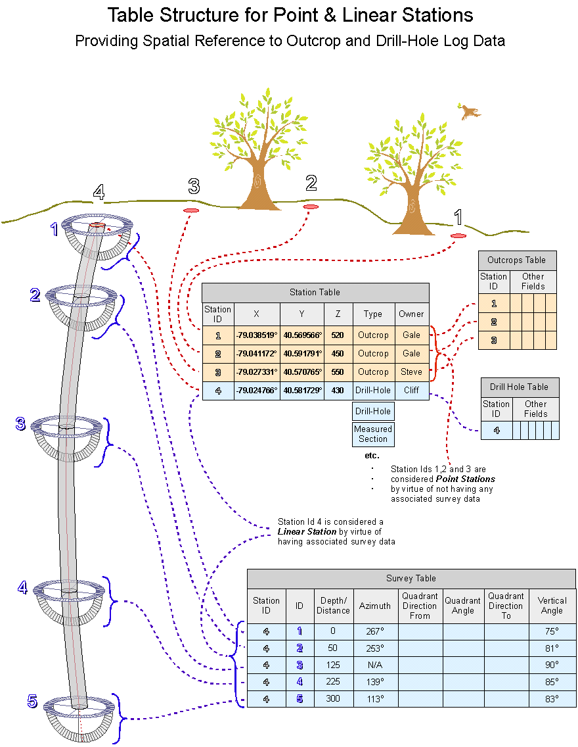

Figure IV-4 Conceptual Model for Linear Stations (Measured Section)
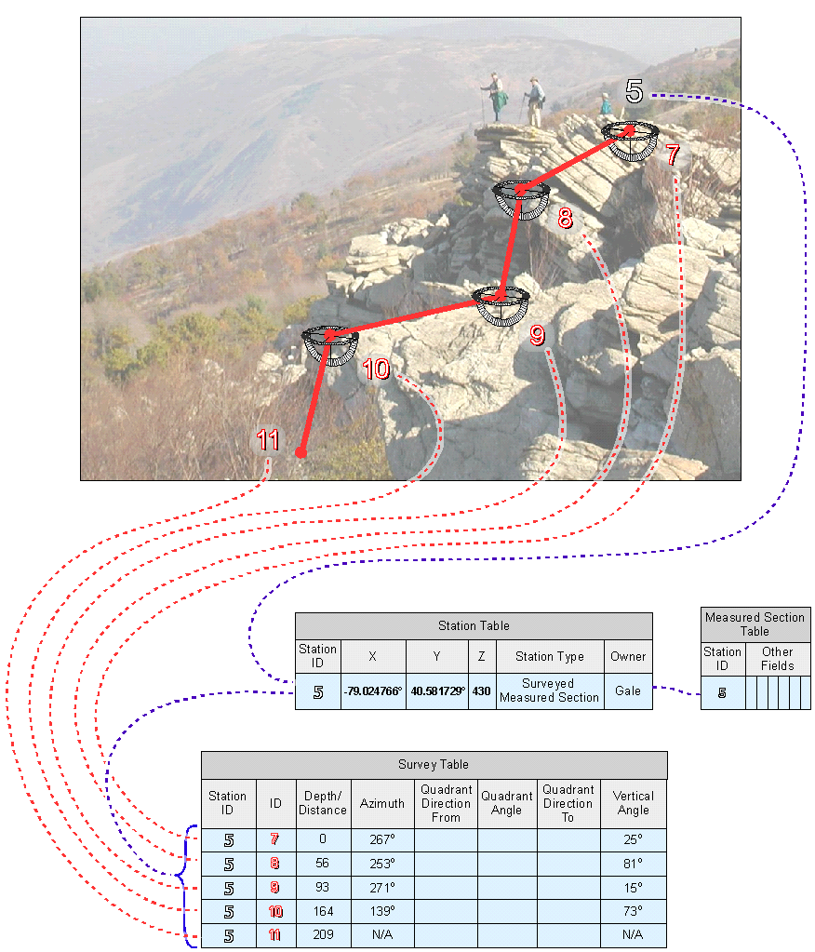

Figure IV-5 Table Structure for Geologic Features, Events & Samples,
Coordinates are Calculated On The Fly
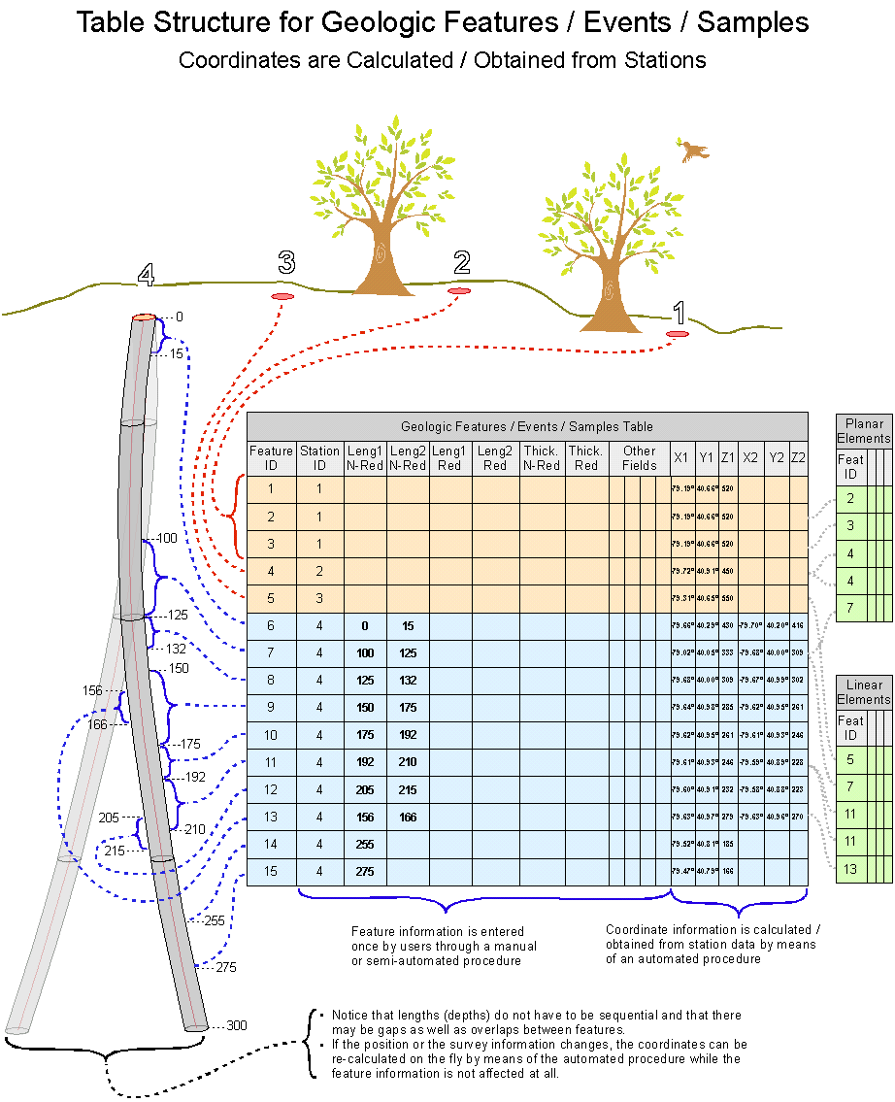

IV-3.3 Work Location

The location for project coordination will be:

Bureau of Topographic and Geologic Survey (T&G)
Department of Conservation and Natural Resources (DCNR)
3240 Schoolhouse Road
Middletown, PA 17057-3534

Primary Contact will be:

Mr. Sandipkumar Patel
Phone: (717) 702-4277
E-mail: sapatel@state.pa.us

Alternate Contact will be:

Mr. Earl Stoltzfus
Phone: (717) 346-1256
E-mail: estoltzfus@pa.gov

IV-3.4 Work Skills

The selected Contractor's team must be comprised of staff with the necessary experience and skills to create an effective data repository encompassing a series of stratigraphic utility tools as per the requirements below.

Research Team:

- Minimum of 5+ years in database design and creation activities, preferably in science-based systems.
- As a team, members are to be experienced with the following technologies, which may be used in the build of the database:
  - Application development experience with designing, programming and implementing web based applications
  - Experience in HTML, CSS, XML, JavaScript, COM+, MS Visual Studio, MS Visual Basic.NET and MS ASP.NET
  - Proficient and/or certified in Oracle 11g as a data modeler/designer. Additionally, the Oracle resource(s) must be fluent in the use of data modeling tools - specifically, Oracle’s SQL Developer Data Modeler.
  - Microsoft Certified Solution Developer (MCSD) credential preferred.
- Previous application development experience in Geology related projects is required.

- TASKS

The following are tasks to be completed by the successful contractor:

IV-4.1 Phase 1 – Requirements Familiarity
- Attend Kick-Off meeting with key stakeholders. At this meeting, scope of the effort is to be reviewed and agreed to by all team members. The T&G and BITS project manager will determine DCNR participants. The Contractor is to provide a scope document as a result of this meeting.
- Contractor is to conduct a thorough review of the RockIT Stratigraphic Information Data Management System, System Requirements Specification (SRS), and the stratigraphic ERD (to obtain a walkthrough of the current database architecture) operating environment for the Stratigraphic Database, and DCNR naming convention standards. The walkthrough will be provided by the DCNR, BITS, Oracle Database Administrator (DBA).
- Deliverables:
- Project Plan - Develop Project Plan that incorporates the deliverables being requested. This Project Plan is to include all major milestones, roles and target dates
- Scope Document – The project scope states what will and will not be included as part of the project. Scope provides a common understanding of the project for all stakeholders by defining the project's overall boundries.
- Validation Of Requirements – As an initial deliverable, the contractor is to review the specification document, verifying their understanding of the RockIT Stratigraphic Information Data Management System, System Requirements Specification (SRS).
IV-4.2 Phase 2- Design and Build
- Upon successful completion and approval of the RockIT Stratigraphic Information Data Management System, System Requirements Specification (SRS) comprehension from Phase 1, a Design Specification is to be developed.
- Given the importance of usability for this application, workflow, look and feel are to be addressed. The contractor is to provide a storyboard concept(s) of the final system look and feel, as the document’s first section. The contractor is to provide a design which will drive a user through the steps necessary for data input and extract.
- Second section is to address database design. This section is to be reviewed and approved by the T&G PM and BITS DBA. The BITS DBA will provide the selected vendor with a copy of the DCNR naming convention standards during the Requirements Familiarity phase.
- Remaining sections are to be broken down per the layout defined in IV-3.3.3, Development.
- In each section, the following expectations are to be considered and reflected:
  - Development – This interface is to be developed in current technologies. The Division Chief of BITS Application Services Division will aid in providing Commonwealth and departmental development standards. Standards will center around naming conventions, code reuse, and code commenting, etc.
  - Database Design – The Contractor is to provide a well normalized ERD. Views are also to be defined, which will target the needs for data exports and reporting.
  - Integration and System Testing – The successful Contractor must develop a plan for the testing of the Units, Integration and System. As the Contractor has determined a successful Unit Test, these Units, along with test scripts, are to be submitted to the T&G Project Manager for quality assurance. This process is to be followed for the integration and system testing as well.
  - User and IT Support Training - DCNR’s Topographic and Geologic Survey (TGS) will need 25 geologists from their Middletown office and four (4) geologists from the Pittsburgh Office (usage of WebEx is acceptable) to be trained. TGS will also need three (3) IT support staff trained on the product for familiarity of usage and support. The DCNR Bureau of Information Technology Services (BITS) will also require knowledge transfer and training for the BITS Database Administrator, and a developer on the user interfaces.
  - User Acceptance Testing – A core set of users will be identified by T&G for User Acceptance. The Contractor is to train this core set of users on system utilization. Users will evaluate the clarity of the Contractor developed user documentation, follow test cases and perform ad hoc testing routines.
  - Implementation and Go Live – This is an internal system, and for the purpose of this RFQ, will remain internal to T&G in Middletown and Pittsburgh until populated. The full production system will use the existing network infrastructure, hardware and software.
  - Documentation/Knowledge Transfer – Close-Out Documentation is to include a Physical Design Document, Logical Flows, Technical Support, User Manuals, and on-line help files. Knowledge transfer is to be provided to the T&G and BITS PM to the extent that upon completion, the T&G and BITS Project Managers will be able to independently perform system support activities, such as backups, minor changes, fulfill data and reporting requests, etc. The successful Contractor is to provide the Database Administrator of the DCNR Bureau of Information Technology Services a representative ERD providing an overview of data tables developed. Application interface documentation will also be provided. T&G and BITS will need a detailed implementation plan for the roll-out within T&G.
  - NOTE: This section is broken into a number of deliverable products – as required by the ITQ process. In the practice of product development, these sections can be done together, but be mindful that no payment is made against developed products until they are completed and approved by DCNR – hence the granularity of these deliverables.
- The Contractor will use this information and map the user needs to the utilities and modules identified in this RFQ. Specifically, key areas for consideration in the construction of the Stratigraphic Database System (RockIT) is as follows:
  - Development – Refer to Figure IV-1. The application is to be developed utilizing Oracle and .Net Technology. The major sub-Deliverables to be developed are as follows:
    - Users/Projects/Stations/Survey Information
      - User
      - Project
      - Station
    - Survey Information
      - Geologic Features/ Events/ Samples
      - Bedrock Geology
      - Surficial Geology
    - Subject Matter Details/Test Results
      - Lithology
      - Thin Section
      - Geochem
      - Mech Properties

  - Data Migration – The backend database for this effort is Oracle. Working with the BITS DBA, the contractor is to develop data migration schema from the collector’s databases or from the pilot database to the final product.
    - NCRDS – One area in particular, migrating Pennsylvania’s data from the US Geological Survey’s National Coal database (NCRDS) into the Pennsylvania Geological Survey’s stratigraphic database.
    - Existing Outcrop database.
    - Other areas as defined in the RockIT Stratigraphic Information Data Management System, System Requirements Specification (SRS), Section 3.3.2, Data Migration Scripts.
    - Others may be identified later and added via contract amendment.
  - Creation of Data Export Utilities – Menu driven Sub-Deliverables to be provided are as follows (working with BITS DBA):
    - Data Export for ArcGIS as a data table – A report writing software such as Oracle Discoverer may be utilized for the purpose of extracting data from the stratigraphic database in ASCII or MS Access format. The contractor will not be responsible for the installation of such software, but will be responsible for creating a view for users to easily extract the data. User would import data table into ArcGIS manually and use latitude/longitude coordinates to create a shape file for analysis.
    - Generic Data Extract Utilities – Section 3.5, Data Export, of the RockIT Stratigraphic Information Data Management System, System Requirements Specification (SRS) reflect the major extract needs from this database. Flexible tools will also be needed for specialized extract requests, which will be received by T&G.
  - Creation of Import Utilities – Import Utilities are to be developed (working with BITS DBA) for import to the centralized Oracle database from a number of alternative sources. Vendor will need to perform import responsibilities on these pre-defined sources:
    - Import data from the STATEMAP database into the Outcrop modules.
    - Import from NCRDS to Drill Hole
    - Import data collected in the field from hand-held devices directly into selected modules. Hand held device data is ported into an Access database. The contractor is to devise a utility, which will allow the user to transport their Access data into the overall stratigraphic repository. Should the contractor have alternative methods they would like to suggest, DCNR is willing to entertain alternative approaches.
    - Develop recurring data migration routines, which will run against internal sources (spreadsheets, databases, etc.). Refer to Section 3.3 Data Import of the RockIT Stratigraphic Information Data Management System, System Requirements Specification (SRS).

- REPORTS AND PROJECT CONTROL

As noted above, a kick-Off meeting is to be conducted at project start-up. During this meeting, responsibilities will be clarified, initial priorities will be set (based on the task list of this RFQ), and a walkthrough of the current stratigraphic database will be conducted. Required forms for project tracking will be presented and agreed upon. These forms will include Change Control and status reports. Procedures for application/database changes and version control will be finalized as well. In general, this process will work as follows:
- The successful Contractor will develop and submit the overall Project Plan. This Plan will be reviewed by the DCNR T&G and BITS Project Manager for completeness and feasibility.
- The successful Contractor will update this Project Plan with an estimate of work involved and project impacts. It should also note any potential complications. T&G will review this revised Project Plan for accuracy. Both the Contractor and DCNR are to sign the final Project Plan before work may begin.
- The successful Contractor will conduct work at the DCNR Middletown site and the Harrisburg Rachel Carson State Office Building (RCSOB). . Because the IT and customer knowledge experts are in differing locations, the project team members will given space at both locations for easy access to DCNR resources, depending on project phase needs. For work identified above, development is to be conducted on a utility component-by-component basis. This will streamline version control and testing. This will also aid in overall documentation cleanup and programming comments.
- Once deliverables are formally approved in writing by the DCNR T&G project manager, the deliverable will be considered as viable for billing.
The successful Contractor will maintain documentation in a timely manner, including but not limited to:

- Documentation for the overall project shall include, but not be limited to, project plans with GANTT charts, status reports and updates, issues, risks, and system documentation. The documents are to follow documentation standards as established by EPMM, the Commonwealth’s standard development methodology (or comparable corporate methodology).
- Weekly reports are to be submitted to the DCNR T&G and BITS Project Manager. These reports are to be submitted prior to weekly status meetings and will be used to determine project prioritizations. Format of this report will be determined with the successful contractor upon award of a purchase order.
- Monthly project status tracking reports and meetings will be held with BTGS and BIT. Reports will be submitted to the DCNR Project Managers.

IV-5 INFORMATION TECHNOLOGY BULLETIN (ITB) COMPLIANCE REQUIREMENT

Service providers delivering services/systems to agencies under the Governor’s jurisdiction are required to comply with the IT standards and policies issued by the Governor’s Office of Administration, Office for Information Technology (OA/OIT), for the Commonwealth enterprise (See http://www.portal.state.pa.us/portal/server.pt?open=512&objID=402&mode=2). When an agency and/or service provider believes there is a need to deviate from these standards/policies, they must first receive approval to do so from the OA/OIT’s Deputy Secretary.

IV-6 DISADVANTAGED BUSINESS PARTICIPATION AND ENTERPRISE ZONE SMALL BUSINESS PARTICIPATION

All contracts containing Disadvantaged Business participation must also include a provision requiring the contractor to meet and maintain those commitments made to Disadvantaged Businesses and/or Enterprise Zone Small Businesses at the time of proposal submittal or contract negotiation, unless a change in the commitment is approved by the BMWBO. All contracts containing Disadvantaged Business participation and/or Enterprise Zone Small Business participation must include a provision requiring Small Disadvantaged Business subcontractors and Enterprise Zone Small Business subcontractors to perform at least 50 percent of the subcontract.

Commitments to Disadvantaged Businesses and/or Enterprise Zone Small Businesses made at the time of proposal submittal or contract negotiation must be maintained throughout the term of the contract. Any proposed change must be submitted to BMWBO which will make a recommendation as to a course of action to the contracting officer.

If a contract is assigned to another contractor, the new contractor must maintain the Disadvantaged Businesses participation and/or Enterprise Zone Small Business participation of the original contract.

The contractor shall complete the Prime Contractor's Quarterly Utilization Report (or similar type document containing the same information) and submit it to the contracting officer of the agency that awarded the contract and BMWBO within 10 workdays at the end of each quarter the contract is in force. If there was no activity, the form must also be completed, stating “No activity in this quarter.” This information will be used to determine the actual dollar amount paid to Small Disadvantaged Business and/or Enterprise Zone Small Business subcontractors and suppliers. Also, it is a record of fulfillment of the commitment your firm made and for which it received Disadvantaged Business and Enterprise Zone Small Business points.

NOTE: EQUAL EMPLOYMENT OPPORTUNITY AND CONTRACT COMPLIANCE STATEMENTS REFERRING TO COMPANY EQUAL EMPLOYMENT OPPORTUNITY POLICIES OR PAST CONTRACT COMPLIANCE PRACTICES DO NOT CONSTITUTE PROOF OF DISADVANTAGED BUSINESS STATUS OR ENTITLE A PROPOSER TO RECEIVE CREDIT FOR DISADVANTAGED BUSINESS UTILIZATION.”

APPENDIX A - PROPOSAL COVER SHEET
COMMONWEALTH OF PENNSYLVANIA
DCNR
Bureau of Administrative Services, Division of Procurement & Supply
RFQ# DCNR-38-11-02

Enclosed in three separately sealed submittals is the proposal of the Contractor identified below for the above-referenced RFQ:

Contractor Information
Contractor Name
Contractor Mailing Address
Contractor Website
Contractor Contact Person
Contact Person’s Phone Number
Contact Person’s Facsimile Number
Contact Person’s Email Address
Contractor Federal ID Number

Submittals Enclosed and Separately Sealed
Technical Submittal
Disadvantaged Business Submittal
Cost Submittal

Signature
Signature of an official authorized to bind the Contractor to the provisions contained in the Contractor’s proposal:
Printed Name
Title

APPENDIX B - DOMESTIC WORKFORCE UTILIZATION CERTIFICATION

To the extent permitted by the laws and treaties of the United States, this certification will be used by the Agency in making a best value selection for each particular assignment. Each quote will be evaluated for its commitment to use the domestic workforce in the fulfillment of the contract. Maximum consideration will be given to those suppliers who will perform the contracted direct labor exclusively within the geographical boundaries of the United States or within the geographical boundaries of a country that is a party to the World Trade Organization Government Procurement Agreement. Those who propose to perform a portion of the direct labor outside of the United States and not within the geographical boundaries of a party to the World Trade Organization Government Procurement Agreement will receive a correspondingly smaller score for this criterion. In order to be eligible for any consideration for this criterion, suppliers must complete and sign the following certification. This certification will be included as a contractual obligation when the contract is executed. Failure to complete and sign this certification will result in no consideration being given to the supplier for this criterion.

I, [title] of [name of Contractor] a [place of incorporation] corporation or other legal entity, (“Contractor”) located at [address], having a Social Security or Federal Identification Number of [number], do hereby certify and represent to the Commonwealth of Pennsylvania ("Commonwealth") (Check one of the boxes below):

All of the direct labor performed within the scope of services under the contract will be performed exclusively within the geographical boundaries of the United States or one of the following countries that is a party to the World Trade Organization Government Procurement Agreement: Aruba, Austria, Belgium, Bulgaria, Canada, Chinese Taipei, Cyprus, Czech Republic, Denmark, Estonia, Finland, France, Germany, Greece, Hong Kong, Hungary, Iceland, Ireland, Israel, Italy, Japan, Korea, Latvia, Liechtenstein, Lithuania, Luxemburg, Malta, the Netherlands, Norway, Poland, Portugal, Romania, Singapore, Slovak Republic, Slovenia, Spain, Sweden, Switzerland, and the United Kingdom

OR

[number (example - One Hundred)] percent [percentage (example - 100%)] of the direct labor performed within the scope of services under the contract will be performed within the geographical boundaries of the United States or within the geographical boundaries of one of the countries listed above that is a party to the World Trade Organization Government Procurement Agreement. Please identify the direct labor performed under the contract that will be performed outside the United States and not within the geographical boundaries of a party to the World Trade Organization Government Procurement Agreement and identify the country where the direct labor will be performed: [Use additional sheets if necessary]

The Department of General Services [or other purchasing agency] shall treat any misstatement as fraudulent concealment of the true facts punishable under Section 4904 of the Pennsylvania Crimes Code, Title 18, of Pa. Consolidated Statutes.

Attest or Witness:

Corporate or Legal Entity's Name

Signature/Date Signature/Date

Printed Name/Title Printed Name/Title

Appendix C - Cost Matrix for Services
(Assume a October 1, 2012 Starting Date)

The total cost for deliverables must be broken down into the following components:

Resource Name
Role

Hourly Rate
Number of Hours per deliverable (NOTE: Monthly invoices are only to include costs for completed and approved deliverables. Hence, you will note in Part IV, Statement of Work, is broken down into modular sections. Contractors are encouraged to break down their Cost Submittal into sub-deliverables, which can be approved and invoiced on a regular basis.)

Example
Deliverable | Title | Name | Hours | Rate | Cost | Subtotal
Project Plan | Programmer | John Smith | 50 | $55.00 | $2,750.00
 | Database Administrator | Jane Smith | 10 | $46.00 | $460.00
 | Program Manager | Joe Doe | 120 | $86.00 | $10,320.00
 | Programmer | John Doe | 100 | $55.00 | $5,500.00 | $19,030.00

Deliverable | Contractor Title | Consultant Name | Hours | Rate | Cost | Total Per Deliverable
Project Plan/Scope Document | Project Manager
 | Consultant, Etc.
Review Current Req. & Design Documentation | Project Manager
 | Consultant, Etc.
Walkthroughs and Standards Review | Project Manager
 | Developer, Etc.
Validation of Requirements
Design/Storyboard:
- Design Modules:
- Users/Projects/Stations/Survey Information  - User  - Project  - Station  - Survey Information  - Geologic Features/ Events/ Samples  - Bedrock Geology  - Surficial Geology  - Subject Matter Details/Test Results  - Lithology  - Thin Section  - Geochem  - Mech Properties | Project Manager
 | Developer, Etc.
- Data Migration | Project Manager
 | Developer, Etc.
- Data Export Utilities | Project Manager
 | Developer, Etc.
- Data Import Utilities | Project Manager
 | Developer, Etc.
Build:
- Build Modules:
- Users/Projects/Stations/Survey Information  - User  - Project  - Station  - Survey Information  - Geologic Features/ Events/ Samples  - Bedrock Geology  - Surficial Geology  - Subject Matter Details/Test Results  - Lithology  - Thin Section  - Geochem  - Mech Properties | Project Manager
 | Developer, Etc.
- Data Migration | Project Manager
 | Developer, Etc.
- Data Export Utilities | Project Manager
 | Developer, Etc.
- Data Import Utilities | Project Manager
Close-Out Documentation/  Knowledge Transfer | Project Manager
 | Developer, Etc.

Total for Services: _______________________________________________

APPENDIX D - TRADE SECRET/CONFIDENTIAL PROPRIETARY INFORMATION NOTICE
Master Information Technology (IT) Services Invitation to Qualify (ITQ)

Instructions:

The Commonwealth may not assert on behalf of a third party an exception to the public release of materials that contain trade secrets or confidential proprietary information unless the materials are accompanied, at the time they are submitted, by this form or a document containing similar information.

It is the responsibility of the party submitting this form to ensure that all statements and assertions made below are legally defensible and accurate. The Commonwealth will not provide a submitting party any advice with regard to trade secret law.

Name of submitting party:

Contact information for submitting party:

Please provide a brief overview of the materials that you are submitting (e.g. bid proposal, grant application, technical schematics):
Please provide a brief explanation of why the materials are being submitted to the Commonwealth (e.g. response to bid #12345, application for grant XYZ being offered by the Department of Health, documents required to be submitted under law ABC)

Please provide a list detailing which portions of the material being submitted you believe constitute a trade secret or confidential proprietary information, and please provide an explanation of why you think those materials constitute a trade secret or confidential proprietary information. Also, please mark the submitted material in such a way to allow a reviewer to easily distinguish between the parts referenced below. (You may attach additional pages if needed)

Note: The following information will not be considered a trade secret or confidential proprietary information:

- Any information submitted as part of a vendor’s cost proposal
- Information submitted as part of a vendor’s technical response that does not pertain to specific business practices or product specification
- Information submitted as part of a vendor’s technical or disadvantaged business response that is otherwise publicly available or otherwise easily obtained
- Information detailing the name, quantity, and price paid for any product or service being purchased by the Commonwealth

Page Number | Description | Explanation

Acknowledgment

The undersigned party hereby agrees that it has read and completed this form, and has marked the material being submitted in accordance with the instructions above. The undersigned party acknowledges that the Commonwealth is not liable for the use or disclosure of trade secret data or confidential proprietary information that has not been clearly marked as such, and which was not accompanied by a specific explanation included with this form.

The undersigned agrees to defend any action seeking release of the materials it believes to be trade secret or confidential, and indemnify and hold harmless the Commonwealth, its agents and employees, from any judgments awarded against the Commonwealth in favor of the party requesting the materials, and any and all costs connected with that defense. This indemnification survives so long as the Commonwealth has possession of the submitted material, and will apply to all costs unless and until the undersigned provides a written statement or similar notice to the Commonwealth stating that it no
longer wishes to exempt the submitted material from public disclosure.

The undersigned acknowledges that the Commonwealth is required to keep all records for at least as long as specified in its published records retention schedule.

The undersigned acknowledges that the Commonwealth reserves the right to reject the undersigned’s claim of trade secret/confidential proprietary information if the Commonwealth determines that the undersigned has not met the burden of establishing that the information constitutes a trade secret or is confidential. The undersigned also acknowledges that if only a certain part of the submitted material is found to constitute a trade secret or is confidential, the remainder of the submitted material will become
public; only the protected information will be removed and remain nonpublic.

If being submitted electronically, the undersigned agrees that the mark below is a valid electronic signature.

Signature Title Date

