

APPENDIX L - JNET ANNUAL REPORT FY 12-13

IMPORTANT NOTE: All references to Appendices within this document “JNET Annual Report FY 12-13” apply to only the appendix material found within this document. These appendix references are not to be confused with the RFP appendices materials

Pennsylvania Justice Network

2012 – 2013 Annual Report

5 Technology Park
Harrisburg, PA 17110

Director’s Message
In 2012 Governor Corbett established the Innovation Office to assist state agencies in finding new, creative and cost effective solutions in addressing the many challenges facing the commonwealth. With the nation’s economic situation limiting financial resources to state government, Governor Corbett’s message was to the point; state agencies must creatively work together to identify opportunities to leverage the strengths, services and capabilities that already exist within the commonwealth.
The Pennsylvania Justice Network (JNET) heard the Governor’s call for action loud and clear! The past year has been one of innovation at JNET.
In September 2012, JNET started a pilot project with the Pennsylvania Department of Labor and Industry (L&I) to match county jail notification messages against current unemployment compensation beneficiaries. Since individuals must be available for work in order to receive unemployment compensation benefits, many incarcerated recipients would have family or friends outside of the jail fraudulently file benefit extensions online. The pilot began using information from the Philadelphia County Jail, but it was so popular, that it quickly expanded to each of the 54 county prisons that utilize the JNET Inmate Admission (ERII) reporting service. Estimates from L&I are that this interface will prevent over $120 million dollars in fraudulent claims annually.
Based on the success of this project, JNET is now working with the Governor’s Innovation Office to explore similar opportunities with other state agencies.
In January 2013, the JNET facial recognition system (JFRS) integrated with the Pennsylvania Department of Transportation (PennDOT) driver’s license database. When combined, the system provides access to over 37 million images that can be used for comparison by criminal investigators. In addition, JFRS is the only known facial recognition system in the world that uses three distinct search algorithms.
The past fiscal year also saw JNET access transitioned to the Internet. Through the use of modern Internet browser security standards and JNET’s existing private key infrastructure (PKI), users can now securely access 29 applications and data sources from any Internet access point. Internet access to JNET means increased mobility, faster performance and easier access for law enforcement. Internet access is the first step in the eventual decommissioning of the secure JNET portal and proprietary county connection network. No longer having to support a private network, firewalls or VPN access will result in significant savings to the state, counties and municipalities.
In concert with our move to the Internet, JNET has begun developing applications using responsive design (HTML 5) standards. This updated design provides a contemporary look to JNET applications while rendering them for use with any smartphone or tablet device.
Whether through the expansion of existing services or embracing new technologies, JNET has been well-positioned to take advantage of the Governor’s call for innovation. The projects and accomplishments outlined in this report demonstrate JNET’s commitment to efficiently and cost-effectively providing critical services to commonwealth business partners and our law enforcement constituents.


Dave Naisby,
JNET Executive Director

Table of Contents
Executive Summary 1
JNET Success Stories 2
The Pennsylvania Justice Network (JNET) Five-Year Strategic Plan 2009-2014 3
Vision 4
Mission 4
Organizational Strategic Goals 4
Business Strategy Objectives 5
JNET Objectives 5
Governance Structure 5
JNET Organization 7
Business Office 7
Communications 8
Applications Development 8
Applications Support 8
Project Management Office 8
JNET Applications/Hosted Applications 9
JNET Budget 13
JNET Budget History 14
JNET Budget and User History 14
JNET Cost by User History 15
Highlights Fiscal Year 2012-2013 15
Awards 15
Projects 16
JNET Saves Labor & Industry $12 Million in FY 12/13 16
JNET Internet Site 16
MARIS Integration – Out-of-State Arrest Notifications 16
JNET Background Check 16
New Information Available from Pennsylvania Department of Transportation (PennDOT) 16
JNET Facial Recognition Adds Access to PennDOT Images 17
Resource Planning 18
JNET Statistics 19
JNET Portal and Internet Sites 19
JNET Web Services 19
JNET Web Service Usage 20
AOPC Court Case Filing Service 21
AOPC CCE /JNET Event Messaging Service 21
AOPC Court Case Request/Reply 22
DCNR ATV Service 22
Fish and Boat Service 23
JNET Address Search 23
JNET Background Check 24
JNET Warrant Service 24
JNET Photo Service 25
PennDOT Driver Status Service 25
PennDOT Vehicle Service 25
JNET Warrant Exchange Services 27
Statewide Warrant Exchange Summary 27
JNET Service Oriented Architecture (SOA) Usage 28
JNET Messaging Infrastructure 29
JNET Messaging Infrastructure Statistics 29
JNET Federated Application Usage 30
JNET Warrant Search Average Monthly Hits: 103,446 30
JNET Photo Search Average Monthly Hits: 61,234 31
JNET Address Search Average Monthly Hits: 9,136 32
JNET Background Check Average Monthly Hits: 5,637 33
Electronic Reporting 34
JNET Notification Service 35
JNET Historical Notifications Totals 36
Federal Agencies 36
Training 37
JNET Outreach 39
JNET Marketing Plan 39
Conferences 40
Service Level Agreements 40
1.1 Appendix A – Summary of Unique Users Accessing JNET 42
Appendix B – Applications Accessed 42
Appendix C – JNET Service Level Agreements 45
Appendix D – JNET Monitoring and Measurement Tools 46
Appendix E – JNET Annual Service Level Report & Availability Report 48
Appendix F JNET Acronym List 53

Executive Summary
The Pennsylvania Justice Network (JNET) continues to enhance public safety through the development of new applications and enhancements to existing applications. A few project highlights from fiscal year 2012-2013 are listed below; additional agency accomplishments are included throughout this report.
Recognition and Awards — For the third year in a row, the Pennsylvania Justice Network (JNET) was honored by the Computerworld Honors Program. JNET was recognized for the development of the JNET Federated Background Check application which allows police and other authorized public safety professionals to more efficiently conduct background checks for criminal investigations and employment screenings. JNET was presented with a Laureate award at the 2013 award ceremony in Washington, D.C.
JNET Facial Recognition Adds PennDOT Search — As the result of a collaborative effort between JNET and PennDOT, JNET facial recognition users can now search PennDOT’s database in addition to arrest, probation and corrections images. With the addition of the PennDOT database, investigators now have the ability to search over 37 million images.
JNET and Department of Labor & Industry Notifications save tax payers over $100 million — The Pennsylvania Department of Labor & Industry (L&I), in collaboration with JNET, is able to identify and stop benefit payments to unemployment compensation claimants incarcerated in the state's county prisons. The system, which began as a pilot in May in Philadelphia, was extended to 54 of the state's 62 county prisons. This collaboration has resulted in an estimated annual savings of approximately $120 million.
Mid-Atlantic Regional Information Sharing Initiative (MARIS) – MARIS is a consortium of several mid-Atlantic states working together to identify opportunities for criminal justice information sharing. Through the MARIS partnership in 2012, JNET began exchanging arrest messages with the State of Maryland. The arrest information from Maryland is being used to generate JNET out-of-state arrest notifications for the Pennsylvania Board of Probation and Parole, county adult probation departments and county jails.
JNET Internet Site (www.jnet.pa.gov) — The JNET Internet site offers users increased mobility, faster performance and easier access. Over 25 applications were deployed during the fiscal year, including: PennDOT information, Warrant Search, Photo Search, Background Check, WebCPIN and JNET Notifications.
JNET Background Check Application — The JNET Background Check application allows JNET Criminal History (CH) users to quickly search ten data sources through one simplified search including; Pennsylvania State Police (PSP) criminal history records, Administrative Office of Pennsylvania Courts (AOPC), and Department of Public Welfare (DPW) Domestic Relations warrants.
Mobile Applications — JNET continues to focus on mobile technology to ensure critical information is available wherever and whenever it is needed. JNET’s responsive design project ensures that applications render on desktops, tablets and smartphone devices.

Web Services — Three new web services were added to JNET’s service offering in the past year:
- PennDOT Vehicle Inspection service – inspection station information from PennDOT.
- Pennsylvania Juvenile Case Management Software service (PAJCMS) – juvenile information from county juvenile probation departments.
- Court Filing service – electronically submits traffic citations and criminal complaints to the AOPC Magisterial District and Common Pleas courts.
Cost Savings — JNET and JNET-related projects saved users and the commonwealth over $12,570,934 during fiscal year 2012-2013.

JNET Success Stories
Pennsylvania’s criminal justice practitioners use JNET to perform their jobs more effectively and efficiently, which translates into improved public safety. Below are a few success stories received from the JNET user community:
Fraud Abatement
The Department of Labor & Industry (L&I) uses the JNET ERII jail reporting notifications to stop benefit payments to unemployment compensation claimants when they become incarcerated in county prisons. Using JNET, L&I is notified if an inmate matches an unemployment record. After investigating the circumstances of the incarceration, L&I staff make a determination if it is appropriate to cancel payments to that individual. L&I has projected an annual saving of over $120 million dollars from this effort.
JNET Facial Recognition
- A confidential informant for PA Office of the Attorney General (OAG) agreed to buy narcotics from a source he knew through Facebook. The source’s real name was unknown. The OAG pulled his image from Facebook and ran it through JNET’s Facial Recognition System. The investigator got a potential hit and later confirmed the identity of the suspected source.
- Detective from Cheltenham Township Police used JNET facial recognition (JFRS) to perform counter-surveillance on a gang member’s court hearing. Officers took photos of the attendees in the parking lot and were able to eventually confirm the identity of other gang members. The detective also reported that he was able to help solve a robbery by running a Twitter photo of a suspect through JFRS.
Interstate Information Sharing
An individual arrested by Baltimore City Police on child pornography related charges was also wanted by Pennsylvania Board of Probation and Parole (PBPP). As a result of a Maryland arrest notification via JNET, the PBPP was able to lodge an out-of-state detainer for the suspect and pursue a parole violation. The PBPP reports that the out-of-state notifications are allowing staff to take immediate action when public safety is threatened; rather than react weeks after an incident occurs.

JNET Notifications
A domestic relations enforcement officer from Clearfield County received a court case warrant notification on an individual of interest through JNET. The office had a warrant for the individual since 2011 and had been unable find the individual to serve it. The officer immediately contacted the agency that completed the notification and was informed that the defendant was still in the magistrate’s office. The suspect was detained and the domestic relations office was able to take him into custody.
JNET Applications – PennDOT and Warrant Search
A police officer from Centre County stopped an individual who was found to be driving under suspension with no insurance. The suspect had counterfeit registration and inspection stickers. The officer used the JNET PennDOT Vehicle Registration application to verify that the individual vehicle registration and driver’s license had been suspended since 2008. Using the JNET Warrant Search the officer discovered 15 warrants for traffic violations. The subject was charged with numerous misdemeanor vehicle code violations and arrested.

The Pennsylvania Justice Network (JNET) Five-Year Strategic Plan 2009-2014
The Pennsylvania Justice Network (JNET) is an integrated, secure justice portal providing an online environment for authorized users to access public safety and criminal justice information. JNET is the commonwealth’s primary public safety integration service provider.
JNET is a result of a collaborative effort of municipal, county, state, bordering states and federal justice agencies to build a secure integrated justice system. Prior to JNET, each state agency had its own computer systems and databases. This resulted in a fragmented justice environment in which information sometimes took days or weeks to get to the appropriate agencies. JNET has helped to solve this problem and represents an unprecedented leap forward in information sharing and cooperation among local, county, state and federal agencies. Authorized users can access offender records and other justice information from participating agencies via JNET.
Commonwealth agencies contributing information within the JNET secure portal include the following:
- Administrative Office of Pennsylvania Courts
- Juvenile Court Judges’ Commission
- Pennsylvania Board of Probation and Parole
- Pennsylvania Commission on Crime & Delinquency
- Pennsylvania Commission on Sentencing
- Pennsylvania Department of Corrections
- Pennsylvania Department of Health
- Pennsylvania Department of Public Welfare
- Pennsylvania Department of Transportation
- Pennsylvania State Police

Based on open Internet and World Wide Web technologies and standards, JNET links information from diverse hardware and software platforms under a common, web browser interface. Firewalls protect agency networks and systems from unauthorized intrusion. JNET has avoided “turf issues” that have traditionally plagued other integration efforts by leveraging existing agency systems, recognizing and ensuring agency independence and allowing agencies to maintain control of their information.
In 1996, an initial blueprint was established by the JNET Steering Committee which outlined the initial objectives for a successful integrated public safety system and organization.
In 2004, JNET conducted visioning sessions with key stakeholders and partners. From these sessions, JNET documented and published a five-year strategic plan.
In October 2008, the JNET Steering Committee participated in organizational visioning sessions to develop concepts for a new organizational strategic plan. To meet the objectives defined by JNET’s governance committee, this five-year strategic plan has been drafted to identify key projects, processes and activities that JNET will execute through June 30, 2014.
Despite the fact that this plan represents multi-year efforts, JNET and its governing body review and update the plan annually.

Vision
Through the full commitment of its business partners, leadership and staff resources, the Pennsylvania Justice Network will provide the Commonwealth of Pennsylvania with:
- A platform for related policy and operational discussions
- A secure integrated justice infrastructure
- A mature service oriented architecture (SOA) platform
- Agile business service solutions
- Innovative and relevant technologies
- Timely and cost-effective access to accurate and complete information.

Mission
The Pennsylvania Justice Network will provide integration leadership throughout the Pennsylvania criminal justice and public safety communities. JNET will continue to be a national leader in timely, accurate and secure information access and exchange.

Organizational Strategic Goals
- The commonwealth and the Governor’s Office of Administration will maintain the Pennsylvania Justice Network’s established role as the commonwealth’s primary public safety integration service provider.
- The Pennsylvania Justice Network will provide a contemporary gateway for the delivery of public safety and criminal justice data among municipal, county, state and federal commonwealth consumers.
- The Pennsylvania Justice Network will provide governance, standards, policy and technology support to public safety and criminal justice partners.
- The Pennsylvania Justice Network will provide extraordinary customer service to the public, agency business partners and stakeholders, and the user community.
- The Pennsylvania Justice Network will preserve and enhance its information technology security disposition.
- The Pennsylvania Justice Network will pursue cost-effective technology solutions that will result in annual and long-term commonwealth savings.
- The Pennsylvania Justice Network will focus on innovation and transformation.

Business Strategy Objectives
- Provide integration services to the public safety community.
- Provide effective and relevant applications and services through JNET’s secure portal.
- Provide oversight and support to business partner technology platforms, transitions and migrations.
- Exceed customer expectations.
- Maintain a secure platform for criminal justice and public safety information exchange and access.
- Develop business intelligence monitoring metrics.
- Reduce operating and support costs.

JNET Objectives
- Increase the number of services available to business partner agencies to reduce costs and increase efficiency.
- Improve application development quality and implementations through continuous scanning of applications while they are in the development stage.
- Develop secure applications for the mobile environment.
- Consolidate JNET’s dependency on leased business partner connections and migrate traffic to the Internet.
- Ability to build and have a functional disaster recover site available.
- Enhance JNET’s new security infrastructure and maintain JNET’s security disposition.
- Enhance JNET’s service oriented architecture (SOA) platform.
- Cross train staff within the agency to reduce risks associated with potential furloughs and or budget cuts.
- Reduce maintenance and support costs.
- Replace contractors with commonwealth employees who have the equivalent skill sets.

Governance Structure
JNET represents an unprecedented example of how individual agencies, at different levels and in different branches of government, can work together to share information and achieve a common goal. Building relationships and encouraging collaboration are critical to the success of JNET.
JNET provides a forum for participating agencies to collaborate and share ideas. The JNET Steering Committee is comprised of members from 16 commonwealth agencies who are appointed by their respective agency heads. Each steering committee member has a voice in the strategic direction of JNET, how and what data is shared, and how policy and technical issues affecting their organizations and integrated justice are addressed. Steering committee members chair and staff the JNET Agency Advisory Subcommittee and are advocates for JNET in each of their respective agencies. Through collaboration, commitment, cooperation and dedication, JNET has matured into one of the most successful integrated justice models in the nation.
The complete governance structure includes an executive council, senior policy team, JNET Steering Committee, JNET Agency Advisory Subcommittee, and the JNET office. The Secretary of Administration serves as the chair of the JNET Executive Council and is responsible for appointing the chair of the JNET Steering Committee.

JNET Governance Structure
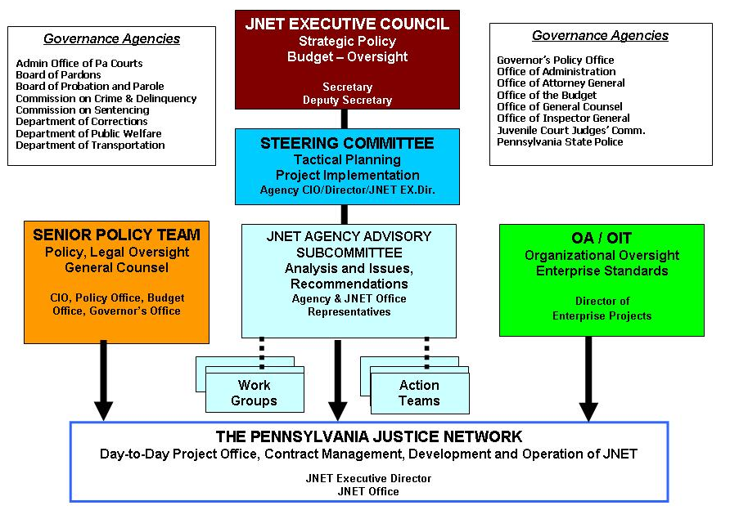

JNET is represented on numerous committees and task forces, including the National Association of Justice Information Systems (NAJIS), Pennsylvania Commission on Crime and Delinquency’s Technology and Automation Advisory Committee, National Governors Association Point of Contact for Justice Integration, federal Global Advisory Committee, and the Governor’s Advisory Board on Probation and Parole.
JNET representatives are board members of the Automated Fingerprint Identification System (AFIS), National Association of Justice Information Sharing (NAJIS), National Information Exchange Model (NIEM) and National Business Architecture Committee (NBAC).
The JNET office also provides technical assistance and presentations to other federal agencies, state agencies, counties and countries on integrated justice.
The JNET office takes direction from the JNET Steering Committee. However, organizationally, the JNET Executive Director now reports to the Chief Information Officer (CIO) of Pennsylvania.

JNET Organization
The JNET office is comprised of commonwealth employees and contracted resources with the overall total increasing and decreasing depending upon current projects, initiatives and organizational goals.

JNET Organizational Structure
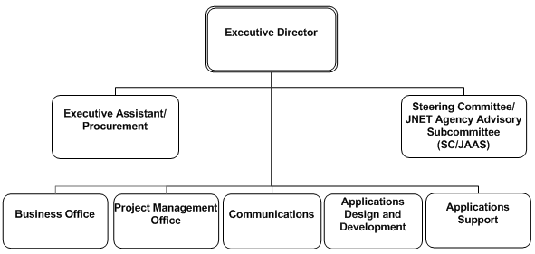

Business Office
The JNET Business Office is responsible for oversight and support of the JNET project life cycle and works with JNET stakeholders in order to elicit, analyze, communicate and validate requirements for changes to business processes, policies and information systems. The office understands business problems and opportunities in the context of the requirements and recommends solutions that enable JNET to achieve its goals.
The business analysts within this area are responsible for explaining to software developers what requirements are needed for system applications and how end users intend to use new applications or services. The business analysts are also involved in validating the system through quality assurance and user acceptance testing.
The JNET Business Office is also responsible for training over 38,000 users across the Commonwealth of Pennsylvania. The training team provides instructor-led classes, web-based training courses, webinars, user’s guides and manuals, application help files and quick reference guides.
The training team works with all aspects of the JNET organization in the development of these materials. The team also provides support to the JNET help desk and solicits feedback from users to improve the training curriculum.

Communications
The JNET Communications Office is responsible for promoting JNET to municipal, county, state and federal agencies within the state. The communications team works with the user community and provides solutions to all issues and inquiries through the JNET Help Desk. The help desk maintains a repository that provides statistical data used for reporting and process improvement modeling purposes.
The communications office is fully engaged in all application development projects. With input from a cross section of the user community, the communications team gathers certain application requirements through joint application development (JAD) sessions. This team also coordinates and assists in performing user acceptance testing, as required.
The communications office is the lead team on all JNET integration activities. These activities provide authorized users with access to JNET and additional services like the JNET messaging infrastructure, notifications, facial recognition, electronic reporting, juvenile tracking system and the evaluation and coordination of biometric technologies as they relate to the offender identification process. The team also functions as the liaison with outside vendors and various state agencies associated with offender processing hardware and software.
The communications team is in contact with the JNET user community through the help desk, agency and county presentations, criminal justice related conferences, JAD sessions and JNET integration meetings. The JNET Communications team also coordinates visits to county criminal justice advisory boards (CJAB’s) with the Pennsylvania Commission on Crime and Delinquency.
Overall, this team is responsible for development and delivery of information and promoting awareness across the JNET community.

Applications Development
The JNET Applications Development team is responsible for developing products and services defined by the JNET Executive Director. This team is responsible for software design, construction, testing and implementation. The JNET software development process integrates software development and quality assurance practices into a flexible, yet orderly, approach.

Applications Support
The JNET Applications Support team is responsible for maintenance and support of the production applications within JNET. The production application environment consists of the following core application areas: web query applications, messaging infrastructure, security platforms, service bus technologies and end-user presentation layers. Primary functional areas within applications support are web hosting and maintenance, application enhancements, web services, support and testing.

Project Management Office
The JNET Project Management Office (PMO) performs coordinated planning, prioritization and execution of projects that are tied to JNET’s overall business objectives. It also provides project management support functions in the form of software (Microsoft Project), standardized policies and procedures and training. The PMO ensures that management receives accurate and timely information about all projects and major activities. Finally, the PMO provides resource allocation planning in order to ensure that appropriate resources are assigned to projects.

JNET Applications/Hosted Applications
JNET is a secure network that provides access to data from various federal, state, county and local agencies. JNET provides a secure infrastructure for transporting this critical data and ensures that it is only accessible to authorized public safety and criminal justice practitioners.
During this fiscal year, the top three accessed applications were PennDOT Driver Information, AOPC UJS Portal and JNET CLEAN.
See Appendices A and B for JNET secure site application access statistics and summarized unique users accessing JNET.
JNET and Hosted Applications
Application | Description
AOPC UJS Portal | This service provides access to docket sheets for Pennsylvania’s Appellate Courts, Court of Common Pleas, and Magisterial District Judges. Authorized users can access the Law Enforcement portal, local rules, court calendars and a statewide warrant search.
Crime Network (cNET) | cNET is a web-based police records management system which allows data sharing between police agencies.

DCNR ATV and Snowmobile Registration Inquiry | Allows JNET users to search for all-terrain vehicle and snowmobile records by owner, vehicle and title information.
DOH Birth Record Inquiry | This application provides JNET users with the ability to search for and retrieve birth certificate record information in order to verify citizenship.
Domestic Relations Warrants | Users may search by individual names, cases, or entire counties for a list of outstanding child support warrants from the Pennsylvania Child Support Enforcement System (PACSES). Information returned includes the amount of arrears owed at the time the warrant was issued as well as contact information for the issuing jurisdiction.
DPW Recipient Address Inquiry System | This system allows JNET users to enter search criteria to determine if an individual of interest is actively receiving cash or food stamp benefits from the department of public welfare.
Electronic Reporting Statistics | Allows JNET users to query reports from the electronic reporting data provided by county probation offices and county prisons.
JCMS View & Inquiry System | Provides juvenile information for the completion of background checks, firearms registrations, and Megan’s law investigations.
JNET Address Search | Provides practitioners with access to comprehensive address information from 11 distinct data sources through a unified search application.
JNET Automated Registration System | Allows new JNET users to electronically apply for JNET access and complete JNET overview training. Routes access request to agency designated sponsors and registrars for review.
JNET Background Check | The JNET Background Check allows JNET criminal history (CH) users to quickly search PSP criminal history records as well as warrants from the AOPC and PACSES.
JNET Photo Search | This application allows users to make a single inquiry and automatically search for photographs from both PennDOT and WebCPIN - which contains photographs from several other systems including: HIDTA, DOC, PBPP, county prisons and county probation offices. Search results include a link to a map depicting the location of the subject’s home address and surrounding area.
JNET Warrant Search | The Federated Warrant Search allows users to query warrant information from CLEAN, NCIC, AOPC and PACSES, through a single search.
JNET CLEAN | JNET CLEAN provides authorized criminal history (CH) users with limited read-only access to the Pennsylvania State Police Commonwealth Law Enforcement Assistance Network (CLEAN) and NCIC.
JNET Facial Recognition System (JFRS) | Allows JNET users to compare an unknown suspect’s image to over 35 million images from PA databases, including PennDOT. JFRS can be used on mobile devices allowing users to upload images from the field for instant comparison.
JNET User Provisioning System | The user provisioning system allows users to request security roles for further access to specific applications. Similar to the automated registration application, user requests for additional security roles are routed to approvers for review.
JTS Inquiry | Allows users from specific agencies to retrieve juvenile data provided by county juvenile probation office sources via a single-point search application and user interface.
Justice Data Flexible Search (JDFS) | Provides state and county jail, state and county adult probation, criminal history, and sentencing information to JNET users through one interface.
Learning Management System (LMS) | An online system that provides both basic and advanced user trainings. Provides training modules for each application available on JNET. Allows JNET Registrars to track users’ completed trainings and progress.
LEJIS Web Interface | Allows all JNET users to query records contained within the Law Enforcement Justice Information System (LEJIS) which houses index information from hundreds of police departments from across the commonwealth.
Master Charge Code (MCC) | MCC allows agency charge codes to be linked to master charge codes. Users are able to research and cross reference charge codes used by different agencies and systems.
Notifications | The JNET Notification Service allows users to subscribe to real-time event messages for comparison against offender watch lists. When an event message is published, it is compared against watch list records and the subscriber is automatically notified via email. When a significant event such as an arrest, disposition, want, warrant, state parole violation, PennDOT change of address or death occurs, users are alerted to check secure JNET for detailed event information.  Virtual notifications are used by federal and municipal users without direct access to JNET through the commonwealth network. Virtual notifications provide these users with the same functionality as traditional JNET notification services without the local database requirements.

PBPP-259 Form Processing | This system allows parole agents to enter Record of Interview Form (PBPP-259) information and supplementary notes online, submit the information and retrieve and print it for subsequent reference. It also includes a standard set of reports that are targeted for agents and management use.
PCCD Constable Query | The Constable Query application allows users to search a database containing certified constable information for all Pennsylvania counties.
PCCD Deputy Sheriff Query | The Deputy Sheriff query application allows users to search a database containing certified deputy sheriff information for all Pennsylvania counties.
PennDOT In-Transit Tag Search | The PennDOT in-transit tag search allows authorized JNET users to query PennDOT’s in-transit tag database. In-transit tags are thirty-day tags that are granted by PennDOT to the purchaser of a vehicle who resides outside of Pennsylvania. These are cardboard tags that are to be used only from the time the non-resident purchases the vehicle in Pennsylvania until he or she registers it in their home state.
PennDOT License/Registration Pickup | This application provides JNET users with access to PennDOT's lists of expired and revoked driver’s licenses and vehicle registrations. Search results include a link to map depicting the location of the subject’s home address and surrounding area.
PennDOT Photos/History | Provides JNET users with access to PennDOT's current and historical driver’s license and photo records, as well as certified driving records. Recently, license suspension information, emergency contact information and CDL medical certification information has been added to the search results. A modified version of this has been developed for exclusive use by Pennsylvania’s organ donation coordination organizations.
PennDOT Vehicle Inspection and Emissions | The PennDOT vehicle inspection and emissions query allows JNET users the ability to quickly obtain inspection or emissions station information. It also assists law enforcement in identifying fraudulent inspection stickers.
PennDOT Vehicle Registration | Provides JNET users with access to PennDOT's certified vehicle records.
Pre-sentence Investigation (PSI) Index | Allows authorized JNET users to search for AOPC pre-sentence related court documents by defendant information, docket number or county.
Protection from Abuse Database (PFAD) | The Protection from Abuse system is a hosted application for the PFA Database from the Pennsylvania Coalition Against Domestic Violence.
PSP CLEAN PortalXL | Provides JNET criminal history (CH) users with a fully functional web-based PSP CLEAN terminal. Provides access to the Pennsylvania Sex-Offender Registration Tool (PA SORT) in addition to numerous federal law enforcement data sources.
Sentencing Guidelines Software (SGS Web) | This is a web-based application developed by the Pennsylvania Commission on Sentencing (PCS). SGS Web provides official sentencing guidelines, calculations and history to the courts of Pennsylvania via JNET.
SID/OTN Lookup | The SID/OTN Lookup application allows users to find or associate a state ID (SID) or offense tracking number (OTN) given the other identifier.
Statistical Reports | Includes nine reports summarizing usage of the JNET system by county, hourly analysis of JNET usage, successful warrant submissions, county jail and adult probation reporting, pre-sentence information, and JNET notification use.
User Transaction Log Lookup Report | Allows users to easily search through log files to document their JNET transactions. This application includes all user log entries collected by JNET.
WebCPIN | This web based application provides users access to the Commonwealth Photo Imaging Network (CPIN) – which includes over five million photos from arrest/booking centers, state and county probation and parole, state and county prisons and NY/NJ High Intensity Drug Trafficking Area (HIDTA). WebCPIN provides the functionality to create photo lineups, perform investigative searches and print wanted/missing person posters.
Web Services Monitoring Tool | The Web Services Monitoring tool provides users with the status of JNET Web Services. The application displays availability of the web service, as well as the date and time of the last successful transaction processed for that specific system.

JNET Budget
The success of JNET can be attributed the effective use of both state and federal funds. The JNET state funding for operations in fiscal year 2012-2013 was $4,180,000. These funds support JNET’s reliable and secure infrastructure, ongoing application development and support, procurement of contracted resources, deployment of JNET’s architectural upgrade and disaster recovery initiatives. As depicted in the JNET budget history graph, allocated funding for JNET has experienced a steady decrease.
For fiscal year 2012-2013, JNET received $93,350 in federal grant funds to support the electronic warrant data exchange and the development of JNET Privacy Policy through National Governor’s Association policy academy. After the projects are developed and implemented, general operating funds will be used to support ongoing maintenance.

JNET Budget History
While JNET’s operating budget has decreased over the years, the number of registered JNET users has generally increased. In fiscal year 2011-2012, JNET fully migrated from certificate based accounts to JNET username and password accounts. In this transition, JNET was able to deactivate a significant number of inactive accounts. While JNET still uses digital certificates as a form of advanced user authentication for criminal history users, the username and password solution ensured that fewer digital certificates needed to be procured and that those certificates were only associated with active JNET accounts.
While budgetary issues remain a concern, JNET continues to pursue cost effective solutions to user, hardware and software challenges.

JNET Budget and User History
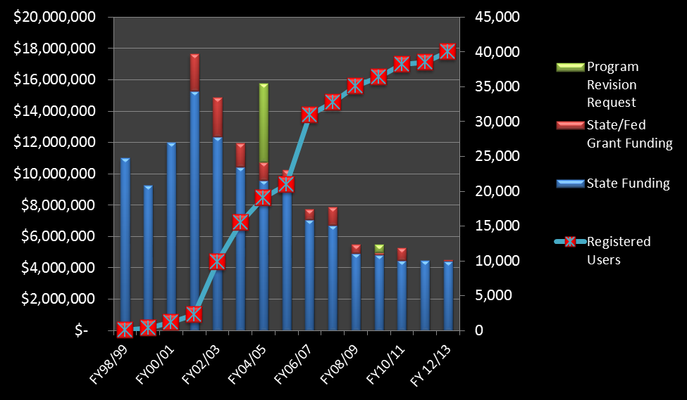

JNET Cost by User History
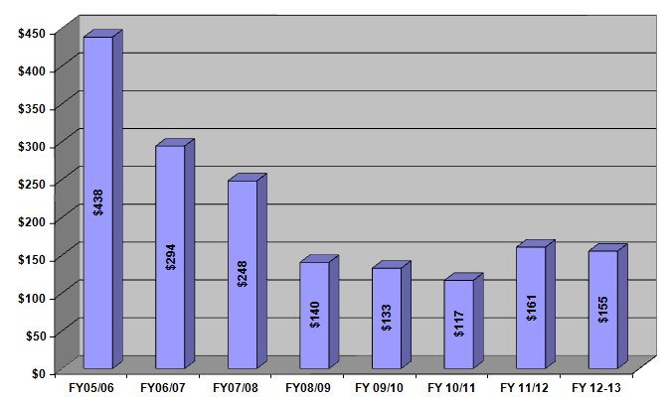
FY 2012/2013 Newly Implemented Costs Savings
Savings generated by: | Costs savings  FY 2012-2013 | Costs savings realized by:
JNET Background Check | $481,934 | Reduction of time involved in conducting background checks.
L&I/Prison notifications | $107 million | Labor and Industry receives JNET notifications on incarcerated claimants receiving unemployment.
AFIS remote terminal maintenance reduction | $64,000 | JNET users
JFRS maintenance reduction | $25,000 | JNET users
Total Savings | $107,570,934

Highlights Fiscal Year 2012-2013

Awards
For the third year in a row, the Pennsylvania Justice Network (JNET) was recognized by the Computerworld Honors Program. JNET received a Laureate award for the development of a background check application that allows police and other authorized public safety professionals to more efficiently conduct background checks for criminal investigations, as well as screening new and existing employees. JNET was presented with a Laureate award at the 2013 award ceremony in Washington, D.C.

Projects
During fiscal year 2012-2013, a number of projects ranging in size and complexity were initiated and completed. The following section highlights those considered to be significant in terms of their contributions to the JNET mission.

JNET Saves Labor & Industry $12 Million in FY 12/13
The Department of Labor & Industry (L&I) and JNET collaborated on a project which resulted in approximately $12 million in savings with future estimated annual savings of approximately $124 million. L&I takes advantage of JNET notifications to identify unemployment compensation claimants who are incarcerated in the state’s county prisons and not eligible to collect unemployment benefits. JNET’s L&I notification service will produce hundreds of millions of dollars of savings for years to come.

JNET Internet Site
The JNET Internet site (www.jnet.pa.gov) deployed at the end of 2012 provides users with easier access and faster performance. The site allows JNET users to access JNET through any Internet connection instead of a county, state or VPN network connection. Information on the new site is secured through a JNET username and password and applications are deployed to the Internet site only after passing stringent security requirements. During fiscal year 2012-2013, over 20 applications were migrated to the site, including PennDOT information, Warrant Search, Photo Search, Background Check, WebCPIN and JNET Facial Recognition. By the end of the fiscal year, approximately 30,000 users were accessing JNET via the new Internet site.

MARIS Integration – Out-of-State Arrest Notifications
MARIS is a consortium of several mid-Atlantic states working together to identify opportunities for criminal justice information sharing. Through the MARIS partnership, JNET began exchanging arrest messages with the State of Maryland in 2012. The arrest information from Maryland is being used to generate JNET out-of-state arrest notifications for the Pennsylvania Board of Probation and Parole, county adult probation departments, and county jails.

JNET Background Check
In July 2012, JNET deployed the JNET Background Check application. The application allows authorized JNET users to conduct a search of PSP criminal records, as well as warrants from the AOPC and Domestic Relations Office repositories through a single query. The reduction of time involved in conducting background checks saves time and money for those taking advantage of the new system.
As mentioned above, the JNET Background Check was recognized as a Computerworld Laureate.

New Information Available from Pennsylvania Department of Transportation (PennDOT)
During the fiscal year, JNET users were provided with access to emergency contact information, vehicle inspection and emissions station information and license plate reader (LPR) files.
The PennDOT Vehicle Inspection and Emissions Query provides officers or investigators with the ability to quickly obtain inspection or emissions station information. This application assists officers with determining the validity of questionable inspection or emissions stickers.
Emergency contact information allows emergency responders to view emergency contact information voluntarily entered by Pennsylvania drivers through the PennDOT website.
PennDOT provides expired license plate and suspended registration information through JNET for use by authorized police departments with license plate readers (LPR).

JNET Facial Recognition Adds Access to PennDOT Images
JNET and PennDOT through a collaborative effort provided JNET Facial Recognition System (JFRS) users with the ability to search 37 million PennDOT images in addition to the 3.5 million arrest, probation and corrections images. The JFRS sends a query request to PennDOT and PennDOT searches its database using its search engine and returns any results to the JFRS system for users to review. With the addition of the PennDOT search, investigators and detectives now have the ability to search a total of 37.5 million images. The system is used as an investigative tool by investigators who have an image of an unknown individual.

Resource Planning
Resource planning has proven to be a key factor in JNET’s ability to deliver a relatively large number of important project outcomes while maintaining a stable operational environment, and ensuring that the right mix of staff resources are assigned to and working on appropriate projects.
Hours Assigned by Project Category (one month sample)
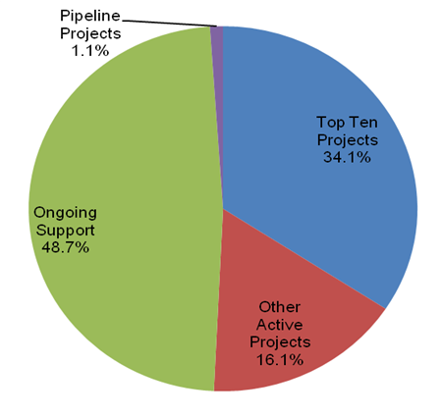
Top Ten Projects  Projects assigned the highest priority | 1,270 hrs.
Other Active Projects  Projects that are assigned a lower priority | 613 hrs.
Ongoing Support  Application system maintenance, help desk support, IT infrastructure support, marketing/PR, web portals maintenance | 1,787 hrs.
Pipeline Projects  Projects that are pending or expected to start within the next six months | 40 hrs.

JNET Statistics

JNET Portal and Internet Sites
The JNET secure portal provides a role-based user interface that manages access and authentication to 35 distinct JNET applications used by over 29,000 users. The JNET secure portal is the primary means through which JNET shares critical criminal justice information with law enforcement and public safety officials within Pennsylvania. However, in November 2012, JNET introduced the new JNET Internet site (www.jnet.pa.gov). The charts below represent monthly unique visitors to the secure JNET portal home page as well as to the new Internet page. As more applications are deployed to the Internet site, the hits for that site will increase and the hits on the secure portal will likely decrease. Eventually the portal site will be decommissioned and all traffic will be processed via the JNET Internet website.

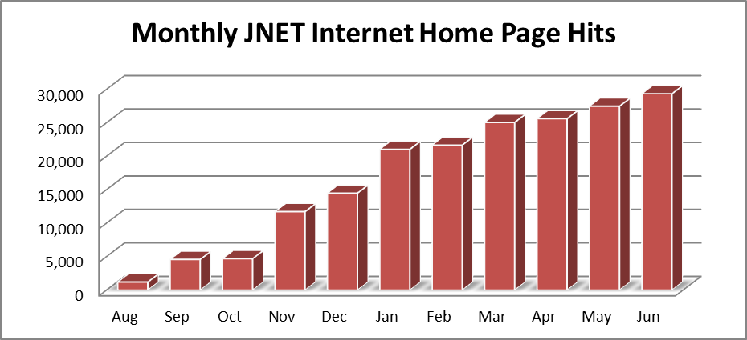

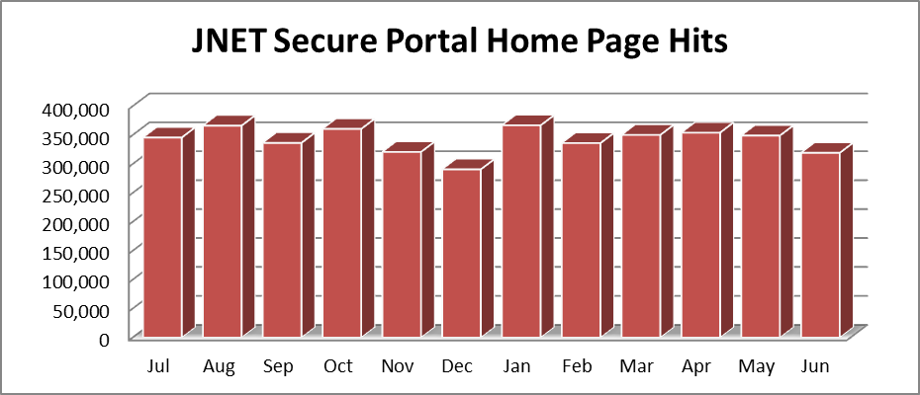

JNET Web Services
JNET has developed and instituted mature and integrated service oriented architecture (SOA). Through this infrastructure, JNET offers a suite of web services that make agency data available to authorized recipients.
With the guidance of the JNET Agency Advisory Subcommittee (JAAS) and the JNET Steering Committee, JNET has created policies that stipulate the procedures for requesting and accessing JNET web services. This governance gives JNET data providers the ability to retain control of their information without having to manage the hardware, software and network needs to securely deliver information as a service.

Currently, JNET offers the following web services:
- AOPC Court Case Filings
- AOPC Court Case Events (available through the JNET Event Messaging service)
- AOPC Court Case request/reply
- DCNR ATV service
- Fish and Boat Registration service
- JNET Address Search
- JNET Background Check
- JNET ERII County Prison
- JNET ER2P County Probation
- JNET ER Inquiry service
- JNET ER Subscription service
- JNET Warrant service
- JNET Photo service
- PA JCMS Inquiry service
- PennDOT Driver Status service
- PennDOT Vehicle service
- PennDOT Vehicle Inspection service

JNET Web Service Usage
The following graphs indicate the total use of key JNET web services. Please note that many of these web services are used by applications on the JNET secure portal (JNET Warrant Search, for example) as well as by external partners and agencies.

AOPC Court Case Filing Service
This service facilitates the electronic filing of traffic citations and criminal complaints to the magisterial district and common pleas courts.

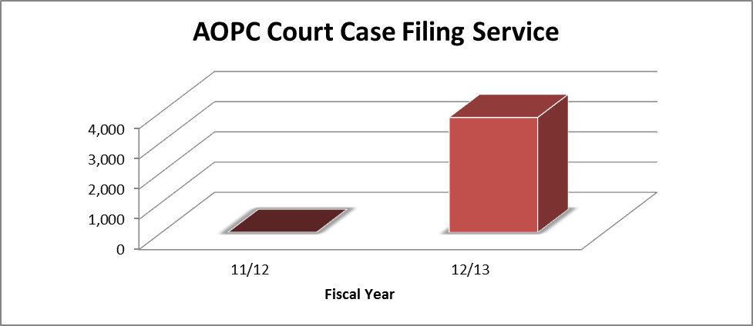

AOPC CCE /JNET Event Messaging Service
This service allows agencies to subscribe to the AOPC court case event message – which provides case events throughout the judicial process (e.g., case initiation, bind over, sentencing and expungement).
The JNET event messaging service also provides confirmation messages to agencies that submit criminal complaints or traffic citations through the AOPC court case filing service or AOPC court case request/reply service queries.
Finally, the JNET event messaging service also provides Pennsylvania arrest information to the state of Maryland.
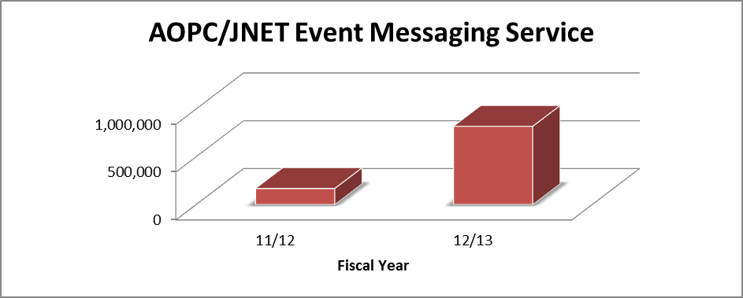

AOPC Court Case Request/Reply
The AOPC Court Case Request/Reply service allows agencies to submit an Offense Tracking Number (OTN) to the AOPC and receive detailed up-to-date court case docketing and status information.

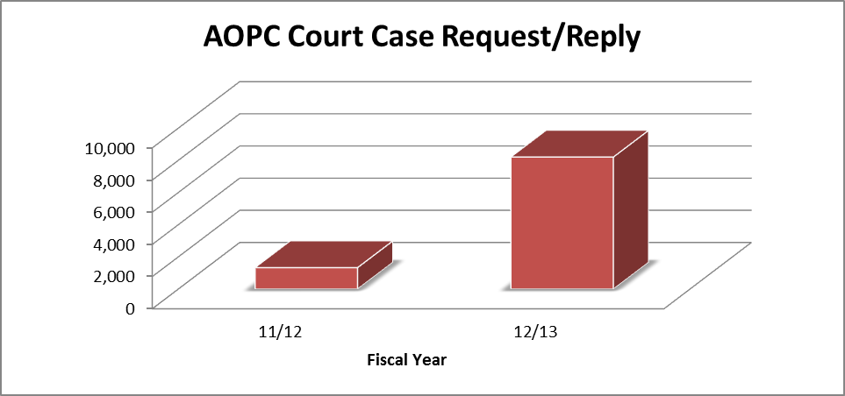

DCNR ATV Service
Allows searches for all-terrain vehicle and snowmobile records by owner, vehicle and title information.
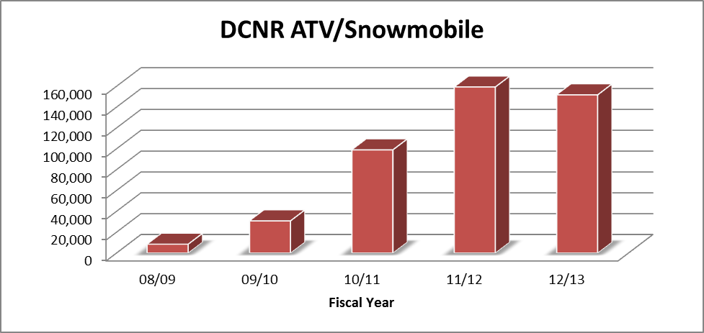

Fish and Boat Service
This service provides information for Pennsylvania boat registrations from the Pennsylvania Fish and Boat Commission.

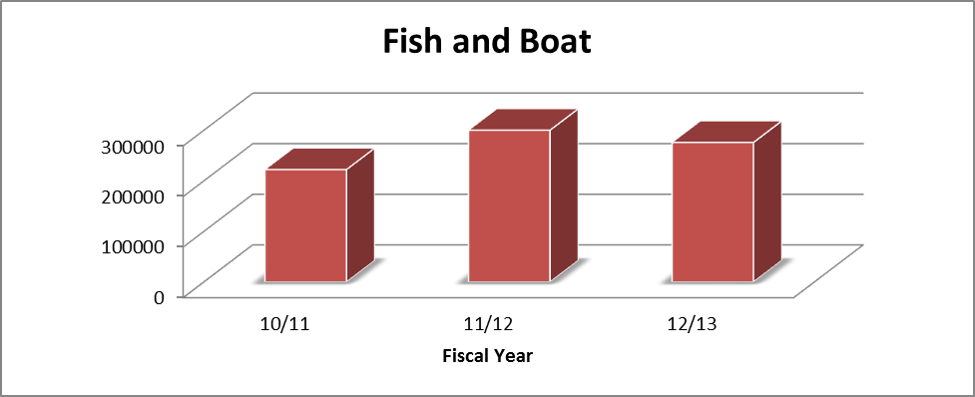

JNET Address Search
The JNET Address Search service queries, organizes and returns address information from up to 11 distinct data sources.
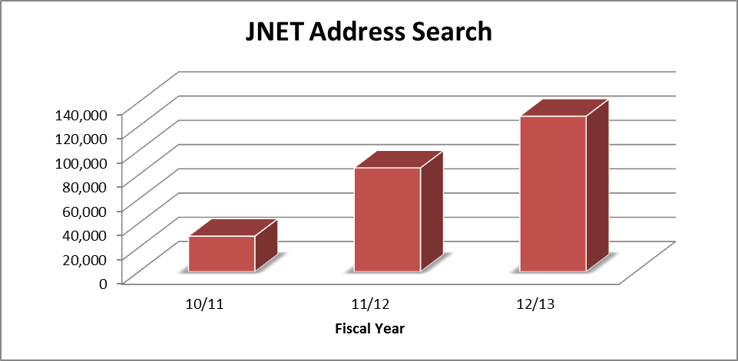

JNET Background Check
The JNET Background Check allows JNET criminal history (CH) users to quickly search PSP criminal history records as well as warrants from the AOPC and PACSES.

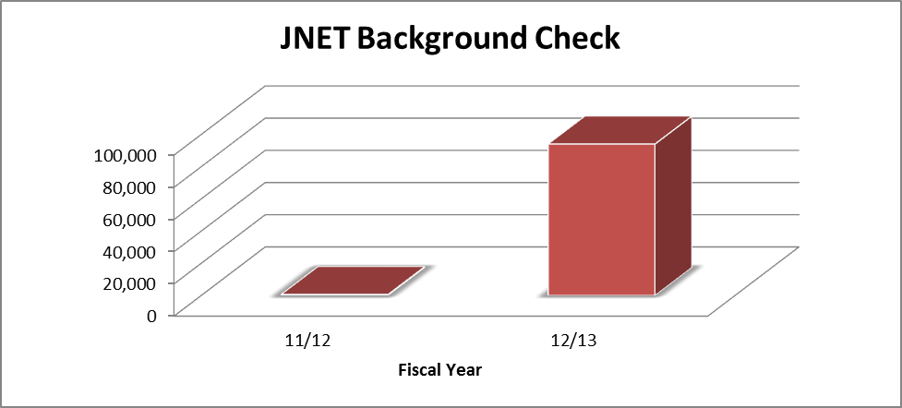

JNET Warrant Service
The JNET Warrant Search application provides JNET users with the ability to search three unique warrant repositories through one federated query.

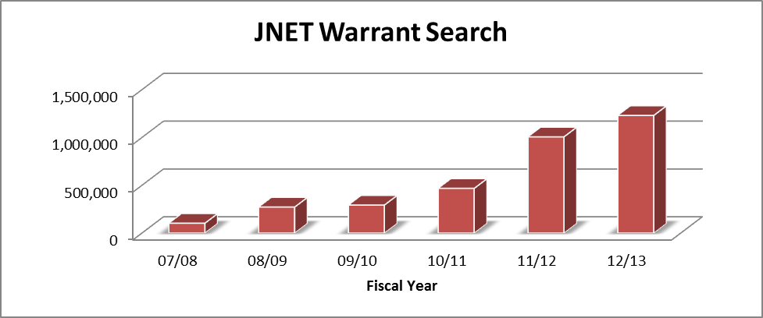

JNET Photo Service
The JNET Photo Search allows searches against the PennDOT driver license photo database as well as criminal mug shots contained within the web-based Commonwealth Photo Imagine Network (WebCPIN).

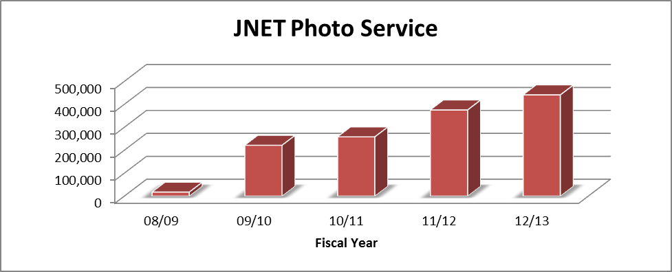

PennDOT Driver Status Service
The PennDOT Driver Status service provides driver status, classification and demographic information from the Pennsylvania Department of Transportation.
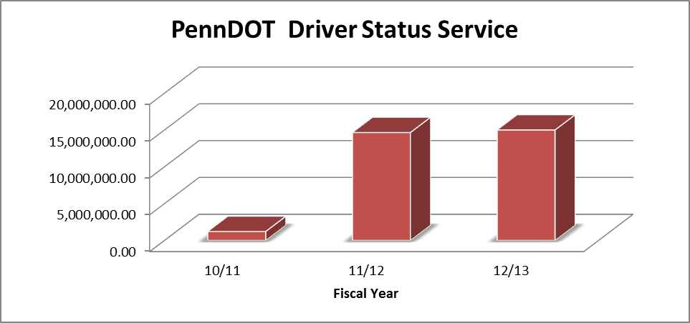

PennDOT Vehicle Service
Provides vehicle registration status, classification and owner information from the Pennsylvania Department of Transportation.

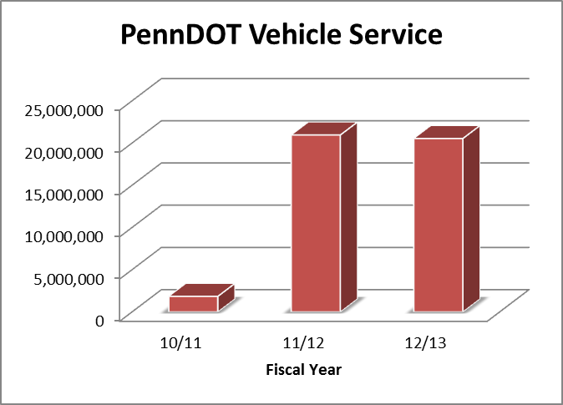

JNET Warrant Exchange Services
JNET currently exchanges warrant information between the Administrative Office of Pennsylvania Courts (AOPC) and the Pennsylvania State Police (PSP). The JNET Warrant Exchange service ensures that warrants issued by the state courts are shared with law enforcement through the PSP CLEAN network. PSP CLEAN in turn shares this information with federal repositories including NCIC, III and NLETS.
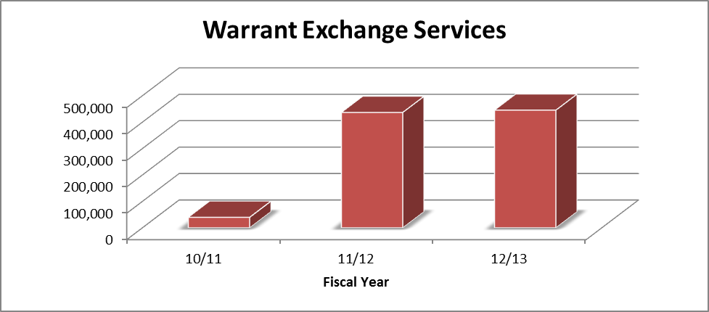

Statewide Warrant Exchange Summary
The report below details the successfully submitted (accepted warrants) and rejected warrant messages processed between the AOPC and PSP.
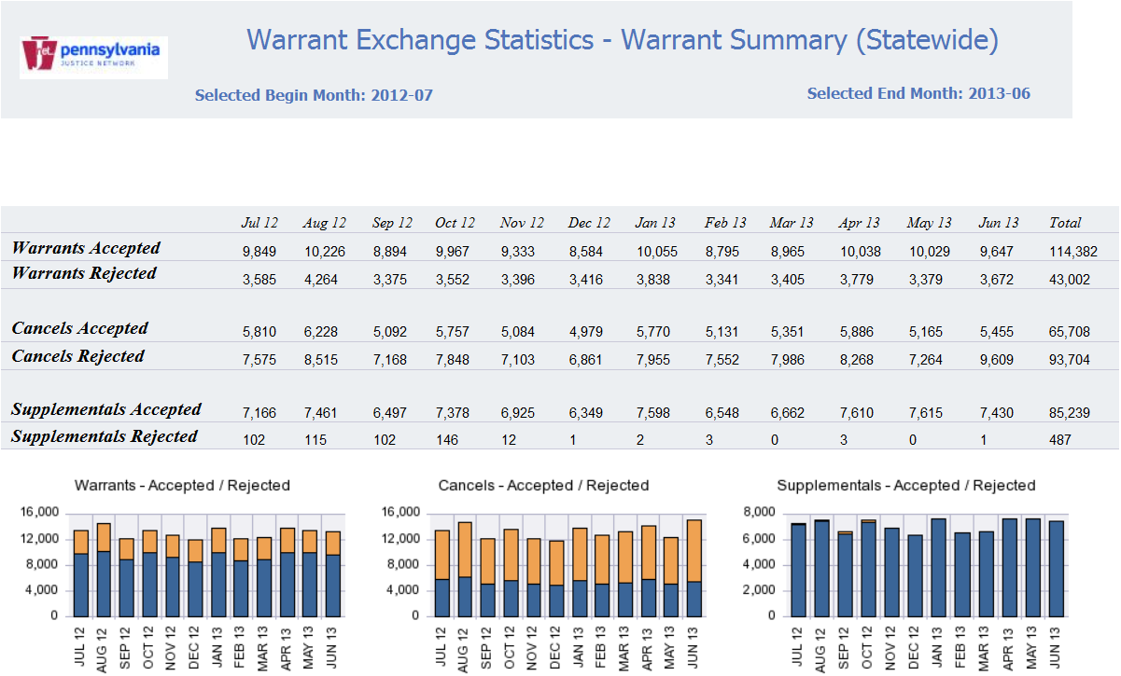

JNET Service Oriented Architecture (SOA) Usage
Initially adopted in 2007, JNET has a service oriented architecture that continues to grow exponentially in use. As detailed by the increased reliance on JNET web services, the SOA approach implemented by JNET provides future re-use and return-on-investment for the commonwealth.
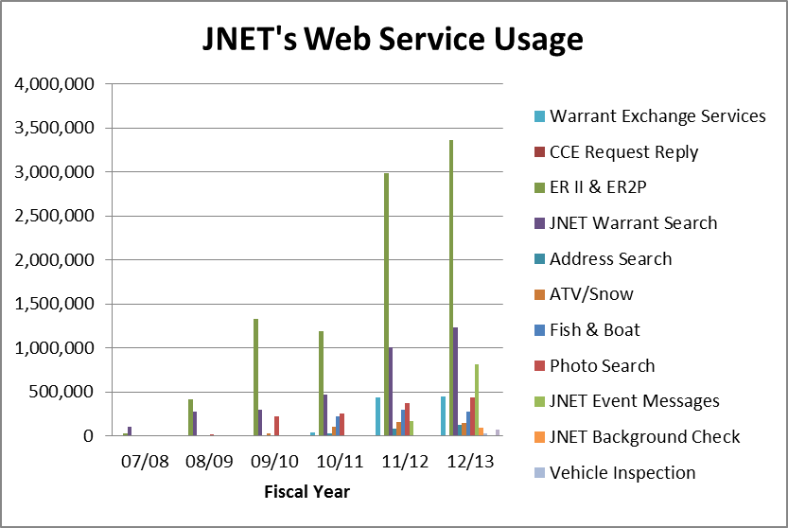
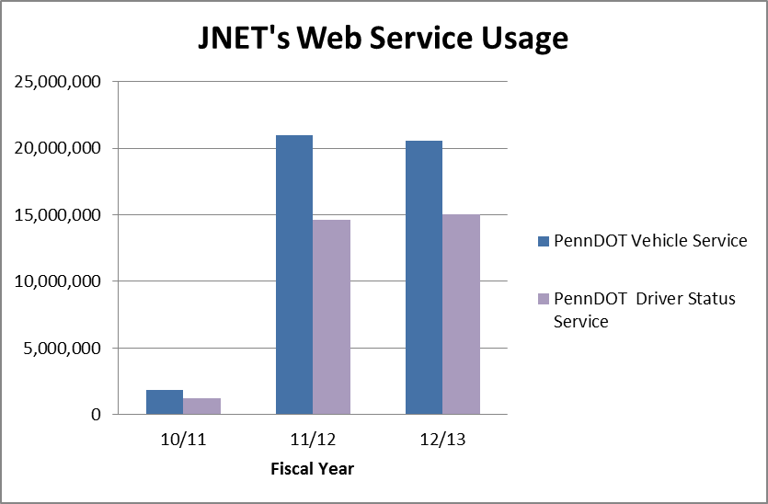

JNET Messaging Infrastructure
JNET Messaging Infrastructure (MI) is the message broker that allows for the secure transfer of information between agency systems and users. This data exchange and event messaging model provides stakeholders with the ability to maintain ownership and control of their data systems. This has elevated county and state agency data availability, including participation in electronic data exchange and subscription to real-time event messaging services.
JNET continues to focus the data exchange effort on the new web service development and trying to move more traffic toward JNET Enterprise Service Bus (ESB) instead of using JNET Messaging Infrastructure. JNET strategy regarding JNET Messaging Infrastructure is to maintain the system without making major enhancement to JNET MI.
In 2012, the number of messages processed dropped significantly. This is due to the fact that in 2012, JNET did not process any DOH deceased person event messages. In addition, JNET did not republish any old deceased person event messages that were published in previous years.

JNET Messaging Infrastructure Statistics

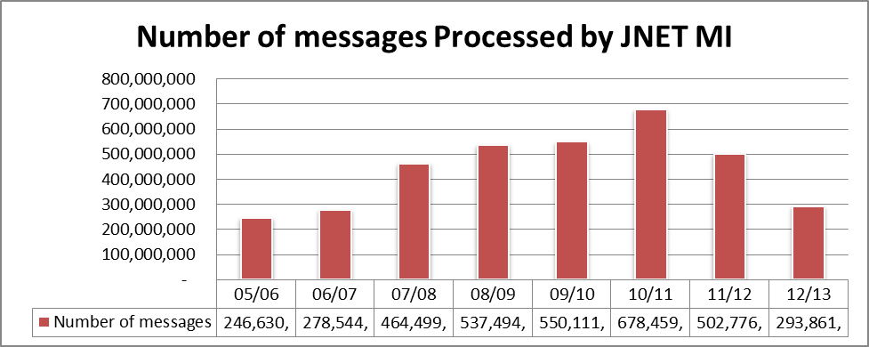

JNET Federated Application Usage
The following graphs detail use of key JNET federated applications on both the secure and Internet JNET portals. Please note that JNET web services provide the information that is made available to end-users through JNET applications. The below charts represent use of JNET applications that are enabled through JNET’s SOA environment.

JNET Warrant Search Average Monthly Hits: 103,446
The JNET Warrant Search application provides JNET users with the ability to search three unique warrant repositories through one federated query.

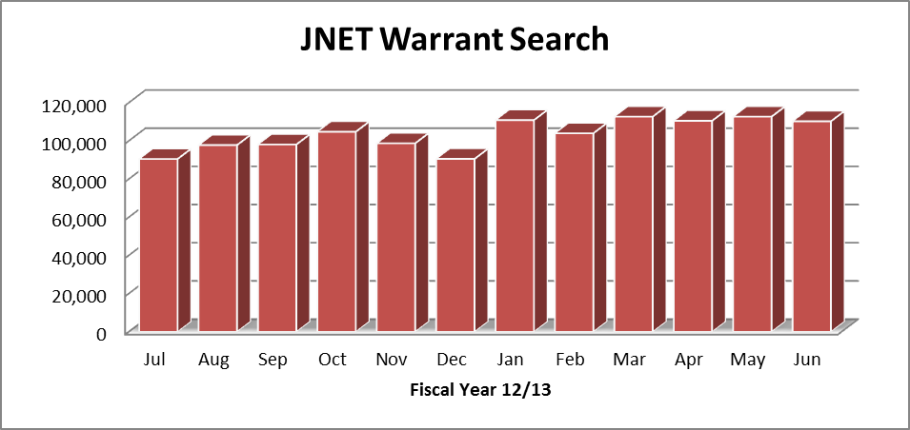

JNET Photo Search Average Monthly Hits: 61,234
Using JNET Photo Search, users can automatically search for photos in the PennDOT and WebCPIN, databases as well as from HIDTA, DOC, PBPP, county prisons and county probation offices. Search results include a link to a map depicting the location of the subject’s home address and surrounding area.

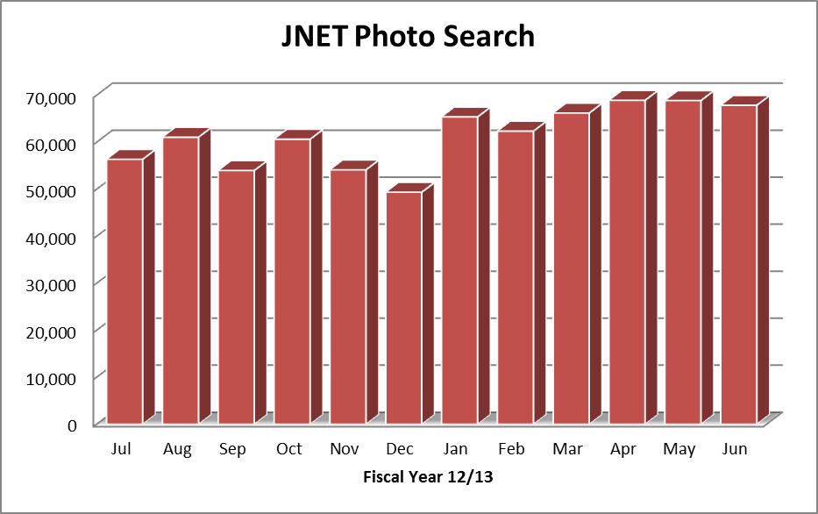

JNET Address Search Average Monthly Hits: 9,136
Deployed in June 2011, the JNET Address Search allows authorized users to simultaneously query address information from up to 11 distinct repositories: common pleas and magisterial district court information from the AOPC, county prison ER records, county probation ER records, state Department of Corrections prison records, Department of Public Welfare recipient address application, JNET domestic relations warrant database, Juvenile Tracking System (JTS), PennDOT, Pennsylvania Board of Probation and Parole, Pennsylvania State Police Computerized Criminal History (PSP CCH), and Commonwealth Photo Imaging Network (WebCPIN).

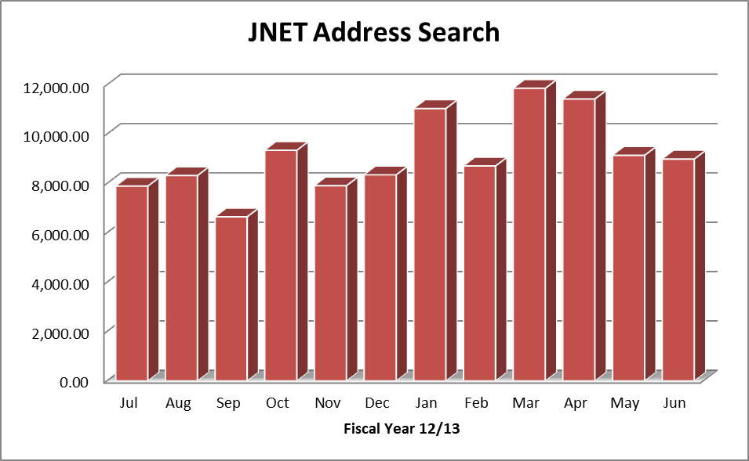

JNET Background Check Average Monthly Hits: 5,637
The JNET Background Check allows JNET criminal history (CH) users to quickly search PSP criminal history records as well as warrants from the AOPC and PACSES.

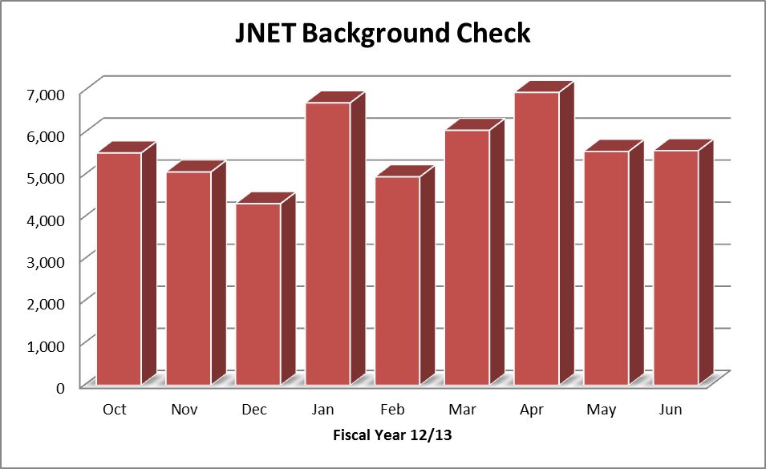

Electronic Reporting
JNET provides the secure reporting infrastructure between county agencies and the Pennsylvania Board of Probation and Parole (PBPP) and the Pennsylvania Department of Corrections (DOC). In order to take greater advantage of the information reported by county agencies, JNET developed the ERII (DOC) and ER2P (PBPP) web services. These services allow county agencies to report information to their respective state agencies in a more reliable and usable format through the adoption of the National Information Exchange Model (NIEM) within the message.
ERII and ER2P allow JNET to provide critical county inmate and offender information through the re-use and republication of JNET web services. Ninety percent of county jails do their reporting through JNET ER and JNET ERII. Of the 62 county prisons in Pennsylvania, 53 county jails are participating in JNET ERII and five county jails are utilizing the legacy electronic reporting interface. The 4 county prisons not reporting their inmate information are in various stages of connectivity with the JNET electronic reporting service.
Seventy five percent of county adult probation departments also report through JNET ER and ERII. A total of 45 report through the legacy ER and three departments reports using the ER2P.
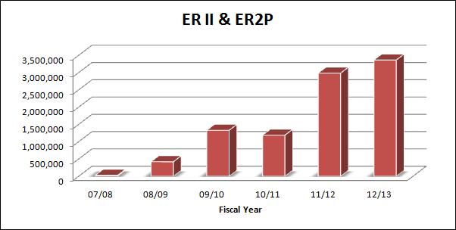

JNET Notification Service
As the hub of the commonwealth’s criminal justice information sharing efforts, JNET is in the unique position of providing notification alerts of critical events within the criminal justice system to interested professionals. Currently, JNET subscribes to:
- Arrest and want (including bench warrants) events from the Pennsylvania State Police.
- Out of state arrests from Maryland.
- Case sentencing, case bind over and warrants from the Administrative Office of Pennsylvania Courts
- Change of address from the Pennsylvania Department of Transportation
- Deceased persons from the Pennsylvania Department of Health
- Parole violations from the Pennsylvania Board of Probation and Parole
- Domestic relations warrants from PACSES

County Jail Notifications:
- County inmate admission
- County inmate permanent release
- County inmate temporary release
- County inmate escape
- County inmate detainer update
- County inmate bond update
County Adult Probation Notifications:
- County offender supervision effective date
- County offender supervision closed
- County absconder message
- County offender change of address
Virtual notifications provide JNET users with the same functionality as traditional JNET notification services without the local database requirements. Authorized users can access the JNET virtual notifications application and either manually enter or upload information to populate a watch list. JNET then securely stores that information and compares it against notification event messages. Each watch list can be configured to ensure that messages matching individual persons of interest are sent to specific recipients.
In fiscal year 2012-2013, JNET delivered 394,184 confirmed notifications.

JNET Historical Notifications Totals

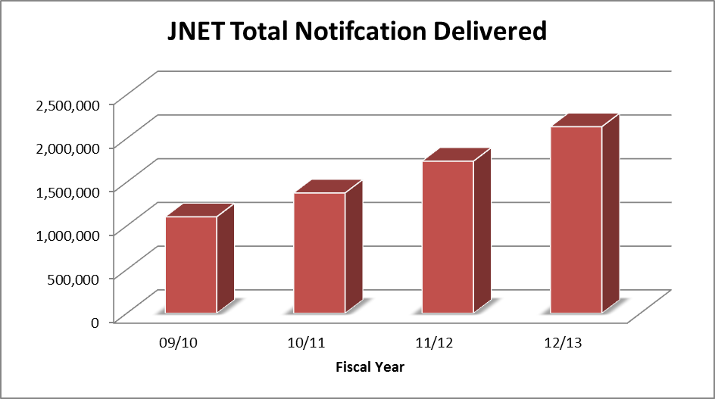

Federal Agencies
Currently there are a total of 30 federal agencies with over 50 fixed locations connected to JNET. During fiscal year 2012-2013, JNET provided access to the following new federal agencies located throughout the state:
- United States Department of State
- United States Bureau of Prisons
- United States Treasury – Office of Inspector General

Training
The JNET training team provides JNET users with both instructor-led training and web-based training through the learning management system (LMS). The following tables outline the number of students trained by these two methods. During fiscal year 2012-2013, three new LMS courses were deployed, including a JTAC user provisioning class and an updated Address Search session. The JNET training team also creates and updates quick reference cards for many of the JNET applications.
The JNET training team provides hands-on training for the JNET facial recognition system and classroom training for a variety of other courses. Most JNET training is accomplished by web-based training modules via the learning management system. This allows users to complete training at their worksites, as their schedules permit. This saves agencies travel costs and minimizes down time for employees.

Number of Students Attending Instructor-led Courses

Course | Number Attended
JFRS | 455
JNET 101 | 87
JNET Overview | 30
JNET CLEAN | 30
JTAC | 69
User Provisioning | 19
PSP Portal XL
TOTAL | 1,618

Number of Students Taking Courses Web-based Courses
Course Name | Number Attended
Address Search | 344
AOPC Applications Overview - Sept 2010 | 3
AOPC: UJS Portal Applications (2012) | 213
Automated Warrant Entry | 108
cNET Records Management Overview | 84
Criminal History - JNET CLEAN Recertification 2009 | 1
DPW Citizenship/Identity Verification | 72
DPW Recipient Address Inquiry | 209
Driver Information and Certified Driver History | 418
Enhanced Warrant Search | 259
JFRS Watchlist | 28
JNET Criminal History - Initial New User Training 09/08 | 2,224
JNET Criminal History - Recertification 2010 | 12
JNET Criminal History - Recertification 2011 | 32
JNET Criminal History - Recertification 2012 | 1,712
JNET Criminal History - Recertification 2013 | 2,753
JNET Digital Certificates | 145
JNET Electronic Reporting Statistics - 10/1/2011 | 45
JNET Limited Access Overview | 6
JNET Overview | 3,973
JNET Photo Search | 312
JTAC Recertification 2012 | 121
JTAC Recertification 2013 | 148
Juvenile Tracking System (JTS) | 98
Notifications | 135
PCS Final Sentencing Guideline Search | 113
PennDOT Authorization of Lift | 106
PennDOT Certified Vehicle Registration | 261
PennDOT Vehicle Inspection and Emissions | 141
Pre-Sentence Investigations Index | 114
PSP TAC to JTAC Training for PortalXL Transition | 27
Registrar Training - JNET User Provision System (new Registrars) | 91
Sponsor Training - JNET User Provisioning System (new Sponsors) | 95
User Provisioning Training - Assign Sponsor/Registrar to Agency | 47
User Provisioning Training - Deactivate User Account | 48
User Provisioning Training - Suspend/Reinstate User Account | 51
Virtual Notifications | 53
Warrant Search | 6
WebCPIN (New Users) - Aug 2010 | 189
WebCPIN Update - IPIN (for existing WebCPIN users) 08/2010 | 70
TOTAL | 14,867

JNET Outreach
JNET outreach is committed to enhancing the JNET mission by increasing awareness of the applications and services available to our criminal justice users. Outreach activities include a variety of communications methods including conducting and attending meetings throughout the state, as well as various targeted emails and online postings or updates.
In fiscal year 2012-2013, JNET held two JNET user meetings in State College, PA. Each meeting was attended by approximately 250 individuals from the user community. During the meetings, JNET staff and business partners provided project updates. Break-out sessions were held to cover topics that were more specific to certain groups such as IT professionals, JNET terminal agency coordinators (JTAC's) and registrars.
Additionally, JNET staff members serve on local work groups such as the Pennsylvania Commission on Crime and Delinquency’s Mental Health and Justice Advisory Committee and the PCCD Local Technology Work Group, which concentrates on criminal justice technology improvements.

JNET Marketing Plan
For JNET to continue to be successful, we need to continually communicate and market our product to current and potential municipal, county, state and federal users. Information communicated includes the positive aspects and the potential benefits of JNET, data and information available through JNET, success stories, best demonstrated practices, new applications, project updates, system enhancements and new or updated policies.
JNET Communications employs a wide variety of cost effective media to communicate with different audiences such as:
- Portal announcements on the JNET home page and updates on the announcement section of the website.
- Quarterly e-newsletters incorporating images and written messages.
- Joint application development sessions or focus groups and user surveys to solicit feedback from a wide range of users; this information can form the basis for on-going program planning.
- Listserv targeted emails to all JNET users or to various JNET groups.
- Online annual report.
- Internet/portal pages on JNET benefits, successes, awards, applications, help desk issues, etc.
- Application user guides and quick reference cards that are easy to understand and follow.

Conferences
JNET staff members attended and participated in various conferences throughout the fiscal year, as shown in the following list.

- Computer World Honors Conference
- County Chief Probation and Parole Officers
- Global Federated Identity and Privilege Management (GFIPM)
- Global Outreach Working Group (GOWG)
- Global Standards Council (GSC)
- Global Justice and Health Task Team (GJHTT)
- Information Sharing Summit for the Middle Atlantic States
- Integrated Justice Information Systems (IJIS) Institute – Justice and Health Use Case Development
- Pennsylvania e-Health Collaborative – Business and Operations Committee
- Pennsylvania e-Health Collaborative (Pa-ECHO) –Technical Sub-Committee
- Pennsylvania e-Health Collaborative (Pa-ECHO) – Policy Sub-Committee
- InterConnect Conference
- Mid Atlantic Regional Information Sharing (MARIS) Effort
- National Association of Justice Information Systems (NAJIS)
- National Identity Exchange Federation (NIEF)
- Pennsylvania Chiefs of Police Association Conference

Service Level Agreements
By using services level agreements (SLA’s), JNET can maintain a high level of service and work to increase the quality of service provided to JNET member organizations. The JNET office provides secured networking, applications services and support to JNET member organizations, including Pennsylvania state agencies, counties and other qualified organizations. During this current fiscal year, all SLA’s were reviewed and updated in a collaborative manner with all affected agencies. These agreements relate to four basic services provided by the JNET office, plus the performance of JNET applications:

- Network Infrastructure Availability (Connectivity) – between business partners and the JNET office.
- JNET Applications and Services – hosted on the JNET servers, for use by JNET users with proper security authorizations and permissions.
- Problem Resolution Services – timely response to service exceptions (outages) and timely resolution of service problems.
- JNET Applications Performance (Response, or Round-Trip Time) – at levels acceptable to the JNET agencies.

For more information on SLA’s, see one of the follow appendixes:
Appendix C, JNET Service Level Agreements, defines the service relationship between the JNET office and JNET member organizations.
Appendix D, JNET Monitoring and Measurement Tools, describes the network and applications availability and performance monitoring and measurement tools used by JNET to ensure the quality of service JNET provides.
Appendix E, Sample JNET Quarterly Service Level Report & Availability Report, shows the annual percentages of uptime and average response times, by application.

Appendix A – Summary of Unique Users Accessing JNET

Fiscal Year 2012-13
Department | Unique Users
Business Partners | 47
County Government | 21,079
Federal Government | 818
State Agencies | 7,116
Total | 29,060

Appendix B – Applications Accessed

Fiscal Year - 2012-13
Application | Total Views
Address Search | 68,253
AOPC-CP Secure Docket Sheets | 889,151
AOPC-MDJ Web Dockets | 1,206,971
AOPC-Warrant Search | 239,652
Background Check | 19,361
Background Check | 6
Background Check Internet | 66
Clean-Canadian Driver Registration (UQ) | 581
Clean-Canadian Vehicle Registration (VQ) | 101
Clean-CCH Summary Request (QH) | 207,331
Clean-Inquiry Wanted - Missing Person (QWA) | 133,337
Clean-Master Name Lookup (MN) | 631,229
Clean-ORION Inquiry (TQ) | 448
Clean-ORI Translation (QO) | 1,337
Clean-Out of State Driver History (KQ) | 13,627
Clean-PDOT Operator License (DQ) | 63,643
Clean-PSP-PA RAP Sheet (RS) | 97,489
Clean-PSP-Protection Order (QPO) | 18,999
Clean-Query Gang Member (QGM) | 2,307
Clean-Query Gang Organization (QGG) | 191
Clean-Query Stolen Articles (QA) | 564
Clean-Query Stolen Boats (QB) | 152
Clean-Query Stolen Guns (QG) | 3,789
Clean-Query Stolen Securities (QS) | 94
Clean-Query Stolen Vehicle (QV) | 1,127
Clean-RapSheet Requests (QR) | 162,535
Clean-Vehicle Registration Query (RQ) | 89,122
CNET_Internet | 58,332
COUNTY-Correction | 35,273
County-Probation | 22,946
DCNR ATV-Snowmobile | 1,001
DOC-Inmate Classification | 7,965
DOC-Inmate Location | 19,381
DOC-Inmate Misconduct | 2,125
DOC-Inmate Photos | 11,462
DOC-Inmate Sentence | 29,023
DOC-Inmate Summary | 36,335
DOH Birth Record Inquiry | 15,149
DOH Birth Record Inquiry Internet | 3
Domestic Relations Warrant Search | 43,862
Domestic Relations Warrant Search Internet | 637
DPW Recipient Address Inquire | 55,179
ER Statistics | 2,856
Find Photos | 450,255
Find Photos Internet | 30,880
Flexible Search (JDFS) | 64,010
Full Copy Protection Order | 2,010
Home Page | 7,420
Home Page Internet | 1,273
InTransitTag | 978
InTransitTag_Internet | 304
ISOATS-SOAB | 19,369
JCMS Inquiry | 826
JNET Warrant Search | 457,675
JNET Warrant Search Internet | 925
Juvenile Inquiry | 127,788
Juvenile Inquiry Internet | 36
LMS | 61,950
Master Charge Code | 905
Mobile | 289
Mobile Internet | 579
Notifications Web Page | 109,886
Notifications Web Page Internet | 718
PBPP-259 | 295,255
PBPP-259_Internet | 1
PBPP-Offender Info | 8,585
PCCD Constable Query | 1,574
PCCD Constable Query Internet | 203
PCCD Deputy Query | 656
PCCD Deputy Query Internet | 128
PennDOT-Driver History | 380,039
PennDOT-Driver History Internet | 10,067
PennDOT-Driver Info | 2,956,843
PennDOT-Driver Info Internet | 189,460
PennDOT-Police Pickup | 3,412
PennDOT-Police Pickup Internet | 417
PennDOT-Vehicle Registration | 527,727
PennDOT-Vehicle Registration Internet | 65,205
PFAD | 6,280
Pre-Sentence Investigations | 3,609
Pre-Sentence Investigations Internet | 504
PSP-CPIN Arrest Mug shots | 21,317
SGSWeb | 565,482
SID Search | 29,191
User Provisioning System | 220,363
Web CPIN | 238,070
Web CPIN Internet | 32,612
Web Service Monitoring | 8,563
Total: | 11,096,631

Appendix C – JNET Service Level Agreements
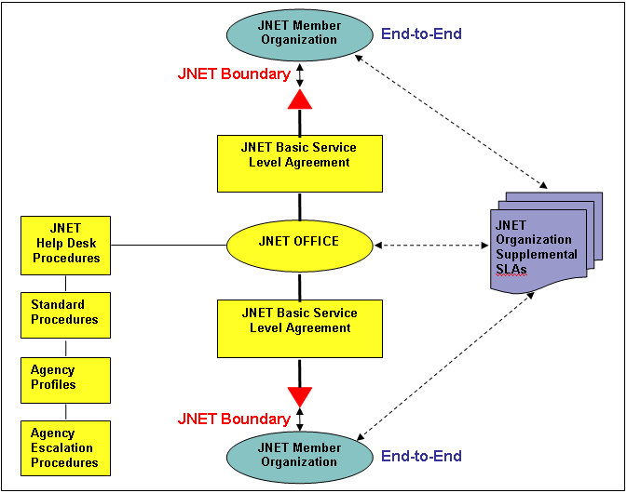

Appendix D – JNET Monitoring and Measurement Tools
The Pennsylvania Justice Network uses a set of monitoring and measurement tools to maintain reliability and performance. These tools are used to measure adherence to the service level agreements (SLA’s). Each tool is described in this appendix.
SiteScope
Mercury Interactive’s SiteScope is used to monitor the availability of JNET applications and application components. It does this by imitating a JNET user; submitting transactions to JNET’s applications on regular intervals according to an overall schedule. The transactions use approved production test data. SiteScope then records the results of those interactions. SiteScope sends alerts via email to both JNET Operations and the JNET Help Desk when an application or component of an application has failed. This alert allows JNET to begin taking action before users notice the outage.
The owners of the data determine the minimum interval between test transactions for each application. The testing intervals currently go from two to 30 minutes (for example, JNET Home Page and RAP sheets). Schedules can be set up on a per application basis and used to distinguish between prime time and non-prime time or to allow for regularly scheduled maintenance windows. However all applications are currently monitored via a single 24 hours per day, seven days per week schedule.
An outage is reported when SiteScope receives two consecutive errors in a transaction. Depending on the transaction, SiteScope may be configured to report an error based on conditions such as transactions taking too long to complete or the presence or absence of key words or phrases in the returned page (which would indicate success or failure). Two consecutive errors are used so that SiteScope can ignore transient errors.
SiteScope can also generate “warning” errors based on criteria specified when the monitor for the application was designed.
In addition to monitoring the status of applications, SiteScope also helps JNET Operations to diagnose the problem by pointing to the specific component or area of an application that has failed. This can decrease the time it takes to resolve issues. The design of the application and the components and facilities that it uses determine the degree to which SiteScope can isolate issues.
SiteScope also provides built-in management reports for daily, weekly and monthly availability summaries. Management reports can be viewed online via a secure URL or SiteScope can automatically send them to a list of email addresses. Currently, the reports are being sent daily via email to members of the JNET Operations team.
Report data includes:
The application/monitor name is the name assigned by JNET to a group of web-based transactions. The transactions typically correlate to an application.
Uptime percentage is calculated by adding the number of transactions that did not return an error or warning within the report period and dividing by the sum of the period intervals. For example, if there were 70 “good” transactions out of 90 attempted, then:
Uptime% = Good Count/Report Period = 70/90 = 77.778%
Because transactions are run at intervals, short outages can be missed. For example, if the interval between which the owners of the data permit transactions is 30 minutes, any outage shorter than that could be missed.
WhatsUp Gold
IPSwitch’s WhatsUp Gold is used by JNET Operations and the help desk to monitor the availability of JNET’s communications network.
It provides a real-time, high-level network map that indicates the overall health of the network. Color-coding the health of any component or segment in green, yellow or red indicates the status. The WhatsUp Gold network map is typically running in both the help desk office and in the network team’s office.
WhatsUp Gold also provides the ability to drill down within the network to look at the current status of a location. The details provided at this level include, among other things, the current status, the last time the location was checked and uptime for the connection. WhatsUp Gold cannot determine the root cause of the error, such as whether connectivity was lost because of a hardware failure, power failure or due to routine maintenance.
In addition to providing the current network status, WhatsUp Gold also provides historical reports on the availability of the network link to various locations. The locations being monitored include the counties and agencies that connect to JNET. The availability reports can be either detailed or summary and can be generated for any combination of starting and ending dates. Historical data exists back to at least January 1, 2003. The reports include the locations identified by the names entered into WhatsUp Gold for each site.
An outage occurs when the equipment being monitored at the remote location has not responded four consecutive times. Each time is 15 seconds apart. This one-minute check is designed to allow for transient errors to be ignored. This means that an outage of less than one minute may be missed. Typically, network traffic can ride through outages of 30 seconds or less with no loss of connectivity. In a network of any size and complexity, some number of transient errors is normal and the quality of data communications in the remote location has an impact on the definition of a normal quantity of errors.
The total downtime listed on the reports is the sum of all outages. An outage could be caused by a failure in the equipment at the location (for example, a router), by a problem in the telecommunications link or a problem with something in between (for example, a business partner firewall, router or switch).
Graphical versions of these reports are also available; however, JNET does not currently produce or use them.
WhatsUp Gold can also use schedules to determine when to monitor equipment and each schedule is set on a per equipment (location) basis. Currently, all equipment is being monitored 24 hours per day, seven days per week.
Finally, WhatsUp Gold is currently being used to provide alerts when remote locations go up or down. It currently sends emails for counties or agencies. It also monitors two other sites on the Internet as a way of determining the availability of the commonwealth’s (and therefore JNET’s) link to the Internet.

JNET Web Service Monitoring
This monitoring application provides JNET customers with the status of JNET web services and underlying applications. Icons will display based on status of the web service or the underlying system. If there is no interruption in service, a green arrow will display showing an on-line status. If one or more underlying sources are interrupted, a yellow yield icon will display showing a warning. If the service is not usable, a red "x" icon will display to indicate that the service is off-line.

Appendix E – JNET Annual Service Level Report & Availability Report

Application name | Percent uptime (excluding maintenance) | Average response (Time in seconds)
MCC Notifications | 100.00% | 0.03
OA Notifications | 99.30% | 0.03
DATAPOWER Health Check | 99.94% | 0.12
WebCPIN Arrest Mug shots | 99.94% | 0.13
Special Metro Home | 99.94% | 0.13
Certificate Enrollment | 99.94% | 0.14
Inmate Locations | 99.94% | 0.14
Learning Management System | 99.94% | 0.14
PennDOT - User Inquiry Report | 99.94% | 0.15
Home Page / Initial Menu | 99.94% | 0.16
DOH Birth Inquiry Home Page Testing | 99.94% | 0.28
Arrest Search - Go to Search Form | 99.94% | 0.62
Citation Search - Go to Search Form | 99.94% | 0.70
MCC | 99.94% | 0.77
JNET PORTAL | 99.94% | 0.83
Person Search - Go to Search Form | 99.94% | 0.87
Offender Info | 99.94% | 0.95
Log into cNET then Display Main Screen | 99.94% | 1.00
Domestic Relations Warrant | 99.94% | 1.07
Person Search (General Name) - Go to Search Form | 99.94% | 1.15
Ticket Search - Fill in Search Form & Display List | 99.94% | 1.18
Juvenile Watch List Inquiry | 99.94% | 1.33
Incident Search - Fill in Search Form & Display List | 99.94% | 1.41
Inmate Photos | 99.94% | 1.42
JNET Home Page | 99.94% | 1.53
Incident Search - Fill in Search Form & Get Form ID | 99.94% | 1.57
Ticket Search - Go to Search Form | 99.94% | 1.69
Inmate Summary | 99.94% | 1.78
DCNR Search ATV Snow mobile | 99.94% | 1.84
CPIN Arrest Mug shots | 99.94% | 1.85
PennDOT Inspection and Emissions | 99.94% | 1.86
Person Search - cNET | 99.94% | 1.91
Deputy Sheriff Query | 99.94% | 1.91
Incident Search – cNET | 99.94% | 1.92
Inmate Location | 99.94% | 2.00
Inmate Classification | 99.94% | 2.03
Inmate Sentence | 99.94% | 2.03
Inmate Classification | 99.94% | 2.15
JDFS - Inmate Photos | 99.94% | 2.19
ISOATS | 99.94% | 2.26
DPW Recipient Address | 99.94% | 2.32
PennDOT Driver's History | 99.94% | 2.39
PennDOT - Inquiry Volume Report | 99.94% | 2.43
Constable Query | 99.94% | 2.49
Citation Search – cNET | 99.94% | 2.68
PennDOT In Transit Tag | 99.94% | 3.01
Notifications Reports | 99.94% | 3.05
PennDOT Photos | 99.94% | 3.05
AOPC UJS PORTAL | 99.94% | 3.12
Citation Search – cNET | 99.94% | 3.13
PennDOT Emergency Contact | 99.94% | 3.19
Digital Dashboard | 99.94% | 3.56
PennDOT Vehicle Registration | 99.94% | 3.58
SGS web Advance Search | 99.94% | 3.76
Juvenile Inquiry | 99.94% | 4.50
JNET Photo Search | 99.94% | 5.06
Person Search – cNET | 99.94% | 5.51
Web Service Monitoring | 99.94% | 6.05
Person Search cNET | 99.94% | 7.90
User White Pages | 99.94% | 12.53
Person Search (General Name) – cNET | 99.94% | 16.68
Rap Sheet (RS/MN) | 99.94% | 20.64
Warrant Search | 99.94% | 38.77

Total Monitored Transactions/Applications: 63
Average Uptime: 98.63%
Average response time 3.25 seconds

Appendix F JNET Acronym List

Acronym | Definition
AOPC | Administrative Office of the Pennsylvania Courts
ATV | All-Terrain Vehicle
CDL | Commercial Driver’s License
CH | Criminal History
CJ | Criminal Justice
CLEAN | Commonwealth Law Enforcement Assistance Network
cNET | Crime Network
CPIN | Commonwealth Photo Imaging Network
DCNR | Department of Conservation and Natural Resources
DOC | Department of Corrections
DOH | Department of Health
DPW | Department of Public Welfare
HIDTA | High Intensity Drug Trafficking Area
JCMS | Juvenile Case Management System
JDFS | Justice Data Flexible Search
JFRS | JNET Facial Recognition System
JNET | Justice Network
JTAC | JNET Terminal Access Control
JTS | Juvenile Tracking System
LEJIS | Law Enforcement Justice Information System
LMS | Learning Management System
MARIS | Mid-Atlantic Regional Information Sharing
MCC | Master Charge Code
NCIC | National Crime Information Center
NY/NJ | New York/New Jersey
OTN | Offense Tracking Number
PA | Pennsylvania
PACSES | Pennsylvania Child Support Enforcement System
PA SORT | Pennsylvania Sex-Offender Registration Tool
PBPP | Pennsylvania Board of Probation and Parole
PCCD | Pennsylvania Commission on Crime and Delinquency
PCS | Pennsylvania Commission on Sentencing
PennDOT | Pennsylvania Department of Transportation
PFAD | Protection from Abuse Database
PSI | Pre-Sentence Investigation
PSP | Pennsylvania State Police
SGS | Sentencing Guidelines Software
SID | State ID
UJS | Unified Judicial System
WebCPIN | Web-based Commonwealth Photo Imaging Network

