USPS EASTERN COUNTY VENDING

DEPARTMENT OF LABOR AND INDUSTRY
BUREAU OF BLINDNESS AND VISUAL SERVICES

IFB 6100022718

Closes July 31, 2012 @10 AM

Table of Contents
Attachment A Statement of Work Pages 2-6
Attachment B Eastern Region Locations Pages 7-8
Attachment D Calendar of Events Page 9
Exhibit 1 Memorandum of UnderstandingPage 10-15
Exhibit 2 Regulated Pricing List Page 16

Attachment C Terms and Conditions Separate File
Instructions to bidders Separate File
Buidding guide Separate File
How to enter % Pricing Separate File
STD 168 – MBE/WBE Separate File

Attachment A

Statement of Work

1 General: The purpose of this “Invitation for Bid” (IFB) is to solicit bid proposals to engage the services of a qualified vending company to provide sales, installation, and service of vending machines for the Office of Vocational Rehabilitation (OVR), Bureau of Blindness and Visual Services (BBVS)/Business Enterprise Program (BEP). This is a three (3) year term contract with a two (2) one (1) year renewal options. Bidders are required to service all United States Postal Services (USPS) locations in the Eastern County Region of the Commonwealth of Pennsylvania (Commonwealth), please refer to Attachment B, regardless of sales volume or size of the location. Failure to service all Eastern Counties locations may also be cause for termination of the contract.

This Bid is to be submitted electronically through the PA Supplier portal by registered vendors only. http://www.pasupplierportal.state.pa.us/ Please print and review all attached documents.

Type of Contract - Vending Service Contract serves to provide vending products such as coffee, ice cream, sodas, juice, water, cold/hot foods, and vending machine snacks. Also provides delivery, maintenance, cleaning, repair, and/or vending machine replacement of machines owned, leased, or contracted by the Bidder.

This Vending and Service Contract is governed by the Commonwealth of Pennsylvania’s “Standard Contract Terms and Conditions”, (Attachment C). The Issuing Office, in its sole discretion, may undertake negotiations with Bidder, who’s Bids, in the judgment of the Issuing Office, show them to be qualified, responsible and capable of performing the Project. Insurance requirements will be part of the Standard Terms and Conditions.

2 Purpose: This invitation for Bid (IFB) provides to those interested in submitting proposals for the subject procurement (“Bidder”) sufficient information to enable them to prepare and submit proposals for the BBVS’ consideration on behalf of the Commonwealth to satisfy a need for vending services (“Project”) in all Eastern County USPS owned and/or leased offices and facilities located in the Commonwealth of Pennsylvania (Attachment B), with the exceptions of facilities operated by current licensed blind vendors in USPS locations.

This IFB seeks bid proposals to engage the services of a qualified vending company to provide food service, sales, installation and service of vending machines as mentioned above for BBVS, Administration of this contract will be through the office of:

Department of Labor and Industry
OVR Bureau of Blindness and Visual Services
1521 N. Sixth Street 2nd Floor
Harrisburg, PA 17102

3 Issuing Office: OVR/BBVS (“Issuing Office”) has issued this IFB on behalf of the Commonwealth. The sole point of contact in the Commonwealth of Pennsylvania for this IFB shall, be: The Department of Labor and Industry, Procurement Office, Attention: Mike Schindler, 651 Boas Street Room 205, Harrisburg, PA. 17121, All inquiries should be directed to: RA-li-OIT-BAS-Procur@state.pa.us Reference IFB 6100022718 in the Subject Line.

4 Scope of Work/Award: This contract shall be awarded to a responsive and responsible bidder whose bid proposal demonstrates over five (5) years of successful experience in the vending/food service industry and is most advantageous to the Commonwealth. BBVS proposes that the Bidder provides a single source, full management program which would provide vending services at various Eastern County United States Post Offices throughout the Commonwealth under the “Randolph Shepherd Act”. The successful bidder would be responsible for all aspects of the program to include, but not limited to, installation, maintenance and operation of all machines, collection, reporting of revenue and disbursements of commissions to Bureau of Blindness and Visual Services (BBVS). This includes issuing various reports detailing machine activity, and providing customer service for problem resolution. Although the number, type, and locations of machines fluctuate and no minimum is guaranteed, all locations will be provided as Attachment B. The Bidder would be permitted to manage, operate, and maintain the program itself or to use subcontractors (subject to the approval of the Commonwealth for certain aspects of the concession as long as there is a single point of contact).

The IFB shall be awarded to a single contractor for the whole Eastern County Region within the Commonwealth. If this contractor should fail to be responsive or responsible, the Commonwealth reserves the right to offer a contract to an alternate bidder to complete the contract requirements. The selected bidder will agree to provide services for USPS locations in the Eastern County Region of the Commonwealth with additional sites to be added at the discretion of BBVS.

If at anytime BBVS determines a USPS site to be a viable business opportunity for a blind operator, BBVS will exercise its right to reclaim the facility and exclude it from the contract. BBVS will provide the USPS and the awarded contractor sixty (60) days written notice prior to exclusion. This will then be an addendum to the awarded contract.

Due to the current economic conditions that the USPS is facing, they may downsize or close any of their facilities at any given time. BBVS will immediately notify the awarded contractor when it receives notice that an USPS facility is closing.

All bid proposals must provide BBVS a minimum of twenty-three (23) percent commissions of the gross sales minus sales tax. Gross sales is defined to be the total invoice value of sales, before deducting customers' discounts, returns, or allowances. In addition, all bidders are required to submit commissions to BBVS on a quarterly basis along with a predetermined report showing the gross sales and reflected commissions.

The quoted Commission % shall be consistent through the entire pricing range as listed on EXHIBIT 1A.

5 Pre-Bid Questions: Bidders should forward all questions to the Issuing Office listed above (RA-li-OIT-BAS-Procur@state.pa.us) by email no later than July 25, 2012. All questions will be answered by posting an FAQ to the IFB and on the online advertisement at: www.emarketplace.state.pa.us (with a notice advising FAQ’s have been attached to the solicitation) no later than July 27, 2012. Included as part of this bid are these attachments (this statement of work is Attachment A)

Attachment A--Statement of Work
Attachment B--Locations of Eastern County Region USPS sites in Pa.
Attachment C--Commonwealth of Pennsylvania Standard Terms and Conditions
Attachment D--Calendar of Events
Exhibit 1 - Agreement between the Pennsylvania Department of Labor and Industry Office of Vocational Rehabilitation Bureau of Blindness and Visual Services Business Enterprise Program and The United States Postal Service
Exhibit 2 - Regulated Price List
STD 168 – MBE/WBE Minority Business Enterprise/Women Owned Business Enterprise Commitment Form

6 All vending machines provided by the contractor shall meet the following requirements:

The contractor shall keep vending machines in proper mechanical and electrical working order at all times. All equipment shall be clean, filled, secured, energy efficient and in a sanitary condition to the satisfaction of the USPS and BBVS.

All vending machines provided by the contractor shall be equipped with energy misers, non-re-settable cash counters and also be outfitted with industry-standard, web-base data format tracking system in order that they specifically provide real time sales information to BBVS. The installation and monthly monitoring costs shall be born by the contractor.

Vending machines shall be equipped with: Dollar Bill validating, coin counters and be capable of accepting and dispensing US dollar coin, locks on doors and coin boxes. Credit Card readers are optional but requested on locations where these would be cost effective.

Machines not equipped with the requirements of this IFB will not be accepted. Contractors are cautioned that any violation of these requirements may result in the termination of its contract.

The contractor is required to keep all vending machines fully stocked, cleaned and in working order.

7 Financial Capability

Describe your company’s financial stability and economic capability to perform the contract requirements. Provide your company’s financial statements for the past three fiscal years. If your company is a publicly traded company, please provide a link to your financial records on your company website; otherwise provide three (3) years of your company’s financial documents such as audited financial statements or recent tax returns. Financial statements must include the company’s Balance Sheet and Income Statement or Profit/Loss statements. Also include a Dun & Bradstreet comprehensive report if available. The Commonwealth reserves the right to request additional information it deems necessary to evaluate a Bidder’s financial capability.

Contractor Prior Experience Submittal

 | Company Name and Address | Contact Information | Project Name | Project Start and End Dates | Brief Description of the Project
1
2
3

8 Contractor Personnel and Qualifications

Provide resumes with names of individuals that will be assigned and demonstrate the qualification and skills required to successfully develop and implement the project as defined in the Scope Of Work.

9 MOBILIZATION AND IMPLEMENTATION PLAN

It is essential that the Commonwealth move forward in a timely manner to have the contract in place. Therefore, the bidder must include as part of its BID a mobilization and implementation plan, beginning with the date of notification of contract award of such mobilization and implementation plan should include the following elements:
(a) A detailed timetable for the mobilization and implementation period of sixty (60) days from the contract award. This timetable should be designed to clearly demonstrate how the bidder will have the contract executed and operational from the date of notification of award.

(b) The bidder's plan for the deployment and use of management, supervisory or other key personnel during the mobilization and implementation period. The plan should show all management; supervisory and key personnel that will be assigned to manage supervise and monitor the bidder’s mobilization and implementation of the contract within the period of sixty (60) days from the contract award.

An incomplete or inadequate plan may cause a bid/bidder to be considered non-responsive and may be grounds for rejection of their bid.

This plan when approved by the Commonwealth shall be added to the contract as a “signed addendum”.

Special tasks and responsibilities of each party are outlined as follows:

- Contractor. All product prices, as prescribed and stipulated on the vending machine retail price sheet listed in Exhibit #2 of this IFB, will remain in effect for the duration of the contract or otherwise specified by BBVS. Prices may not be changed without the prior written approval by BBVS. Price increases will only be granted if it can be substantiated that contributing factors, e.g. price increases from manufacturers or suppliers, require a price increase above those specified in this IFB. If a price increase is granted by BBVS, the contractor will be permitted to raise the price of the product up to the new pricing level.
- Contractor. Permission is required for the contractor to change, remove, or add vending machines at any location, and must be secured in writing from the Commonwealth of Pennsylvania contract manager. The contractor is encouraged to explore and suggest upgrades, additions, and improvements to each location to maximize profitability and commissions.
- Contractor. All vending machines are, and remain the property of the contractor. The Contractor shall take such action as may be reasonably required for the protection of the vending machines against loss by pilferage or destruction e.g. machines may be requested to be secured/bolted together where applicable.

- Contractor. Final connections shall be made by the vending machine contractor.

- Contractor will ensure that the area around the vending machines is clean and in an orderly fashion and will place trash, garbage and debris in areas designated by USPS. It will be requested that the Contractor will move vending machines every six (6) months for cleaning of floors and ventilation to be coordinated with Contractor, USPS and BBVS. Any failure on the part of the Contractor to immediately advise BBVS of its inability to satisfy the required services or provide these services in the required time allotted shall be treated as a breach of contract and may result in the cancellation of the contract.

- Contractor shall service designated non occupied locations by BEP blind operators within the Eastern County Region USPS facilities within the Commonwealth.

- Contractor shall grant BBVS a log in or user account that is user friendly and accessible for real time sales information for each vending machine from the installed web base data format tracking system. The Contractor shall also submit quarterly commission checks with a detailed report reflecting the web base data. The report should include monthly gross sales and commissions per identified location per machine per month. From the award of the contract, the quarterly commission checks with a detailed report to BBVS should be received by the 15th of the month following quarter end.

- BBVS. Following the award of this contract, BBVS will notify all the using agencies that a new contract has been awarded and identify the awarded contractor. Upon the expiration of the current contract the current contractor will be notified that they shall have thirty (30) days to remove all vending equipment from the various locations they service and vacate the premises. Through this transition period, BBVS will contact the new contractor and arrange for services to begin as soon as the previous contractor vacates the premises. This should be well coordinated with the goal of having a minimum of downtime and to insure service is not disrupted unnecessarily.

- BBVS will ensure that USPS furnishes all necessary water lines, plumbing, electric and electrical service connections for operation of the vending machines.
ADDITIONAL INFORMATION AND UPDATES TO ANY REQUIREMENTS SHALL BE COMMUNICATED BY AN ADDENDUM ATTACHED TO THE SOLICITATION AND ADVERTISED ON WWW.EMARKETPLACE.STATE.PA.US
UPDATES MAY ALSO BE SENT BY EMAIL BUT THE RESPONSIBILITY REMAINS WITH THE PROSPECTIVE BIDDER TO MONITOR THE WEBSITES FOR ANY NEW INFORMATION PROVIDED.

Attachment B

Eastern County Region Sites

City | Address | Number of Machines | Gross Sales from January Through December 2011
Coatesville | 230 E Chestnut St | 1 | $630.95
Downingtown | 470 Boot Rd | 4 | $4,656.56
Exton | 430 Exton Square Pkw | 2 | $343.20
Kennet Sq | 222 E State St | 1 | $0
West Chester | 1050 Airport Rd | 4 | $9,261.76
Phoenixville | 116 Gay St | 3 | $3,695.00
Levittown | 7200 New Falls Rd | 3 | $9,472.00
Southampton | 1050 Street Rd | 7 | $5,028.09
Bristol | 699 Beaver St | 3 | $2,630.81
Doylestown | 8 Atkinson Dr | 3 | $4,737.59
Warminster | 1135 Meams Rd | 4 | $5,339.97
Philadelphia | 3000 Chestnut Rd | 7 | $21,410.15
Philadelphia | 900 Market St | 3 | $6,722.05
Philadelphia | 7232 Rising Sun Ave | 3 | $5,659.41
Philadelphia | 9925 Bustleton Ave | 3 | $5,709.09
Philadelphia | 4410 Paul St | 3 | $696.38
Philadelphia | 925 Dickinson Rd | 3 | $5,687.50
Philadelphia | 10380 Drummond Rd | 3 | $5,283.53
Philadelphia | 1602 Frankford Ave | 2 | $861.96
Philadelphia | 900 N 19th St | 5 | $8,270.23
Philadelphia | 4624 Longshore Ave | 3 | $3,435.60
Philadelphia | 2904 S 70th St | 3 | $3,052.55
Philadelphia | 2500 Snyder Ave | 3 | $2,064.27
Philadelphia | 658 N 63rd St | 3 | $1,204.19
Philadelphia | 3854 Morrell Ave | 3 | $1,582.66
Philadelphia | 5300 W Jefferson St | 3 | $5,156.40
Philadelphia | 2601 N 16th St | 3 | $3,694.80
Philadelphia | 2031 66th Ave | 3 | $1,672.01
Philadelphia | 5011 Samson St | 3 | $2,882.86
Philadelphia | 6150 N Broad St | 3 | $5,070.76
Philadelphia | 2801 Levick St | 3 | $6,174.43
Philadelphia | 901 Market St | 1 | $0
Philadelphia | 7782 Crittenden St | 5 | $6,410.62
Philadelphia | 101 E Olney Ave | 4 | $4,000.16
Philadelphia | 555 Green Ln | 3 | $3,060.16
Philadelphia | 2001 E Willard St | 3 | $3,627.27
Philadelphia | 4350 N Front St | 3 | $4,044.74
Philadelphia | 5311 Florence Ave | 3 | $5,031.91
Philadelphia | 5209 Greene St | 3 | $7,508.38
Willow Grove | 611 N Easton Rd | 3 | $3,891.75
Abington | 1925 Keith Rd | 3 | $4,084.20
Wyncote | 207 Glenside Ave | 5 | $999.18
Lansdale | 20 Vine St | 3 | $6,703.08
Hatboro | 121 N York Rd | 3 | $2,716.22
Washington | 575 Pinetown Rd | 5 | $3,470.77
Ardmore | 30 Ardmore Ave | 5 | $782.20
Clifton Heights | 135 S Springfield Ave | 5 | $1,484.37
Jenkintown | 101 West Ave | 3 | $6,538.94
Collegeville | 52 W 3rd Ave | 3 | $3,032.22
Elkins Park | 800 Ashbourne Rd | 1 | $0
Horsham | 600 Enterprise Rd | 3 | $4,754.20
King of Prussia | 190 Town Center Rd | 3 | $3,830.30
Langhorne | 980 Wheeler Way | 6 | $11,590.72
Morrisville | 950 W Trenton Ave | 3 | $3,068.85
Norristown | 28 E Airy St | 3 | $4,503.52
Pottstown | 770 E High St | 3 | $6,137.95
Media | 22 S Penndl Rd | 1 | $0

*Attachment B Eastern County Region Sites data provided by 3rd party contractor

Eastern County Region Counties—also see Map

- Chester
- Montgomery
- Bucks
- Philadelphia
- Delaware

Attachment D

CALENDAR OF EVENTS

The Commonwealth will make every effort to adhere to the following schedule:

Activity | Responsibility | Date
Deadline to submit Questions via email to Procurement RA-li-OIT-BAS-Procur@state.pa.us. Please have subject read: USPS IFB 6100022718 Bid Question. Do not call with questions, emails are required. If you have registration concerns or need assistance completing your bid please call 1-877-435-7363 for the Help Desk. | Bidder | July 25, 2012
Answers to Bidder questions by posting an FAQ to the IFB. Pertinent or material changes shall be posted on the solicitation on the Pa supplier Portal, and eMarketplace @state.pa.us  (http://www.pasupplierportal.state.pa.us) no later than this date. | Issuing Office | July 27, 2012
Please monitor PA Supplier Portal http://www.pasupplierportal.state.pa.us and www.emarketplace.state.pa.us website for all communications regarding the IFB. | Bidder | ongoing
Electronic Bid proposal must be submitted to the Issuing Office online at the PA Supplier Portal http://www.pasupplierportal@state.pa.us by 10:00 AM. | Bidder | July 31, 2012 @10 AM
Projected Contract effective date shall be September 1, 2012 depend ing on final Commonwealth Approvals. | Issuing Office | September 1,2012
Bid Tabs and awards will be posted at: www.emarketplace.state.pa.us at the earliest time possible. Every attempt will be made to post the Bid Tab within 24-36 hours of the closing. Awards shall be posted within 24-36 hours of selection of the contracted vendor. | Issuing Office

Exhibit 1--Memorandum of Understanding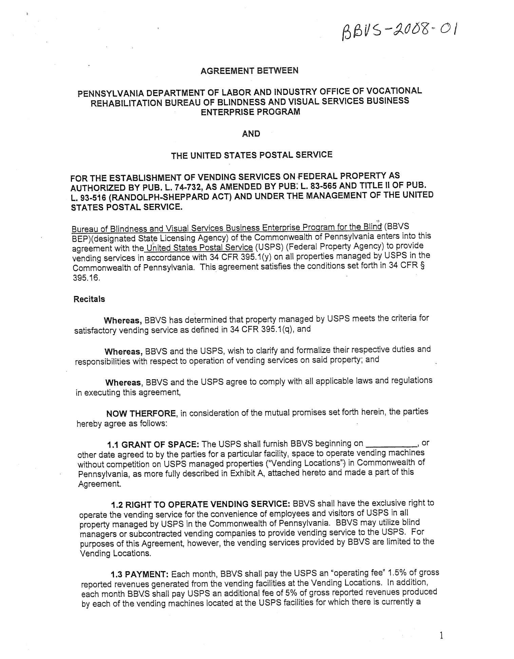
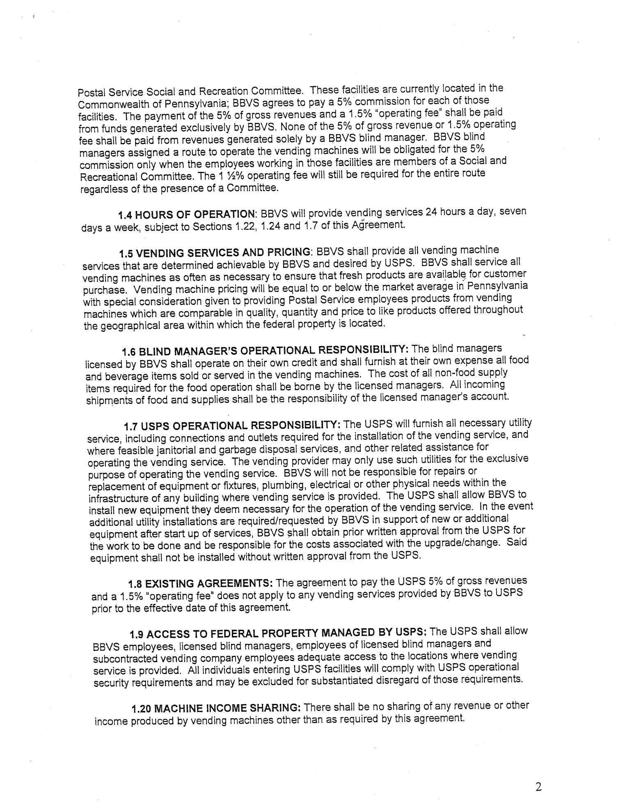
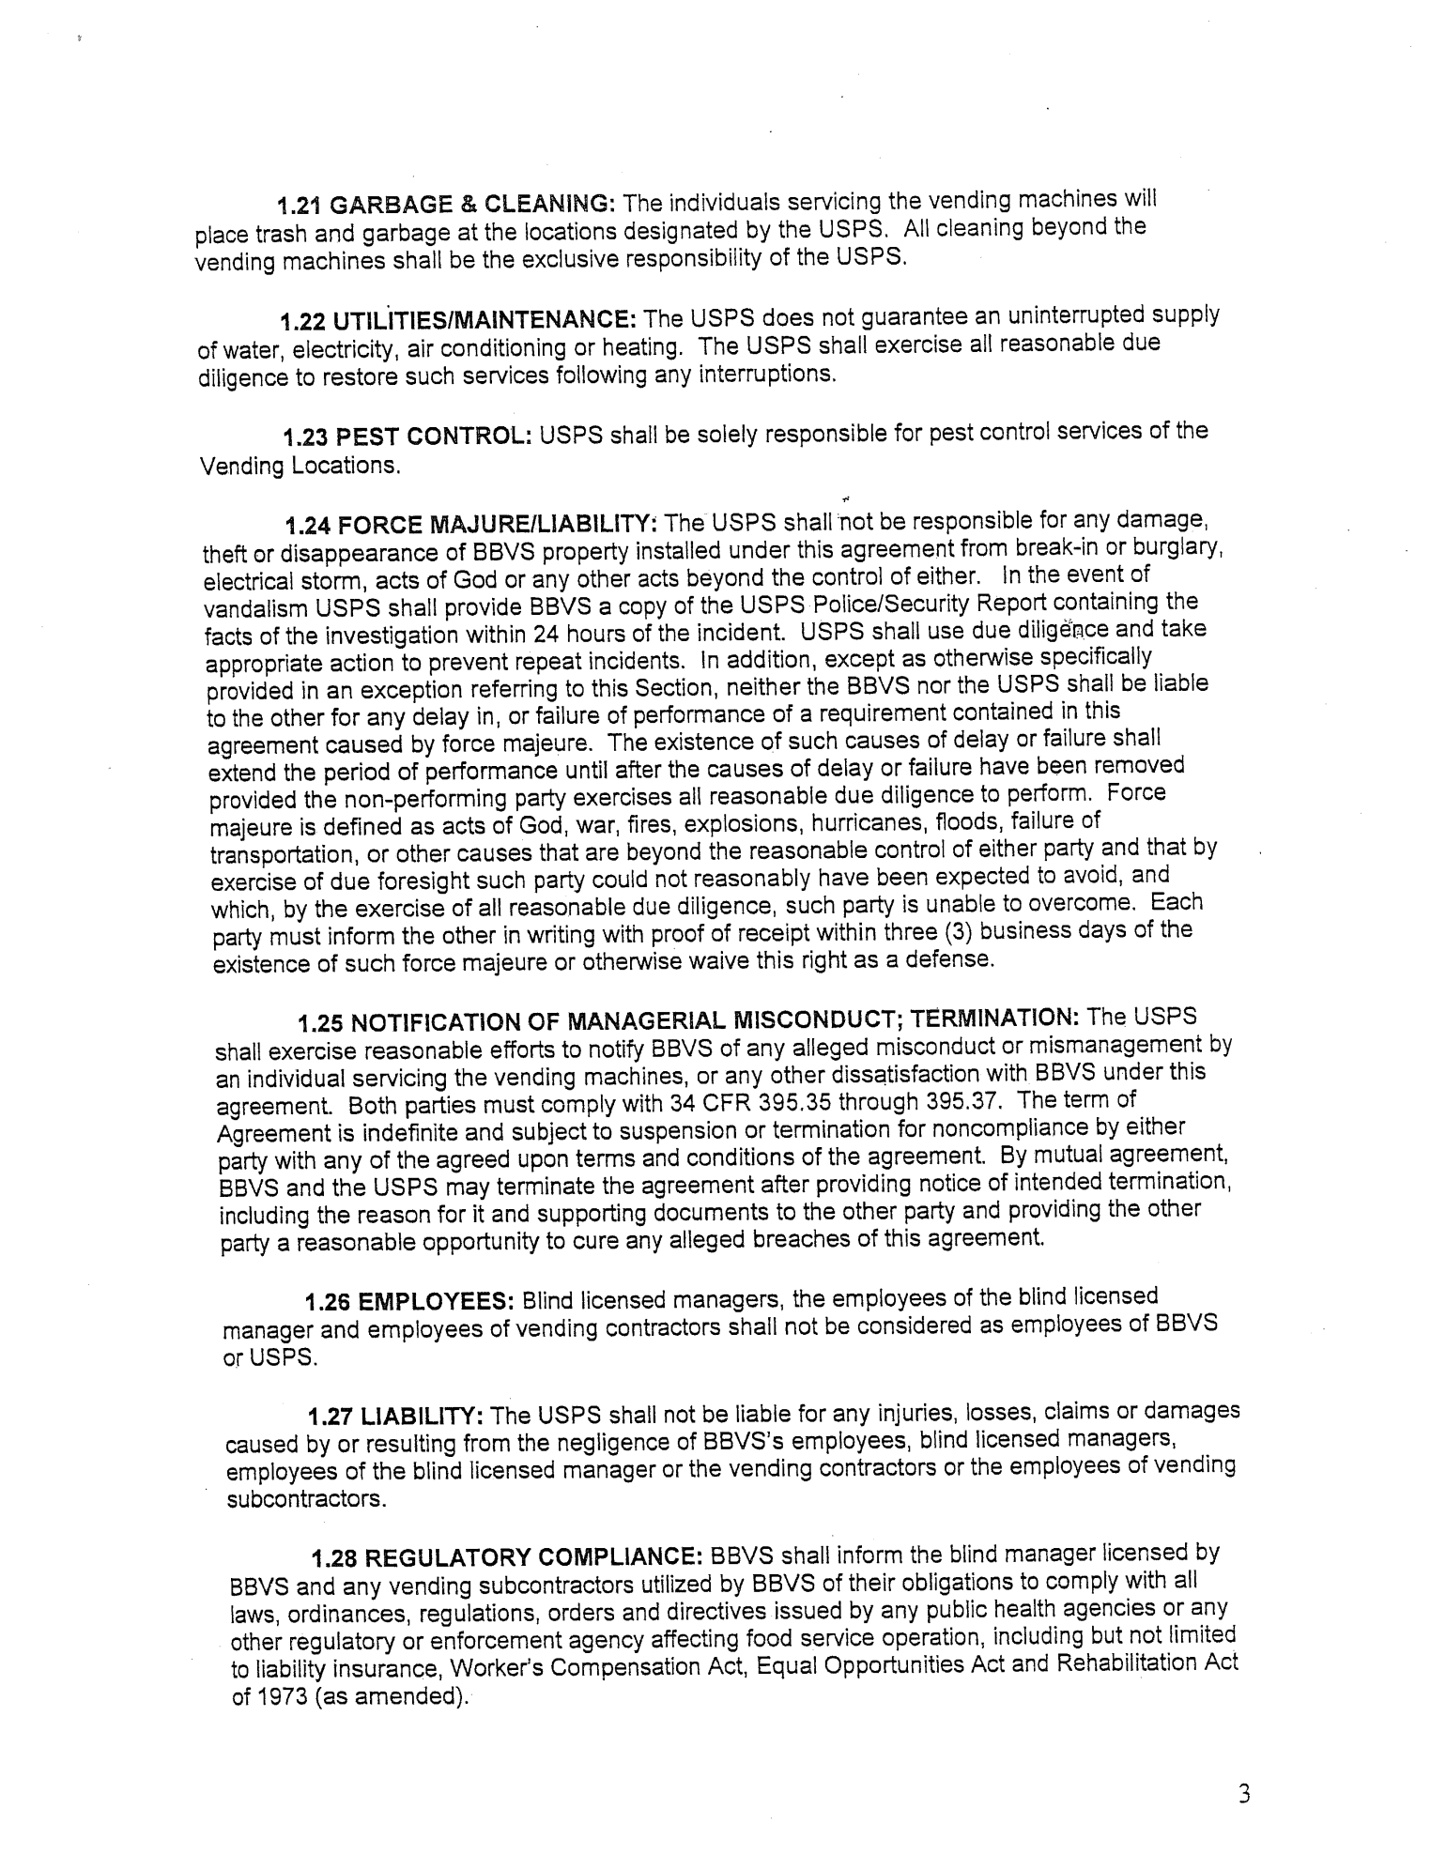

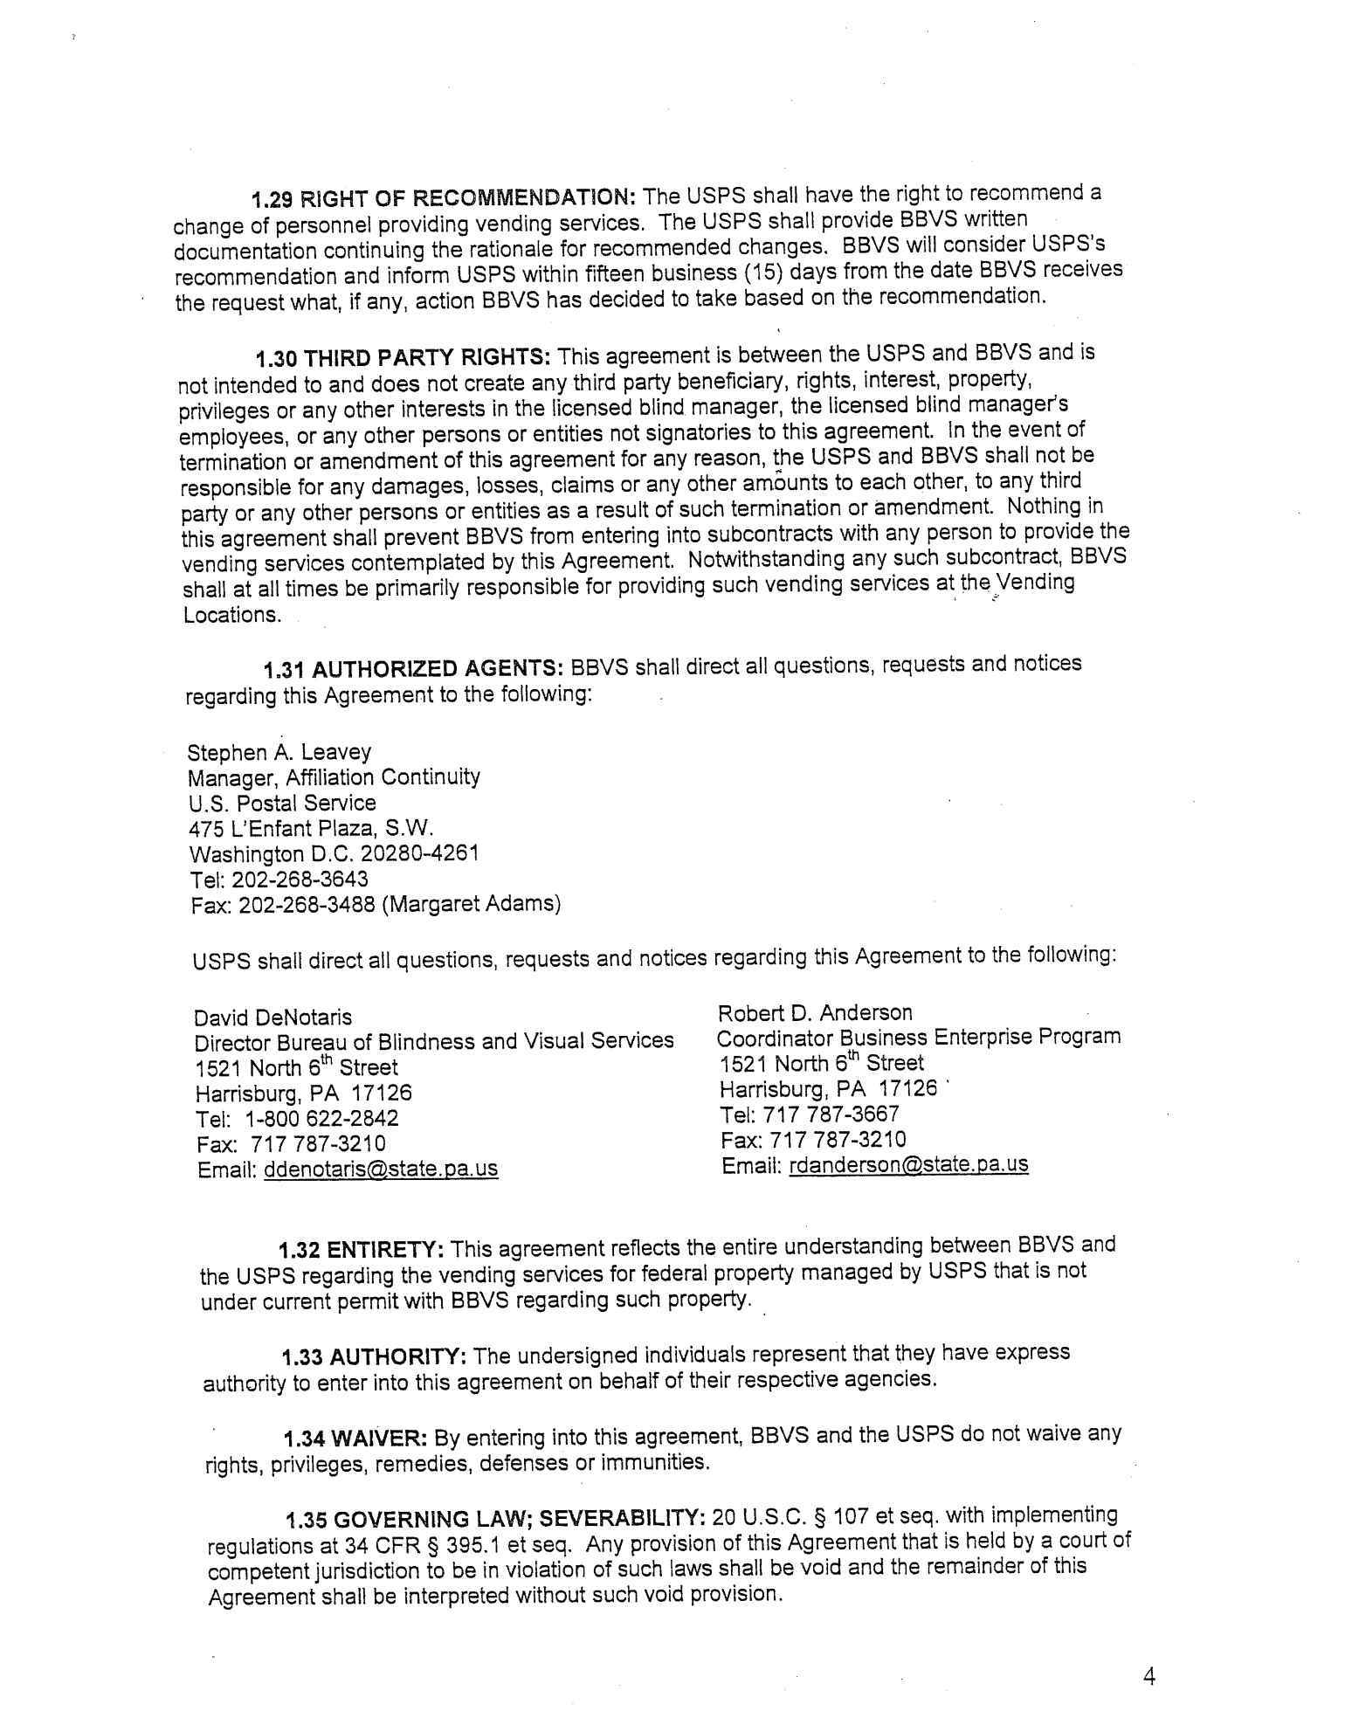

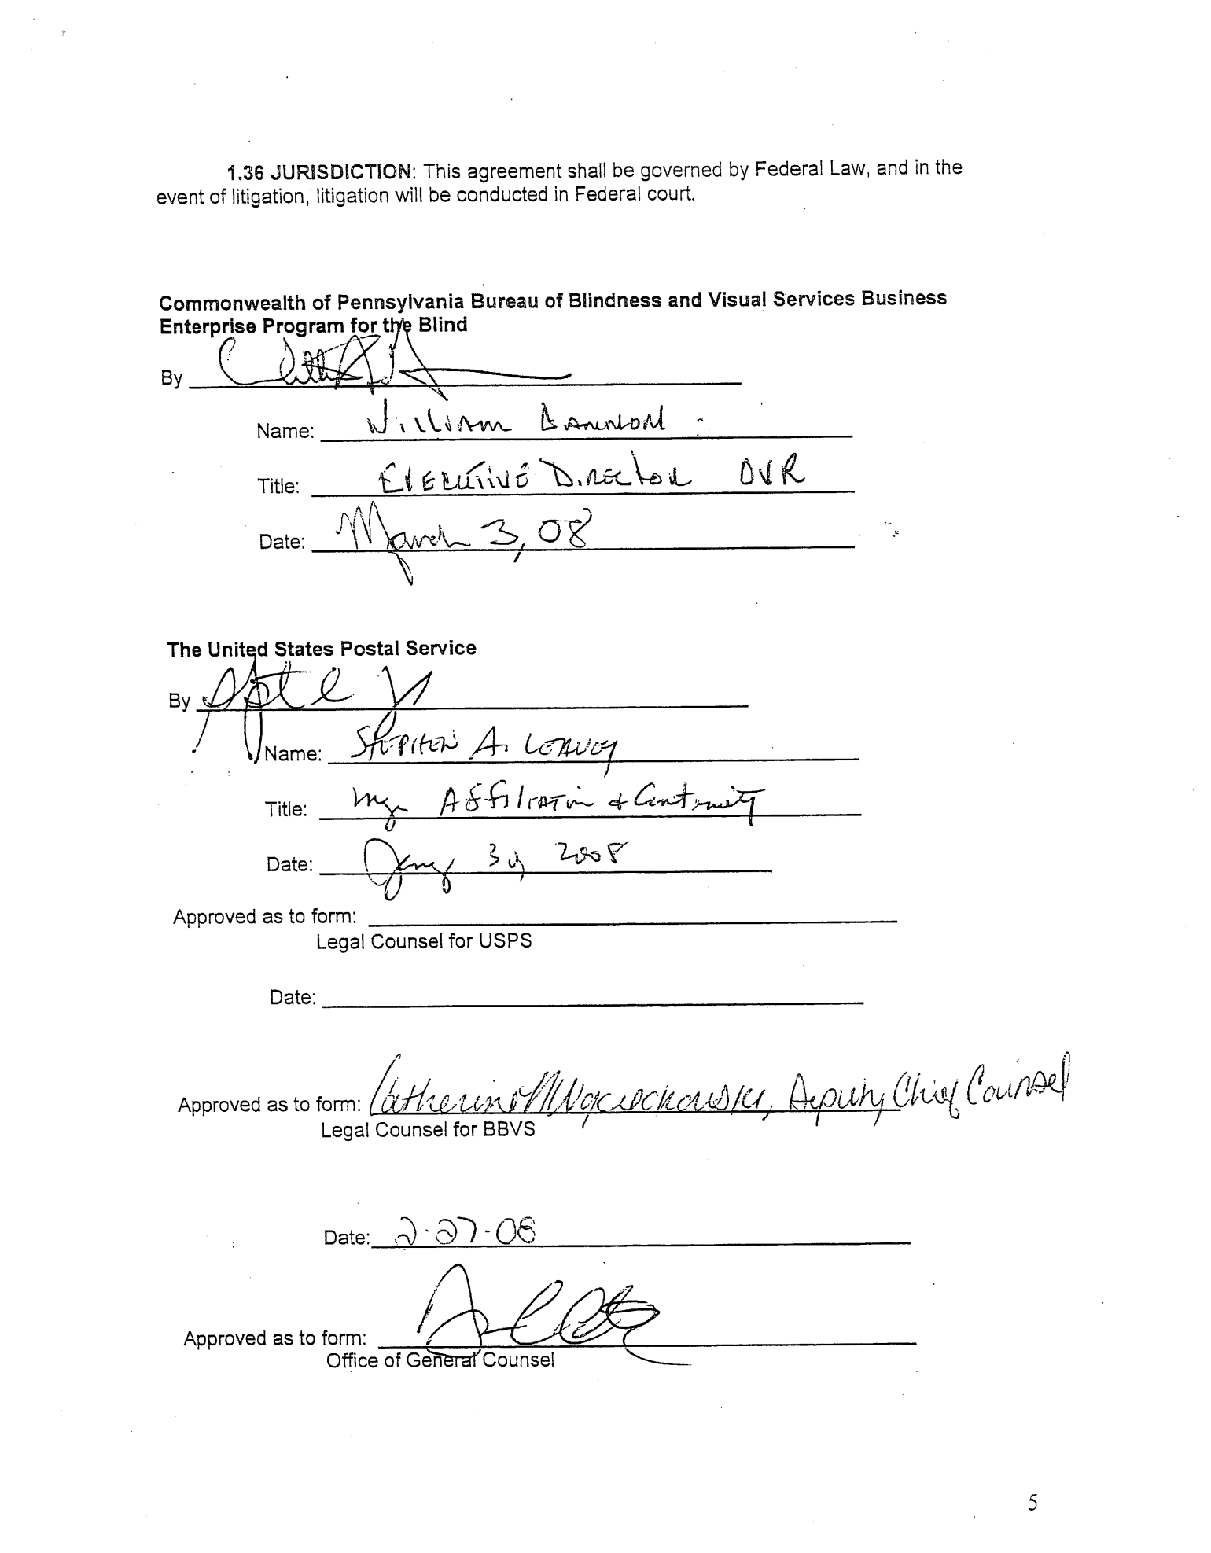

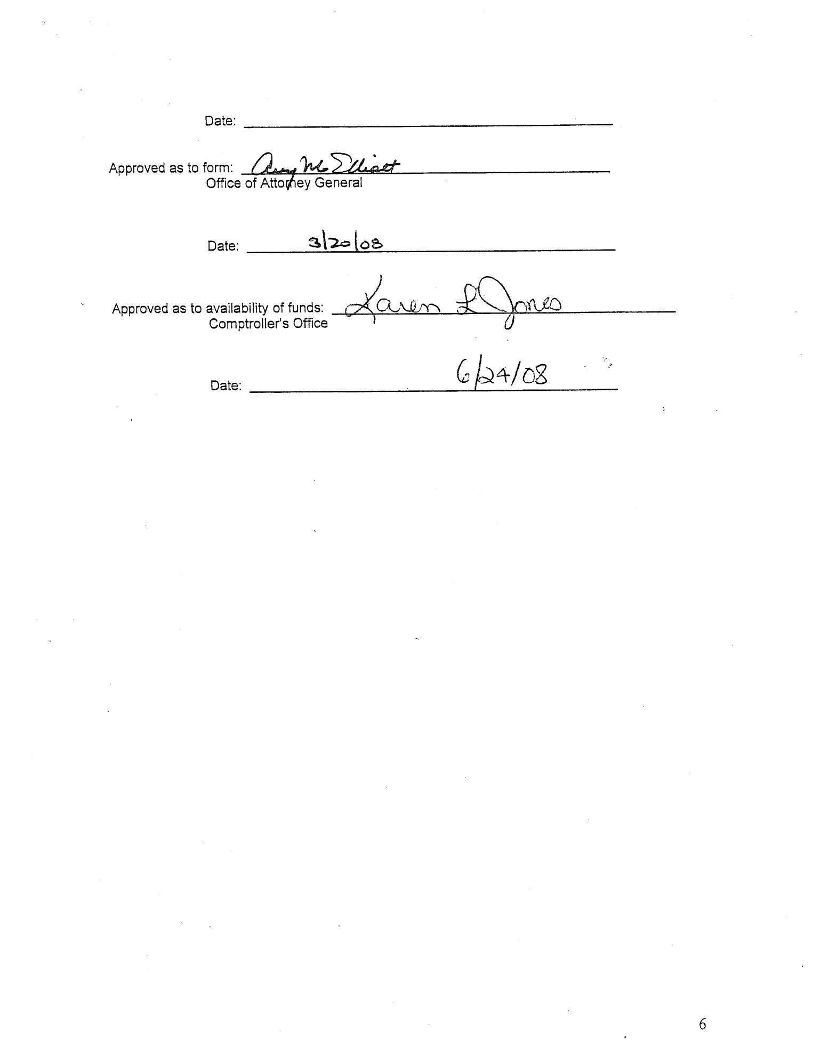

Exhibit 2 Regulated Price List

Under the Public Facilities Concession Regulation Act, Act 1978-315, BBVS reserves the right to regulate the kinds, quality and prices of goods and services upon such terms and conditions as may be appropriate to protect the general welfare of the people of the Commonwealth.

The minimum and maximum prices listed below will be charged on all interstate roads ways, rest areas, and vending sites operated by or contracted by BBVS.

Product Price
Minimum Maximum
Soda (12 oz. Can) $1.00 $1.25
Soda (20 oz. Bottle) $1.50 $2.00
Juice/bottled (12 oz. To 20 oz.) $1.75 $2.25
Bottled Water (16 oz to 20 oz.) $1.30 $1.50
Hot Drinks (8 oz.) $0.75 $1.00
Hot Drinks (12 oz.) $1.00 $1.25
Energy Drinks (8 oz. to 12 oz.) $2.25 $2.50
Energy Drinks (16 oz. to 20 oz.) $3.00 $3.50
Vitamin Water $1.50 $2.00
Gatorade/Powerade $1.50 $1.75

Snack products:

Chips, Pretzels, RSS (RSS to 1 oz.) $0.60 $0.75
Party Mix, Popcorn, Chex Mix,
Doritos, Fritos, Cheetos (LSS Over 1 oz.) $1.00 $1.10
Beef Jerky $1.50 $2.00
6-pk Crackers/Cheez-its, Cookies, $0.60 $0.75
Peanuts (1oz)
Peanuts (Over 1oz) $1.00 $1.50
Nuts (cashews, pistachios 1oz) $0.75 $1.00
Nuts (cashews, Pistachios, etc Over 1oz) $1.25 $1.75
Combos $1.00 $1.25
Cereal Snack Pouches $0.75 $1.00
Granola/Fruit Bars/Nuts(cashews, $0.75 $1.00
pistachios, etc 1oz)
Candy, Chocolate Bars (RSC) $1.00 $1.25
Candy King Size $1.75 $2.00
Cakes/Pastries $1.00 $1.50
Cereal Snack Pouches $0.75 $1.00
Gum $0.60 $0.75
Gum Large Size (jumbo pk.) $1.50 $1.75
Life Savers / Breath Mints $0.60 $0.75
Mints Large Size (tic tac, etc,) $1.25 $1.75
Halls $1.00 $1.25
Hot Foods $2.00 $4.00
Ice Cream Products $1.00 $1.75

