Department of Environmental Protection
Window Cleaning Specifications
May 1, 2017

SCOPE OF WORK:

The Department of Environmental Protection (DEP) requires window cleaning services for the Rachel Carson State Office Building (RCSOB) located at 400 Market Street, Harrisburg, PA. The Rachel Carson Building is a 16-story high rise building. The windows in the building must be cleaned both inside and outside. All exterior windows must be acid washed.

MANDATORY SITE INSPECTION:

A mandatory pre-bid site inspection will take place onsite at Rachel Carson State Office Building, 400 Market Street, Harrisburg, PA, 17101, on Tuesday, May 16, 2017 at 10:00 a.m. Attendees should report to the 15th Floor, Green Room. Visitors are required to sign at the lobby reception desk to gain entry to the building. Photo identification (usually a valid driver’s license) must be presented at time of admittance. This site inspection is a mandatory prerequisite of acceptance of the bid proposal.

SUB-CONTRACTING:

The DEP must be notified in writing along with the bid submission if any part of the project will be subcontracted. The Prime contractor MUST attend the pre-bid site inspection outlined in Section 2. Sub-contractors are welcome to attend the pre-bid site inspection with their prime.

INSURANCE:
  - The awarded contractor is required to have in place during the term of the contract the types of insurance outlined in Section V.44, page 27 of the attached Commonwealth Terms and Conditions document.

- AGENCY CONTACTS:

Questions regarding the bidding or contract execution procedures should be directed to Janet Noll; telephone (717) 772-5747, email: janoll@pa.gov. Email communication is preferred.

Questions regarding the mandatory pre-bid site inspection, project management, coordinating after hours building access, or invoicing should be directed to Joel Miller; telephone (717) 783-8731, email: joelmiller@pa.gov. Email communication is preferred.

GENERAL SPECIFICATIONS AND REQUIREMENTS:

Company must have the appropriate equipment and safety training to clean windows on high rise buildings.

Company should have a fall safety plan in place.

When the window cleaning work commences, company must provide a minimum of two (2) employees on a daily basis to perform the requested work until the job is completed. The exception to this would be the inability to work outside due to inclement weather that would not permit window cleaning duties to be accomplished.

Perimeter (Interior and Exterior) window cleaning must be performed on weekdays between the hours of 6:00 a.m. and 6:00 p.m. The Hall of Flags, Atrium stairway, Atrium, and Rotunda cleaning must be performed on Saturdays between the hours of 7:00 a.m. and 7:00 p.m. (See Attachment A, Figures 2-5)
  - The DEP staff on each floor will open the blinds prior to the windows being cleaned on their floor. If there were any blinds that are non-functional, DEP will call the blind company to open them so the windows can be cleaned. The awarded window cleaning company will not be held responsible for damage resulting from opening and closing blinds.

  - In cases where a cubicle is situated against a window, the awarded window cleaning vendor will be responsible to clean only the accessible surface of the window.

CONTRACT TERM:

  - The period of performance for this project DEP shall begin on September 1, 2017 and shall be completed by September 30, 2017. The actual execution date will be indicated on the resulting Purchase Order (PO) document and will be considered complete upon final inspection and sign-off from the Department of Environmental Protection contact, Joel Miller. The PO expiration date will be no later than October 31, 2017. The interval of payment may be negotiated pre-award and written as part of the final contract execution document. Payment shall be made on a reimbursement basis for actual services performed and accepted by DEP. Payment shall be made in full after all work has been completed.

  - The contract shall commence September 1, 2017 and terminate June 30, 2018. Further, the parties hereto may agree to renew this contract for up to four (4) additional consecutive annual terms with a final termination date of 6/30/2022. The services to be performed and the applicable prices for the renewal terms shall be negotiated between DEP and the contractor.

SPECIAL REQUIREMENTS:

There is a Peregrine Falcon’s nest on the south side of the 15th Floor of the Rachel Carson Building. Special consideration must be given to the falcons in order to maintain their safety and the safety of any personnel that are employed by the chosen window cleaning company. The falcons are usually gone after August 1.

The interior windows have been treated with LLumar film. The awarded contractor must exercise special care when cleaning these treated windows. Please reference Attachments B, page 11, which outlines how these windows should be cleaned. Special care must be taken so as to not use any type of sharp object during the cleaning process.

The roof anchors have been tested and the test results will be shared with the awarded vendor prior to contract execution.

Spider webs and layers of dust shall be cleaned from the ceiling, walls and light fixture of the Rotunda.

A Scissor Lift will be required on the floor of the Atrium to complete work in the Rotunda and Hall of flags. The maximum weight limit for the lift that should not be exceeded is 1,200 lbs.

CONTRACTOR QUALIFICATIONS AND EXPERIENCE:

After bid opening and prior to award, the awarded contractor shall submit no less than two references for jobs of similar size and scope successfully performed within the past three years. The references should include a valid contact name, telephone number, and email address.

Letters of reference are acceptable if they contain a valid name and telephone number for a contact person.

- RCSOB WINDOW NOMANCLATURE DEFINITIONS:

The Rachel Carson State Office Building is a sixteen story high-rise structure that reflects a modern architectural style which consists of many different shape windows and skylights. Listed below are the definitions with regard to the different type of windows associated with RCSOB. Please reference Attachment A, Figures 1-5 for Pictorial Views of these spaces.
  - Perimeter: Windows located on the outside walls of the building. This includes the skylights that are incorporated mainly along the fifteenth floor of the building. (See Attachment A, Figure 1.)
  - Exterior: Windows on the outside of the building. This includes the skylights that are incorporated mainly along the fifteenth floor of the building. (See Attachment A, Figure 1-5.) In cases of some specialty windows the window “exterior” of the window could actually be on the inside of the building.
  - Interior: Windows on the inside of the building. This includes the skylights that are incorporated mainly along the fifteenth floor of the building.
  - Specialty windows: Are defined to include both interior and exterior windows located in the building Atrium, Hall of Flags, Rotunda, and Atrium stairway. (See Attachment A, Figures 2-5.)
  - Hall of Flags: Approximately four story hallway within the building that contains large windows. In this case the “exterior” of the window would be the actual hallway inside the building and the “interior” would be the window that is located in offices and other rooms. (See Attachment A, Figure 2.)
  - Rotunda: Main entrance of the building which is approximately four stories high with a large dome skylight directly overhead. The dome is surrounded by several large windows where the interior is inside the building and the exterior is outside the building. (See Attachment A, Figure 3.)
  - Atrium Stairway: is located off of the rotunda and the stairs rise two floors. The stairs are lined with windows and the ceiling is a series of skylights, the outside windows are covered by netting. The interior and exterior of the stair windows are both located inside the building, whereas the skylights exterior are on the outside of the structure. (See Attachment A, Figure 4.)
  - Atrium: This is a recessed rectangular space between the rotunda and the elevators. It has a set of three windows on all four sides. The interior of these windows are offices and the exterior is also inside the building. (See Attachment A, Figure 5.)

BID AWARD:

Contractor shall submit their total all-inclusive bid price in the form of per hour basis as designated in the “Requirements List” section (outlined on page 6, lines 1 & 2) via the Department of General Services website bid form. The bid price must include all costs associated with execution of the job i.e. travel, materials, equipment, labor, and any other required costs necessary to complete the job. The bid award will be based upon the total sum of all lines (1-6) of the “Requirement List” found on page 6 of this document.

Where “hours” are annotated in the line items of the bid, these hours are estimated and may or may not be adjusted accordingly at the sole discretion of the Department of Environmental Protection as a result of site inspection meeting discussions. Any changes to the bid will be issued in writing and posted to the DGS website.

Bidders must bid all items set forth in the bid. DEP reserves the right to award lines 3-6 in all, partial, or any combination of items set forth in the bid.

PAYMENT TERMS:

Payment shall be made on a reimbursement basis for actual services performed.

If the Department chooses to award the options; (lines 3-6 found on page 6), those options will be paid at the lump sum price not to exceed the amount quoted by the bidder.

ESTIMATED QUANTITIES:

The contract quantities contained herein are estimated only and may increase or decrease dependent upon the needs of DEP. The contractor shall be paid at the hourly price bid for perimeter cleaning (lines 1 & 2.) Any overage must be explained in detail, submitted to the DEP in writing, and approval must be granted prior to the work being performed.

NOTE: This sheet is provided for informational purposes. Please complete/insert your pricing into the electronic portion of the Invitation for Bid. Perimeter (including skylights)
(See Item 10, page 4 for definitions. Also reference Attachment A, Figure 1-5 for illustrations)
Line 1: Perimeter Interior: 200 hours x $ _______per hr. = $ ________ (Total)
Line 2: Perimeter Exterior: 300 hours x $ _______per hr. = $_________(Total)

Specialty windows
(See Item 10, page 4 for window definitions. Also reference Attachment A, Figure 2-5 for illustrations).
Please provide a price for each “Specialty Windows” (below) on a Lump Sum Basis
Line 3: Rotunda
Rotunda Interior: Lump Sum * $_____________
Rotunda Exterior: Lump Sum $_____________
Line 4: Hall of Flags
Hall of Flags Interior: Lump Sum $_____________
Hall of Flags Exterior: Lump Sum * $_____________
Line 5: Atrium Stairway
Atrium Stairway Interior: Lump Sum * $_____________
Atrium Stairway Exterior: Lump Sum $_____________
Line 6: Atrium
Atrium Interior: Lump Sum * $_____________
Atrium Exterior: Lump Sum $_____________
*Note: All costs must include window ledge cleaning for both interior and exterior.

ATTACHMENT A:

Rachel Carson State Office Building
Specialty Window Illustrations

Figure 1: Rachel Carson State Office Building (exterior view)

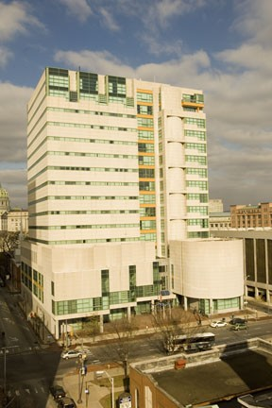

ATTACHMENT A:

Figure 2: RCSOB Hall of Flags

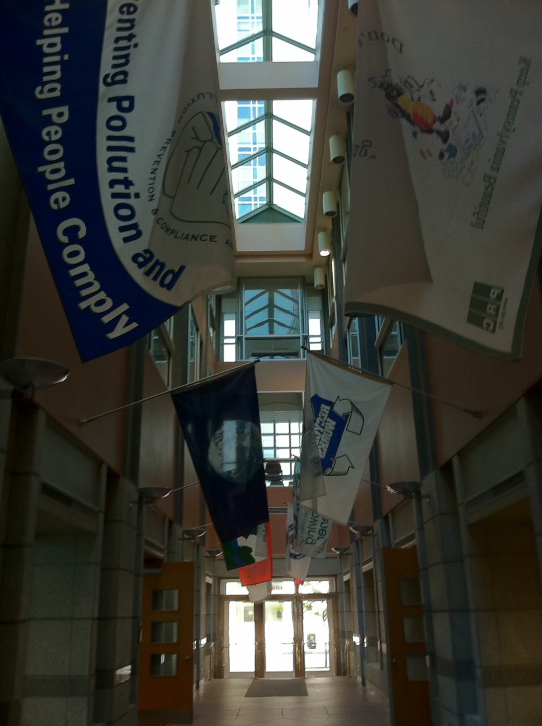

ATTACHMENT A:

Figure 3: RCSOB Rotunda

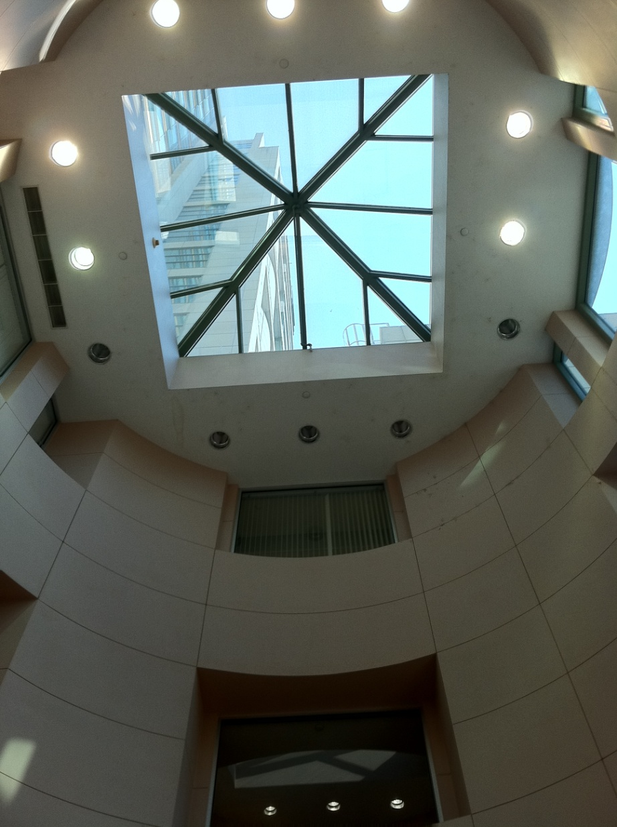

ATTACHMENT A:

Figure 4: RCSOB Atrium Stairs

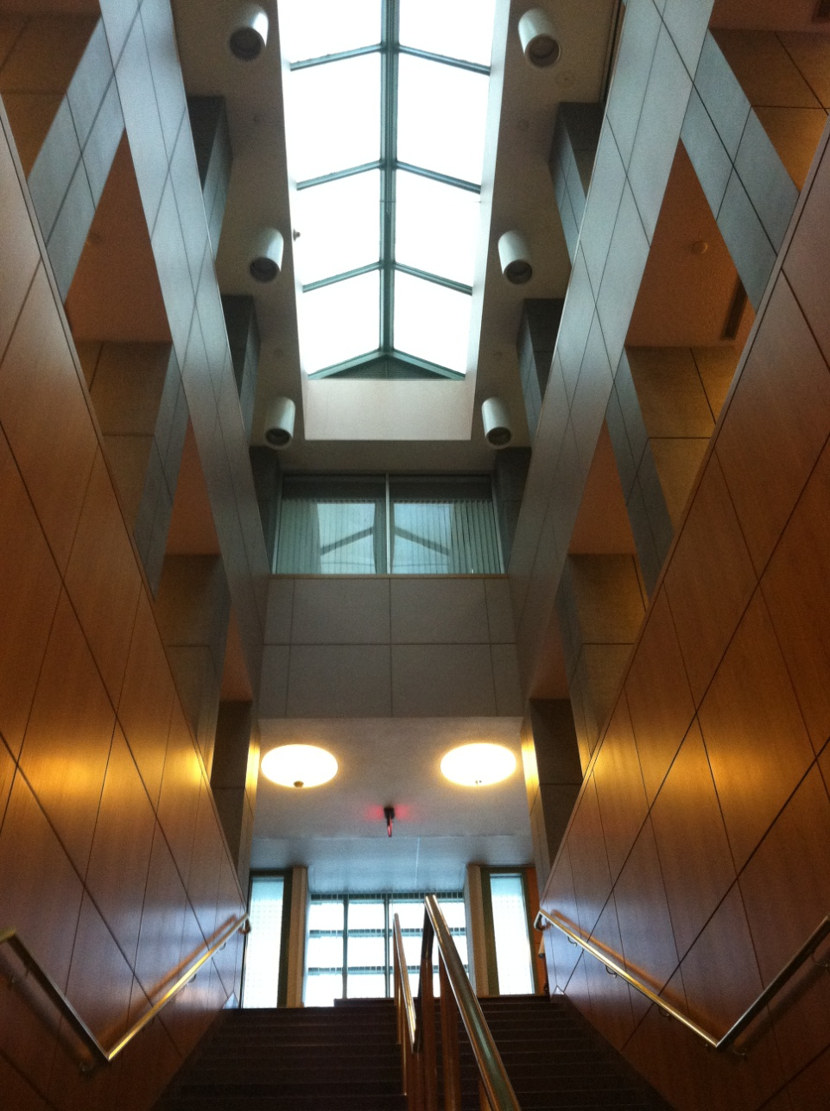

ATTACHMENT A:

Figure 5: RCSOB Atrium

(Note this shows one window of a rectangular space with windows on all four sides)

