COMMONWEALTH OF PENNSYLVANIA
DEPARTMENT OF GENERAL SERVICES

Request for Information 6100053005

Law Enforcement CAD/RMS/MCT System

Summary.
The Commonwealth of Pennsylvania (Commonwealth) issues this Request for Information (RFI) to solicit information that will be used to assist with the development of a solicitation for Law Enforcement Computer Aided Dispatch (CAD), Records Management System (RMS), Mobile Computer Terminal (MCT) System which may be released by the Commonwealth in the future.

Specifically, this request seeks information from which the Commonwealth can formulate specifications and requirements, realistic timeframes and cost structures for the referenced procurement and project. The Commonwealth desires to produce a solicitation that promotes vendor competition and creative technical solutions. The Commonwealth is open to any and all ideas in relation to this project and encourages alternative ideas that will help the Commonwealth better define its requirements. This RFI is an earnest attempt to become aware of and knowledgeable about current solutions to support the project requirements of the Commonwealth. This RFI will also help the Commonwealth identify vendors who are able to provide the required services to support this goal.

Background.
The Pennsylvania State Police (PSP) is interested in learning more about capabilities available in CAD/RMS/MCT systems used in public safety. Specifically, PSP desires to receive information from the vendor community regarding available and suitable solutions to replace all or parts of its current CAD/RMS/MCT system.
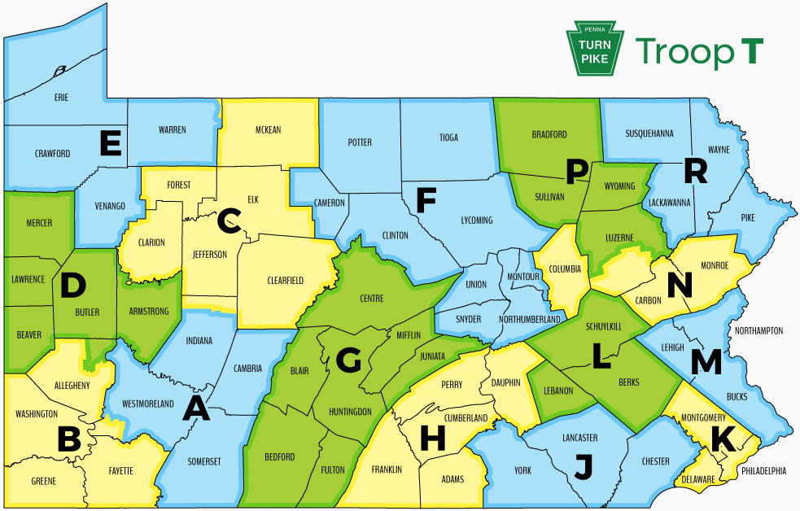

PSP Troop Designation and Area of Responsibility
The mission of the PSP is to seek justice, preserve peace and improve the quality of life for all.

The PSP promotes traffic safety, investigates crime and reduces criminal activity, and provides investigative assistance and support services to all law enforcement agencies within the commonwealth. In addition, the PSP maintains and provides to criminal justice agencies up-to-date law enforcement information, evaluates the competence level of law enforcement within the commonwealth and provides prompt, competent service in emergency situations. The PSP ensures personal protection and security for the governor and other persons designated by proper authority, and enforces all other state statutes as directed by proper authority.

Pennsylvania has 12.8 million residents across an area of 46,000 square miles with 67 counties. The PSP has jurisdiction in all political subdivisions within the Commonwealth. PSP has approximately 6,000 employees including 4,700 sworn officers (Troopers) to provide full- or part-time police service to approximately 67 percent of the Commonwealth’s municipalities, 61 percent of the Commonwealth’s roadways, 82 percent of the Commonwealth’s total land area, and 26 percent of the Commonwealth’s total population.

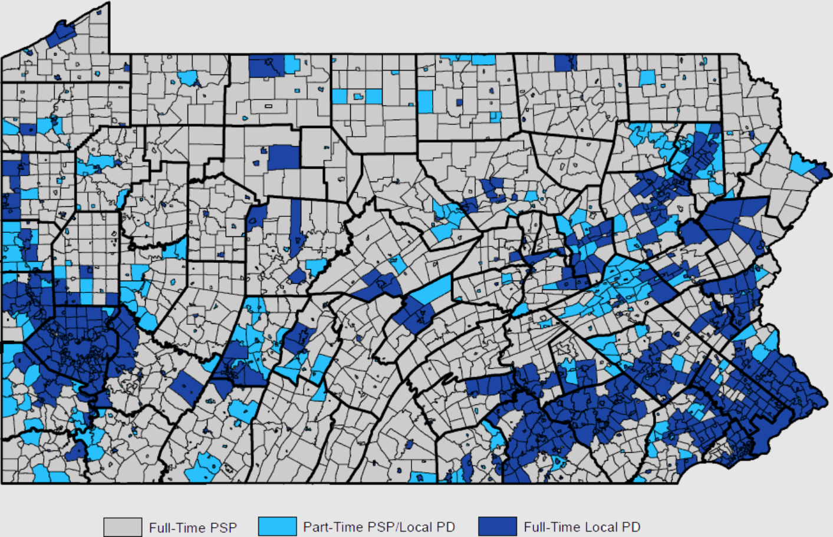
Pennsylvania Police Primary Jurisdiction
The organization is managed from a Department Headquarters in Harrisburg and 88 Stations distributed among 16 Troops with additional Bureaus and Offices. The organizational hierarchy is complex in nature and can result in different submission procedures dependent upon investigation type. In 2020, PSP dispatched approximately 5,000 calls for service per day. Troops, Stations, and other PSP Bureaus access and use RMS. Within Pennsylvania, several other state agencies may access and use RMS. PSP has had its existing CAD/RMS/MCT solution since 2015.

Any CAD/RMS/MCT system used by PSP must interface with industry standard systems as well as custom systems, including:

Traffic and Criminal Software (TraCS) - Used by PSP to complete electronic traffic citations, police warning notices, commercial vehicle inspection reports, crashes investigation reports, non-traffic Citations, and criminal complaints. TraCS transmits crash reports to a Station for review by a supervisor and, when approved, transmits them to the Pennsylvania Department of Transportation (PennDOT). Citations are efiled with the appropriate court and concurrently routed to a supervisor for review. The efiling of criminal complaints is being developed.

Commonwealth Law Enforcement Assistance Network (CLEAN) - Administered by PSP, this system performs as the nexus for driver’s license- and vehicle registration-related information as well as criminal justice information sharing within Pennsylvania and among federal, state, and local partners.

National Incident Based Reporting System (NIBRS) - Used by PSP to report incident information to the Federal Bureau of Investigation (FBI). Data is extracted from criminal investigative reports and organized per NIBRS specifications.

Geographic Information Services (GIS) sources, including street data, base maps, aerial photographs, etc. Currently the Commonwealth utilizes street data from ADCI.
Internal Systems - PSP Bureau of Liquor Control Enforcement (BLCE) Incident Tracking System (ITS), Property Management System, Human Resources, etc.

Other Known Systems - National Data Exchange (N-DEx), BlueTeam, mobile applications, Administrative Office of Pennsylvania Courts (AOPC), etc.

Vendor Trusted Solutions - Describe other solutions you may offer to improve or enhance a statewide police agency.

Issues to Be Addressed.
The Commonwealth is requesting feedback from firms with expertise in law enforcement CAD/RMS/MCT systems, as set forth below:

- Include a cover letter, with the RFI response, on Company Letterhead, which includes a point of contact name, phone number and email address.

- Complete Attachment A, Law Enforcement CAD/RMS/MCT System Questionnaire. Please respond to the questions in the questionnaire and limit the responses to these questions only.

Point of Contact:
The sole point of contact for this RFI shall be Jamie Zarr, jzarr@pa.gov

Due Date.
The Commonwealth is requesting that all responses to this RFI be submitted via email to jzarr@pa.gov by on May 4, 2021 at 10:00AM with the subject line of Law Enforcement CAD/RMS/MCT System - 6100053005.

Disclaimer.
This RFI is issued solely for information and planning purposes only and does not constitute a solicitation for future business, an offer for procurement or any other type of current or future procurement or contractual action and is only intended to gather input. The Commonwealth will not award a contract on the basis of this RFI nor will it pay for information it receives. Responses to this notice are not offers and cannot be accepted by the Commonwealth to form a binding contract. No party is bound by the information provided in response to this RFI.

Respondents are solely responsible for all expenses associated with responding to this RFI. The Commonwealth of Pennsylvania is not liable for any costs or expenses incurred by the Respondent in the preparation of its responses.

Respondents needing confidential treatment for any proprietary information they furnish must clearly identify that in their respective Responses. All information received in response to this RFI that is marked proprietary will be handled in accordance with applicable law including the Right To Know Law, as amended.

All material submitted shall be considered the property of the Commonwealth of Pennsylvania and may be returned only at the Commonwealth’s option. Notwithstanding any Respondents copyright designations contained on responses, the Commonwealth shall have the right to make copies and distribute responses internally and to comply with public record or other disclosure requirements under the provisions of any Commonwealth or United States statute or regulation, or rule or order of any court of competent jurisdiction.

Respondents to this request shall not provide recommendations as to specific courses of action and shall not be deemed to be an advisor or consultant to the Commonwealth. The Commonwealth will evaluate the information presented and determine any subsequent course of action, which may consist of contracting for implementation of Commonwealth-determined work. Such work may be procured through any procurement method available, and respondents to this request may be considered for selection to perform such work.

Responses to this RFI will not be returned. Respondents will not be notified of the result of the review, nor will they be provided copies of it.

Commonwealth Reservation of Rights.
The Commonwealth reserves the right to consider or reject any and all responses to this request, to amend and/or reissue this request and to abandon and then recommence at any time, or not recommence, this process. All costs of any response to this request and participation in any presentations to the Commonwealth are solely the responsibility of the Respondent and the Commonwealth shall not be liable for payment of any such costs.
REQUEST FOR INFORMATION
ATTACHMENT A
LAW ENFORCEMENT CAD/RMS/MCT SYSTEM QUESTIONNAIRE

Responding vendors are requested to provide answers to the following questions to assist PSP with understanding the current market for law enforcement CAD/RMS/MCT system solutions and to assess the advantages and disadvantages of replacing its current CAD/RMS/MCT system. Where an answer requests a “yes” or “no” response, please elaborate and explain the response. Provide responses to the following requests in the order they are presented. Each answer should be entirely self-contained; do not refer to other questions, pages, or other documents.

A.1 General

- Provide an overview of your CAD/RMS/MCT technology, including available modules and key features. Be sure to distinguish between features and functionality that are operational today and those that are in the company’s roadmap for future development or release.

- What are key trends in the market for public safety technology, and how are you contributing to or responding to those trends?

- Provide information about the company’s history and experience in the market for public safety information systems. Please describe the history of acquisitions, mergers, and changes to the company or product names.

- Provide information about up to four of your most comparable installations to what PSP is seeking. Agency size, geographic size and complexity, application configuration and dates of install are all considered relevant factors by PSP. Include the following for each project: agency name, references, project dates, and applications installed.

- Provide information regarding how your system interfaces and integrates with other software vendors (standard solutions such as NIBRS or custom state-specific databases/systems).

A.2 CAD and GIS

- What hardware and software architecture is required for your solution?

- Provide a basic description of how your CAD system supports law enforcement activities and documentation from inception to completion (e.g., designation of call type, priority level per call type, integrated public safety records to enhance call details, defined disposition codes, location history and advisories, definable function keys for streamlined dispatching, etc.).

- Does your solution offer a customizable list of function via a command line? Does your solution offer drag-and-drop functionality for dispatching?

- How does your solution display and track Trooper and unit activities and status changes? Can a unit icon change based upon its unit type (K9, Commercial Vehicle, Forensic Services, etc.) or status (available or busy)?

- How does your solution store information about incidents and Trooper activities? Can remarks be added to a call? Is the remarks field limited or unlimited?

- Can your solution create a scheduled CAD call daily, monthly, yearly?

- How are duplicate calls handled within your solution (i.e., two complainants call for the same incident and two tracking numbers are created)?

- What type of administrative logs are available within your solution after an incident is documented (logging by call, dispatcher, unit)?

- What capability does your solution have for a single CAD user to open more than one simultaneous CAD window (e.g., multiple screens required for viewing a status screen, call dispatching screen, and mapping software).

- How does your solution provide for multiple methods of interaction, namely shortcuts, command line entry of transactions, or drag-and-drop dispatching features?

- What help functions are available to provide intuitive choices and information as transactions and dispatches are performed?

- What capabilities does your solution have for querying CLEAN/NCIC from the CAD environment and for saving (copy/pasting) returned information into CAD screens? Can your solution query RMS for warrants and past contacts?

- Describe how your solution tracks the time of each Trooper when assigned to an incident and notifies the appropriate CAD user when any timer expires so that the welfare of the Trooper can be verified.

- How are timers configured and managed? Are your timers capable of being modified by agency personnel from within the CAD application (e.g., longer for some event types versus shorter for other types)?

- How intuitive are your timer controllers, and do they reset automatically as CAD assignments and transactions occur?

- Does your solution provide dispatching via addressing?

- What GIS technology is used? How does your GIS solution use commercial datasets and what customization is likely needed for PSP? What proprietary dataset conversion tools are required by your GIS solution?

- What differences in GIS mapping exist between the dispatch desktop computers and the in-vehicle mobile computers (e.g., geodatabases, shapefiles, street alias names)?

- What policy for refresh of mapping data do you recommend for your clients?

- What features make your mapping interface clear for mobile users and support the real-time work of police officers across an entire state? Please address three categories:

  - Mapping: incident address, address validation, street name disambiguation, street name limitations, mile markers, alias files, compatible projections, location coordinates, location search.
  - Viewing: zoom and rotate, satellite view, configurable refresh, view all vehicles, day and night views, label control APIs, smart label layers.
  - Directing: route-to-call function, voice directions, alternate directions, drive time, distance units.

- Describe how location information in CAD/RMS and MCT are validated and incorporated into your solution.

- How many user-defined layers does your mapping solution allow?

- Does your solution store shape file information with each incident for use in RMS?

- Does your map view show active incidents and Automatic Vehicle Locator (AVL) information from mobile units at the CAD workstation? Does it include centering maps on incidents as they are being handled by dispatch personnel? Can location comments be added to the map along with any special locations (e.g., landmarks, common places, businesses)? Can complainant history and advisories be displayed on the map?

A.3 Mobile Client

- What hardware and operating system restrictions are required of your MCT solution?

- What communications dependencies are required for your MCT solution (e.g., bit rates, security, availability)?

- How does your solution operate when an MCT is in an area of little to no broadband coverage?

- How does your MCT solution provide self-dispatching functionality?

- Does your MCT solution allow the Trooper the ability to initiate status changes in the same manner as the operator of the CAD workstation?

- Does your MCT solution allow a Trooper to pre-fill information or utilize information already existing in CAD to complete forms in either the MCT or RMS?

- How does your mobile map view display information related to active and past incidents?

- Does your MCT solution allow Troopers to view other Troopers’ locations within the map view?

- How does your MCT solution provide Troopers with directions to assigned calls from their current location and can it plot directions to other unassigned calls, addresses, or Trooper locations? Is it interactive with active voice?

- How does your MCT solution manage forms (i.e., create, issue, complete, and submit)?

- Does your MCT solution have a message system that will allow for messaging to occur between mobile users and CAD workstation users?

- How are messages logged and stored in the system?

- How is your messaging solution configurable? Does it include the capability to define control-specific groups (e.g., message to Station, Troop, and statewide)?

- How does your MCT solution provide for CLEAN, NCIC, and RMS queries to be made from the mobile environment?

- How does your MCT solution provide for pre-filling (copy/pasting) returned information into mobile screens or into the RMS?

- Does your MCT solution support barcode-scanning for drivers’ licenses and vehicle registrations?

- What other database queries, internal or external, can be supported by your solution?

- Does your solution have a voice-to-text/text-to-voice capability capable of reading messages and responses received by the client terminal?

- Does your solution alert the Trooper of an incoming assignment via either an audible or visual cue while driving?

- Does your solution offer an emergency alert function which can be activated by the MCT or CAD?

- How does your solution deploy updates to applications, software, and operational datasets?

A.4 Report Creation

- Does your system allow for custom agency-specific fields that can be added to the existing report modules? Can fields be added without having to implement programmatic changes to the user interface by programmers?

- Does your solution support logic-driven data entry (e.g., data fields displayed are based on previously entered report criteria)?

- What tools help standardize data entry across agency Sections/Bureaus (e.g., custom PSP specific report validation rules, NIBRS validation rules)?

- Does your solution permit the Trooper to create a report from the MCT as well as an in-Station computer?

- Does your solution allow users to replicate a report or a partial report to save time? If so, please describe the process.

- Users should be able to start a supplemental report before the primary report is written. Describe how your solution would support this workflow.

- What other tools facilitate data entry?

- Does your solution support barcode scanning for drivers’ licenses and vehicle registrations? Can users import scanned information into reports?

- How does your solution embed media files in reports (e.g., photographs, video)?

- Does your solution permit reports to be written without intranet or internet connectivity? How are reports written offline synchronized or uploaded once the user attains connectivity?

- Does your solution provide for an import of data returned from CLEAN/NCIC/RMS queries? If so, please describe the process.

- Does your solution allow users to attach a CLEAN/NCIC return to a report?

- How does your solution generate a paper copy? Does your solution provide for printing capabilities both from a mobile and in-Station desktop computer? Can the paper copies be customized via agency-specific rules?

- Does your solution provide for the ability to capture use-of-force information per incident?
A.5 Report Evolution and Supervision

- How does your solution track the status of reports before and after CAD closes a call for service?

- How does your solution help identify missing or overdue reports?

- What tools and data does your solution offer to track the life of a report? (e.g., how long has the report been assigned, how long has it existed in various queues/statuses, etc.)

- Can your solution support different report-writing interfaces across different Section/Bureaus within an agency as large and diverse as PSP?

- Does your solution support unique report approval workflows depending on the type of report (e.g., criminal reporting versus call for service reporting)?

- Does your solution permit a supervisor to validate a report for specific business rules during the approval process?

- Does your solution have a multi-level approval process in place, configurable by report type?

- In your solution, how do supervisors access reports requiring review?

- In your solution, how do supervisors return a report to a user and notify the user of required changes? How are supervisors alerted when requests changes have been made?

- In your solution, how are report writing errors tracked? Can the errors be reviewed to assist with refresher training or evaluations?

- How does your solution document report dissemination/tracking?

A.6 Case Management

- How does your solution track the management of cases and their applicable reports? Is it possible to configure your solution to forward reports automatically based on the offense or other user-defined criteria?

- How does your solution track case assignment/status (e.g., overdue cases)?

- Does your solution support the assignment of a single case to multiple persons?

- Does your solution permit a “batch assign” function to assign multiple cases to a new investigator?

- Does your solution automatically notify an investigator when a suspect who is already being investigated on another case enters the system?

- How does your solution enable investigators to add updates to case records, including additional entities, narratives, evidence and updated suspect information? How does your solution track the changing of entity statuses (e.g., a suspect now becomes an arrestee)?

- How does your solution notify or alert investigators when other individuals add updates to their assigned cases?

- For an incident with multiple arrestees, can your solution accommodate clearing one arrestee while keeping a case open for other arrestees?

- Is it possible to limit access to a record, report, or report type (e.g., arrest report) to a select group of people? If so, explain how your solution limits the access.

- Does your solution provide the capability to display and analyze case management data, including case assignments, investigative status, clearance rates, and case status duration, e.g., “pending review” status?

- Is it possible to auto-populate case disposition based on information received from the Administrative Office of Pennsylvania Courts (AOPC) case management system?

- Can custom rules be added to send reports to other internal Bureaus, Offices, or sections (e.g., A stolen vehicle report notifies the auto theft section.)?

A.7 Records Management

- Can an investigator identify a name in a Name Index (NI) and receive an alert when a member of another organizational segment or agency has an encounter with that person? Is it possible to receive the alert without alerting the person encountering that person?

- What tools are available to prevent multiple entries for the same person or vehicle into the NI?

- How does your solution link alias names and identifiers (e.g., SSNs, DLs) entered via different reports?

- How are names verified? Can the process be automated?

- Does your solution provide tools to identify records that could potentially be for the same person (e.g., audit reports, automatic notifications, etc.)?

- Does your solution provide the ability to merge two or more name records into a single name record?

- Does your solution provide for business and vehicle indices?

A.8 Citations and Crash Reports

- Does your solution include a module for citations and investigative crash reports? If so, please describe.

- Can your solution accept citation, crash, and other data from TraCS?

- Can your solution link citations or police warning notices to reports?

- How does data in your crash/citation solution interact with the NI?

- Can a crash report written in your solution be uploaded to TraCS? Would data automatically populate corresponding fields?

- Can a crash report written in TraCS be uploaded to your solution? Would data automatically populate corresponding fields?

- Can data from a crash report be sent to external interface (e.g., PennDOT)?

- Please provide a list of all third-party citation or accident reporting vendor solutions with which your solution has interfaced.

- Please provide a list of all relevant state agencies with which your solution has interfaced.

A.9 Online Reporting

- Does your solution provide an online reporting module for public incident/crime reporting?

- If your solution is capable of public reporting, how are reporting standards validated so that the submitter provides a report which meets agency reporting standards?

- If your solution is capable of public reporting, how are online reports submitted to the appropriate agency for review, approval and acceptance?

A.10 Arrests and Warrant Management

- Does your solution include an arrest tracking system? If so, can it be automatically linked to the associated report?

- Does your solution map details from the criminal report to an arrest system? This would include generating charging documents such as a criminal complaint, affidavit of probable cause, etcetera, from information in the RMS?

- Does your solution support multi-Station/Bureau warrant storage and access? Is it possible to allow viewing privileges to all authorized users but limit adding, editing, and/or removal privileges to a user’s own Station or Bureau?

- Does your solution enable viewing of warrant documents to be limited to only authorized users?

- How does your solution support warrant workflows for different warrant types (bench/civil versus criminal warrants)? Does your solution provide for warrant status tracking and overdue service attempts?

- How would your solution communicate with CLEAN/NCIC to add, edit, and remove warrants?

- How does the warrant system interact with the NI database?

- Describe any data validation/verification features.

A.11 Intelligence Tracking

- Describe the functionality available to track gangs, groups, and associates, as well as the ability to purge information.

- How does your solution track tips?

- How does your solution manage intelligence data and confidential informant information?

A.12 Property Management

- Does your solution provide a property management system? If yes, please provide answers to the following questions.

- Can all authorized users search property records?

- How does property information link to the NI?

- Does your solution provide functionality to generate labels in the field to start the chain of custody?

- How does your solution track individual evidence items associated with a single case?

- How does your solution facilitate property management from collection through disposition?

- How does your solution handle digital evidence?
- List third-party property management systems with which your solution has interfaced. Are any of these interfaces standard or are they all considered custom interfaces?

- List third-party lab information management systems with which your solution has interfaced. Are any of these interfaces standard or are they all considered custom interfaces?

- How are staff notified when a piece of property needs to be reviewed for disposal?

- How does your solution handle property dispositions including destruction, auction and return to owner?

- Describe how a user would research the location of a property item.

- How does your solution provide tracking of property that has been checked out (e.g., evidence at court)?

- How does your solution track vehicles in the custody at an impound yard?

- How does your solution facilitate property room inventory checks and random audits?

- Does your solution offer any alerts within the property management system (e.g., overdue alerts)?

- How does your solution facilitate entry of stolen and recovered property into the state PAUCRS/PIBRS and national systems (NIBRS)?

- How does your solution control security for both administrators and property submitters?

- Describe how your solution provides for organized property rooms. Does your solution generate barcode labels that indicate the location of the property in the evidence room?

A.13 NIBRS

- Is your solution NIBRS compliant? Please describe any past implementations with NIBRS. List all Pennsylvania law enforcement agencies for whom you have implemented NIBRS compliant systems.

- Have you ever translated or mapped Pennsylvania statutes to IBR offenses?

- How are changes to state and federal crime reporting requirements reflected in your latest software versions?

- How does your solution facilitate accurate data capture for NIBRS?

- How would your solution report NIBRS information for a structurally complex police agency like the PSP (e.g., Bureau/Office reporting versus Station reporting)?

- How does your solution identify NIBRS errors (reporting standards violations) prior to and during submission? Can custom agency/state specific errors be added?

- Please provide examples of NIBRS error (reporting standards violation) messages.

- Can error reports be generated at the Station, Troop, Bureau/Office, and Department-wide levels?

A.14 Public Records, Report Releasing, and Redaction

- How does your solution facilitate producing reports for public consumption?

- Describe how your solution facilitates redaction and the generation/tracking of a report’s release.

- Does your solution track who completed the redaction and when the redaction occurred?

- How does your solution preserve the redacted and unredacted versions of a report?

- If your solution provides a redaction function, does the redaction function have a text replacement function?

- Can your redaction tool support the rule-based redaction of data elements (e.g., data on juveniles)?

A.15 Retention and Deletion

- Can your solution permanently delete a record?

- Can your solution delete a portion of a record or select information from within a record (e.g., a person) without deleting the entire report? How would this deleting of information impact the NI?

- How does your solution ensure that all information about a person is removed throughout the system?

- How does your solution accommodate retention schedules? Are retention schedules customizable by incident types?

- Can designated roles (e.g., investigator assigned to a case, property room supervisors, other supervisors) receive notifications of cases, property, or documents that need to be reviewed per the retention schedules?

A.16 Administrative Functionality

- How can your solution support accreditation activities?

- Does your solution have a tracking mechanism for training and qualifications by members?

- Please describe any experience with tracking certifications for NCIC and Criminal Justice Information Systems (CJIS) compliance.

- Does your solution provide alerts when certifications and passwords are about to expire from external sources (e.g., CLEAN, Microsoft Windows)?

- Does your solution have functionality to provide situational awareness to users at the beginning of their shifts? Can this function be controlled by non-IT administrators?

- Does your solution permit non-IT administrators to change tables and other values throughout your system?

- Does your system provide for logging of view, edit, and printing of reports? Can only administrators view these logs?

- Does your solution keep a record of information before and after edits?

- Does your solution provide printing customization? (e.g., re-organize a document)

A.17 Queries and Searches

- Does your solution support the ability to run NCIC, Nlets, CLEAN and a variety of other external and internal queries on persons, vehicles, and property?

- Can your solution search multiple databases/modules simultaneously?

- Can users select which databases/modules they want to search?

- Does your solution support narrative text searches?

- Does your solution support partial field text searches (e.g., partial address or license plate)?

- Does your solution permit wildcard searches?

- Does your solution allow searches on any field? List any limitations to search capabilities.

- How can users tailor a search to a geographical area?
- Does your solution permit a user to conduct a search by refining a mapped list of responses?

- Does your solution allow users to view results of pre-configured searches, such as in a “dashboard”?

A.18 Crime Analysis and Statistics

- Does your solution architecture support a separate reporting database such that activities like searching, running reports, and analyzing data do not impact the production environment?

- Describe the level of detail that is available for conducting queries (e.g., all burglary incidents that occurred within a time frame and geographical location)?

- Describe any near-real-time crime analysis capabilities that an officer may use. Can this information be exported in a paper copy for dissemination to the public?

- What data visualization tools are provided in your solution?

- Does your solution include any analytical tools?

- Does your solution provide for analysis of dispatch, busy, or any other times from CAD (e.g., available time vs. allocated time)?

- Is data exportable in a format that can be read by industry-standard software?

- What crime or incident mapping capabilities are available within your solution?

- Does your solution provide any case cross-referencing or linking analysis between people and/or vehicles? If so, please describe the functionality.

- How does your solution accommodate the need to collect specialized information (e.g., to conform to grant-reporting requirements or inquiries from elected officials)? Can custom reports be written from within the solution and exported to Excel, PDF, or CSV files?

A.19 System Administration/Technical

- What in-house resources will PSP require to support Cloud and/or on-premises solutions?

- Describe the tools for managing permissions and security.

- Describe the solution’s logging and auditing capabilities.

- Is it possible for the user to add fields “on the fly” to allow for the temporary collection of data (e.g., for grants reporting)? Can these fields be added by PSP personnel?
- Does your solution support a single system logon so that users can log into the system once?

- List the types of end-user devices with which your solution is compatible.

- Is your solution compatible with a tablet or smartphone?

- Does your solution support electronic signatures?

A.20 Implementation and Support

- What agency resources are recommended for implementation of your solution?

- Provide an estimate for the expected duration of the implementation.

- Describe end-user training options. Can you provide short video tutorials?

- Describe the standard support provided to customers. Is 24x7 support an option? Is there an additional cost for 24/7 support?

- How are enhancements and change requests prioritized? When an enhancement is requested, is there an additional cost? Can you describe typical schedules/timeframes for minor and major enhancements? Are your enhancements delivered via major software upgrades or can they be customized and released to an individual customer?

- Does your solution have the flexibility to update and comply with federal and state requirements and statutes on a yearly/monthly basis? Can this be managed by agency personnel rather than IT support?

- Describe how you would implement your solution in a large state-wide system.

- Does your organization provide for any on-premise support and/or training?

A.21 Interfaces

- What APIs do you support? Do you currently have any APIs with other RMS, CAD, or MCT vendors?

- How does your solution support the population of information into master index fields from third-party applications (such as TraCS), warrants uploaded from AOPC, and property and evidence programs?

- Can your solution interface with a use of force program?

- Describe a standard interface with third-party CAD or MCT applications.

- Please describe your experience with state-based human resource data provided by SAP databases/information systems.

A.22 Pricing

- Provide estimated pricing for a CAD/RMS/MCT solution that can accommodate the number of users and the range of functionality desired as described in this RFI. Please note that any pricing information provided is non-binding and for PSP’s budgetary purposes only.

- Provide separate pricing for SaaS, Cloud and on-premises solutions, as appropriate.

- List the modules (functionality) included in the price.

- How would the pricing change if PSP interfaced to a third-party provider of a property and evidence management system versus using the module provided with the CAD/RMS/MCT solution?

- What implementation costs should PSP expect to incur for the following: project management, training, testing, interface development, data conversions, other implementation costs?

- What should PSP expect for annual maintenance fees? When would PSP start incurring annual maintenance fees? What type of upgrade pricing plans are offered within annual maintenance fees?

